BTTLETECH
OUTWORLDS WASTES



Event Scenario Pack
BATTLETECH: OUTWORLDS WASTES

THE LEGATE

--------------------------- START TRANSMISSION ----------------------------
A CORRUPT LEGATE ON CARSPHAIRN HAS ASSASSINATED THE GOVERNOR OF THE PLANET AND IS CONSOLIDATING CONTROL. OTHER GROUPS ARE LANDING FORCES ON PLANET IN AN ATTEMPT TO CLAIM IT THEMSELVES. YOU WILL JOIN THEM IN A TEMPORARY TRUCE AND TAKE CARSPHAIRN FOR US.
---------------------------- END TRANSMISSION -----------------------------

These are player-vs-GM scenarios for BattleTech: Outworlds Wastes with combined arms and simplified campaign logistics rules.

Each player may bring 3,000 BV of combined arms from a single faction in the Dark Age era on the Master Unit List, following the BattleTech: Outworlds Wastes event list building rules.

Players use BattleTech: Outworlds Wastes Force Maintenance event rules to improve their force between scenarios. Players can improve their force up to 5,000 BV. The enemy force uses the full BattleTech: Outworlds Wastes Force Maintenance rules for repair between scenarios.

The following optional rules are recommended:
- Initiative Deck: Initiative is determined by playing cards.
Each player receives one card; their whole force activates together.
The Movement Phase is resolved from lowest value to highest.
The Attack Phases are resolved from highest value to lowest.
- Fire for Effect: Attack declaration and resolution occur simultaneously.
- Multiple Attack Rolls: Separate attack rolls for each point of damage. (Alpha Strike)
- Minefields: The GM may place minefields (TO AR) prior to deployment.
- Hull Down: Vehicles may use prepared positions to use Hull Down rules (TO AR).
- Floating Criticals: If a hit location of 2 is rolled, roll a second time to determine the
location of the through armor critical hit.

BattleTech Outworlds Wastes:
Web: https://outworlds-wastes.jeremylt.org/event-play
PDF: https://outworlds-wastes.jeremylt.org/downloads?event

BattleTech: Outworlds Wastes is fan-made and based upon the official BattleTech rules from Catalyst Game Labs. BattleTech is a registered trademark of The Topps Company, Inc. in the United States and other countries.

Author: Ian T
Editor: Jeremy L Thompson
--------------------------- START TRANSMISSION ----------------------------

MISSION BACKGROUND

THE REPUBLIC OF THE SPHERE WAS FORMED AFTER THE DEFEAT OF THE WORD OF BLAKE. NEGOTIATIONS BETWEEN ALMOST ALL THE MAJOR POWERS OF THE INNER SPHERE AND PERIPHERY RESULTED IN A BUFFER STATE UNDER THE RULE OF DEVLIN STONE. THE NATION CAME INTO BEING IN 3081, CONTROLLING OVER 200 SYSTEMS THAT WOULD BE CEDED FROM THE SURROUNDING GREAT HOUSES.

DEVLIN STONE USHERED IN AN ERA OF DEMILITARIZATION AND RELATIVE CALM, WITH THE YOUNG NATION'S ONLY MAJOR CONFLICT BEING WITH THE CAPPELLAN CONFEDERATION FROM 3104 TO 3113. STONE WOULD EVENTUALLY STEP DOWN FROM POWER IN 3130. THE REPUBLIC OF THE SPHERE WOULD SUFFER GREATLY FOLLOWING THE HPG BLACKOUT IN 3132. MANY SPLINTER FACTIONS FROM WITHIN THE REPUBLIC FORMED, WITH MANY MILITARY, GOVERNMENT AND CIVILIAN LEADERS CLAMORING FOR POWER AND DECLARING ALLEGIANCE TO FOREIGN NATIONS. A RAPID PERIOD OF REARMAMENT BEGAN. EVENTUALLY, OTHER MAJOR NATIONS WOULD ALSO LAUNCH ASSAULTS INTO THE REPUBLIC, SEEKING TO GAIN CONTROL OF SYSTEMS THEY HAD CEDED A FEW DECADES EARLIER.

EVENTUALLY, THE REPUBLIC WOULD WITHDRAW TO A FEW CORE WORLDS AND RAISE AN IMPENETRABLE WALL AROUND ITS SPACE. AFTER ONLY A FEW DECADES, THE WALL CAME DOWN, AND THE REPUBLIC WOULD SUCCUMB TO ASSAULTS BY OTHER POWERS. IN 3151 DEVLIN STONE FORMALLY SURRENDERED TO LEADERS FROM CLAN WOLF AND CLAN JADE FALCON; AND DISSOLVED THE REPUBLIC OF THE SPHERE.

LOCAL AREA STAR MAP

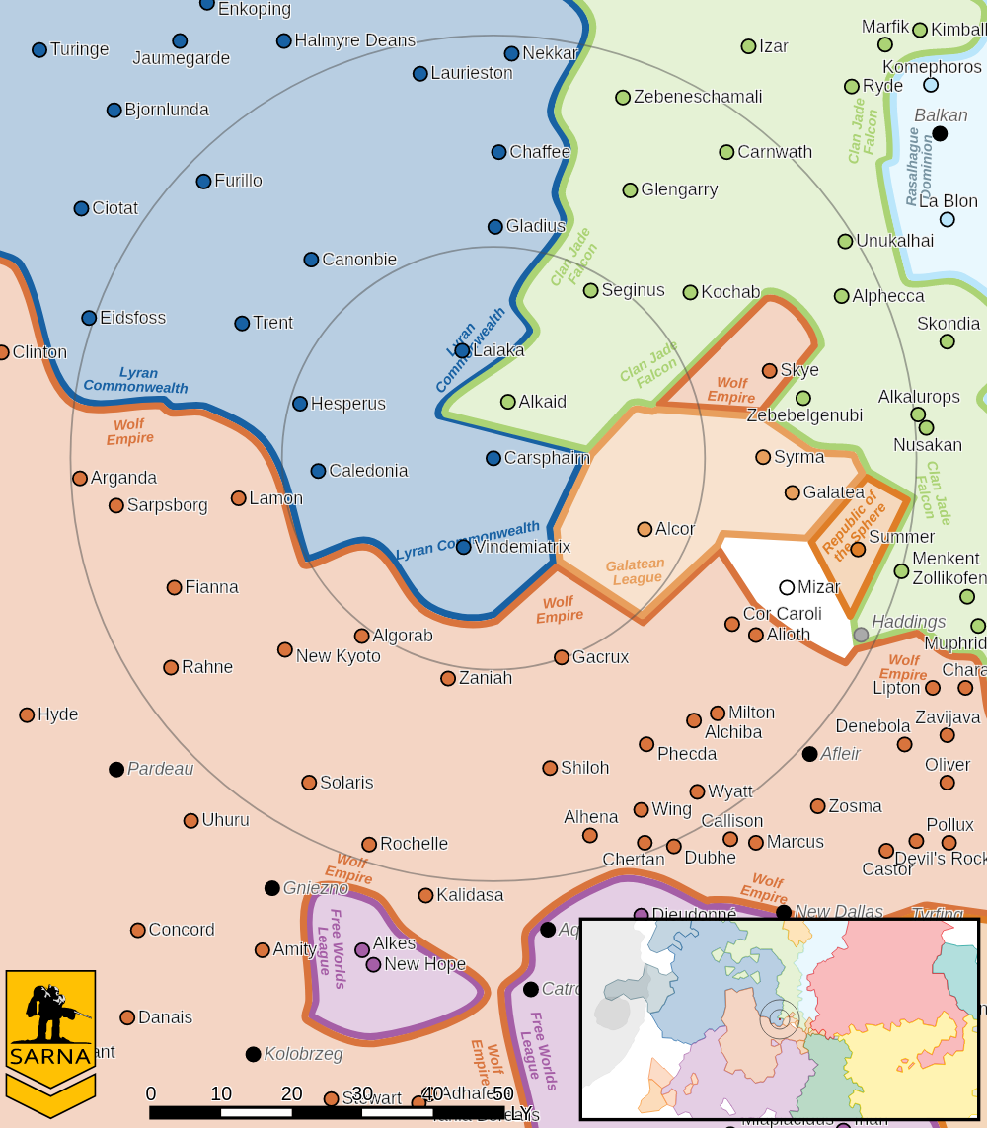

CARSPHAIRN III PLANETARY READOUT

STAR TYPE : KIV (192 HOURS RECHARGE TIME)
POSITION IN SYSTEM : 3 OF 8
NATURAL SATELLITES : 3
TIME TO JUMP POINT : 5.2 DAYS
SURFACE GRAVITY : 1.13 G
DAY LENGTH : 22.0 HOURS
ATMOSPHERIC PRESSURE : STANDARD (BREATHABLE)
EQUATORIAL TEMPERATURE : 33*C
SURFACE WATER : 77 PERCENT
CAPITAL : NARCISSE
POPULATION : 3,013,000,000
HPG : NONE
SOCIO-INDUSTRIAL LEVELS : B-B-C-B-A
TECHNOLOGICAL SOPHISTICATION : B (ADVANCED WORLD)
INDUSTRIAL DEVELOPMENT : B (MODERATELY INDUSTRIALIZED)
RAW MATERIAL DEPENDENCE : C (LIMITED RAW MATERIAL PRODUCTION)
INDUSTRIAL OUTPUT : B (GOOD INDUSTRIAL OUTPUT)
AGRICULTURAL DEPENDENCE : A (BREADBASKET)

MISSION 1: CONVOY AMBUSH

A CARSPHAIRN MILITIA CONVOY HAS BEEN SPOTTED MOVING THROUGH TERRITORY IN THE COUNTRYSIDE. INTELLIGENCE SUGGESTS THIS CONVOY HAS IMPORTANT EQUIPMENT FOR THE MILITIA. THE CONVOY'S EXPECTED TO PASS THROUGH AN IDEAL LOCATION FOR AN AMBUSH. WAIT THERE AND TAKE THEM BY SURPRISE; DESTROY THE CONVOY AND, IF POSSIBLE, PREVENT FUTURE TRAVEL ALONG THE ROAD.

PRIMARY OBJECTIVES:
DESTROY ENEMY TRANSPORTS AND HEAVY EQUIPMENT
DESTROY THE BRIDGE

OPPOSITION FORCES:
ONE 'MECH LANCE SUPPORTED BY COMBAT VEHICLES

MISSION 2: FACILITY RAID

WE HAVE LOCATED ONE OF THE CARSPHAIRN MILITIA'S MOD REFIT FACILITIES IN AN OLD NETWORK OF MINES. GO INTO THE MINES, DESTROY THE FACILITY, AND REMOVE THE MILITIA'S ABILITY TO PRODUCE MORE MILITARIZED INDUSTRIAL 'MECHS.

PRIMARY OBJECTIVES:
DESTROY ENEMY ASSEMBLY AND MAINTENANCE EQUIPMENT
DOWNLOAD DATA FROM FACILITY MAINFRAME

OPPOSITION FORCES:
ONE 'MECH LANCE SUPPORTED BY COMBAT VEHICLES AND INDUSTRIAL MECHS

MISSION 3: SPACEPORT ASSAULT

THE TIME HAS FINALLY COME, MEET THE REMAINING CARSPHAIRN MILITIA FORCES IN PITCHED BATTLE, KILL THE LEGATE AND TAKE THE SPACEPORT.

PRIMARY OBJECTIVES:
CAPTURE OR KILL THE LEGATE
CAPTURE CRITICAL SPACEPORT INFRASTRUCTURE

ADDITIONAL RULES:
EACH COMMANDER RECEIVES 10 BSP POINTS

OPPOSITION FORCES:
ONE 'MECH LANCE SUPPORTED BY COMBAT VEHICLES AND THE LEGATE'S MECH

---------------------------- END TRANSMISSION -----------------------------
--------------------------- START TRANSMISSION ----------------------------

INTELLIGENCE HAS PROVIDED SATELLITE IMAGERY OF THE CONVOY ROUTE.
|-- FRIENDLY DEPLOYMENT ZONE --|
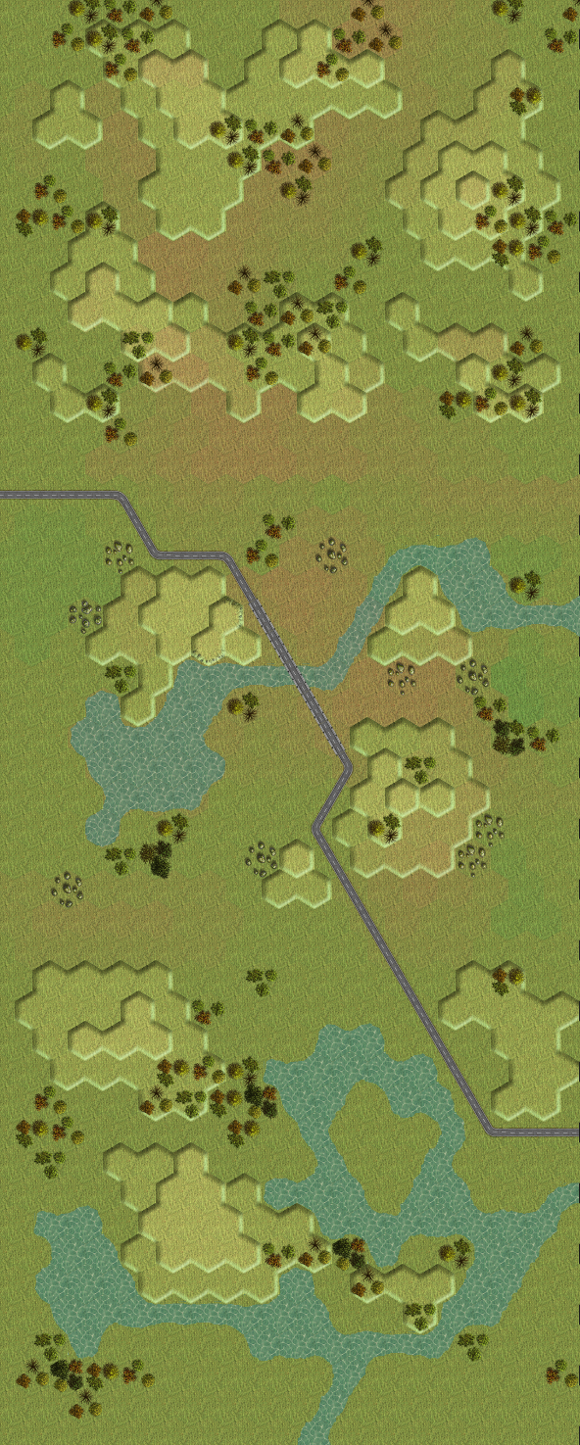

---------------------------- END TRANSMISSION -----------------------------
--------------------------- START TRANSMISSION ----------------------------

INTELLIGENCE HAS PROVIDED SATELLITE IMAGERY OF THE ABANDONED MINE.

MINE ENTRANCE REPAIR GANTRIES
|-- FRIENDLY DEPLOYMENT ZONE --|

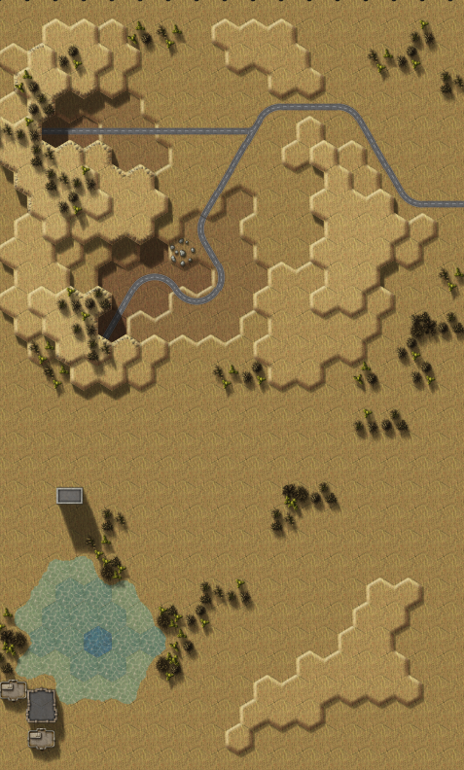

---------------------------- END TRANSMISSION -----------------------------
--------------------------- START TRANSMISSION ----------------------------

INTELLIGENCE HAS PROVIDED SATELLITE IMAGERY OF THE MINE INTERIOR.

REPAIR GANTRIES

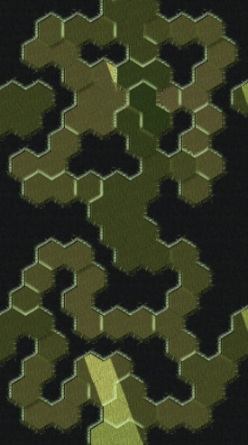
|---------- FRIENDLY DEPLOYMENT ZONE ----------|

---------------------------- END TRANSMISSION -----------------------------
--------------------------- START TRANSMISSION ----------------------------

INTELLIGENCE HAS PROVIDED SATELLITE IMAGERY OF THE LANDING PORT.
PORT INFRASTRUCTURE
|-- FRIENDLY DEPLOYMENT ZONE --|
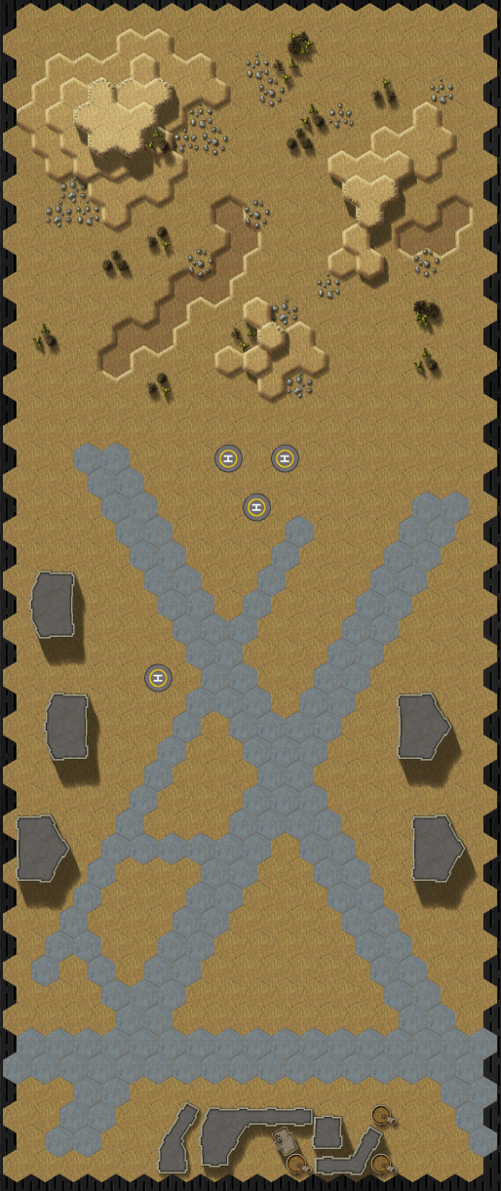

---------------------------- END TRANSMISSION -----------------------------
--------------------------- START TRANSMISSION ----------------------------

MISSION BOUNTIES

THE FOLLOWING BOUNTIES HAVE BEEN ISSUED FOR THIS MISSION.

PAYMENT | ACTIVITY
100,000 | DAMAGE ENEMY UNIT (PER UNIT)
100,000 | DAMAGE ENEMY DROPSHIP (PER DROPSHIP)
100,000 | CRITICAL OR MOTIVE DAMAGE (PER UNIT)
100,000 | COMPLETE A PHYSICAL ATTACK
100,000 | COMPLETE AN ANTI-MECH ATTACK
100,000 | DAMAGE A UNIT WITH INDIRECT FIRE
100,000 | SKID A UNIT WITHOUT DESTROYING IT
250,000 | KNOCK 'MECH PILOT UNCONSCIOUS
250,000 | REDUCE A COMBAT VEHICLE TO 0 MP
250,000 | KILL ALL BUT 1 TROOP IN AN INFANTRY UNIT
250,000 | HAVE A UNIT SCORE A HIT AT ALL 3 RANGES
250,000 | COMPLETE A CHARGE ATTACK
250,000 | COMPLETE A DEATH FROM ABOVE ATTACK
500,000 | SHOOT DOWN A VTOL WITH A TMM OF 5+
500,000 | SHOOT A 'MECH IN THE HEAD
500,000 | PHYSICAL ATTACK A 'MECH IN THE HEAD
500,000 | CAPTURE A VEHICLE CREW OR 'MECH PILOT

---------------------------- END TRANSMISSION -----------------------------
BATTLETECH: OUTWORLDS WASTES

SNOW RAVEN RAID - GM Notes

Mission 1
Maps: Deserts Pack, AeroBase #1, AeroBase #2, Oasis
Scoring: 0.4M for each convoy vehicle destroyed, 0.4M for bridge destroyed

Militia: Battle Armor will ride on the convoy vehicles to provide extra armor. Given the Dark Age lore, combat vehicles will augment the ‘Mech lance since BattleMechs are less common in the era.

Mission 2
Maps: Deserts Pack, Mines #1, Mines #2, Ishiyama Pack, any
Scoring: 0.5M for each gantry destroyed, 0.5M for data downloaded

Militia: Focus on preserving equipment. IndustrialMechs will join the defenses since this is their repair facility.

Defense: No back exit in the mines if the 3rd convoy vehicle was destroyed. Reduce the CF of the IndustrialMech gantries from 40 to 20 if the 4th convoy vehicle was destroyed.

Mission 3
Maps: Deserts Pack, AeroBase #1, AeroBase #2, Washout #1
Scoring: 1.0M for capturing /killing the Legate, 0.33M for capturing buildings

Militia: Focus on protecting the Legate.

Defense: No mines if the first convoy vehicle was destroyed. No prepared Hull Down positions for combat vehicles if the second convoy vehicle was destroyed.

BTTLETECH
OUTWORLDS WASTES

