BATTLETECH
OUTWORLDS WASTES

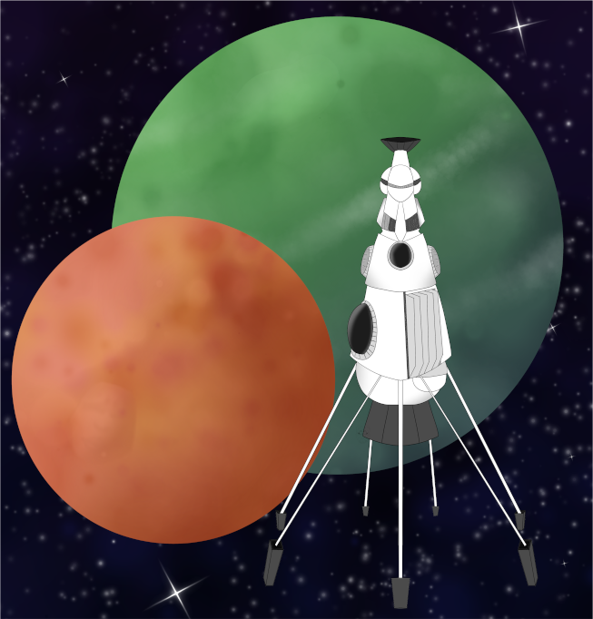

Event Scenario Pack
BATTLETECH: OUTWORLDS WASTES

PRIDE MONTH 2024

--------------------------- START TRANSMISSION ----------------------------
MAGISTRACY OF CANOPUS HAS AN IMMEDIATE JOB FOR ALL AVAILABLE MERCENARY UNITS! A WORD OF BLAKE SPLINTER GROUP CALLING THEMSELVES 'RED CELL' HAS BEEN RAIDING MAGISTRACY WORLDS. MAGISTRACY INTELLIGENCE MINISTRY HAS IDENTIFIED TETSKI AS THE BASE OF OPERATIONS FOR 'RED CELL'.
---------------------------- END TRANSMISSION -----------------------------

These are player-vs-GM scenarios for BattleTech: Outworlds Wastes with combined arms and simplified campaign logistics rules.

Each player may bring 3,000 BV of combined arms from a single faction in the ilClan era on the Master Unit List, following the BattleTech: Outworlds Wastes event list building rules.

Players use BattleTech: Outworlds Wastes Force Maintenance event rules to improve their force between scenarios. Players can improve their force up to 5,000 BV. The enemy force uses the full BattleTech: Outworlds Wastes Force Maintenance rules for repair between scenarios.

The following optional rules are recommended:
- Initiative Deck: Initiative is determined by playing cards.
Each player receives one card; their whole force activates together.
The Movement Phase is resolved from lowest value to highest.
The Attack Phases are resolved from highest value to lowest.
- Fire for Effect: Attack declaration and resolution occur simultaneously.
- Multiple Attack Rolls: Separate attack rolls for each point of damage. (Alpha Strike)

BattleTech Outworlds Wastes:
Web: https://outworlds-wastes.jeremylt.org/event-play
PDF: https://outworlds-wastes.jeremylt.org/downloads?event

BattleTech: Outworlds Wastes is fan-made and based upon the official BattleTech rules from Catalyst Game Labs. BattleTech is a registered trademark of The Topps Company, Inc. in the United States and other countries.

Editor: Jeremy L Thompson
--------------------------- START TRANSMISSION ----------------------------

MISSION BACKGROUND

'RED CELL' IS A VIOLENT SPLINTER GROUP FORMED FROM WORD OF BLAKE REMNANTS. THEY MANDATE STRICT ADHERENCE TO THEIR INTERPRETATION OF BLAKEIST IDEOLOGY AND RESTRICT LOCAL POPULATIONS THEY CONTROL.

TETSKI IS AN ABANDONED SYSTEM NEAR THE MAGISTRACY OF CANOPUS. TETSKI WAS ABANDONED DURING THE SECOND SUCCESSION WAR DUE TO CONTAMINATION FROM BIOLOGICAL AGENTS RELEASED DURING THE CONFLICT WITH THE TAURIAN CONCORDAT. THE 'RED CELL' APPEARS TO HAVE REMOVED THE CONTAMINATION.

SEVERAL MAGISTRACY WORLDS ARE WITHIN RANGE OF TETSKI; IT IS THEREFORE CRITICAL THAT WE PREVENT 'RED CELL' OPERATIONS IN THE REGION. A STRIKE ON THEIR MAIN BASE SHOULD CURTAIL THEIR OPERATIONS.

LOCAL AREA STAR MAP

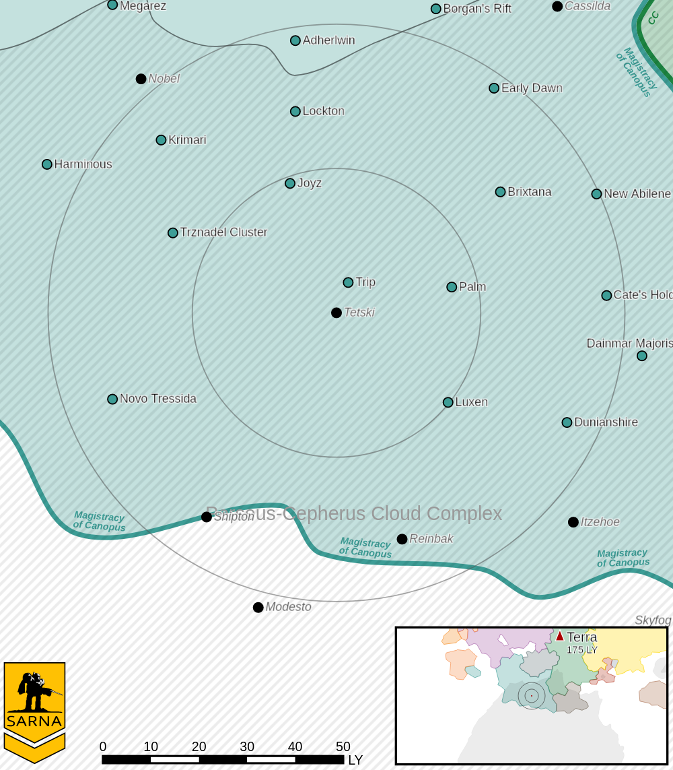

TETSKI I PLANETARY READOUT

STAR TYPE : M7V (208 HOURS RECHARGE TIME)
POSITION IN SYSTEM : 1 OF 1
NATURAL SATELLITES : 0
TIME TO JUMP POINT : 2.22 DAYS
SURFACE GRAVITY : 0.84 G
DAY LENGTH : 27.0 HOURS
ATMOSPHERIC PRESSURE : STANDARD (BREATHABLE)
EQUATORIAL TEMPERATURE : 31*C
SURFACE WATER : 32 PERCENT
CAPITAL : TOKHAI
POPULATION : 0
HPG : NONE
SOCIO-INDUSTRIAL LEVELS : X-X-X-X-X
TECHNOLOGICAL SOPHISTICATION : X (NONE)
INDUSTRIAL DEVELOPMENT : X (NONE)
RAW MATERIAL DEPENDENCE : X (NONE)
INDUSTRIAL OUTPUT : X (NONE)
AGRICULTURAL DEPENDENCE : X (NONE)

----------------------------- END TRANSMISSION ----------------------------

SCENARIO 1: DO CRIME

---------------------------- START TRANSMISSION ---------------------------
YOUR FORCES WILL EXECUTE A COMBAT DROP ON THE 'RED CELL' BASE OF OPERATIONS. CAPTURE CRITICAL POINTS MARKED BY FLAGS AND DESTROY ALL ENEMY FORCES. THIS ENEMY MUST BE STOPPED.
----------------------------- END TRANSMISSION ----------------------------

Unit Limits: 5K BV for each force dropping on the planet and a corresponding 4K BV of defending forces.

Map: One central mapsheet with a large base and 8 adjoining mapsheets with flat desert terrain. The GM places 2 control points and 2 turrets for every friendly force. The turrets are heavy buildings with a construction factor of 100. Turrets contain 2 ER Large Lasers or 2 Clan LRM 10s. The GM also secretly determines where all defending forces are positioned.

Friendly forces use modified combat drop rules: Each dropping unit selects a target hex. Roll 1d6 to determine the scatter direction and 1d6-1 to determine the scatter distance for the dropping unit. If the target hex is occupied, displace by 1 hex in the opposite direction of the scatter direction. Enemy units may be revealed in this fashion. Friendly forces may not select a target hex on or within 6 hexes the center mapsheet.

Primary Objective: Destroy all enemy forces. Enemy units are not salvageable. Earn a portion of 3M C-bills based upon the percentage of enemy units destroyed.

Secondary Objectives:
Hoist the flag. Randomly earn 1 Battlefield Support (BSP) action for each flag hoisted over a control point. Secure a control point by occupying the control point with a 'Mech with no enemy units in adjacent hexes. Select the BSP by random roll or by drawing from the BSP deck.

Capture the turrets. If a friendly infantry unit ends its turn in the same hex as turret, it may capture the turret. During the End Phase, the turret may be destroyed or the infantry unit inside the turret may use the turret weapons with their gunnery skill during the next turn.
--------------------------- START TRANSMISSION ----------------------------

MISSION BOUNTIES

THE FOLLOWING BOUNTIES HAVE BEEN ISSUED FOR THIS MISSION.

PAYMENT | ACTIVITY
100,000 | DAMAGE ENEMY UNIT (PER UNIT)
100,000 | CRITICAL OR MOTIVE DAMAGE (PER UNIT)
100,000 | COMPLETE A PHYSICAL ATTACK
100,000 | COMPLETE AN ANTI-MECH ATTACK
100,000 | DAMAGE A UNIT WITH INDIRECT FIRE
100,000 | SKID A UNIT WITHOUT DESTROYING IT
100,000 | DESTROY ENEMY UNIT (PER UNIT)
250,000 | KNOCK 'MECH PILOT UNCONSCIOUS
250,000 | REDUCE A COMBAT VEHICLE TO 0 MP
250,000 | KILL ALL BUT 1 TROOP IN AN INFANTRY UNIT
250,000 | HAVE A UNIT SCORE A HIT AT ALL 3 RANGES
250,000 | COMPLETE A CHARGE ATTACK
250,000 | COMPLETE A DEATH FROM ABOVE ATTACK
500,000 | SHOOT DOWN A VTOL WITH A TMM OF 5+
500,000 | SHOOT A 'MECH IN THE HEAD
500,000 | PHYSICAL ATTACK A 'MECH IN THE HEAD
500,000 | CAPTURE A VEHICLE CREW OR 'MECH PILOT

---------------------------- END TRANSMISSION -----------------------------

SCENARIO 2: BE GAY

---------------------------- START TRANSMISSION ---------------------------
YOUR FORCES HAVE SET UP A FRIENDLY COMPETITION IN THE RUINS OF TOKHAI TO CELEBRATE THEIR VICTORY.
----------------------------- END TRANSMISSION ----------------------------

Unit Limits: 5K BV for each force, plus 1 coolant truck for each force.

Map: 4 mapsheets with city terrain, with at least 5 buildings per force evenly distributed across the mapsheets.

Primary Objective: Each force has a coolant truck with paint. The truck has a gunnery skill of 3 with range 2/4/6 (BattleTech) or short range (Alpha Strike). The prize pool is 5,000,000 C-bills per force present. Earn a portion of the prize pool based upon the percentage of buildings you paint.

Sample Color Schemes: (Additional schemes on https://hrc.org)
Traditional Pride Flag Trans Pride Flag NonBinary Pride Flag


Asexual Pride Flag Bisexual Pride Flag Agender Pride Flag

BATTLETECH: OUTWORLDS WASTES

PRIDE MONTH 2024 - GM Notes

Notes:
GM forces are only needed for Scenario 1: Do Crime. The GM may join as an additional
player for Scenario 2: Be Gay.

The mission bounties assume a combined arms force for the defenders, but the bounties
may be adjusted to reflect the personal preferences of the GM and the players.
PesudoTech is a good place to look for additional bounties to add to the scenario.

The list of flag colors for Scenario 2: Be Gay is not exhaustive. The GM should pick
whatever colors best resonate with the players. Additional flags can be found on the
HRC website, among other places.

This scenario is intended to be inclusive of all players. It is important to ensure a friendly
and welcoming environment for this event.

BATTLETECH
OUTWORLDS WASTES

