BATTLETECH
OUTWORLDS WASTES

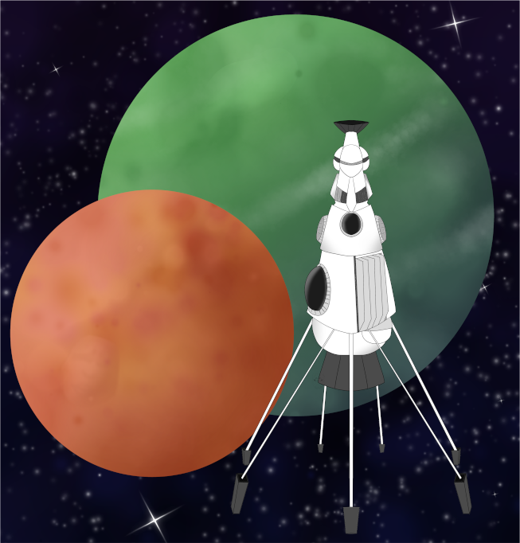

Event Scenario Pack
BATTLETECH: OUTWORLDS WASTES

BOX CANYON

--------------------------- START TRANSMISSION ----------------------------
INTERSTELLAR EXPEDITIONS IS LOOKING FOR INDEPENDENT SECURITY CONTRACTORS FOR A LONG HAUL MISSION IN THE OUTWORLDS WASTES. WE OFFER FLEXIBLE CONTRACT TERMS AND GENEROUS SALVAGE RIGHTS. JOIN OUR SPINWARD OPERATIONS TEAM TODAY!
---------------------------- END TRANSMISSION -----------------------------

These are player-vs-GM scenarios for BattleTech: Outworlds Wastes with combined arms and simplified campaign logistics rules.

Each player may bring 3,000 BV of combined arms from a single faction in the ilClan era on the Master Unit List, following the BattleTech: Outworlds Wastes event list building rules.

Players use BattleTech: Outworlds Wastes Force Maintenance event rules to improve their force between scenarios. Players can improve their force up to 5,000 BV. The enemy force uses the full BattleTech: Outworlds Wastes Force Maintenance rules for repair between scenarios.

The following optional rules are recommended:
- Initiative Deck: Initiative is determined by playing cards.
Each player receives one card; their whole force activates together.
The Movement Phase is resolved from lowest value to highest.
The Attack Phases are resolved from highest value to lowest.
- Fire for Effect: Attack declaration and resolution occur simultaneously.
- Tainted (Caustic): Conventional infantry must be XCT troops, weapon attacks against CI
do an additional 1D6, vehicles with breached armor suffer Crew Stunned, 'mechs that
suffer cockpit damage take 1 extra warrior dit
- Low Gravity: Divide default MPs by 0.68 and round to compute the unit’s new MPs.
Add +1 to-hit for all Missile and Direct-Fire Ballistic weapon attacks.
- Low Temperature: Each unit records -1 heat each End Phase

BattleTech Outworlds Wastes:
Web: https://outworlds-wastes.jeremylt.org/event-play
PDF: https://outworlds-wastes.jeremylt.org/downloads?event

BattleTech: Outworlds Wastes is fan-made and based upon the official BattleTech rules from Catalyst Game Labs. BattleTech is a registered trademark of The Topps Company, Inc. in the United States and other countries.

Era: Succession Wars or later

Editor: Jeremy L Thompson
--------------------------- START TRANSMISSION ----------------------------

MISSION BACKGROUND

VOEHN IS A SYSTEM ALONG ONE OF THE POPULAR ROUTES FROM RAVEN ALLIANCE WORLDS TO WYNN'S ROOST. WHILE CONDUCTING OPERATIONS ON VOEHN II, INTERSTELLAR EXPEDITIONS RECEIVED A STRANGE MESSAGE FROM NEARBY VOEHN III.

A LOCAL INDIVIDUAL CALLING HIMSELF 'BIG ROOSTER' HAS INVITED YOUR TEAM TO PARTICIPATE IN 'BLOOD GULCH', A GLADIATORIAL STYLE GAME HE IS HOSTING. IN THIS CAPTURE THE FLAG TOURNAMENT, THE WINNER GETS TO CLAIM SALVAGE RIGHTS, IF THEY SURVIVE.

REGION BACKGROUND

THE OUTWORLDS ALLIANCE WAS FOUNDED IN 2413 AND ENJOYED PROSPERITY THROUGHOUT THE STAR LEAGUE ERA. BY THE START OF THE AMARIS CIVIL WAR IN 2766, THE OUTWORLDS ALLIANCE CONTAINED OVER 135 MAJOR SYSTEMS ACROSS 7 ADMINISTRATIVE DISTRICTS. UNFORTUNATELY, THE OUTWORLDS ALLIANCE SUFFERED DURING THE SUCCESSION WARS THAT FOLLOWED THE FALL OF THE STAR LEAGUE IN 2780, AND THEY HAD TO STEADILY ABANDON SYSTEMS THEY NO LONGER HAD THE RESOURCES TO SUPPORT.

CLAN SNOW RAVEN BEGAN EXPLORING THE PERIPHERY FOR RESOURCES SOON AFTER THE BATTLE OF TUKAYYID ENDED OPERATION REVIVAL. IN 3064, CLAN SNOW RAVEN AND THE OUTWORLDS ALLIANCE BEGAN DEVELOPING MUTUAL RESPECT AND TENTATIVE ALLIANCE. FOLLOWING THEIR ABJURATION FROM THE CLAN HOMEWORLDS IN 3075 AS A RESULT OF THE WARS OF REAVING, CLAN SNOW RAVEN TOOK REFUGE IN THE OUTWORLDS ALLIANCE. IN 3083, CLAN SNOW RAVEN AND THE OUTWORLDS ALLIANCE MERGED TO FORM THE RAVEN ALLIANCE.

BY THE ILCLAN TRIAL IN 3151, THE RAVEN ALLIANCE CONTAINED ONLY 47 SYSTEMS. AT LEAST 88 SYSTEMS THAT WERE PART OF THE OUTWORLDS ALLIANCE DURING THE STAR LEAGUE ERA HAVE BEEN LOST. MANY FACTIONS ARE EAGER TO EXPLORE THESE LOST WORLDS IN THE OUTWORLDS WASTES IN SEARCH OF LOST STAR LEAGUE TECHNOLOGY.

LOCAL AREA STAR MAP

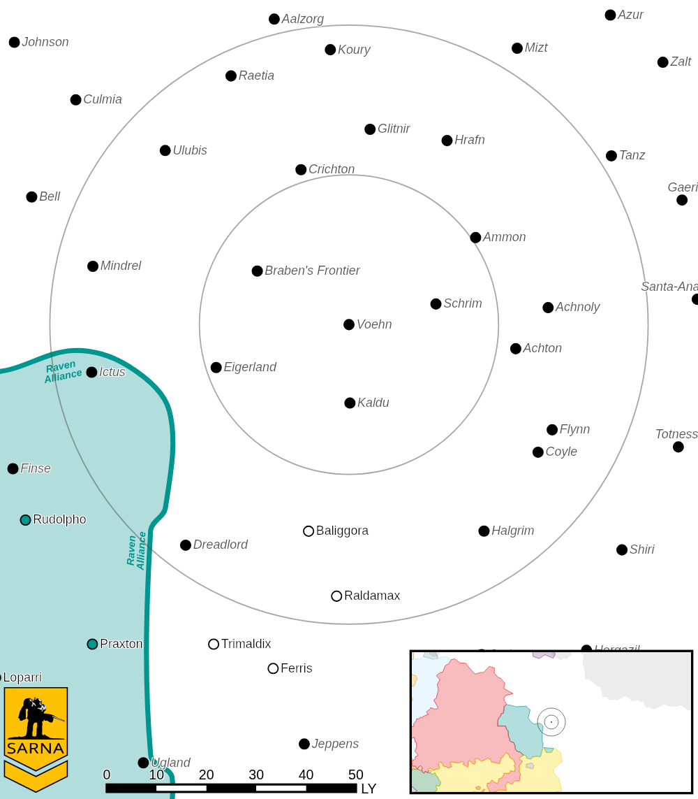

VOEHN III PLANETARY READOUT

STAR TYPE : G8V (189 HOURS RECHARGE TIME)
POSITION IN SYSTEM : 3 OF 5
NATURAL SATELLITES : 5
TIME TO JUMP POINT : 6.30 DAYS
SURFACE GRAVITY : 0.68 G
DAY LENGTH : 21.0 HOURS
ATMOSPHERIC PRESSURE : STANDARD (TAINTED, CAUSTIC)
EQUATORIAL TEMPERATURE : -41*C
SURFACE WATER : 0 PERCENT
CAPITAL : NONE
POPULATION : 0
HPG : NONE
SOCIO-INDUSTRIAL LEVELS : REGRESSED-X-X-X-X
TECHNOLOGICAL SOPHISTICATION : D (PRE-INDUSTRIAL)
INDUSTRIAL DEVELOPMENT : X (PRE-INDUSTRIAL)
RAW MATERIAL DEPENDENCE : X (PRE-INDUSTRIAL)
INDUSTRIAL OUTPUT : X (PRE-INDUSTRIAL)
AGRICULTURAL DEPENDENCE : X (PRE-INDUSTRIAL)

MISSION 1: BLOOD GULCH

A LOCAL INDIVIDUAL CALLING HIMSELF 'BIG ROOSTER' HAS INVITED YOUR TEAM TO PARTICIPATE IN 'BLOOD GULCH', A GLADIATORIAL STYLE GAME HE IS HOSTING. IN THIS CAPTURE THE FLAG TOURNAMENT, THE WINNER GETS TO CLAIM SALVAGE RIGHTS, IF THEY SURVIVE.

PRIMARY OBJECTIVES:
CAPTURE THE FLAG

SECONDARY OBJECTIVES:
DESTROY OPPONENT FORCES

OPPOSITION FORCES:
PLAYERS WILL BE SPLIT INTO TWO TEAMS AND FACE UNKNOWN TRAPS AND
DEFENSES INSIDE OF THE ARENA

---------------------------- END TRANSMISSION -----------------------------
--------------------------- START TRANSMISSION ----------------------------

INTELLIGENCE HAS PROVIDED SATELLITE IMAGERY OF THE ARENA.

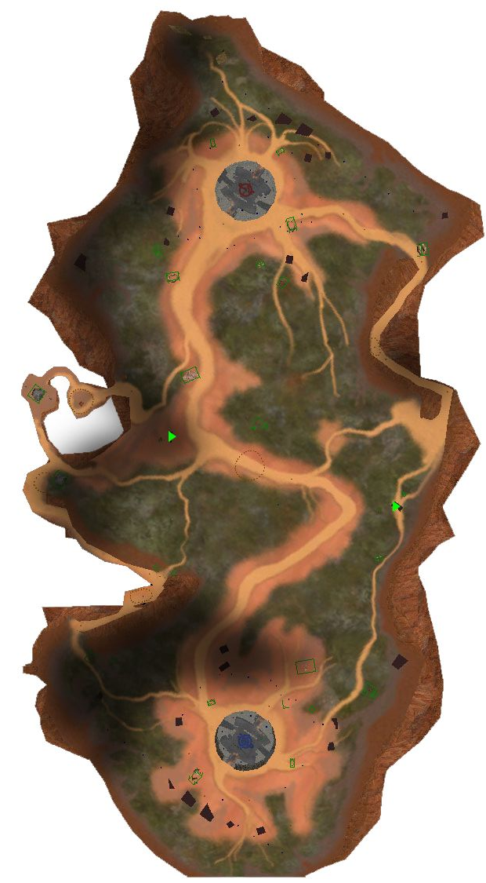

---------------------------- END TRANSMISSION -----------------------------
--------------------------- START TRANSMISSION ----------------------------

MISSION BOUNTIES

THE FOLLOWING BOUNTIES HAVE BEEN ISSUED FOR THIS MISSION.

PAYMENT | ACTIVITY
100,000 | DAMAGE ENEMY UNIT (PER UNIT)
100,000 | CRITICAL OR MOTIVE DAMAGE (PER UNIT)
100,000 | COMPLETE A PHYSICAL ATTACK
100,000 | COMPLETE AN ANTI-MECH ATTACK
100,000 | DAMAGE A UNIT WITH INDIRECT FIRE
100,000 | SKID A UNIT WITHOUT DESTROYING IT
250,000 | KNOCK 'MECH PILOT UNCONSCIOUS
250,000 | REDUCE A COMBAT VEHICLE TO 0 MP
250,000 | KILL ALL BUT 1 TROOP IN AN INFANTRY UNIT
250,000 | HAVE A UNIT SCORE A HIT AT ALL 3 RANGES
250,000 | COMPLETE A CHARGE ATTACK
250,000 | COMPLETE A DEATH FROM ABOVE ATTACK
500,000 | SHOOT DOWN A VTOL WITH A TMM OF 5+
500,000 | SHOOT A 'MECH IN THE HEAD
500,000 | PHYSICAL ATTACK A 'MECH IN THE HEAD
500,000 | CAPTURE A VEHICLE CREW OR 'MECH PILOT

---------------------------- END TRANSMISSION -----------------------------
BATTLETECH: OUTWORLDS WASTES

BOX CANYON - GM Notes

Mission 1
Maps: Box Canyon
Scoring: 0.5M for each enemy flag returned to friendly base

OpFor: The GM selects emplacements and drones to use in the arena. The goal is to
slowly increase the pressure until both sides start collaborating against the GM forces.

BATTLETECH
OUTWORLDS WASTES

