BATTLETECH
OUTWORLDS WASTES

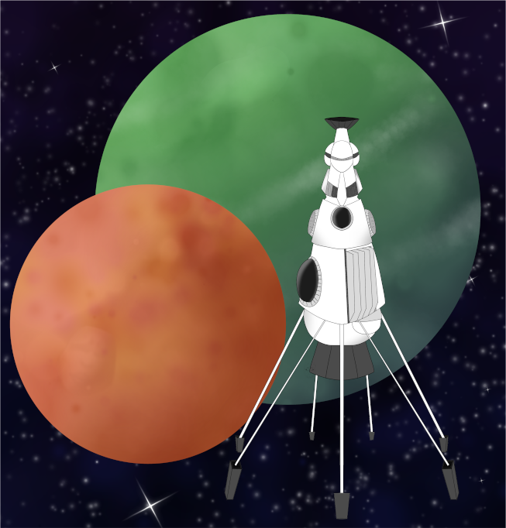

Event Scenario Pack
BATTLETECH: OUTWORLDS WASTES

DEATH KANGAROOS ORIGINS

--------------------------- START TRANSMISSION ----------------------------
PLAY THROUGH THE ORIGINS OF THE DEATH KANGAROOS! FORM YOUR MERCENARY FORCE AND MAKE ENDS MEET ON GALATEA. COMPLETE THE ODD JOBS AND TRY TO SCRAPE TOGETHER TO LAUNCH YOUR MERCENARY CAREER!
---------------------------- END TRANSMISSION -----------------------------

These are player-vs-GM scenarios for BattleTech: Outworlds Wastes with combined arms and simplified campaign logistics rules.

Each player may bring 2,000 BV of 'Mechs from a single faction in the Dark Age or ilClan eras on the Master Unit List, following the BattleTech: Outworlds Wastes event list building rules. The list should have at least 2 'Mechs, one of which is piloted by your force commander.

After the first scenario, you may add up to 1,500 BV of units to your force. You must have at least one Battle Armor unit and one unit capable of carrying Battle Armor.

Players use BattleTech: Outworlds Wastes Force Maintenance event rules to improve their force between scenarios. Players can improve their force up to 5,000 BV. The enemy force uses the full BattleTech: Outworlds Wastes Force Maintenance rules for repair between scenarios.

The following optional rules are recommended:
- Initiative Deck: Initiative is determined by playing cards.
Each player receives one card; their whole force activates together.
The Movement Phase is resolved from lowest value to highest.
The Attack Phases are resolved from highest value to lowest.
- Fire for Effect: Attack declaration and resolution occur simultaneously.

BattleTech Outworlds Wastes:
Web: https://outworlds-wastes.jeremylt.org/event-play
PDF: https://outworlds-wastes.jeremylt.org/downloads?event

BattleTech: Outworlds Wastes is fan-made and based upon the official BattleTech rules from Catalyst Game Labs. BattleTech is a registered trademark of The Topps Company, Inc. in the United States and other countries.

Era: Succession Wars or later

Editor: Jeremy L Thompson
--------------------------- START TRANSMISSION ----------------------------

MISSION BACKGROUND

GALATEA IS A PLANET NEAR THE CENTER OF THE INNER SPHERE WELL KNOWN AS A MERCENARY HUB. INDUSTRIALIST EPHRAM WHEELER IS LOOKING FOR A UNIT TO PULL A JOB AND THIS OFFERS YOU A WAY TO MAKE A QUICK BUCK WITH YOUR NEW UNIT.

REGION BACKGROUND

GALATEA IS NEAR THE CENTER OF THE INNER SPHERE, NEAR THE SUMMER AND SYRMA SYSTEMS. THROUGHOUT THE SUCCESSION WARS, GALATEA WAS KNOWN AS THE CENTER OF THE MERCENARY TRADE DUE TO CLEVER NEGOTIATIONS WITH COMSTAR.

AFTER THE CONTRACTION OF THE REPUBLIC OF THE SPHERE TO FORTRESS REPUBLIC, GALATEA BECAME AN INDEPENDENT WORLD AND EVENTUALLY FORMED THE GALATEAN LEAGUE TO PROTECT THE WORLD AND ITS NEIGHBORS FROM FURTHER ATTTACKS BY CLAN JADE FALCON AND CLAN WOLF. FOLLOWING THE SUCCESSFUL UPRISING OF SKYE AGAINST THE WOLF EMPIRE, GALATEAN JOINED THE NEW ISLE OF SKYE. GALATEA MAINTAINED STRONG TIES TO THE LYRAN COMMONWEALTH THROUGHOUT ITS HISTORY, INCLUDING STRONG BUSINESS TIES.

LOCAL AREA STAR MAP

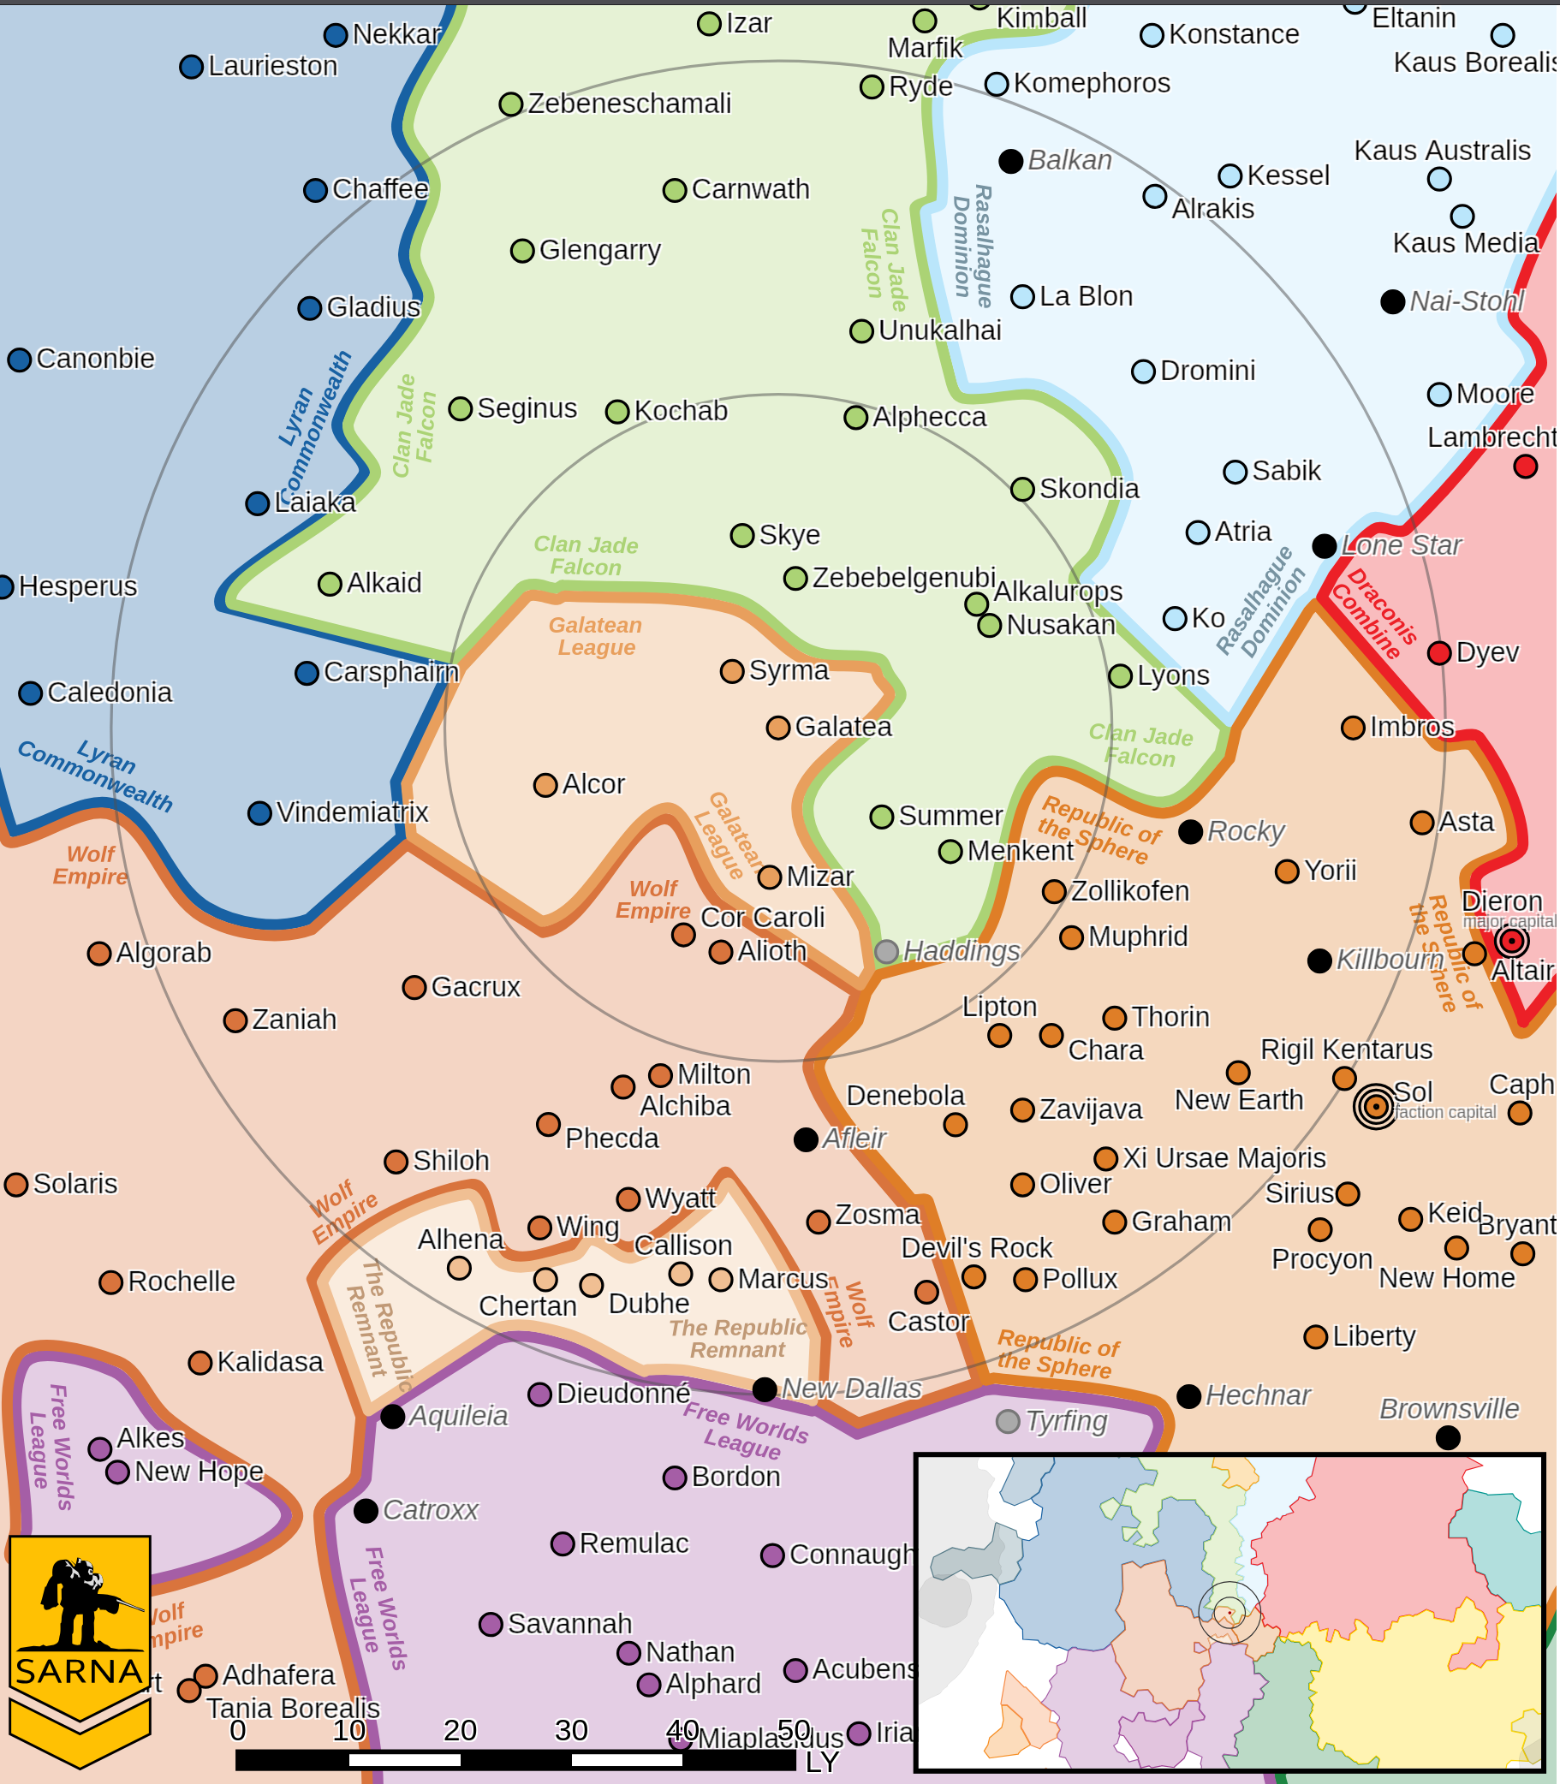

GALATEA VI PLANETARY READOUT

STAR TYPE : F8II (176 HOURS RECHARGE TIME)
POSITION IN SYSTEM : 6 OF 8
NATURAL SATELLITES : 1
TIME TO JUMP POINT : 12.11 DAYS
SURFACE GRAVITY : 0.99 G
DAY LENGTH : 23.0 HOURS
ATMOSPHERIC PRESSURE : STANDARD (BREATHABLE)
EQUATORIAL TEMPERATURE : 55*C
SURFACE WATER : 35 PERCENT
CAPITAL : Galatea City
POPULATION : 607,502,826
HPG : NONE
SOCIO-INDUSTRIAL LEVELS : B-C-B-B-C
TECHNOLOGICAL SOPHISTICATION : B (ADVANCED WORLD)
INDUSTRIAL DEVELOPMENT : C (BASIC HEAVY INDUSTRY)
RAW MATERIAL DEPENDENCE : B (MOSTLY SELF-SUFFICIENT PRODUCTION)
INDUSTRIAL OUTPUT : B (GOOD INDUSTRIAL OUTPUT)
AGRICULTURAL DEPENDENCE : C (MODEST AGRICULTURE)

MISSION 1: AT THE LAKE

BUSINESS MAGNATE EPHRAM WHEELER WANTS YOU TO RECOVER HIS DAUGHTER, WHO HAS RUN OFF WITH A FARMHAND PILOTING AN AGROMECH. IT SHOULD BE AN EASY JOB.

PRIMARY OBJECTIVES:
DRIVE AWAY ENEMY FORCES
RECOVER WHEELER'S DAUGHTER FROM LAKESIDE CABIN

SECONDARY OBJECTIVES:
DESTROY ENEMY FORCES

OPPOSITION FORCES:
INITIAL FORCES CONSISTING OF 2 ARGOMECHS

MISSION 2: IN THE WOODS

THE KENTARES CLUB WOULD LIKE YOUR LANCE TO PARTICIPATE IN A REENACTMENT OF THE KENTARES MASSACRE.

PRIMARY OBJECTIVES:
DESTROY OPPOSITION FORCES

SECONDARY OBJECTIVES:
RAID LOSTECH CACHE, STAY WITHIN 3 HEXES OF CACHE POINT

OPPOSITION FORCES:
ONE LANCE OF ENEMY 'MECHS

---------------------------- END TRANSMISSION -----------------------------
--------------------------- START TRANSMISSION ----------------------------

INTELLIGENCE HAS PROVIDED SATELLITE IMAGERY OF THE LAKE.

LAKESIDE CABIN
|-- FRIENDLY DEPLOYMENT ZONE --|

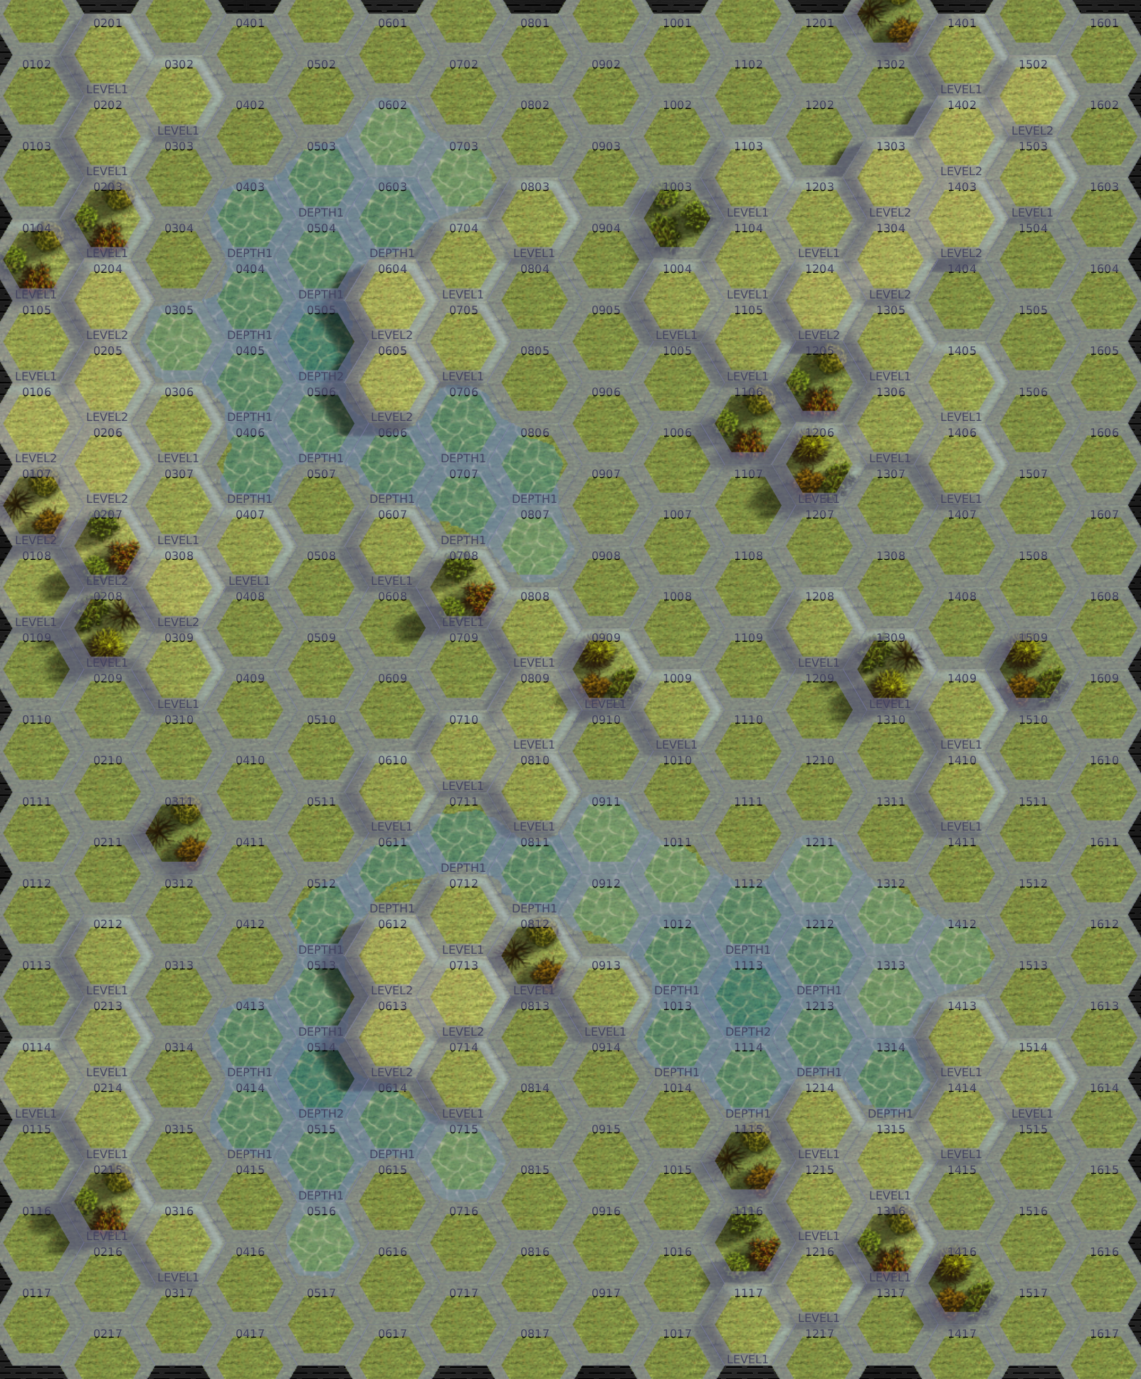

---------------------------- END TRANSMISSION -----------------------------
--------------------------- START TRANSMISSION ----------------------------

INTELLIGENCE HAS PROVIDED SATELLITE IMAGERY OF THE REENACTMENT SITE.

CACHE
|-- FRIENDLY DEPLOYMENT ZONE --|

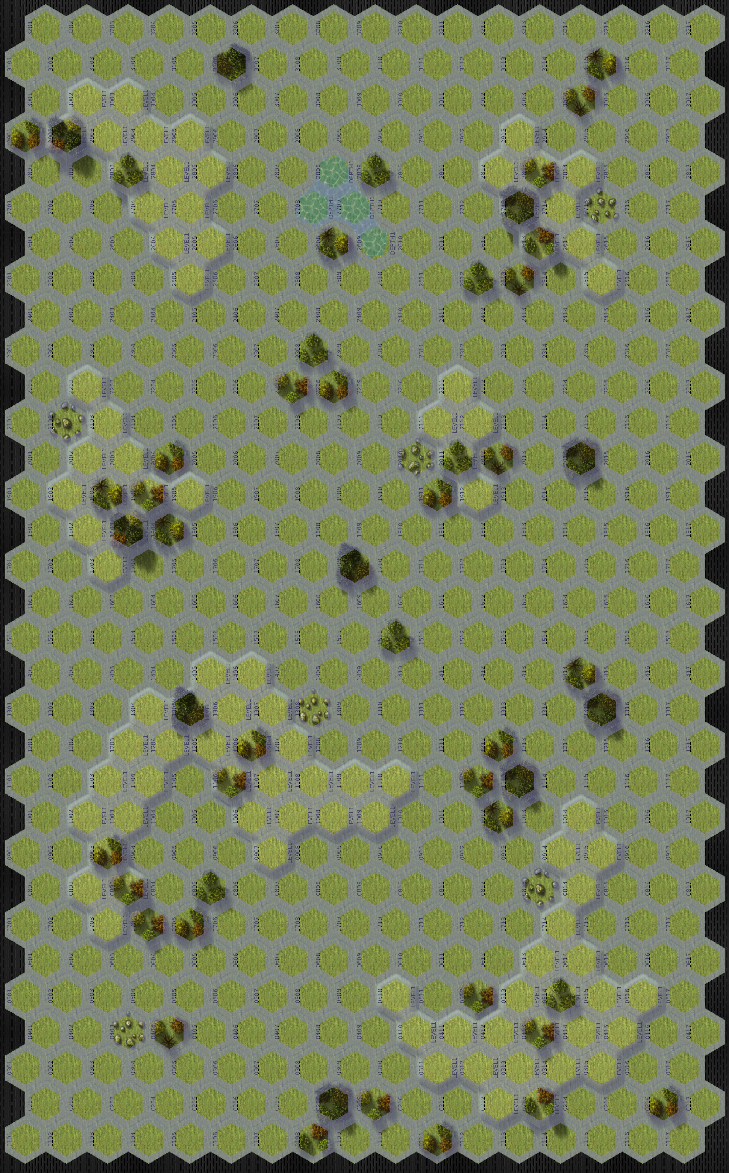

---------------------------- END TRANSMISSION -----------------------------
--------------------------- START TRANSMISSION ----------------------------

MISSION BOUNTIES

THE FOLLOWING BOUNTIES HAVE BEEN ISSUED FOR THIS MISSION.

PAYMENT | ACTIVITY
100,000 | DAMAGE ENEMY UNIT (PER UNIT)
100,000 | CRITICAL OR MOTIVE DAMAGE (PER UNIT)
100,000 | COMPLETE A PHYSICAL ATTACK
100,000 | COMPLETE AN ANTI-MECH ATTACK
100,000 | DAMAGE A UNIT WITH INDIRECT FIRE
100,000 | SKID A UNIT WITHOUT DESTROYING IT
250,000 | KNOCK 'MECH PILOT UNCONSCIOUS
250,000 | REDUCE A COMBAT VEHICLE TO 0 MP
250,000 | KILL ALL BUT 1 TROOP IN AN INFANTRY UNIT
250,000 | HAVE A UNIT SCORE A HIT AT ALL 3 RANGES
250,000 | COMPLETE A CHARGE ATTACK
250,000 | COMPLETE A DEATH FROM ABOVE ATTACK
500,000 | SHOOT DOWN A VTOL WITH A TMM OF 5+
500,000 | SHOOT A 'MECH IN THE HEAD
500,000 | PHYSICAL ATTACK A 'MECH IN THE HEAD
500,000 | CAPTURE A VEHICLE CREW OR 'MECH PILOT

---------------------------- END TRANSMISSION -----------------------------
--------------------------- START TRANSMISSION ----------------------------

SAMPLE FORCE

THE FOLLOWING IS A SAMPLE FORCE THAT IS SIMILAR TO THE DEATH KANGAROOS:

FIRST MISSION:
BLACKJACK BJ-3 1,271 BV
COMMANDO COM-7S 676 BV
----------------=----------
TOTAL 1,947 BV

SECOND MISSION:
BLACKJACK BJ-3 1,271 BV
COMMANDO COM-8S 775 BV
PANTHER PNT-12A 982 BV
IS STANDARD (MAG) 205 BV
---------------------------
TOTAL 3,233 BV

---------------------------- END TRANSMISSION -----------------------------
BATTLETECH: OUTWORLDS WASTES

DEATH KANGAROOS ORIGINS - GM Notes

Mission 1
Maps: Grasslands Pack, Lakes
Scoring: 1M if daughter recovered
0.33 M for each 'mech destroyed

OpFor: The ArgoMechs will start to flee when damaged. The Hatchetman will
become stuck in the building if drawn into the hex. Apply standard fall damage and
roll a critical hit check for each leg.
Recommend 2x HVR-199 and 1x HCT-5D

Mission 2
Maps: Grasslands Pack, Open Terrain 2 and Open Terrain 3
Scoring: 0.25M for each 'mech destroyed
0.2M for each 'mech within 3 hexes of cache during the End Phase

OpFor: The OpFor will attempt to reach the cache as well, but the UrbanMech will
attempt to dual the nearest mech.
Recommend 1x CDA-3M, 1x OTT-12R, 1x UM-R100

BATTLETECH
OUTWORLDS WASTES

