BATTLETECH
OUTWORLDS WASTES

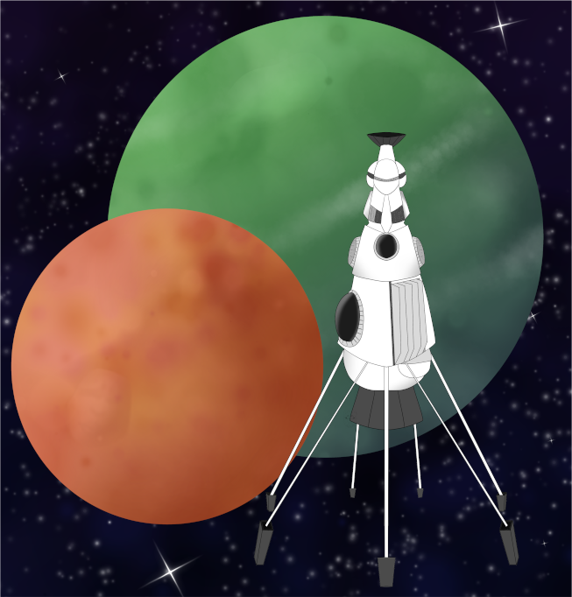

Event Scenario Pack
BATTLETECH: OUTWORLDS WASTES

GHOST DOGS ORIGINS

--------------------------- START TRANSMISSION ----------------------------
PLAY THROUGH THE ORIGINS OF THE GHOST DOGS! FORM YOUR MERCENARY FORCE AND TRY TO SURVIVE THE JADE FALCON ONSLAUGHT. CAN YOUR UNIT SURVIVE WITHOUT SUPPORT OF YOUR FORMER PARENT COMMAND?!
---------------------------- END TRANSMISSION -----------------------------

These are player-vs-GM scenarios for BattleTech: Outworlds Wastes with combined arms and simplified campaign logistics rules.

Each player may bring 2,000 BV of 'Mechs from a single faction in the Dark Age or ilClan eras on the Master Unit List, following the BattleTech: Outworlds Wastes event list building rules. The list should have at least 2 'Mechs, one of which is piloted by your force commander.

After the first scenario, you may add up to 1,500 BV of units to your force. You must have at least one Battle Armor unit and one unit capable of carrying Battle Armor.

Players use BattleTech: Outworlds Wastes Force Maintenance event rules to improve their force between scenarios. Players can improve their force up to 5,000 BV. The enemy force uses the full BattleTech: Outworlds Wastes Force Maintenance rules for repair between scenarios.

The following optional rules are recommended:
- Initiative Deck: Initiative is determined by playing cards.
Each player receives one card; their whole force activates together.
The Movement Phase is resolved from lowest value to highest.
The Attack Phases are resolved from highest value to lowest.
- Fire for Effect: Attack declaration and resolution occur simultaneously.

BattleTech Outworlds Wastes:
Web: https://outworlds-wastes.jeremylt.org/event-play
PDF: https://outworlds-wastes.jeremylt.org/downloads?event

BattleTech: Outworlds Wastes is fan-made and based upon the official BattleTech rules from Catalyst Game Labs. BattleTech is a registered trademark of The Topps Company, Inc. in the United States and other countries.

Era: Succession Wars or later

Editor: Jeremy L Thompson
--------------------------- START TRANSMISSION ----------------------------

MISSION BACKGROUND

CARSPHAIRN IS A LYRAN COMMONWEALTH PLANET NEAR THE JADE FALCON OCCUPATION ZONE. THE SECOND BATTALION OF THE KELL HOUNDS IS DEFENDING WHILE THE JADE FALCONS DECLARE TOTAL WAR AGAINST THE KELL HOUNDS, LEAVING THE GHOST DOGS TO ESCAPE AND REBRAND.

BALKAN IS AN ABANDONED LYRAN COMMONWEALTH FACTORY WORLD IN CLAN OCCUPIED TERRITORY. THE DRACONIS COMBINE WOULD LIKE TO HIRE YOUR NEW UNIT TO RECOVER AN ASSET FROM A RUINED FACTORY BEING USED BY PIRATES AS A HIDING PLACE.

REGION BACKGROUND

CARSPHAIRN HAS BEEN A LYRAN COMMONWEALTH PLANET FOR LARGE PORTIONS OF ITS HISTORY. GIVEN THE PLANET’S HIGH AGRICULTURAL, IT WAS RAIDED SEVERAL TIMES BY WORD OF BLAKE TROOPS FOR FOOD. IN 3146, CLAN JADE FALCON LAUNCHED AN ASSAULT ON THE PLANET, ATTACKING THE CAPITAL.

BALKAN WAS ABANDONED DURING THE THIRD SUCCESSION WAR. ULTIMATELY, THE PLANET ENDED UP IN THE RASALHAGUE DOMINION BUT CONTINUED TO BE ABANDONED AND UNOCCUPIED, EXCEPT BY OCCASIONAL PIRATE FORCES.

LOCAL AREA STAR MAP

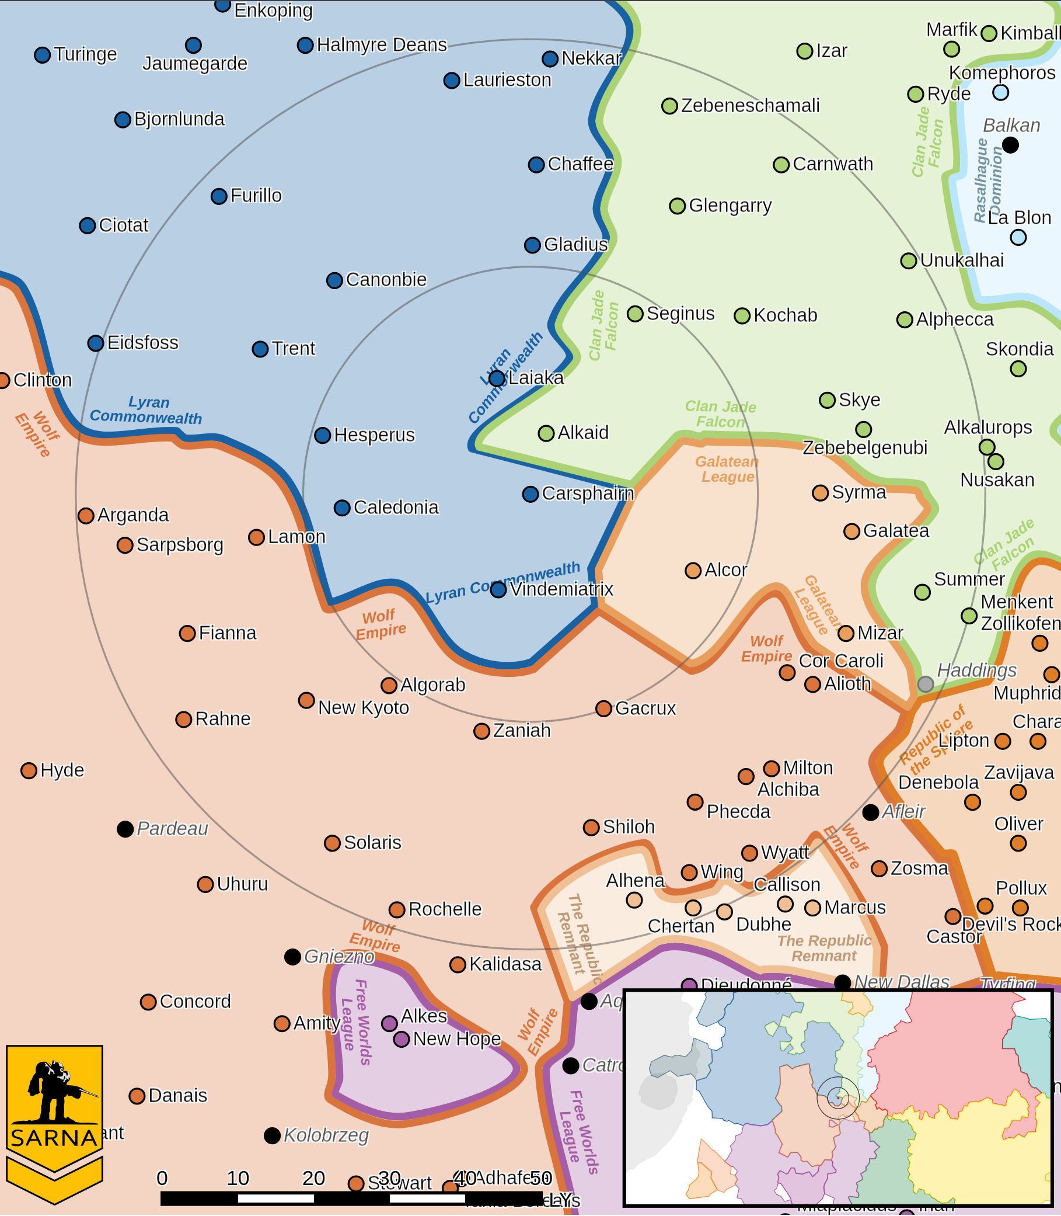

CARSPHAIRN III PLANETARY READOUT

STAR TYPE : K1V (192 HOURS RECHARGE TIME)
POSITION IN SYSTEM : 3 OF 6
NATURAL SATELLITES : 3
TIME TO JUMP POINT : 5.20 DAYS
SURFACE GRAVITY : 1.17 G
DAY LENGTH : 22.0 HOURS
ATMOSPHERIC PRESSURE : STANDARD (BREATHABLE)
EQUATORIAL TEMPERATURE : 33*C
SURFACE WATER : 77 PERCENT
CAPITAL : NARCISSE
POPULATION : 1,534,506,957
HPG : NONE
SOCIO-INDUSTRIAL LEVELS : B-B-C-B-A
TECHNOLOGICAL SOPHISTICATION : B (ADVANCED WORLD)
INDUSTRIAL DEVELOPMENT : B (MODERATELY INDUSTRIALIZED)
RAW MATERIAL DEPENDENCE : C (LIMITED RAW MATERIAL PRODUCTION)
INDUSTRIAL OUTPUT : B (GOOD INDUSTRIAL OUTPUT)
AGRICULTURAL DEPENDENCE : A (BREADBASKET)

LOCAL AREA STAR MAP

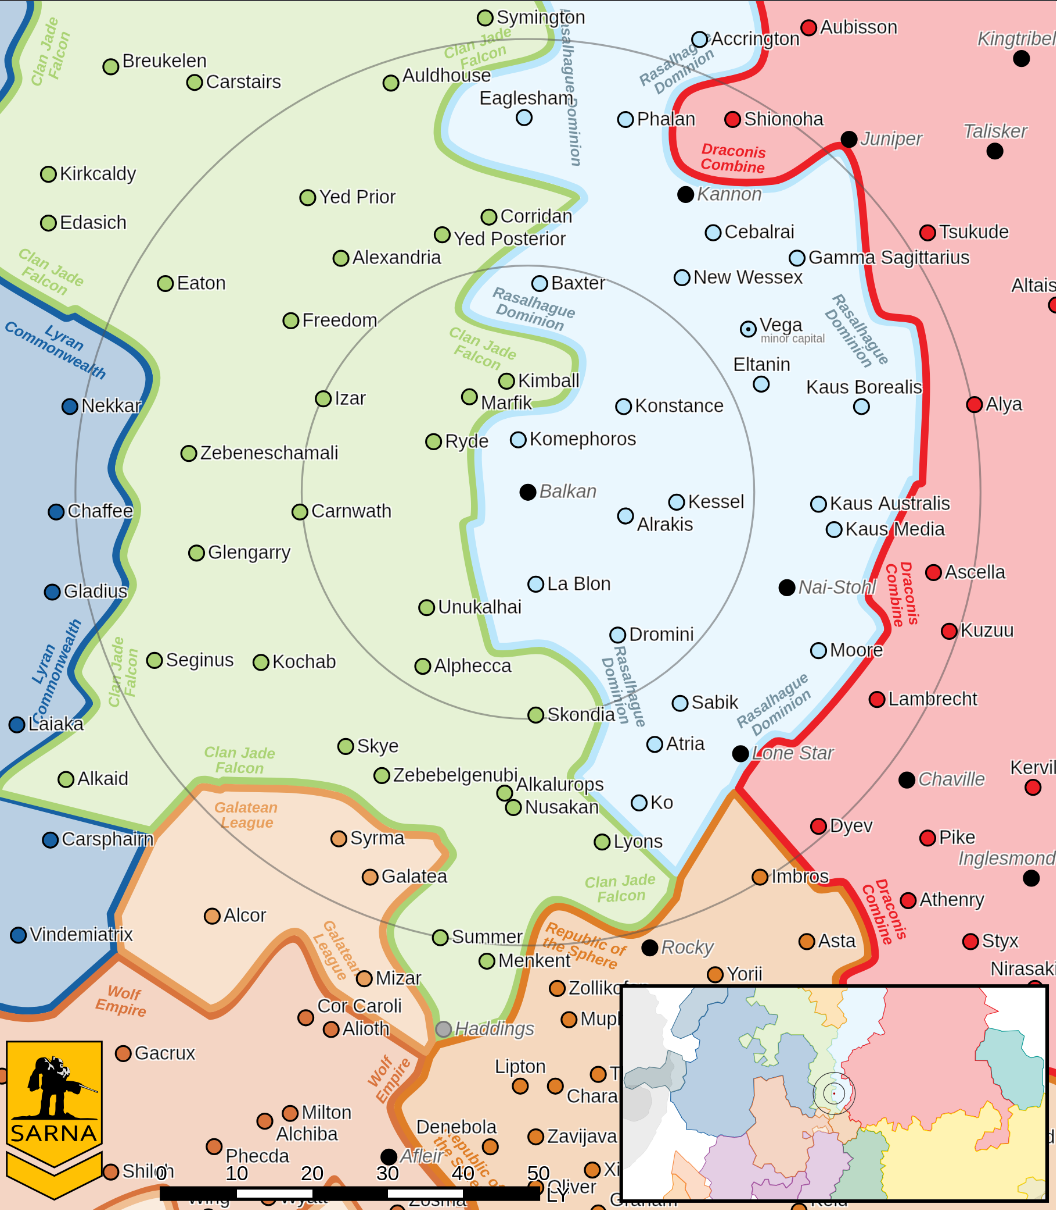

BALKAN I PLANETARY READOUT

STAR TYPE : G3V (184 HOURS RECHARGE TIME)
POSITION IN SYSTEM : 1 OF 14
NATURAL SATELLITES : 6
TIME TO JUMP POINT : 8.53 DAYS
SURFACE GRAVITY : 1.0 G
DAY LENGTH : 25.0 HOURS
ATMOSPHERIC PRESSURE : STANDARD (BREATHABLE)
EQUATORIAL TEMPERATURE : 35*C
SURFACE WATER : 25 PERCENT
CAPITAL : NEW ANTONOVO
POPULATION : 0
HPG : NONE
SOCIO-INDUSTRIAL LEVELS : X-X-X-X-X
TECHNOLOGICAL SOPHISTICATION : X (REGRESSED)
INDUSTRIAL DEVELOPMENT : X (NONE)
RAW MATERIAL DEPENDENCE : X (NONE)
INDUSTRIAL OUTPUT : X (NONE)
AGRICULTURAL DEPENDENCE : X (NONE)

MISSION 1: ESCAPE

WHILE YOU ARE DEFENDING CARSPHAIRN, COL CALLANDRE KELL GIVES THE ORDER FOR ALL FORMER KELL HOUNDS TO GO TO GROUND. ESCAPE AND REBRAND.

PRIMARY OBJECTIVES:
ESCAPE FROM FAR MAP EDGE

SECONDARY OBJECTIVES:
DAMAGE ENEMY FORCES

OPPOSITION FORCES:
INITIAL FORCES CONSISTING OF AN ASSAULT MECH

MISSION 2: RECOVER

RECOVER THE ASSET FROM THE RUINED BATTLEMECH FACTORY ON BALKAN. THE PIRATES BARNSON'S BARNSTORMERS ARE USING THIS PLANET AS A HIDING LOCATION.

PRIMARY OBJECTIVES:
RECOVER TARGET ASSET (UNIT WITH HANDS OR INFANTRY)

SECONDARY OBJECTIVES:
DESTROY PIRATE FORCES

OPPOSITION FORCES:
ONE LANCE OF ENEMY 'MECHS

---------------------------- END TRANSMISSION -----------------------------
--------------------------- START TRANSMISSION ----------------------------

INTELLIGENCE HAS PROVIDED SATELLITE IMAGERY OF THE ESCAPE ZONE.

|-- FRIENDLY DEPLOYMENT ZONE --|

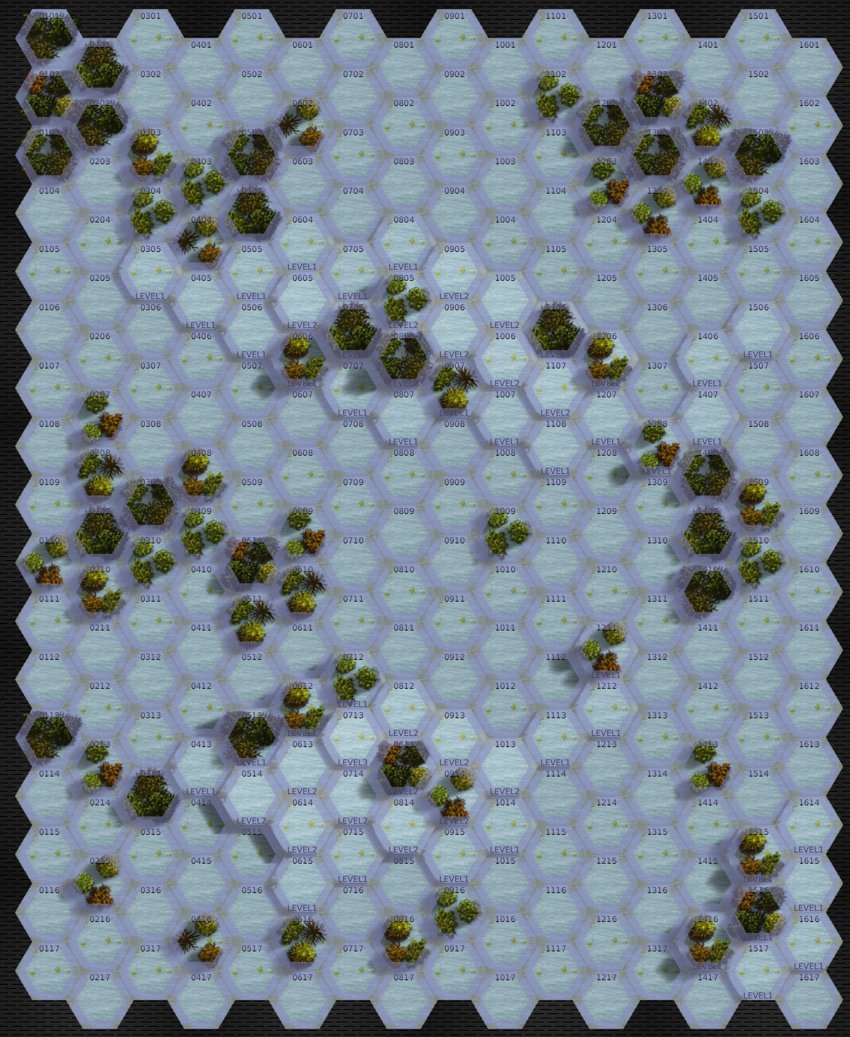

---------------------------- END TRANSMISSION -----------------------------
--------------------------- START TRANSMISSION ----------------------------

INTELLIGENCE HAS PROVIDED SATELLITE IMAGERY OF THE FACTORY.

ASSET
|-- FRIENDLY DEPLOYMENT ZONE --|
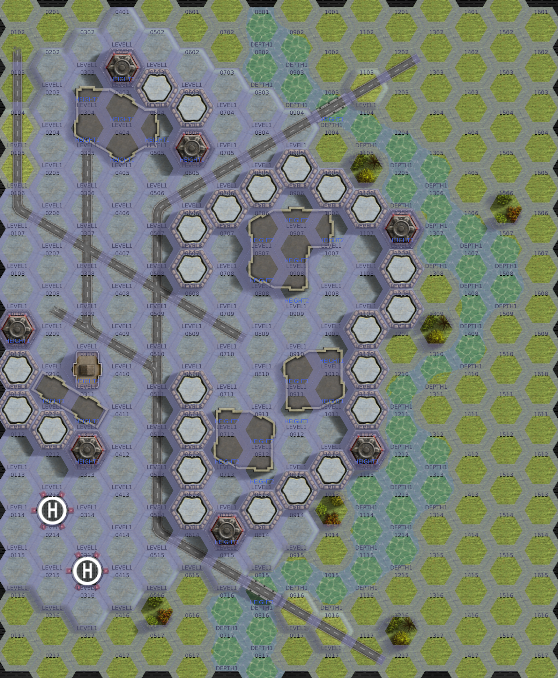

---------------------------- END TRANSMISSION -----------------------------
--------------------------- START TRANSMISSION ----------------------------

MISSION BOUNTIES

THE FOLLOWING BOUNTIES HAVE BEEN ISSUED FOR THIS MISSION.

PAYMENT | ACTIVITY
100,000 | DAMAGE ENEMY UNIT (PER UNIT)
100,000 | CRITICAL OR MOTIVE DAMAGE (PER UNIT)
100,000 | COMPLETE A PHYSICAL ATTACK
100,000 | COMPLETE AN ANTI-MECH ATTACK
100,000 | DAMAGE A UNIT WITH INDIRECT FIRE
100,000 | SKID A UNIT WITHOUT DESTROYING IT
250,000 | KNOCK 'MECH PILOT UNCONSCIOUS
250,000 | REDUCE A COMBAT VEHICLE TO 0 MP
250,000 | KILL ALL BUT 1 TROOP IN AN INFANTRY UNIT
250,000 | HAVE A UNIT SCORE A HIT AT ALL 3 RANGES
250,000 | COMPLETE A CHARGE ATTACK
250,000 | COMPLETE A DEATH FROM ABOVE ATTACK
500,000 | SHOOT DOWN A VTOL WITH A TMM OF 5+
500,000 | SHOOT A 'MECH IN THE HEAD
500,000 | PHYSICAL ATTACK A 'MECH IN THE HEAD
500,000 | CAPTURE A VEHICLE CREW OR 'MECH PILOT

---------------------------- END TRANSMISSION -----------------------------
--------------------------- START TRANSMISSION ----------------------------

SAMPLE FORCE

THE FOLLOWING IS A SAMPLE FORCE THAT IS SIMILAR TO THE GHOST DOGS:

FIRST MISSION:
WOLFHOUND WLF-1 949 BV
VALKYRIE C 936 BV
----------------=----------
TOTAL 1,885 BV

SECOND MISSION:
WOLFHOUND WLF-1 949 BV
VALKYRIE C 936 BV
HOUND HD-2F 1,389 BV
IS STANDARD (MAG) 205 BV
---------------------------
TOTAL 3,479 BV

---------------------------- END TRANSMISSION -----------------------------
BATTLETECH: OUTWORLDS WASTES

GHOST DOGS ORIGINS - GM Notes

Mission 1
Maps: Any snowy mapsheet
Scoring: 0.75M for each 'mech that escapes
0.5 M if Shrike has internal damage

Falcons: The Shrike will continue attacking the player until they retreat or the Shrike is
destroyed.
Recommend 1x Shrike 2

Mission 2
Maps: Grasslands Pack, River Comm Center, or similar
Scoring: 1M for recovering the asset
0.25M for each enemy 'mech destroyed

Pirates: The pirates will begin to flee once half of their forces are crippled.
Recommend 1x GHR-5J, 1x NTL-UG

BATTLETECH
OUTWORLDS WASTES

