BATTLETECH
OUTWORLDS WASTES

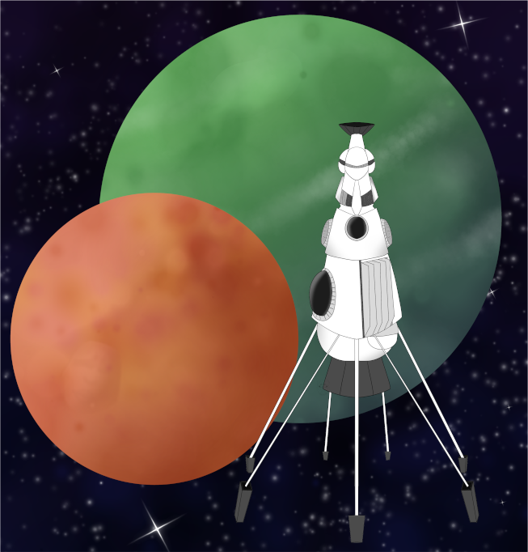

Event Scenario Pack
BATTLETECH: OUTWORLDS WASTES

LOCAL CONTRACT

--------------------------- START TRANSMISSION ----------------------------
INTERSTELLAR EXPEDITIONS IS LOOKING FOR INDEPENDENT SECURITY CONTRACTORS FOR A LONG HAUL MISSION IN THE OUTWORLDS WASTES. WE OFFER FLEXIBLE CONTRACT TERMS AND GENEROUS SALVAGE RIGHTS. JOIN OUR SPINWARD OPERATIONS TEAM TODAY!
---------------------------- END TRANSMISSION -----------------------------

These are player-vs-GM scenarios for BattleTech: Outworlds Wastes with combined arms and simplified campaign logistics rules.

Each player may bring 3,000 BV of combined arms from a single faction in the ilClan era on the Master Unit List, following the BattleTech: Outworlds Wastes event list building rules.

Players use BattleTech: Outworlds Wastes Force Maintenance event rules to improve their force between scenarios. Players can improve their force up to 5,000 BV. The enemy force uses the full BattleTech: Outworlds Wastes Force Maintenance rules for repair between scenarios.

The following optional rules are recommended:
- Initiative Deck: Initiative is determined by playing cards.
Each player receives one card; their whole force activates together.
The Movement Phase is resolved from lowest value to highest.
The Attack Phases are resolved from highest value to lowest.
- Fire for Effect: Attack declaration and resolution occur simultaneously.

BattleTech Outworlds Wastes:
Web: https://outworlds-wastes.jeremylt.org/event-play
PDF: https://outworlds-wastes.jeremylt.org/downloads?event

BattleTech: Outworlds Wastes is fan-made and based upon the official BattleTech rules from Catalyst Game Labs. BattleTech is a registered trademark of The Topps Company, Inc. in the United States and other countries.

Era: Succession Wars or later

Editor: Jeremy L Thompson
--------------------------- START TRANSMISSION ----------------------------

MISSION BACKGROUND

WYNN'S ROOST IS A COMMON RESUPPLY POINT FOR INTERSTELLAR EXPEDITIONS MISSIONS IN THE SPINWARD REGION OF THE PERIPHERY. WYNN'S ROOST WAS PREVIOUSLY THE CAPITAL OF THE TRADERS DOMAIN REGION OF THE OUTWORLDS WASTES. FOLLOWING THE FALL OF THE STAR LEAGUE, WYNN'S ROOST ATTEMPTED TO TURN THE SURVIVING TRADER'S DOMAIN WORLDS INTO A NEW NATION; HOWEVER, ONLY WYNN'S ROOST REMAINED STABLE.

PIRATE RAIDS ARE A COMMON PROBLEM FOR WYNN’S ROOST. THE LOCAL GOVERNMENT HAS EXTENDED A CONTRACT TO YOUR FORCES, AND INTERSTELLAR EXPEDITIONS HAS AUTHORIZED YOU TO COMBAT THIS PIRATE RAID IN THE SPIRIT OF COOPERATION WITH A KEY WORLD IN THE REGION.

REGION BACKGROUND

THE OUTWORLDS ALLIANCE WAS FOUNDED IN 2413 AND ENJOYED PROSPERITY THROUGHOUT THE STAR LEAGUE ERA. BY THE START OF THE AMARIS CIVIL WAR IN 2766, THE OUTWORLDS ALLIANCE CONTAINED OVER 135 MAJOR SYSTEMS ACROSS 7 ADMINISTRATIVE DISTRICTS. UNFORTUNATELY, THE OUTWORLDS ALLIANCE SUFFERED DURING THE SUCCESSION WARS THAT FOLLOWED THE FALL OF THE STAR LEAGUE IN 2780, AND THEY HAD TO STEADILY ABANDON SYSTEMS THEY NO LONGER HAD THE RESOURCES TO SUPPORT.

CLAN SNOW RAVEN BEGAN EXPLORING THE PERIPHERY FOR RESOURCES SOON AFTER THE BATTLE OF TUKAYYID ENDED OPERATION REVIVAL. IN 3064, CLAN SNOW RAVEN AND THE OUTWORLDS ALLIANCE BEGAN DEVELOPING MUTUAL RESPECT AND TENTATIVE ALLIANCE. FOLLOWING THEIR ABJURATION FROM THE CLAN HOMEWORLDS IN 3075 AS A RESULT OF THE WARS OF REAVING, CLAN SNOW RAVEN TOOK REFUGE IN THE OUTWORLDS ALLIANCE. IN 3083, CLAN SNOW RAVEN AND THE OUTWORLDS ALLIANCE MERGED TO FORM THE RAVEN ALLIANCE.

BY THE ILCLAN TRIAL IN 3151, THE RAVEN ALLIANCE CONTAINED ONLY 47 SYSTEMS. AT LEAST 88 SYSTEMS THAT WERE PART OF THE OUTWORLDS ALLIANCE DURING THE STAR LEAGUE ERA HAVE BEEN LOST. MANY FACTIONS ARE EAGER TO EXPLORE THESE LOST WORLDS IN THE OUTWORLDS WASTES IN SEARCH OF LOST STAR LEAGUE TECHNOLOGY.

LOCAL AREA STAR MAP

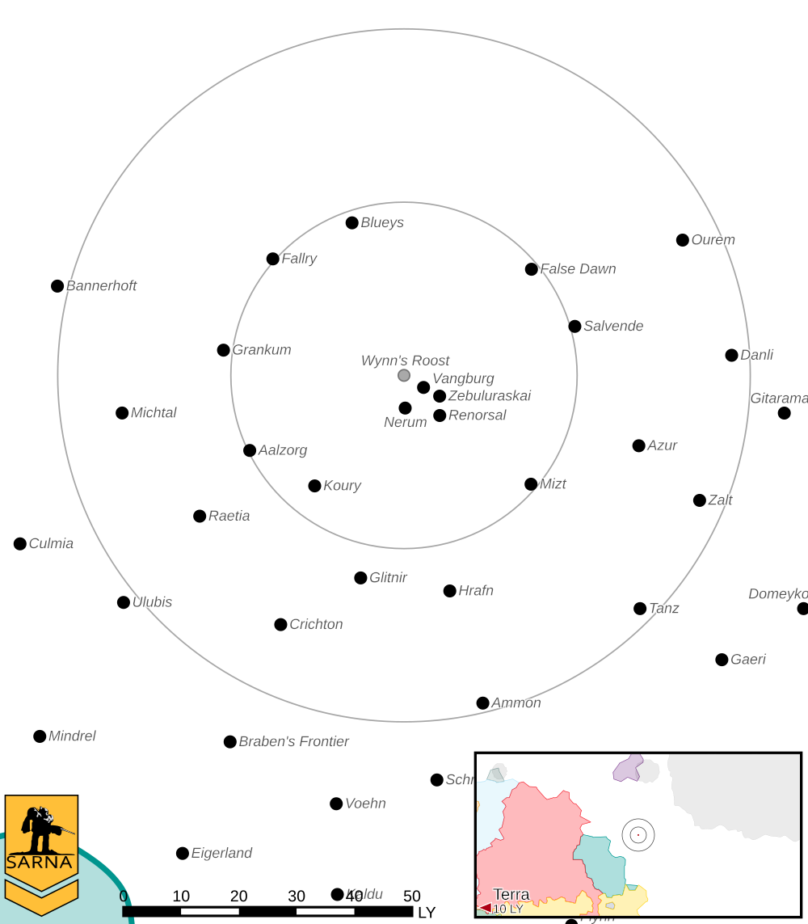

WYNN 'S ROOST II PLANETARY READOUT

STAR TYPE : M4V (205 HOURS RECHARGE TIME)
POSITION IN SYSTEM : 2 OF 8
NATURAL SATELLITES : 1
TIME TO JUMP POINT : 3.70 DAYS
SURFACE GRAVITY : 1.0 G
DAY LENGTH : 26.0 HOURS
ATMOSPHERIC PRESSURE : STANDARD (TAINTED)
EQUATORIAL TEMPERATURE : 34*C
SURFACE WATER : 50 PERCENT
CAPITAL : TURNERVILLE
POPULATION : 92,700,000
HPG : NONE
SOCIO-INDUSTRIAL LEVELS : C-C-A-B-C
TECHNOLOGICAL SOPHISTICATION : C (MODERATELY ADVANCED WORLD)
INDUSTRIAL DEVELOPMENT : C (BASIC HEAVY INDUSTRY)
RAW MATERIAL DEPENDENCE : A (FULLY SELF-SUFFICIENT)
INDUSTRIAL OUTPUT : B (GOOD OUTPUT)
AGRICULTURAL DEPENDENCE : C (MODEST AGRICULTURE)

MISSION 1: MINE HEIST

THE PIRATES ARE TARGETING GERMANIUM MINES ON WYRN'S ROOST. INTERCEPT THE PIRATES AND DISABLE THE CONVOY CARRYING GERMANIUM AND MINING SUPPLIES. WYRN'S ROOST DOES NOT WANT THE VEHICLES OR EQUIPMENT DESTROYED IF AT ALL POSSIBLE.

PRIMARY OBJECTIVES:
INTERCEPT PIRATE CONVOY
CAPTURE ALL CONVOY VEHICLES

SECONDARY OBJECTIVES:
DESTROY PIRATE FORCES

ADDITIONAL RULES:
ONLY INFANTRY/BATTLE ARMOR UNITS CAN CAPTURE VEHICLES

OPPOSITION FORCES:
PIRATE FORCES ON PLANET ARE 1 COMPANY IN STRENGTH, WITH COMBINED ARMS
INCLUDING MECHS, INFANTRY, AND TANKS

MISSION 2: NO ESCAPE

PIRATE MECHS AND TANKS ARE ATTEMPTING TO BOARD THEIR DROPSHIP. DESTROY AS MANY HOSTILE UNITS AS POSSIBLE TO DELAY OR PREVENT FUTURE RAIDS.

PRIMARY OBJECTIVES:
DESTROY PIRATE FORCES

SECONDARY OBJECTIVES:
CAPTURE PIRATE DROPSHIP

OPPOSITION FORCES:
PIRATE FORCES ON PLANET ARE 1 COMPANY IN STRENGTH, WITH COMBINED ARMS
INCLUDING MECHS, INFANTRY, AND HEAVY TANKS

---------------------------- END TRANSMISSION -----------------------------
--------------------------- START TRANSMISSION ----------------------------

INTELLIGENCE HAS PROVIDED SATELLITE IMAGERY OF THE MINING FACILITY.

|-- FRIENDLY DEPLOYMENT ZONE --|
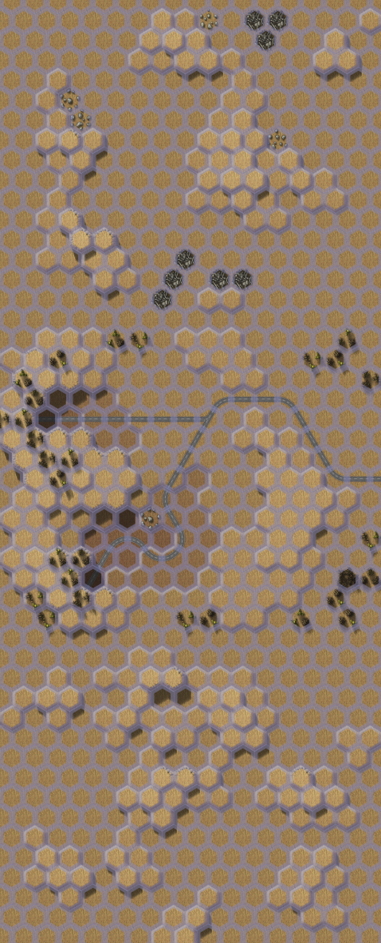

---------------------------- END TRANSMISSION -----------------------------
--------------------------- START TRANSMISSION ----------------------------

INTELLIGENCE HAS PROVIDED SATELLITE IMAGERY OF DROPSHIP LANDING SITE.

-
|
|
D
F E
R P
I L Z
E O O
N Y N
D M E
L E
Y N
T
|
|
-

|-- ENEMY DROPSHIP --|

---------------------------- END TRANSMISSION -----------------------------
--------------------------- START TRANSMISSION ----------------------------

MISSION BOUNTIES

THE FOLLOWING BOUNTIES HAVE BEEN ISSUED FOR THIS MISSION.

PAYMENT | ACTIVITY
100,000 | DAMAGE ENEMY UNIT (PER UNIT)
100,000 | CRITICAL OR MOTIVE DAMAGE (PER UNIT)
100,000 | COMPLETE A PHYSICAL ATTACK
100,000 | COMPLETE AN ANTI-MECH ATTACK
100,000 | DAMAGE A UNIT WITH INDIRECT FIRE
100,000 | SKID A UNIT WITHOUT DESTROYING IT
250,000 | KNOCK 'MECH PILOT UNCONSCIOUS
250,000 | REDUCE A COMBAT VEHICLE TO 0 MP
250,000 | KILL ALL BUT 1 TROOP IN AN INFANTRY UNIT
250,000 | HAVE A UNIT SCORE A HIT AT ALL 3 RANGES
250,000 | COMPLETE A CHARGE ATTACK
250,000 | COMPLETE A DEATH FROM ABOVE ATTACK
500,000 | SHOOT DOWN A VTOL WITH A TMM OF 5+
500,000 | SHOOT A 'MECH IN THE HEAD
500,000 | PHYSICAL ATTACK A 'MECH IN THE HEAD
500,000 | CAPTURE A VEHICLE CREW OR 'MECH PILOT

---------------------------- END TRANSMISSION -----------------------------
BATTLETECH: OUTWORLDS WASTES

LOCAL CONTRACT - GM Notes

Mission 1
Maps: Deserts Pack, Mines 1, Sand Drift 1, Clan Invasion Box, Barren Lands 1
Scoring: 0.25M for a convoy vehicle destroyed, 0.5M for a convoy vehicle captured

Trucks: Trucks have 10 points of structure, if the unit is damaged during the Attack
Phase, roll 2D6 roll and the unit is immobilized on a result greater than or equal to
the remaining structure, but on roll of 12 the unit is destroyed. Infantry/Battle Armor
can capture the unit without risk of destruction if there is no enemy infantry present.

Pirates: Pirates start on the center mapsheet and try to escape off the Sand Drift
mapsheet. Pirates will try to escape with as many vehicles as possible, but pirate
MechWarriors will always prioritize their own safety first.

Mission 2
Maps: Twycross Great Gash
Scoring: 1M for Dropship, 1M proportionally for % of enemy units destroyed

Dropship: Infantry/Battle Armor can capture the Dropship as song as no enemy
infantry/Battle Armor are present.

Pirates: Pirates will take off once at least half of the surviving units have boarded.

BATTLETECH
OUTWORLDS WASTES

