BATTLETECH
OUTWORLDS WASTES

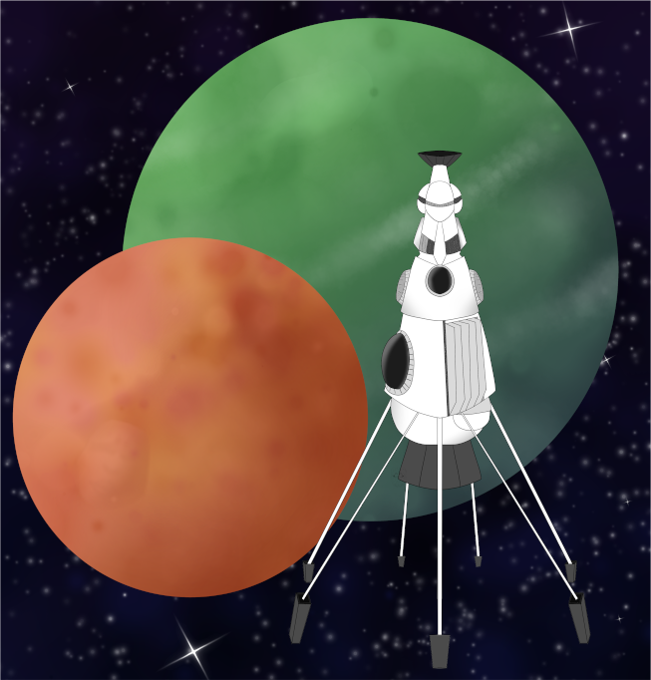

League Scenario Pack
BATTLETECH: OUTWORLDS WASTES

INTERSTELLAR EXPEDITIONS 'CONVOY'

---------------------------- START TRANSMISSION ---------------------------
INTERSTELLAR EXPEDITIONS IS ORGANIZING A DEEP PERIPHERY EXPEDITION. THIS EXPEDITION WILL PASS THROUGH WYNN'S ROOST. A SIZABLE TRADE FLEET HAS JOINED THIS EXPEDITION, WITH THE GOAL OF TRADING WITH VARIOUS PARTIES ON WYNN'S ROOST. THIS FLEET AND THE INTERSTELLAR EXPEDITIONS TEAM HAVE ATTRACTED A SIZABLE NUMBER OF MERCENARY FORCES. THERE ARE RUMORS OF MYSTERIOUS BENEFACTORS IN THE FLEET HIRING THESE MERCENARIES FOR JOBS EN ROUTE.
----------------------------- END TRANSMISSION ----------------------------

These are player-vs-player scenarios for BattleTech: Outworlds Wastes with combined arms and simplified campaign logistics rules.

Each player may bring 10,000 BV of combined arms, following the BattleTech: Outworlds Wastes league list building rules.

The following optional rules for BattleTech: Outworld Wastes are used:
- Slim Resources: Commanders may only Purchase new units or Refit to variants on the
Periphery General list on the MUL. Commanders may Train, Replace, Repair, Recruit,
Omni Refit, Salvage, and Sell as usual.
http://masterunitlist.info/Era/FactionEraDetails?FactionId=57&EraId=257
- Reputation: There are three factions in the fleet, Interstellar Expeditions, Benefactor A,
and Benefactor B. Before each scenario, commanders declare which faction they are
fighting for. Round the number of C-bills your earn from objectives (primary and
secondary) to the nearest million. This is the number of reputation points you earn for
the declared faction. If you are fighting for one of the Benefactors and playing against
the other, the reduce your reputation with opposing Benefactor by half the earned
reputation, rounded down. Reputation will unlock new intel and units for commanders.

BattleTech: Outworlds Wastes:
Web: https://outworlds-wastes.jeremylt.org
PDF: https://outworlds-wastes.jeremylt.org/downloads?league

BattleTech: Outworlds Wastes is fan-made and based upon the official BattleTech rules from Catalyst Game Labs. BattleTech is a registered trademark of The Topps Company, Inc. in the United States and other countries.

Era: ilClan

Editor: Jeremy L Thompson

LOCAL AREA STAR MAP

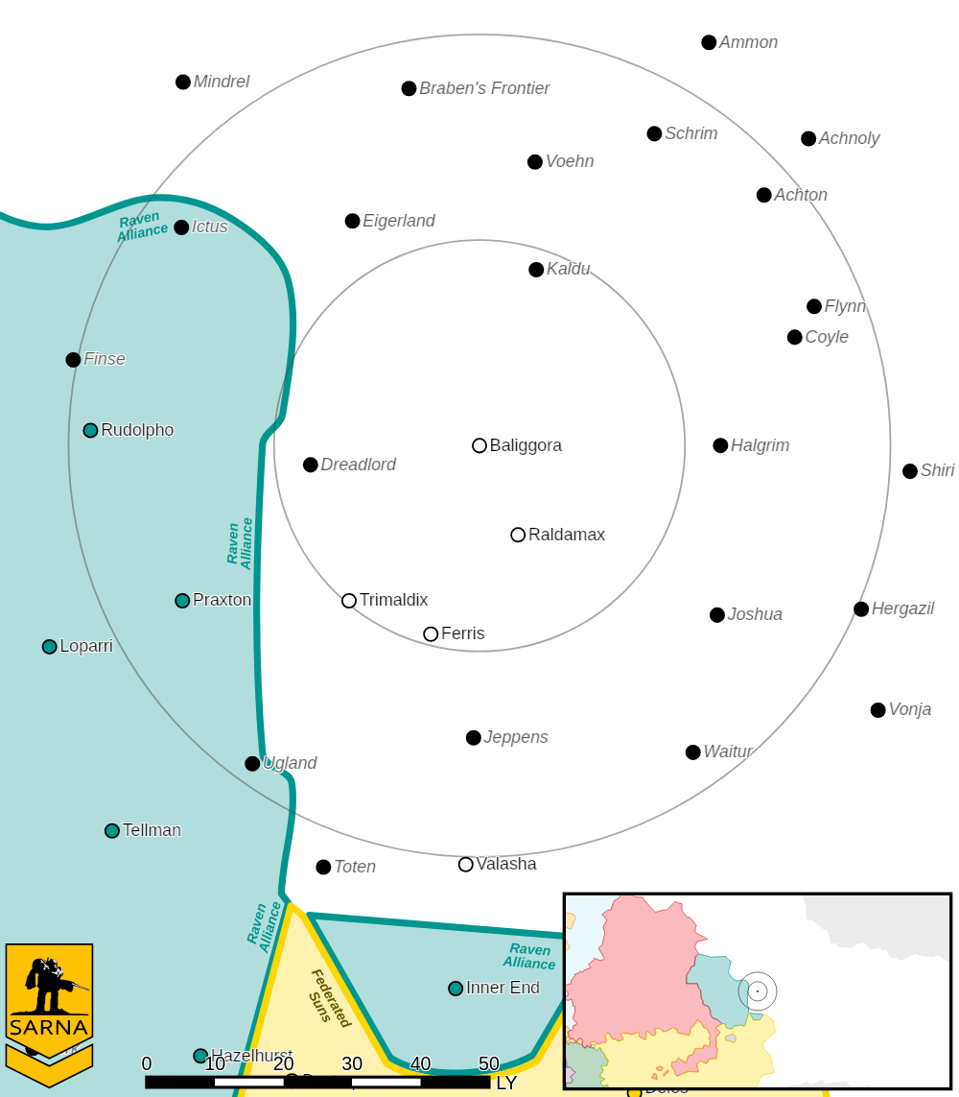

BALIGGORA I PLANETARY READOUT

STAR TYPE : M4V (205 HOURS RECHARGE TIME)
POSITION IN SYSTEM : 1 OF 6
NATURAL SATELLITES : 2
TIME TO JUMP POINT : 2.58 DAYS
SURFACE GRAVITY : 0.97 G
DAY LENGTH : 18.0 HOURS
ATMOSPHERIC PRESSURE : STANDARD (BREATHABLE)
EQUATORIAL TEMPERATURE : 17*C
SURFACE WATER : 41 PERCENT
CAPITAL : NEW DAVISTOWN
POPULATION : 23,288,370
HPG : NONE
SOCIO-INDUSTRIAL LEVELS : D-D-B-F-D
TECHNOLOGICAL SOPHISTICATION : D (LOWER-TECH WORLD)
INDUSTRIAL DEVELOPMENT : D (LOW INDUSTRIALIZATION)
RAW MATERIAL DEPENDENCE : B (MOSTLY SELF SUFFICIENT)
INDUSTRIAL OUTPUT : F (NONE)
AGRICULTURAL DEPENDENCE : D (POOR AGRICULTURE)
---------------------------- START TRANSMISSION ---------------------------
AS FLEET VESSELS ARE LOADED FOR TRANSIT, ANONYMOUS THIRD PARTIES HAVE OFFERED TO SPONSOR A CAPTURE THE FLAG COMPETITION.
----------------------------- END TRANSMISSION ----------------------------

MISSION 1
Unit Limits: 6K BV for 1v1, 10K for 2v2.

Map: Four mapsheets, with any terrain. Place 3-7 tokens evenly spaced along the centerline of the map.

Primary Objective: Recover as many flags as possible. A unit may pick up a flag in their during the End Phase if no enemy units are in the hex. A 'Mech must have a hand actuator to pick up a flag. They may not fire any weapons in the arm used to carry the flag while holding the flag. Infantry may carry a flag. They may not fire any weapons while holding the flag. Infantry in a vehicle may load a flag into the vehicle. A unit may voluntarily drop a flag during the End Phase. If the unit is destroyed, then the flag drops in the hex. Units claim a flag by returning it to one of the hexes on their home edge and surviving to the End Phase. A flag respawns at its original location immediately after it is claimed. Any flag picked up but not claimed counts as only half for scoring at the end of the scenario. Award 7.0M proportionally based upon the number of flags claimed.

Secondary Objective: Headhunting. Each side declares a commander and a lieutenant. Earn 1.5M C-bills for damaging the commander or lieutenant unit (target must pay to Repair/Recruit). Earn 3.0M C-bills for damaging both units. If a unit withdraws, then it is considered damaged for scoring.

Base Pay: 1.2M (1v1) or 1.0M (2v2) C-bills per commander if no objectives are completed.

Special Rules: No units are destroyed and units cannot be salvaged. Any unit that would need to be replaced only needs to be repaired.
No commander declares a faction for this scenario. A messaged introducing the 3 benefactor points of contact will be sent to commanders afterwards.

LOCAL AREA STAR MAP

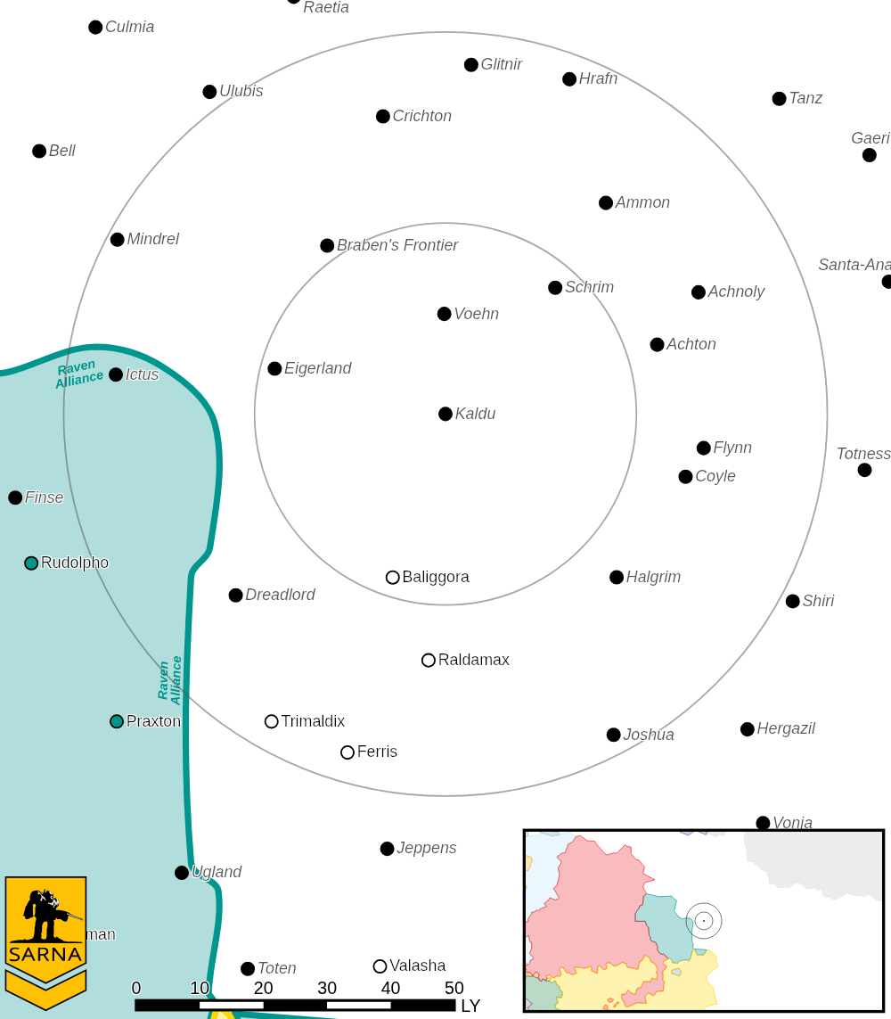

KALDU IV PLANETARY READOUT

STAR TYPE : F5V (176 HOURS RECHARGE TIME)
POSITION IN SYSTEM : 4 OF 9
NATURAL SATELLITES : 0
TIME TO JUMP POINT : 14.95 DAYS
SURFACE GRAVITY : 1.14 G
DAY LENGTH : 20.0 HOURS
ATMOSPHERIC PRESSURE : THIN (BREATHABLE)
EQUATORIAL TEMPERATURE : 26*C
SURFACE WATER : 52 PERCENT
CAPITAL : NEW WESTFORD
POPULATION : 0
HPG : NONE
SOCIO-INDUSTRIAL LEVELS : X-X-X-X-X
TECHNOLOGICAL SOPHISTICATION : X (REGRESSED WORLD)
INDUSTRIAL DEVELOPMENT : X (NONE)
RAW MATERIAL DEPENDENCE : X (NONE)
INDUSTRIAL OUTPUT : X (NONE)
AGRICULTURAL DEPENDENCE : X (NONE)

---------------------------- START TRANSMISSION ---------------------------
A LOCAL GROUP HAS CONTACTED THE FLEET ON AN OPEN CHANNEL, INDICATING THAT THEY HAVE ENDO STEEL THEY HAVE REMOVED FROM AN ABANDONED SLDF FACILITY THAT THEY ARE PREPARED TO SELL TO ANY WILLING BUYERS. FACTIONS IN THE FLEET ARE OFFERING REWARDS TO ANY FORCES ON THE PLANET THAT DIRECT SHIPMENTS TOWARDS SPECIFIC SHIPS IN THE FLEET.
----------------------------- END TRANSMISSION ----------------------------

MISSION 1
Unit Limits: 6K BV for 1v1, 10K for 2v2.

Map: Four mapsheets, with rocky terrain. Place 3 exit points for the SLDF facility along the centerline of the map. One must be on the centerline, and the other two may be the same distance from the centerline, but in opposite directions, no more than 3 hexes (6") from the centerline.

Primary Objective: Direct endo steel shipments. At each exit point, the side with the greatest total Size of units in adjacent hexes controls the point. VTOLs must be at elevation 0 or 1 to extern control. In a tie, neither side controls the point. Only infantry may occupy the exit point hex, which is considered to be a building 5 levels below the terrain. Infantry in the target hex count as twice their Size. At the end of each turn, roll 1D6 for each exit point, in a random order. If the roll is less than or equal to the turn number + 1, then the controlling side directs a shipment of endo steel for 1M C-bills. Up to 7 shipments of endo steel may be scored. If infantry occupy the exit point, roll an additional 1D6. If the roll is less than or equal to the turn number, apply 1D6 damage to the unit as the facility falls apart.

Secondary Objective: Secret Delivery. Your employer wants you to deliver an special payment for remaining equipment in the facility. Each side secretly selects 2 hexes at least 4 hexes away from each other and any exit point on their opponent's side of the map. Earn 1.5M per secret entrance if your infantry secures these hexes uncontested during any end phase.

Base Pay: 1.2M (1v1) or 1.0M (2v2) C-bills per commander if no objectives are completed.

---------------------------- START TRANSMISSION ---------------------------
THE BONUS PAYMENT HAS BEEN RECEIVED AND YOUR BENEFACTORS HAVE CONTACTED YOU TO ESCORT A CONVOY OF THE PURCHASED SUPPLIES TO AN EXTRACTION POINT. UNFORTUNATELY, THE LOCATION OF THE STAGING ZONE FOR THESE CONVOY VEHICLES HAS BEEN DISCOVERED. REACH THE STAGING ZONE AND ESCORT OUT AS MANY CONVOY VEHICLES AS POSSIBLE.
----------------------------- END TRANSMISSION ----------------------------

MISSION 1
Unit Limits: 6K BV for 1v1, 10K for 2v2.

Map: Three mapsheets, with rocky terrain. Place 7 convoy vehicles on the line between the first and second mapsheet, distributed evenly across the mapsheet from side to side. Both sides start on the map edge labeled START.

START
FINISH

Primary Objective: Escort convoy vehicles. Starting on the second turn, the vehicles will take the most direct path to the far map edge, labeled FINISH above. The convoy vehicles will move at cruse speed. While not under control of players, move the convoy vehicles as a third faction that lost Initiative to both sides. During the End Phase, if a side has a unit in the same hex as a convoy vehicle with no enemy units present, then they take control of the convoy vehicle. VTOLs must be within 1 elevation of the target to take control of the vehicle. If the vehicle is under control of a player, it may move at flaking speed but must record any damage from failed sideslip checks. The vehicle may be damaged or immobilized but not destroyed. Earn 1.0M C-bills for each convoy vehicle you control as it exits the far map edge. Earn 0.5M C-bills for each convoy vehicle controlled but not extracted. Convoy vehicles cannot be targeted or destroyed. Convoy vehicles are modified Maultier Hover APCs with 4/5 crew: https://masterunitlist.info/Unit/Details/2109/maultier-hover-apc

Secondary Objective: Tag the boss. The benefactor wants to see you conduct anti-'Mech and anti-vehicle attacks. Each side selects a commander and lieutenant from their 'Mech and vehicle units. Earn 1.5M for successfully swarming each target. The benefactor requests your infantry spray paint an obvious design on top of the target.

Base Pay: 1.2M (1v1) or 1.0M (2v2) C-bills per commander if no objectives are completed.

LOCAL AREA STAR MAP

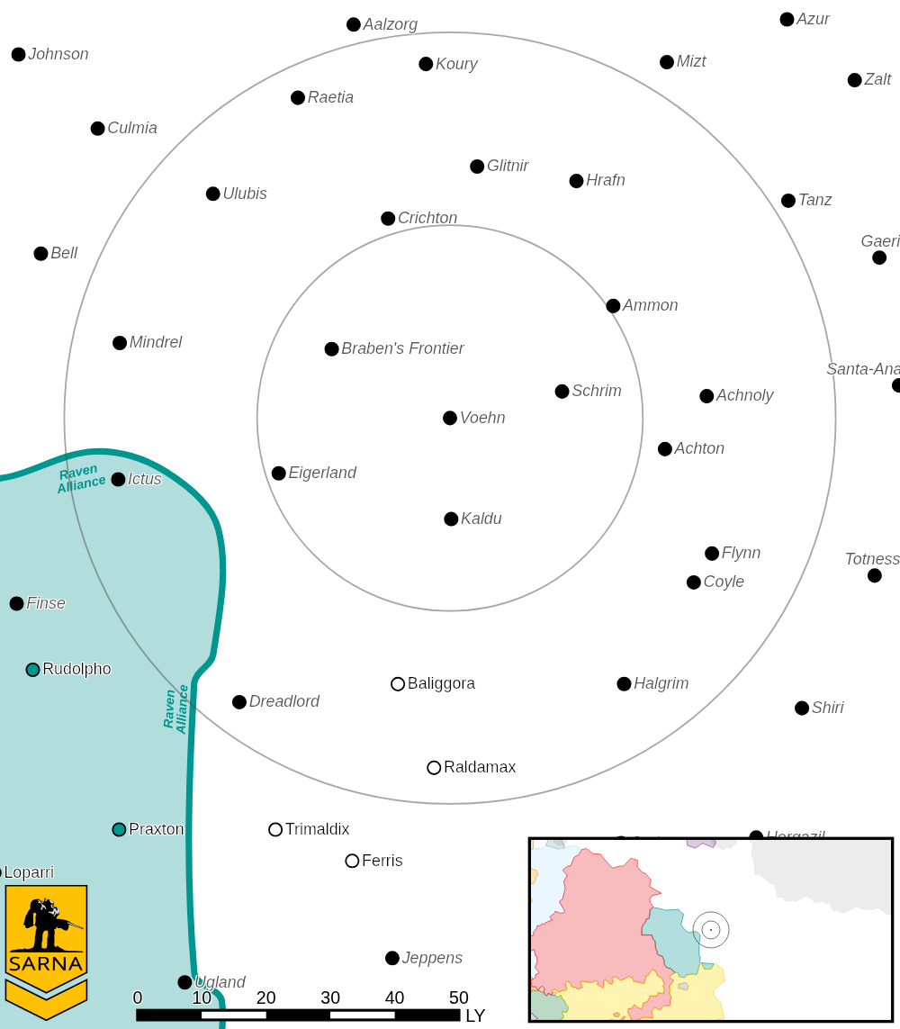

VOEHN II PLANETARY READOUT

STAR TYPE : G8V (189 HOURS RECHARGE TIME)
POSITION IN SYSTEM : 2 OF 7
NATURAL SATELLITES : 4
TIME TO JUMP POINT : 6.23 DAYS
SURFACE GRAVITY : 10.97 G
DAY LENGTH : 20.0 HOURS
ATMOSPHERIC PRESSURE : STANDARD (BREATHABLE)
EQUATORIAL TEMPERATURE : 22*C
SURFACE WATER : 47 PERCENT
CAPITAL : NOVA
POPULATION : 0
HPG : NONE
SOCIO-INDUSTRIAL LEVELS : X-X-X-X-X
TECHNOLOGICAL SOPHISTICATION : X (REGRESSED WORLD)
INDUSTRIAL DEVELOPMENT : X (NONE)
RAW MATERIAL DEPENDENCE : X (NONE)
INDUSTRIAL OUTPUT : X (NONE)
AGRICULTURAL DEPENDENCE : X (NONE)

---------------------------- START TRANSMISSION ---------------------------
SURVEYS HAVE DISCOVERED STRANGE FACTORIES ON THE SURFACE OF VOEHN III. THEY APPEAR TO BE USED FOR MANUFACTURING SOME SORT OF ADVANCED ULTRA-LIGHT 'MECHS. YOUR BENEFACTOR WOULD LIKE YOUR FORCE TO SECURE AS MANY FACTORY BUILDINGS AS POSSIBLE AND DENY ACCESS TO OTHER FORCES ON THE PLANET.
----------------------------- END TRANSMISSION ----------------------------

MISSION 1
Unit Limits: 6K BV for 1v1, 10K for 2v2.

Map: Three mapsheets, with desert terrain. Place 7 factory buildings on the map. Each building 2 levels high with a construction factor of 150. Roll off. The side with the higher roll gets to place first. Alternate placing one building on the map within 1 hex of the centerline. Buildings may be in adjacent hexes. The side that places the fewest buildings deploys first. Deploy forces per the standard rules for initiative. Up to 50% of your total BV may be placed anywhere on the map. Your remaining forces must be placed in a hex along your home map edge.

Primary Objective: Capture buildings. The side with the highest total Size in hexes adjacent to the building controls the building. Only infantry may enter the building hex, and they count as Size 2 when in the building hex. VTOLs must be within 1 elevation of the building. Earn 1M C-bills for each undamaged building you control. Earn 0.67M C-bills for each damaged building you control. Earn 0.33M C-bills for each building have damaged but do not control. Any unit in the Line of Sight and at the same height of a direct attack to a building may choose to Take Fire. To Take Fire, apply the damage from any successful attack on the building to your unit instead.

Secondary Objective: Salvage prototypes. The benefactor wants you to collect 2 prototype units. Prototypes may be found in any hex adjacent to a factory building. A 'Mech with 2 hand actuators may collect a prototype but may not fire arm mounted weapons while carrying the prototype. Infantry may load a prototype into a vehicle with 10 tons of cargo or infantry bays during the End Phase. Prototypes may be deposited on your home map edge. Earn 1.5M for each prototype deposited or carried at the end of the game.

Base Pay: 1.2M (1v1) or 1.0M (2v2) C-bills per commander if no objectives are completed.

LOCAL AREA STAR MAP

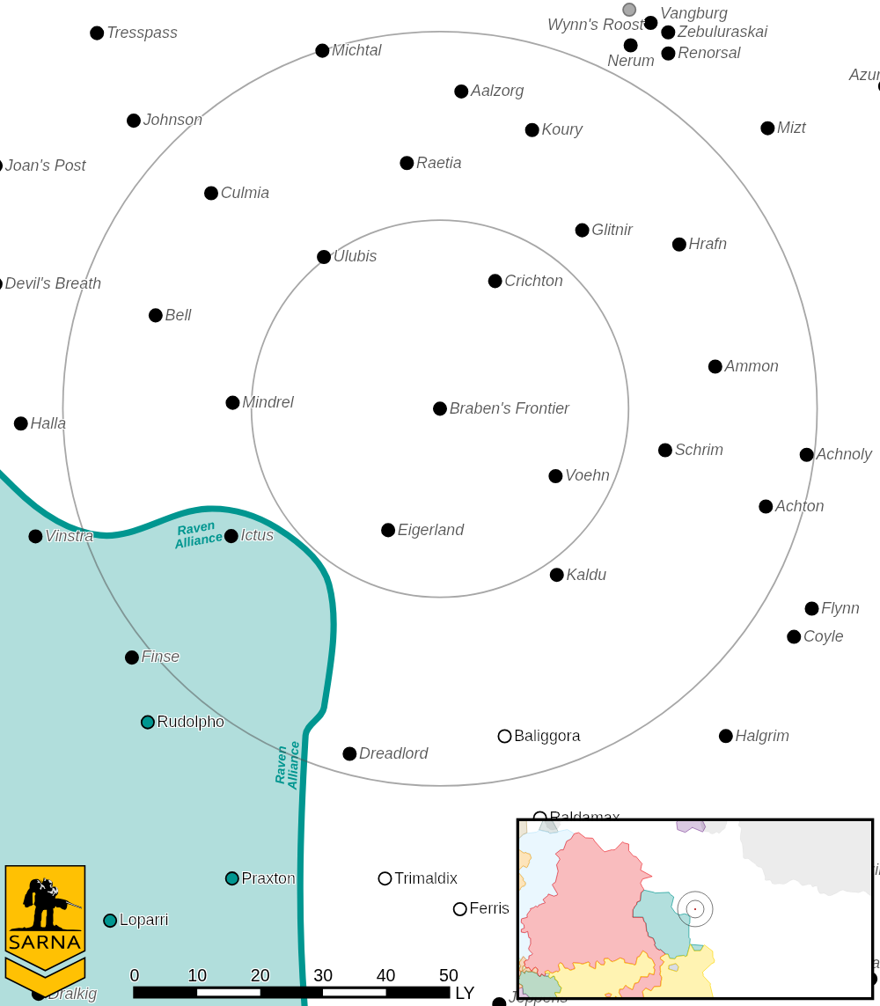

BRABEN'S FRONTIER I PLANETARY READOUT

STAR TYPE : M8V (209 HOURS RECHARGE TIME)
POSITION IN SYSTEM : 1 OF 7
NATURAL SATELLITES : 1
TIME TO JUMP POINT : 2.12 DAYS
SURFACE GRAVITY : 0.87 G
DAY LENGTH : 218.0 HOURS
ATMOSPHERIC PRESSURE : HIGH (BREATHABLE)
EQUATORIAL TEMPERATURE : 31*C
SURFACE WATER : 39 PERCENT
CAPITAL : NEW SIRVER CREEK
POPULATION : 0
HPG : NONE
SOCIO-INDUSTRIAL LEVELS : X-X-X-X-X
TECHNOLOGICAL SOPHISTICATION : X (REGRESSED WORLD)
INDUSTRIAL DEVELOPMENT : X (NONE)
RAW MATERIAL DEPENDENCE : X (NONE)
INDUSTRIAL OUTPUT : X (NONE)
AGRICULTURAL DEPENDENCE : X (NONE)

LOCAL AREA STAR MAP

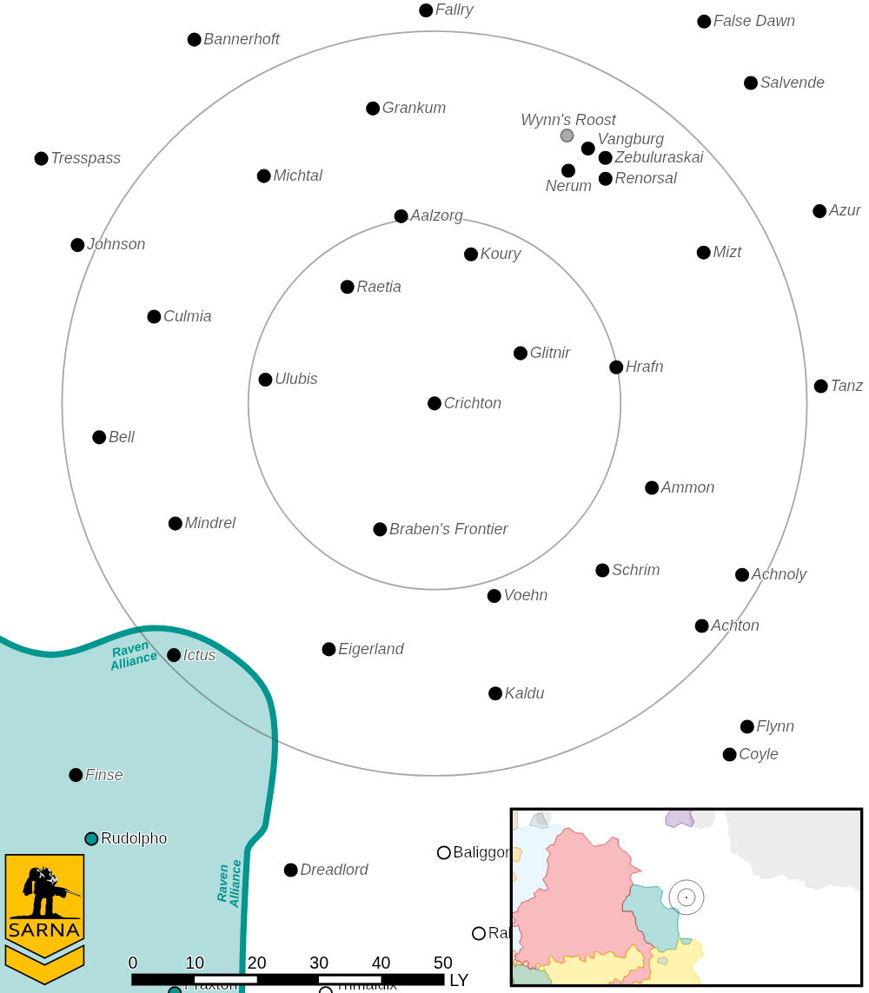

CHRICHTON I PLANETARY READOUT

STAR TYPE : B6V (207 HOURS RECHARGE TIME)
POSITION IN SYSTEM : 1 OF 5
NATURAL SATELLITES : 1
TIME TO JUMP POINT : 2.34 DAYS
SURFACE GRAVITY : 0.95 G
DAY LENGTH : 22.0 HOURS
ATMOSPHERIC PRESSURE : STANDARD (TAINTED - POISONOUS)
EQUATORIAL TEMPERATURE : 22*C
SURFACE WATER : 84 PERCENT
CAPITAL : NOVA BLAIRSVILLE
POPULATION : 0
HPG : NONE
SOCIO-INDUSTRIAL LEVELS : X-X-X-X-X
TECHNOLOGICAL SOPHISTICATION : X (REGRESSED WORLD)
INDUSTRIAL DEVELOPMENT : X (NONE)
RAW MATERIAL DEPENDENCE : X (NONE)
INDUSTRIAL OUTPUT : X (NONE)
AGRICULTURAL DEPENDENCE : X (NONE)

LOCAL AREA STAR MAP

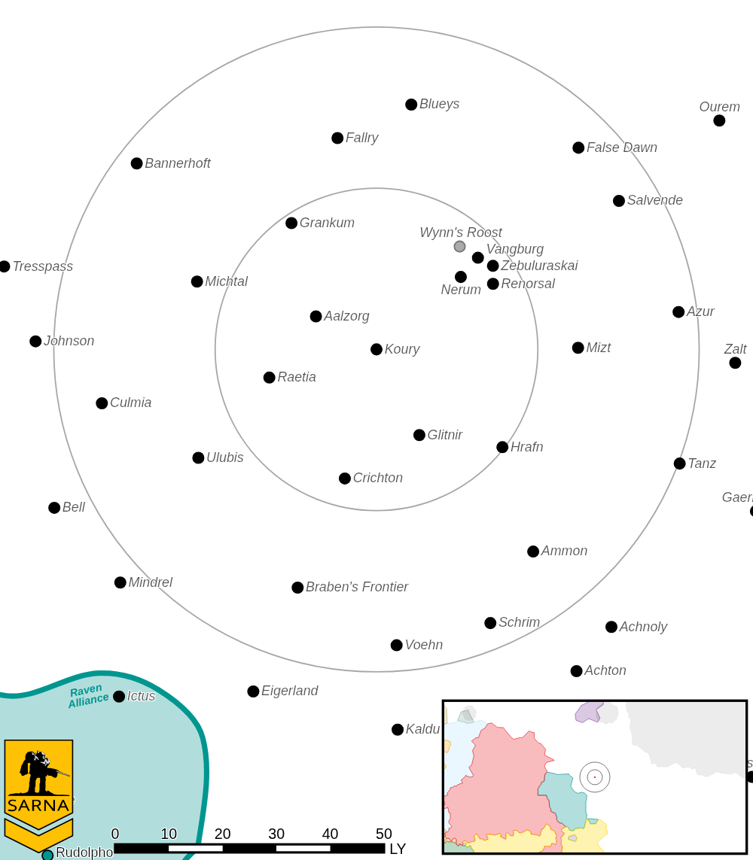

KOURY III PLANETARY READOUT

STAR TYPE : F5V (176 HOURS RECHARGE TIME)
POSITION IN SYSTEM : 3 OF 9
NATURAL SATELLITES : 6
TIME TO JUMP POINT : 14.94 DAYS
SURFACE GRAVITY : 0.67 G
DAY LENGTH : 15.0 HOURS
ATMOSPHERIC PRESSURE : THIN (TOXIC - POISONOUS)
EQUATORIAL TEMPERATURE : 29*C
SURFACE WATER : 34 PERCENT
CAPITAL : PERRIN'S PLANET CITY
POPULATION : 0
HPG : NONE
SOCIO-INDUSTRIAL LEVELS : X-X-X-X-X
TECHNOLOGICAL SOPHISTICATION : X (REGRESSED WORLD)
INDUSTRIAL DEVELOPMENT : X (NONE)
RAW MATERIAL DEPENDENCE : X (NONE)
INDUSTRIAL OUTPUT : X (NONE)
AGRICULTURAL DEPENDENCE : X (NONE)

LOCAL AREA STAR MAP

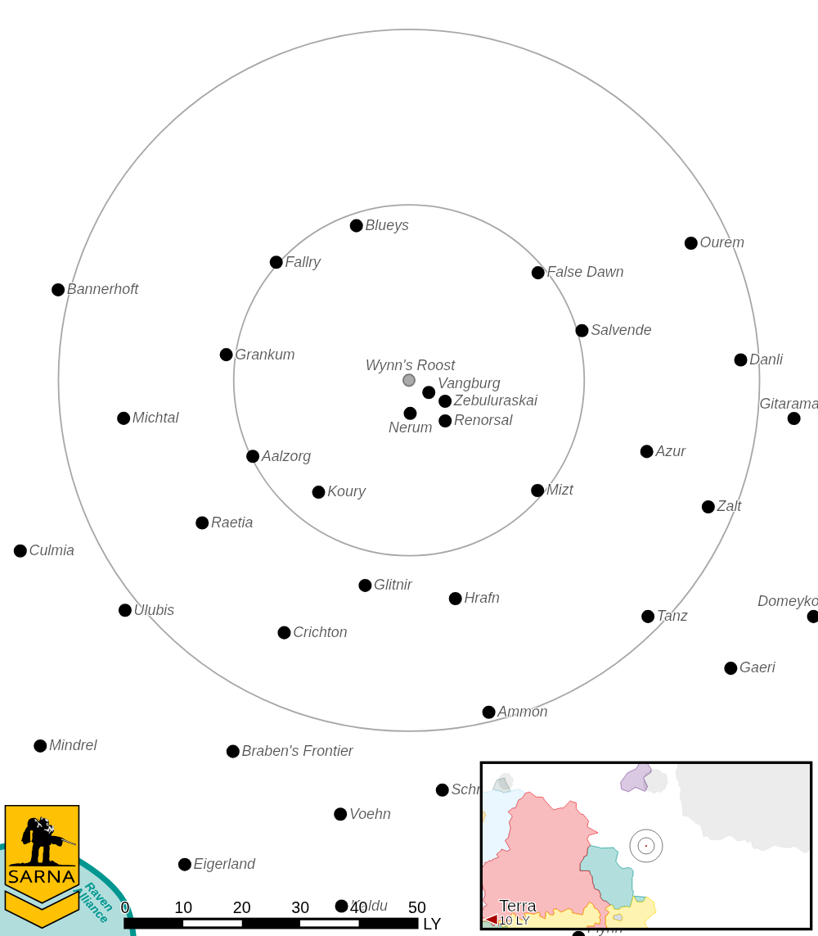

WYNN’S ROOST III PLANETARY READOUT

STAR TYPE : K7V (198 HOURS RECHARGE TIME)
POSITION IN SYSTEM : 2 OF 98
NATURAL SATELLITES : 1
TIME TO JUMP POINT : 3.70 DAYS
SURFACE GRAVITY : 1.00 G
DAY LENGTH : 26.0 HOURS
ATMOSPHERIC PRESSURE : STANDARD (TAINTED - NEGLIGIBLE)
EQUATORIAL TEMPERATURE : 34*C
SURFACE WATER : 50 PERCENT
CAPITAL : TURNERVILLE
POPULATION : 92,700,000
HPG : NONE
SOCIO-INDUSTRIAL LEVELS : C-C-A-B-C
TECHNOLOGICAL SOPHISTICATION : C (MODERATELY ADVANCED WORLD)
INDUSTRIAL DEVELOPMENT : C (BASIC HEAVY INDUSTRY)
RAW MATERIAL DEPENDENCE : A (FULLY SELF-SUFFICIENT)
INDUSTRIAL OUTPUT : B (GOOD OUTPUT)
AGRICULTURAL DEPENDENCE : C (MODEST AGRICULTURE)

BATTLETECH
OUTWORLDS WASTES

