BTTLETECH
OUTWORLDS WASTES

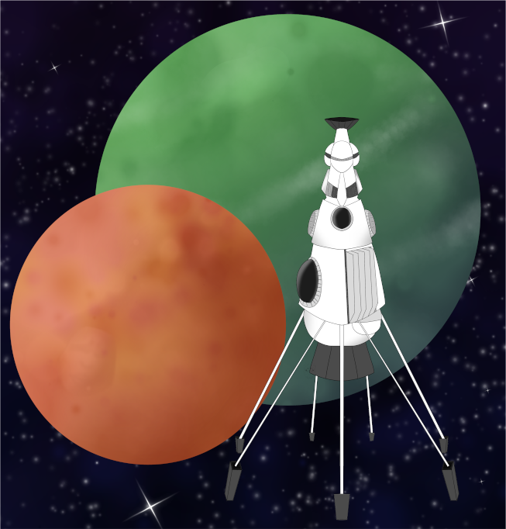

League Scenario Pack
BATTLETECH: OUTWORLDS WASTES

Antallos 'DESERTERS'

---------------------------- START TRANSMISSION ---------------------------
SNOW RAVEN FORCES ARE DROPPING ON ANTALLOS TO DESTROY PIRATE AND DARK CASTE FORCES ON THE BORDER OF THE OUTWORLDS ALLIANCE. CLAN SNOW RAVEN IS LEADING THE OPERATION AND SUPPLYING THE MAJORITY OF THE ATTACKING FORCES; HOWEVER THE ALLIANCE MILITARY CORPS IS DROPPING A SMALL FORCE TO LOCATE AND CAPTURE OR KILL THE REMAINING MEMBERS OF A COMPANY OF DESERTERS.
----------------------------- END TRANSMISSION ----------------------------

These are player-vs-player scenarios for BattleTech: Outworlds Wastes with combined arms and simplified campaign logistics rules.

Each player may bring 10,000 BV of combined arms, following the BattleTech: Outworlds Wastes league list building rules.

The following optional rules for BattleTech: Outworld Wastes are used:
- Pick a Side: Outworlds Alliance and Clan Snow Raven forces are always on the side of
the planetary attackers. Pirate, Dark Caste, and Word of Blake forces are always on
the side of the planetary defenders. All other forces should pick a side of the conflict
and generally support that side.
- On the Move: Due to the fast moving combat on Antallos, maintenance activities will
be restricted. Each scenario will list which maintenance activities are permitted
following the scenario. Pilot hits do not heal between these scenarios.

BattleTech: Outworlds Wastes:
Web: https://outworlds-wastes.jeremylt.org
PDF: https://outworlds-wastes.jeremylt.org/downloads?league

BattleTech: Outworlds Wastes is fan-made and based upon the official BattleTech rules from Catalyst Game Labs. BattleTech is a registered trademark of The Topps Company, Inc. in the United States and other countries.

Editor: Jeremy L Thompson

LOCAL AREA STAR MAP

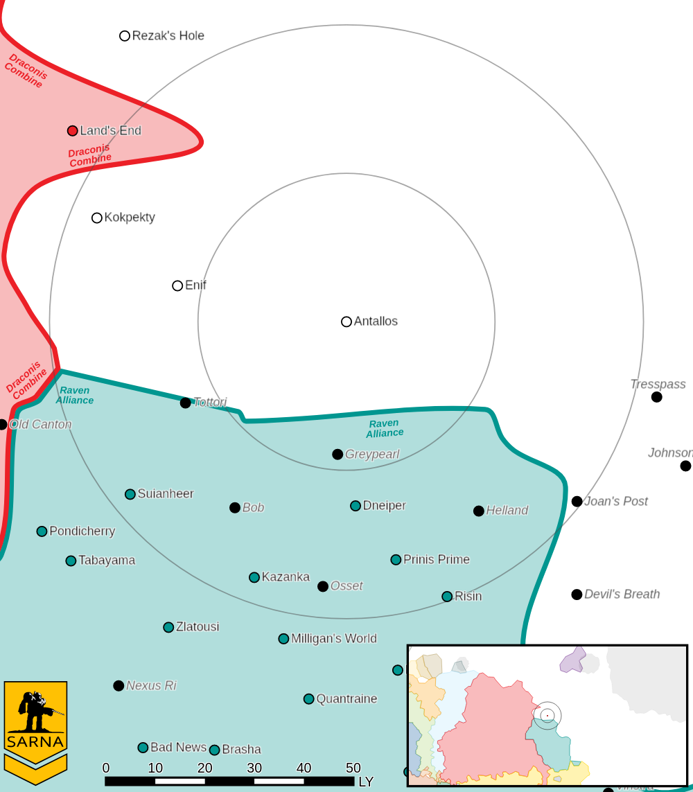

ANTALLOS III PLANETARY READOUT

STAR TYPE : K4IV (195 HOURS RECHARGE TIME)
POSITION IN SYSTEM : 3 OF 7
NATURAL SATELLITES : 2
TIME TO JUMP POINT : 4.44 DAYS
SURFACE GRAVITY : 0.92 G
DAY LENGTH : 27.0 HOURS
ATMOSPHERIC PRESSURE : STANDARD (BREATHABLE)
EQUATORIAL TEMPERATURE : 49*C
SURFACE WATER : 11 PERCENT
CAPITAL : PORT KRIN
POPULATION : 60,757,822
HPG : B-RATED HPG
SOCIO-INDUSTRIAL LEVELS : C-D-C-D-C
TECHNOLOGICAL SOPHISTICATION : C (MODERATELY ADVANCED WORLD)
INDUSTRIAL DEVELOPMENT : D (LOW INDUSTRIALIZATION)
RAW MATERIAL DEPENDENCE : C (LIMITED RAW MATERIAL PRODUCTION)
INDUSTRIAL OUTPUT : D (NEGLIGIBLE INDUSTRIAL OUTPUT)
AGRICULTURAL DEPENDENCE : C (MODEST AGRICULTURE)
---------------------------- START TRANSMISSION ---------------------------
OUTWORLDS ALLIANCE FORCES ARE COMBAT DROPPING ON AN OLD DROPPORT TO SECURE A BASE OF OPERATIONS. DEFENDING FORCES NEED TO DESTROY CRITICAL INFRASTRUCTURE TO SLOW THE INVADING FORCES.
----------------------------- END TRANSMISSION ----------------------------

MISSION 1
Unit Limits: 6K BV for 1v1, 10K for 2v2.

Map: Four mapsheets, with an airport, dropport, or flat desert terrain. The defender selects 5 single hex buildings as port infrastructure, evenly distributed and at least 3 hexes from the edge of the map. These buildings are hardened with a construction factor of 200. The defender secretly selects where all defending forces are positioned and reveals their locations after the attacking forces drop. Defending forces must start at least 2 hexes away from the buildings.

Attacking forces use modified combat drop rules: Each dropping unit selects a target hex. Roll 1d6 to determine the scatter direction and 1d6-1 to determine the scatter distance for the scatter dropping unit. If the target hex is occupied, displace by 1 hex in the opposite direction of the scatter direction. Enemy units may be revealed in this fashion. Attacking forces may not select a target hex within 6 hexes of the edge of the map.

Primary Objective: Destroy the infrastructure. During the End Phase, an uncontested infantry unit inside of the infrastructure buildings may destroy all critical equipment in the building. Earn a portion of 7.0M C-bills based upon the percentage of buildings with intact (attacker) or destroyed (defender) equipment.

Secondary Objective: Headhunting. Each side declares a commander. Earn 1.5M C-bills for damaging the commander's unit and 3.0M C-bills for destroying the commander's unit.

Base Pay: 1.2M (1v1) or 1.0M (2v2) C-bills per commander if no objectives are completed.

Maintenance: None, to include refilling ammunition.

---------------------------- START TRANSMISSION ---------------------------
DEFENDING FORCES MUST BREAK THROUGH ENEMY LINES TO REJOIN THEIR PARENT COMMAND. HOWEVER, THE OUTWORLDS ALLIANCE FORCES CANNOT BE LEFT UNMONITORED. DEPLOY SPIES TO MONITOR THE PROGRESS OF THE ATTACKING FORCES.
----------------------------- END TRANSMISSION ----------------------------

MISSION 2
Unit Limits: 6K BV for 1v1, 10K for 2v2.

Map: Three mapsheets with desert terrain, arranged with short edges touching. The defender secretly selects 3 hexes in the center mapsheet to drop off spies. Defending forces enter on one far map edge. Attacking forces start positioned on the center mapsheet.

Primary Objective: Breakthrough enemy lines. Each side earns a portion of 7.0M C-bills based upon the percentage of the defenders starting BV that crosses the opposite map edge.

Secondary Objective: Drop off spies. A defending unit with an infantry bay may drop off spies. Defenders secretly select 3 hexes on the center mapsheet. These hexes must be at least 2 hexes away from the edge of the map. Defenders may announce they are dropping off spies when they are in a target hex at the end of the Movement Phase. Attackers may search a target hex with infantry or a unit with an active probe during a following End Phase. Earn 1.0M for each spy dropped off (defender) or each target hex searched (attacker).

Base Pay: 1.2M (1v1) or 1.0M (2v2) C-bills per commander if no objectives are completed.

Maintenance: Any. However, units destroyed during the scenario or that exit off any edge other than the far edge cannot be used in scenario 3.
---------------------------- START TRANSMISSION ---------------------------
OUTWORLDS ALLIANCE FORCES ARE LINKING UP WITH THEIR OWN LOCAL GUIDES. DEFENDING FORCES MUST INTERCEPT THESE LOCAL GUIDES TO PROTECT THE LOCATION OF DEFENDING LEADERSHIP.
----------------------------- END TRANSMISSION ----------------------------

MISSION 3
Unit Limits: 6K BV for 1v1, 10K for 2v2.

Map: Four mapsheets with hilly or wooded terrain. Place two radio towers in the middle of the map as shown below. These towers cannot be destroyed.

Primary Objective: Pick up the local guides. The attacker secretly chooses 4 hexes on the defender's side of the map. These hexes must be at least 3 hexes away from the edges of the map and the center-line of the map. A unit with a cargo bay can pick up a local guide as long as the hex is not contested. The attacker declares during the End Phase which hex they intend to pick up a local guide from during the following End Phase. Earn a portion of 7.0M C-bills based upon the percentage of the local guides collected (attacker) or remaining (defender).

Secondary Objective: Broadcast propaganda. An uncontested infantry unit inside of a radio tower may broadcast propaganda during the End Phase. Earn 1.0M C-bills for successfully broadcasting propaganda from a radio tower. A maximum of 3.0M C-bills may be earned for broadcasting propaganda.

Base Pay: 1.2M (1v1) or 1.0M (2v2) C-bills per commander if no objectives are completed.

Maintenance: Any.

BTTLETECH
OUTWORLDS WASTES

