BATTLETECH: OUTWORLDS WASTES
BOARDING ACTION

--------------------------- START TRANSMISSION ----------------------------
INTERSTELLAR EXPEDITIONS IS LOOKING FOR INDEPENDENT SECURITY CONTRACTORS FOR A LONG HAUL MISSION IN THE OUTWORLDS WASTES. WE OFFER FLEXIBLE CONTRACT TERMS AND GENEROUS SALVAGE RIGHTS. JOIN OUR SPINWARD OPERATIONS TEAM TODAY!
---------------------------- END TRANSMISSION -----------------------------

This is a player-vs-GM narrative scenario. This scenario will use advanced rules, so experience playing Classic BattleTech is recommended.

Each player may bring one mech from the Mercenary faction list for the ilClan era. This mech may be no more than 1,500 BV with a 4/5 pilot and weigh no more than 75 tons. This mech may not be experimental or unique. See masterunitlist.info for the list of options. If your mech uses rules that are not in BattleTech: Total Warfare, please bring the appropriate rulebook. All players will have 3/4 pilots during the scenario. There will be minis available to borrow, if needed.

There are 6 available player slots to run Interstellar Expeditions mercenary mechs. There is an additional player slot to run part of the Dark Caste opposition forces. Contact the GM on the Colorado BattleTech Discord (username Jeremy) if you are interested in helping run the Dark Caste forces. If nobody contacts the GM, the 7th player to sign up will run part of the Dark Caste forces. All 7 players will receive a painted mini from the Dark Caste forces.

Colorado BattleTech Discord:
https://discord.gg/dbCSXbJspc
--------------------------- START TRANSMISSION ----------------------------
WE HAVE LOCATED AREAS OF INTEREST ON VOEHN II. UNFORTUNATELY, THE LOCAL WARLORD IS UNWILLING TO ALLOW ACCESS TO THE PLANET. THE WARLORD IS USING A MODIFIED STAR LEAGUE ENGINEERING CORPS ZEPPELIN FOR RECONNAISSANCE AND C3. YOUR MISSION IS TO CAPTURE THIS ZEPPELIN AND ASSOCIATED SUPPORT INFRASTRUCTURE. THE CAPTURE OF THIS PLATFORM WILL GIVE US VALUABLE STAR LEAGUE TECHNOLOGY AND ALLOW ACCESS TO OUR SITES OF INTEREST. EXPECT HEAVY OPPOSITION.

REGION BACKGROUND: THE OUTWORLDS ALLIANCE WAS FOUNDED IN 2413 AND ENJOYED PROSPERITY THROUGHOUT THE STAR LEAGUE ERA. BY THE START OF THE AMARIS CIVIL WAR IN 2766, THE OUTWORLDS ALLIANCE CONTAINED OVER 135 MAJOR SYSTEMS ACROSS 7 ADMINISTRATIVE DISTRICTS. UNFORTUNATELY, THE OUTWORLDS ALLIANCE SUFFERED DURING THE SUCCESSION WARS THAT FOLLOWED THE FALL OF THE STAR LEAGUE IN 2780, AND THEY HAD TO STEADILY ABANDON SYSTEMS THEY NO LONGER HAD THE RESOURCES TO SUPPORT.

CLAN SNOW RAVEN BEGAN EXPLORING THE PERIPHERY FOR RESOURCES SOON AFTER THE BATTLE OF TUKAYYID ENDED OPERATION REVIVAL. IN 3064, CLAN SNOW RAVEN AND THE OUTWORLDS ALLIANCE BEGAN DEVELOPING MUTUAL RESPECT AND TENTATIVE ALLIANCE. FOLLOWING THEIR ABJURATION FROM THE CLAN HOMEWORLDS IN 3075 AS A RESULT OF THE WARS OF REAVING, CLAN SNOW RAVEN TOOK REFUGE IN THE OUTWORLDS ALLIANCE. IN 3083, CLAN SNOW RAVEN AND THE OUTWORLDS ALLIANCE MERGED TO FORM THE RAVEN ALLIANCE.

BY THE ILCLAN TRIAL IN 3151, THE RAVEN ALLIANCE CONTAINED ONLY 47 SYSTEMS. AT LEAST 88 SYSTEMS THAT WERE PART OF THE OUTWORLDS ALLIANCE DURING THE STAR LEAGUE ERA HAVE BEEN LOST. MANY FACTIONS ARE EAGER TO EXPLORE THESE LOST WORLDS IN THE OUTWORLDS WASTES IN SEARCH OF LOST STAR LEAGUE TECHNOLOGY.

LOCAL AREA STAR MAP:

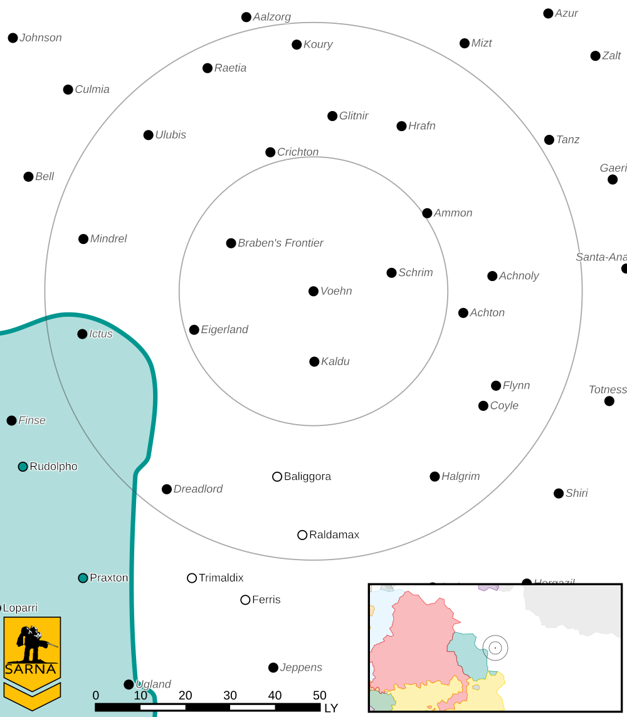
VOEHN II PLANETARY READOUT:

STAR TYPE : G8V (189 HOURS RECHARGE TIME)
POSITION IN SYSTEM : 2 OF 5
NATURAL SATELLITES : NONE
TIME TO JUMP POINT : 6.23 DAYS
SURFACE GRAVITY : 0.97 G
DAY LENGTH : 20.0 HOURS
ATMOSPHERIC PRESSURE : STANDARD (BREATHABLE)
EQUATORIAL TEMPERATURE : 22*C
SURFACE WATER : 47 PERCENT
CAPITAL : NOVA GROßRÖHRSDORF
POPULATION : UNK
HPG : NONE
SOCIO-INDUSTRIAL LEVELS : REGRESSED-X-X-X-X
TECHNOLOGICAL SOPHISTICATION : D (PRE-INDUSTRIAL)
INDUSTRIAL DEVELOPMENT : X (PRE-INDUSTRIAL)
RAW MATERIAL DEPENDENCE : X (PRE-INDUSTRIAL)
INDUSTRIAL OUTPUT : X (PRE-INDUSTRIAL)
AGRICULTURAL DEPENDENCE : X (PRE-INDUSTRIAL)

MISSION OBJECTIVES:

PART 1: BOARDING ACTION - WE HAVE LOCATED A MOUNTAIN PASS WITH MINERAL DEPOSITS THAT DISRUPT THE COMMUNICATION SYSTEMS ON THE ZEPPELIN. WE WILL BOARD AND CAPTURE THE ZEPPELIN AS IT FLIES OVER THIS PASS. DESTROY THE ENEMY AIR DEFENSES AND COMMUNICATION STATION.

PRIMARY OBJECTIVES:
PROTECT BOARDING TEAM VTOLS
DESTROY COMMUNICATIONS STATION

SECONDARY OBJECTIVES:
DESTROY AIR DEFENSES
MINIMIZE FRIENDLY LOSSES

FRIENDLY FORCES:
6 MERCENARY MECHS
6 SQUADS OF JUMP INFANTRY (BALLISTIC)
2 KARNOV UR TRANSPORTS

OPPOSITION FORCES:
EXPECT AT LEAST 1 STAR OF DEFENDING MECHS AND STATIC DEFENSES
PART 2: CAPTURE THE BASE - CAPTURE THE ZEPPELIN HOME BASE. WE NEED THE ZEPPELIN DOCKING TOWER AND MAINTENANCE FACILITIES INTACT. IF THE COMMUNICATIONS STATION WAS DESTROYED, THE ZEPPELIN WILL DOCK BEFORE YOUR ATTACK COMMENCES.

PRIMARY OBJECTIVES:
CAPTURE DOCKING TOWER
CAPTURE BASE COMMAND CENTER
CAPTURE OR DESTROY BASE DEFENSES

SECONDARY OBJECTIVES:
MINIMIZE DAMAGE TO BASE FACILITIES
MINIMIZE FRIENDLY LOSSES

FRIENDLY FORCES:
6 MERCENARY MECHS
6 SQUADS OF JUMP INFANTRY (BALLISTIC)

OPPOSITION FORCES:
EXPECT AT LEAST 1 STAR OF DEFENDING MECHS AND STATIC DEFENSES
GOOD LUCK

---------------------------- END TRANSMISSION -----------------------------
--------------------------- START TRANSMISSION ----------------------------

INTELLIGENCE HAS PROVIDED SATELLITE IMAGERY OF THE MOUNTAIN PASS. WE HAVE NOT BEEN ABLE TO LOCATE THE ZEPPELIN HOME BASE AT THIS TIME.

STATIC DEFENSES COMMUNICATIONS TOWER
|-- FRIENDLY DEPLOYMENT ZONE --|
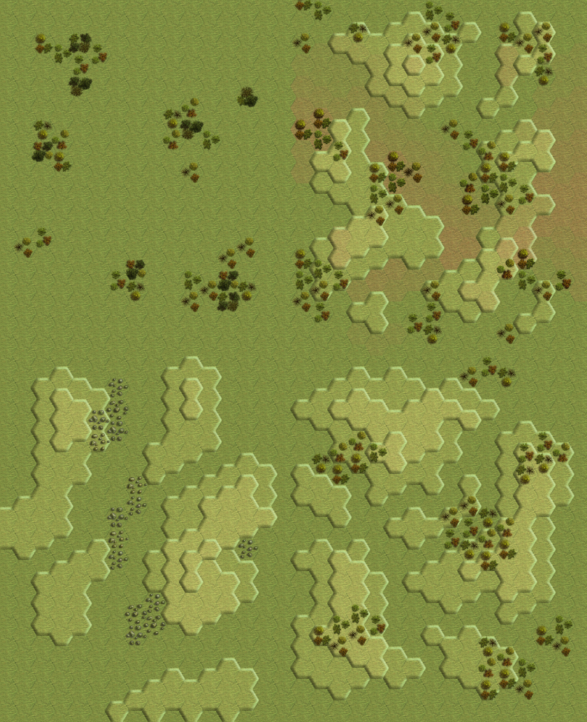
|--- ENEMY DEPLOYMENT ZONE ---|
AIRSHIP FLIGHT PATH

---------------------------- END TRANSMISSION -----------------------------
--------------------------- START TRANSMISSION ----------------------------

INTELLIGENCE HAS PROVIDED SATELLITE IMAGERY OF THE ZEPPELIN HOME BASE.

STATIC DEFENSES DOCKING TOWER COMMAND CENTER
|-- FRIENDLY DEPLOYMENT ZONE --|
|--- ENEMY DEPLOYMENT ZONE ---|
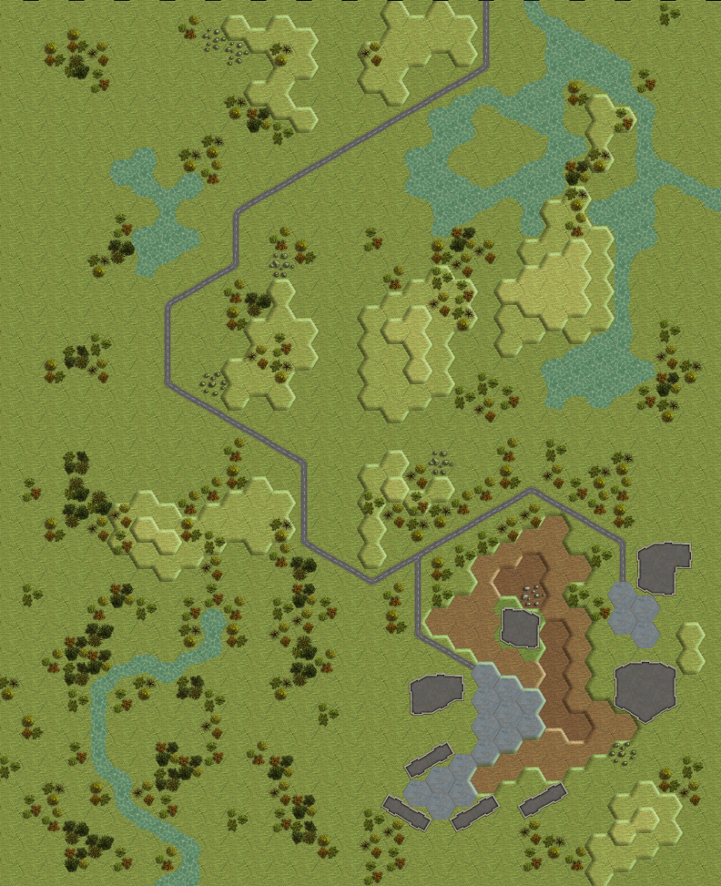
AIRSHIP FLIGHT PATH

---------------------------- END TRANSMISSION -----------------------------

GM Notes

--------------------------- START TRANSMISSION ----------------------------

SETUP:

WITH 5 PLAYERS, EACH PLAYER CAN USE A MECH THAT IS NO MORE THAN 1,800 BV (BV CALCULATED WITHOUT PILOT). WITH ONLY 4 PLAYERS, THE MECH CAN BE NO MORE THAN 2,250 BV. PLAYERS USE 3/4 PILOTS, ENEMY USES 3/5 PILOTS.

EACH PLAYER GETS 1 EDGE POINT. THIS EDGE POINT CAN BE USED TO REROLL A SINGLE ROLL INVOLVING ONE OF THEIR UNITS. THIS CAN BE ANY ROLL, TO INCLUDE HIT LOCATIONS, TO-HIT ROLLS, CRITICAL HIT LOCATIONS, ETC.

PART I:

DEPLOYMENT ZONES: DEPLOYMENT ZONES ARE ANNOTATED ON THE MAP.

TANKS: DEPLOY THE 3 ENEMY TANKS AS BLANK MARKERS IN THE PORTION OF THE MAP BEHIND THE AIRSHIP FLIGHT PATH. THE MINERAL DEPOSITS BLOCK ACCURATE SCANS. WHEN A FRIENDLY UNIT ENTERS LINE OF SIGHT OF THE TANK, REVEAL WHICH TYPE OF TANK IS PRESENT.

REINFORCEMENTS: ROLL 1D6 DURING EACH END PHASE FOR EACH GROUP OF UNITS NOT DEPLOYED. DEPLOY THEM DURING THE NEXT MOVEMENT PHASE IF YOUR ROLL MEETS THE VALUES BELOW.
* AIRSHIP: 1-2 ROUND 1; 1-4 ROUND 2; 1-6 ROUND 3
* VTOLS: 1-2 ROUND 1; 1-4 ROUND 2; 1-6 ROUND 3
* ENEMY STAR: DEPLOY 1 ROUND AFTER VTOLS

VTOLS: EACH PLAYER GETS 1 JUMP INFANTRY UNIT. PLAYERS NEED TO KEEP TRACK OF WHICH VTOL THEIR JUMP INFANTRY PLATOON BOARDED. EACH VTOL CAN HOLD A MAXIMUM OF 3 JUMP INFANTRY PLATOONS. IF THE VTOL HOLDING A PLAYERS JUMP INFANTRY PLATOON IS SHOT DOWN, THEN THEY CANNOT USE JUMP INFANTRY ON PART II. THE GM CONTROLS THE VTOLS AND THEY TAKE THE SAFEST PATH TO THE AIRSHIP.
JUMP INFANTRY WILL BOARD THE AIRSHIP IF THE VTOLS END THEIR MOVEMENT PHASE IN A HEX DIRECTLY ABOVE THE AIRSHIP.

LRM TOWERS: THE LRM TOWERS WILL SHOOT AT THE VTOLS WHENEVER THEY HAVE A SHOT. OTHERWISE THEY TARGET THE NEAREST UNIT. EACH LRM TOWER IS GUNNERY 5. THE GM SELECTS THE CONSTRUCTION FACTOR AND NUMBER OF LRMS PER TOWER.

COMMUNICATION STATION: THE GM SELECTS THE CONSTRUCTION FACTOR.

SCORING: PLAYERS GET THE FOLLOWING POINTS
* JUMP INFANTRY SURVIVES: 2PTS
* SHOT AT COMMUNICATIONS STATION: 2PTS
* KILLING SHOT AT COMMUNICATIONS STATION: 1PT
* LRM TOWER DESTROYED: 1PT
* ENEMY MECH DESTROYED: 2PT
* OTHER ENEMY UNIT DESTROYED: 1PT
PART II:

DEPLOYMENT ZONES: DEPLOYMENT ZONES ARE ANNOTATED ON THE MAP.

REINFORCEMENTS: ROLL 1D6 DURING EACH END PHASE FOR EACH GROUP OF UNITS NOT DEPLOYED. DEPLOY THEM DURING THE NEXT MOVEMENT PHASE IF YOUR ROLL MEETS THE VALUES BELOW.
ENEMY STAR: 1-2 ROUND 1; 1-4 ROUND 2; 1-6 ROUND 3

AIRSHIP: IF THE COMMUNICATIONS TOWER WAS DESTROYED IN PART I, THEN THE AIRSHIP STARTS DOCKED AT THE DOCKING TOWER. OTHERWISE IT DEPLOYS FROM ITS DEPLOYMENT ZONE ON THE FIRST TURN.

JUMP INFANTRY: IF THE JUMP INFANTRY SURVIVED, THEY MAY JUMP FROM THE AIRSHIP INTO ANY HEX DIRECTLY BELOW THE AIRSHIP DURING THE MOVEMENT PHASE OF THE FIRST ROUND.

CAPTURING BUILDINGS: THE DOCKING TOWER AND COMMAND CENTER ARE CAPTURED IF OCCUPIED BY A JUMP INFANTRY UNIT DURING THE END PHASE. CONTROL IS LOST IF THE JUMP INFANTRY UNIT LEAVES THE BUILDING. IF THE DOCKING TOWER IS CAPTURED, THEN DURING THE NEXT TURN THE PLAYERS CONTROL THE TWO CLOSEST LRM TOWERS. IF THE COMMAND CENTER IS CAPTURED, THE PLAYERS CONTROL ALL LRM TOWERS.

LRM TOWERS: THE LRM TOWERS WILL TARGET THE NEAREST ENEMY UNIT, DEPENDING UPON WHO CONTROLS THEM. EACH LRM TOWER IS GUNNERY 5. THE GM CHOOSES THE CONSTRUCTION FACTOR AND NUMBER OF LRMS EACH TOWER HAS.

SCORING: PLAYERS GET THE FOLLOWING POINTS
* JUMP INFANTRY CAPTURES DOCKING TOWER: 2PTS
* JUMP INFANTRY CAPTURES COMMAND CENTER: 2PTS
* JUMP INFANTRY SURVIVES: 1PT
* ENEMY MECH DESTROYED: 2PT
* OTHER ENEMY UNIT DESTROYED: 1PT
SALVAGE:

PLAYERS WHO SURVIVED GET FIRST PICK OF SALVAGE. PLAYERS WITH THE HIGHEST SCORE GET FIRST PICK. THE NUMBER OF POINTS FROM PRIMARY OBJECTIVES IS THE TIEBREAKER. PLAYERS CAN ALSO ASSIGN SALVAGE BY MUTUAL AGREEMENT. THE 5 MECHS OF THE AD HOC STAR AND THE 2 VTOLS ARE ALL AWARDED INDIVIDUALLY, MEANING 7 UNITS ARE AWARDED AS SALVAGE.

---------------------------- END TRANSMISSION -----------------------------

