BATTLETECH
OUTWORLDS WASTES

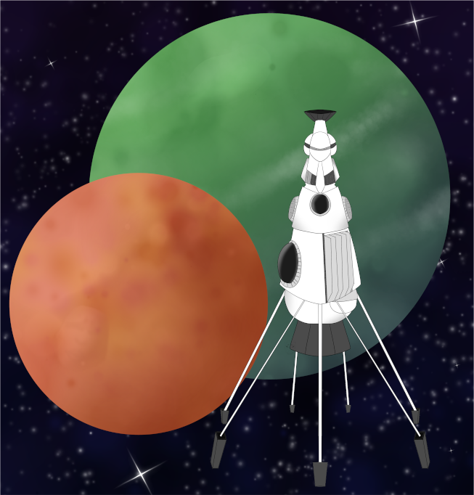

Event Scenario Pack
BATTLETECH: OUTWORLDS WASTES

RESCUE MISSION

--------------------------- START TRANSMISSION ----------------------------
INTERSTELLAR EXPEDITIONS HAS RECEIVED A DISTRESS MESSAGE FROM NEARBY KALDU III (MUGHAL) WHILE CONDUCTING OPERATIONS ON KALDU IV (KALDU). THE AUTHENTICATION CODES ARE OLD BUT CHECK OUT. IE HAS AUTHORIZED EMERGENCY PAY FOR ANY UNIT WILLING TO IMMEDIATELY RESPOND TO THIS DISTRESS MESSAGE.
---------------------------- END TRANSMISSION -----------------------------

These are player-vs-GM scenarios for BattleTech: Outworlds Wastes with combined arms and simplified campaign logistics rules.

Each player may bring 3,000 BV of combined arms from a single faction in the ilClan era on the Master Unit List, following the BattleTech: Outworlds Wastes event list building rules.

Players use BattleTech: Outworlds Wastes Force Maintenance event rules to improve their force between scenarios. Players can improve their force up to 5,000 BV. The enemy force uses the full BattleTech: Outworlds Wastes Force Maintenance rules for repair between scenarios.

The following optional rules are recommended:
- Initiative Deck: Initiative is determined by playing cards.
Each player receives one card; their whole force activates together.
The Movement Phase is resolved from lowest value to highest.
The Attack Phases are resolved from highest value to lowest.
- Fire for Effect: Attack declaration and resolution occur simultaneously.

BattleTech Outworlds Wastes:
Web: https://outworlds-wastes.jeremylt.org/event-play
PDF: https://outworlds-wastes.jeremylt.org/downloads?event

BattleTech: Outworlds Wastes is fan-made and based upon the official BattleTech rules from Catalyst Game Labs. BattleTech is a registered trademark of The Topps Company, Inc. in the United States and other countries.

Era: Succession Wars or later

Editor: Jeremy L Thompson
--------------------------- START TRANSMISSION ----------------------------

MISSION BACKGROUND

KALDU IS A SYSTEM FOR ONE OF THE POPULAR ROUTES FROM RAVEL ALLIANCE WORLDS TO WYNN'S ROOST. WHILE CONDUCTING OPERATIONS ON KALDU IV, INTERSTELLAR EXPEDITIONS RECEIVED A DISTRESS MESSAGE FROM MUGHAL (KALDU III). INTERSTELLAR EXPEDITIONS HAS REQUESTED ASSOCIATED FORCES TO SEND A DETACHMENT TO ANSWER THE DISTRESS MESSAGE.

PIRATE RAIDS ARE A COMMON PROBLEM IN THE OUTWORLDS WASTES. THE DISTRESS MESSAGE MENTIONS PIRATES BUT IS INCOMPLETE. INTERSTELLAR EXPEDITIONS RECOMMENDS CAUTION BUT WILL PAY WELL FOR RECOVERY OF PERSONNEL AND ANY EQUIPMENT.

REGION BACKGROUND

THE OUTWORLDS ALLIANCE WAS FOUNDED IN 2413 AND ENJOYED PROSPERITY THROUGHOUT THE STAR LEAGUE ERA. BY THE START OF THE AMARIS CIVIL WAR IN 2766, THE OUTWORLDS ALLIANCE CONTAINED OVER 135 MAJOR SYSTEMS ACROSS 7 ADMINISTRATIVE DISTRICTS. UNFORTUNATELY, THE OUTWORLDS ALLIANCE SUFFERED DURING THE SUCCESSION WARS THAT FOLLOWED THE FALL OF THE STAR LEAGUE IN 2780, AND THEY HAD TO STEADILY ABANDON SYSTEMS THEY NO LONGER HAD THE RESOURCES TO SUPPORT.

CLAN SNOW RAVEN BEGAN EXPLORING THE PERIPHERY FOR RESOURCES SOON AFTER THE BATTLE OF TUKAYYID ENDED OPERATION REVIVAL. IN 3064, CLAN SNOW RAVEN AND THE OUTWORLDS ALLIANCE BEGAN DEVELOPING MUTUAL RESPECT AND TENTATIVE ALLIANCE. FOLLOWING THEIR ABJURATION FROM THE CLAN HOMEWORLDS IN 3075 AS A RESULT OF THE WARS OF REAVING, CLAN SNOW RAVEN TOOK REFUGE IN THE OUTWORLDS ALLIANCE. IN 3083, CLAN SNOW RAVEN AND THE OUTWORLDS ALLIANCE MERGED TO FORM THE RAVEN ALLIANCE.

BY THE ILCLAN TRIAL IN 3151, THE RAVEN ALLIANCE CONTAINED ONLY 47 SYSTEMS. AT LEAST 88 SYSTEMS THAT WERE PART OF THE OUTWORLDS ALLIANCE DURING THE STAR LEAGUE ERA HAVE BEEN LOST. MANY FACTIONS ARE EAGER TO EXPLORE THESE LOST WORLDS IN THE OUTWORLDS WASTES IN SEARCH OF LOST STAR LEAGUE TECHNOLOGY.

LOCAL AREA STAR MAP

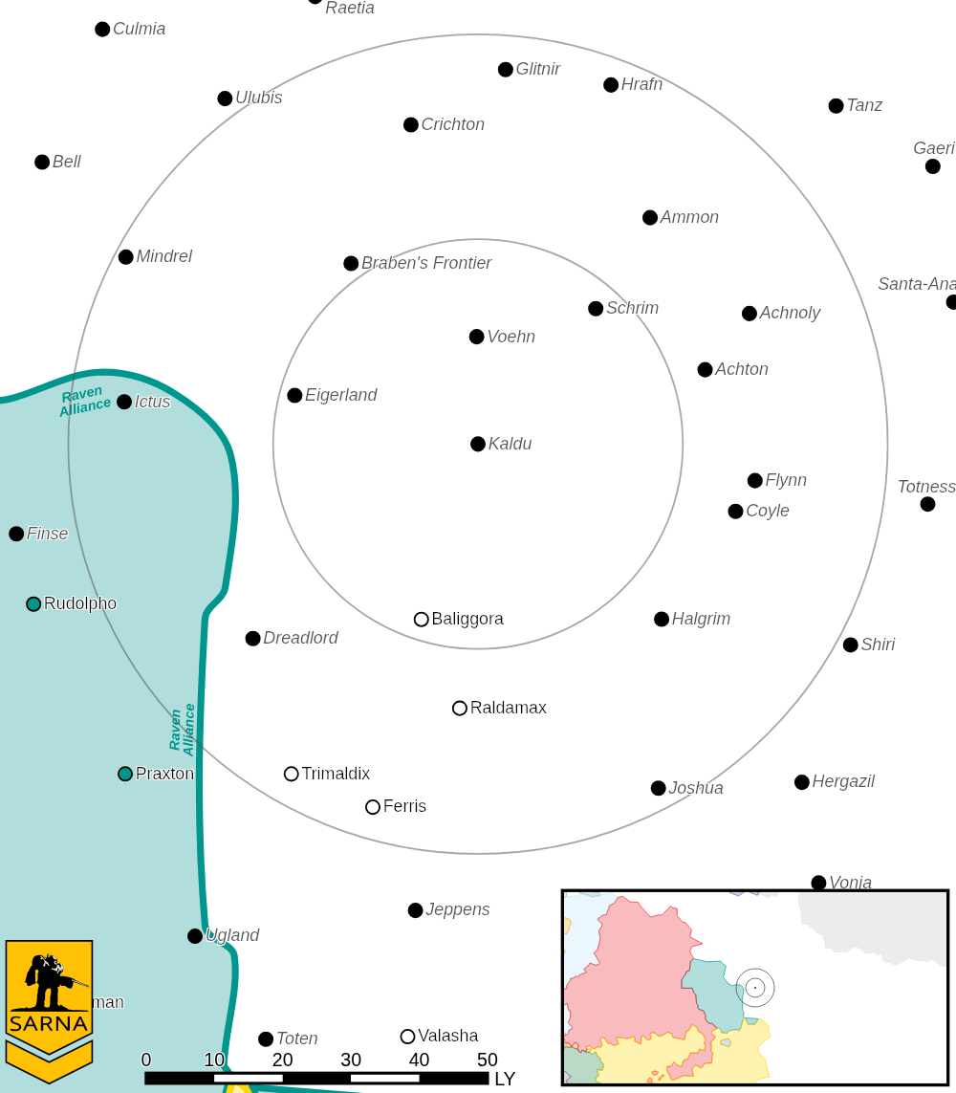

KALDU III PLANETARY READOUT

STAR TYPE : F5V (176 HOURS RECHARGE TIME)
POSITION IN SYSTEM : 3 OF 9
NATURAL SATELLITES : 2
TIME TO JUMP POINT : 14.94 DAYS
SURFACE GRAVITY : 0.95 G
DAY LENGTH : 20.0 HOURS
ATMOSPHERIC PRESSURE : TRACE (TOXIC - POISONOUS)
EQUATORIAL TEMPERATURE : 53*C
SURFACE WATER : 0 PERCENT
CAPITAL : NONE
POPULATION : 0
HPG : NONE
SOCIO-INDUSTRIAL LEVELS : X-X-X-X-X
TECHNOLOGICAL SOPHISTICATION : X (REGRESSED WORLD)
INDUSTRIAL DEVELOPMENT : X (NONE)
RAW MATERIAL DEPENDENCE : X (NONE)
INDUSTRIAL OUTPUT : X (NONE)
AGRICULTURAL DEPENDENCE : X (NONE)

MISSION 1: EXTRACTION

THE DISTRESS MESSAGE IS COMING FROM AN ENCAMPMENT ON THE SOUTHERN HEMISPHERE. NO ACTIVITY IS VISIBLE AT THE SITE FROM ORBIT. APPROACH WITH CAUTION AND RESCUE ANY IE UNITS AND PERSONNEL AT THE SITE. RECOVER ANY IE EQUIPMENT AND DIG ARTIFACTS.

PRIMARY OBJECTIVES:
RESCUE ANY IE UNITS
RECOVER ANY IE EQUIPMENT

SECONDARY OBJECTIVES:
DESTROY PIRATE FORCES

ADDITIONAL RULES:
MECHS WITH HANDS MAY RECOVER EQUIPMENT OR ARTIFACTS. VEHICLES MAY
ALSO RECOVER IF THEY HAVE INFANTRY NEARBY (MOUNTED OR IN THE SAME HEX).

OPPOSITION FORCES:
PIRATE FORCES ON PLANET ARE 1 COMPANY IN STRENGTH, WITH COMBINED ARMS
INCLUDING MECHS AND TANKS

MISSION 2: ESCAPE

YOUR FORCE IS BEING PURSUED BY PIRATES. RETREAT BACK TO REINFORCEMENTS. YOU MAY DEPLOY ARTILLERY AGAINST TARGETS YOU SEE.

PRIMARY OBJECTIVES:
RETREAT OFF OF MAP

SECONDARY OBJECTIVES:
DESTROY PIRATE FORCES

OPPOSITION FORCES:
PIRATE FORCES ON PLANET ARE 1 COMPANY IN STRENGTH, WITH COMBINED ARMS
INCLUDING MECHS AND TANKS

---------------------------- END TRANSMISSION -----------------------------
--------------------------- START TRANSMISSION ----------------------------

INTELLIGENCE HAS PROVIDED SATELLITE IMAGERY OF THE MINING FACILITY.

|-- FRIENDLY DEPLOYMENT ZONE --|
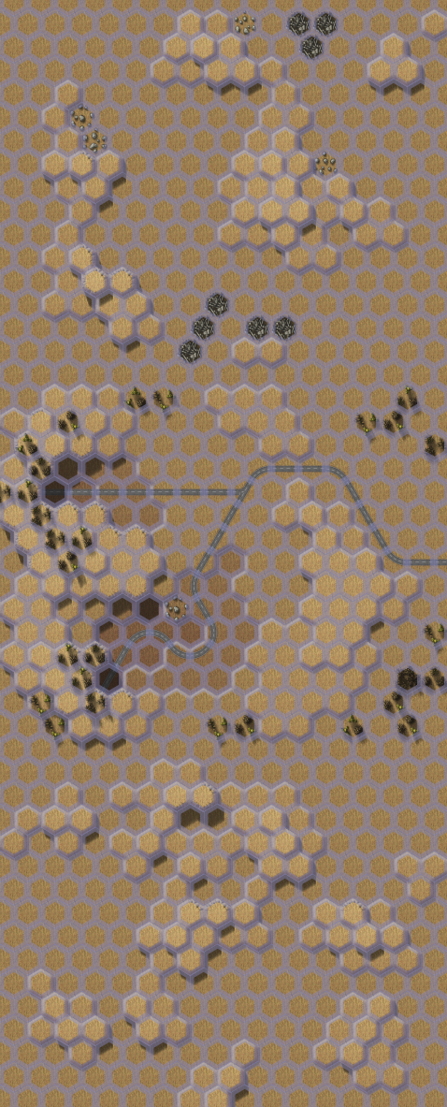

---------------------------- END TRANSMISSION -----------------------------
--------------------------- START TRANSMISSION ----------------------------

INTELLIGENCE HAS PROVIDED SATELLITE IMAGERY OF DROPSHIP LANDING SITE.

-
|
|
D
F E
R P
I L Z
E O O
N Y N
D M E
L E
Y N
T
|
|
-

|-- ENEMY DROPSHIP --|

---------------------------- END TRANSMISSION -----------------------------
--------------------------- START TRANSMISSION ----------------------------

MISSION BOUNTIES

THE FOLLOWING BOUNTIES HAVE BEEN ISSUED FOR THIS MISSION.

PAYMENT | ACTIVITY
100,000 | DAMAGE ENEMY UNIT (PER UNIT)
100,000 | CRITICAL OR MOTIVE DAMAGE (PER UNIT)
100,000 | COMPLETE A PHYSICAL ATTACK
100,000 | COMPLETE AN ANTI-MECH ATTACK
100,000 | DAMAGE A UNIT WITH INDIRECT FIRE
100,000 | SKID A UNIT WITHOUT DESTROYING IT
250,000 | KNOCK 'MECH PILOT UNCONSCIOUS
250,000 | REDUCE A COMBAT VEHICLE TO 0 MP
250,000 | KILL ALL BUT 1 TROOP IN AN INFANTRY UNIT
250,000 | HAVE A UNIT SCORE A HIT AT ALL 3 RANGES
250,000 | COMPLETE A CHARGE ATTACK
250,000 | COMPLETE A DEATH FROM ABOVE ATTACK
500,000 | SHOOT DOWN A VTOL WITH A TMM OF 5+
500,000 | SHOOT A 'MECH IN THE HEAD
500,000 | PHYSICAL ATTACK A 'MECH IN THE HEAD
500,000 | CAPTURE A VEHICLE CREW OR 'MECH PILOT

---------------------------- END TRANSMISSION -----------------------------
BATTLETECH: OUTWORLDS WASTES

LOCAL CONTRACT - GM Notes

Mission 1
Maps: Deserts Pack, Mines 1, Sand Drift 1, Clan Invasion Box, Barren Lands 1
Scoring: 0.25M for a convoy vehicle destroyed, 0.5M for a convoy vehicle captured

Trucks: Trucks have 10 points of structure, if the unit is damaged during the Attack
Phase, roll 2D6 roll and the unit is immobilized on a result greater than or equal to
the remaining structure, but on roll of 12 the unit is destroyed. Infantry/Battle Armor
can capture the unit without risk of destruction if there is no enemy infantry present.

Pirates: Pirates start on the center mapsheet and try to escape off the Sand Drift
mapsheet. Pirates will try to escape with as many vehicles as possible, but pirate
MechWarriors will always prioritize their own safety first.

Mission 2
Maps: Twycross Great Gash
Scoring: 1M for Dropship, 1M proportionally for % of enemy units destroyed

Dropship: Infantry/Battle Armor can capture the Dropship as song as no enemy
infantry/Battle Armor are present.

Pirates: Pirates will take off once at least half of the surviving units have boarded.

BATTLETECH
OUTWORLDS WASTES

