BTTLETECH
OUTWORLDS WASTES

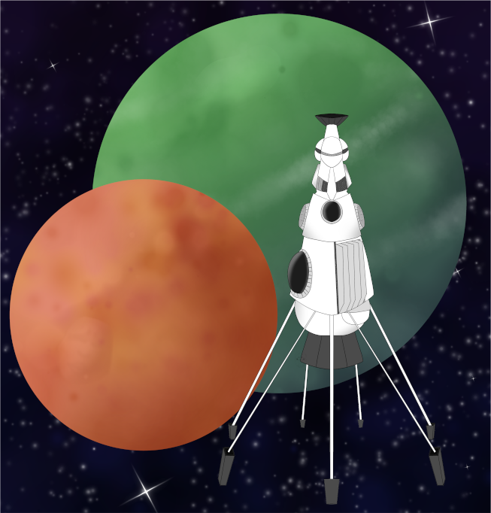

Event Scenario Pack
BATTLETECH: OUTWORLDS WASTES

RESUPPLY

--------------------------- START TRANSMISSION ----------------------------
INTERSTELLAR EXPEDITIONS IS LOOKING FOR INDEPENDENT SECURITY CONTRACTORS FOR A LONG HAUL MISSION IN THE OUTWORLDS WASTES. WE OFFER FLEXIBLE CONTRACT TERMS AND GENEROUS SALVAGE RIGHTS. JOIN OUR SPINWARD OPERATIONS TEAM TODAY!
---------------------------- END TRANSMISSION -----------------------------

These are player-vs-GM scenarios for BattleTech: Outworlds Wastes with combined arms and simplified campaign logistics rules.

Each player may bring 3,000 BV of combined arms from a single faction in the ilClan era on the Master Unit List, following the BattleTech: Outworlds Wastes event list building rules.

Players use BattleTech: Outworlds Wastes Force Maintenance event rules to improve their force between scenarios. Players can improve their force up to 5,000 BV. The enemy force uses the full BattleTech: Outworlds Wastes Force Maintenance rules for repair between scenarios.

The following optional rules are recommended:
- Initiative Deck: Initiative is determined by playing cards.
Each player receives one card; their whole force activates together.
The Movement Phase is resolved from lowest value to highest.
The Attack Phases are resolved from highest value to lowest.
- Fire for Effect: Attack declaration and resolution occur simultaneously.
- Multiple Attack Rolls: Separate attack rolls for each point of damage. (Alpha Strike)

BattleTech Outworlds Wastes:
Web: https://outworlds-wastes.jeremylt.org/event-play
PDF: https://outworlds-wastes.jeremylt.org/downloads?event

BattleTech: Outworlds Wastes is fan-made and based upon the official BattleTech rules from Catalyst Game Labs. BattleTech is a registered trademark of The Topps Company, Inc. in the United States and other countries.

Editor: Jeremy L Thompson
--------------------------- START TRANSMISSION ----------------------------

MISSION BACKGROUND

BALIGGORA WAS THE HEADQUARTERS OF THE EXPLORER CORPS SPINWARD OPERATIONS AREA COMMAND. OUR EXPEDITION WILL SURVEY THE ABANDONED COMSTAR FACILITIES ON BALIGGORA BEFORE PROCEEDING DEEPER INTO THE OUTWORLDS WASTES.

REGION BACKGROUND

THE OUTWORLDS ALLIANCE WAS FOUNDED IN 2413 AND ENJOYED PROSPERITY THROUGHOUT THE STAR LEAGUE ERA. BY THE START OF THE AMARIS CIVIL WAR IN 2766, THE OUTWORLDS ALLIANCE CONTAINED OVER 135 MAJOR SYSTEMS ACROSS 7 ADMINISTRATIVE DISTRICTS. UNFORTUNATELY, THE OUTWORLDS ALLIANCE SUFFERED DURING THE SUCCESSION WARS THAT FOLLOWED THE FALL OF THE STAR LEAGUE IN 2780, AND THEY HAD TO STEADILY ABANDON SYSTEMS THEY NO LONGER HAD THE RESOURCES TO SUPPORT.

CLAN SNOW RAVEN BEGAN EXPLORING THE PERIPHERY FOR RESOURCES SOON AFTER THE BATTLE OF TUKAYYID ENDED OPERATION REVIVAL. IN 3064, CLAN SNOW RAVEN AND THE OUTWORLDS ALLIANCE BEGAN DEVELOPING MUTUAL RESPECT AND TENTATIVE ALLIANCE. FOLLOWING THEIR ABJURATION FROM THE CLAN HOMEWORLDS IN 3075 AS A RESULT OF THE WARS OF REAVING, CLAN SNOW RAVEN TOOK REFUGE IN THE OUTWORLDS ALLIANCE. IN 3083, CLAN SNOW RAVEN AND THE OUTWORLDS ALLIANCE MERGED TO FORM THE RAVEN ALLIANCE.

BY THE ILCLAN TRIAL IN 3151, THE RAVEN ALLIANCE CONTAINED ONLY 47 SYSTEMS. AT LEAST 88 SYSTEMS THAT WERE PART OF THE OUTWORLDS ALLIANCE DURING THE STAR LEAGUE ERA HAVE BEEN LOST. MANY FACTIONS ARE EAGER TO EXPLORE THESE LOST WORLDS IN THE OUTWORLDS WASTES IN SEARCH OF LOST STAR LEAGUE TECHNOLOGY.

LOCAL AREA STAR MAP

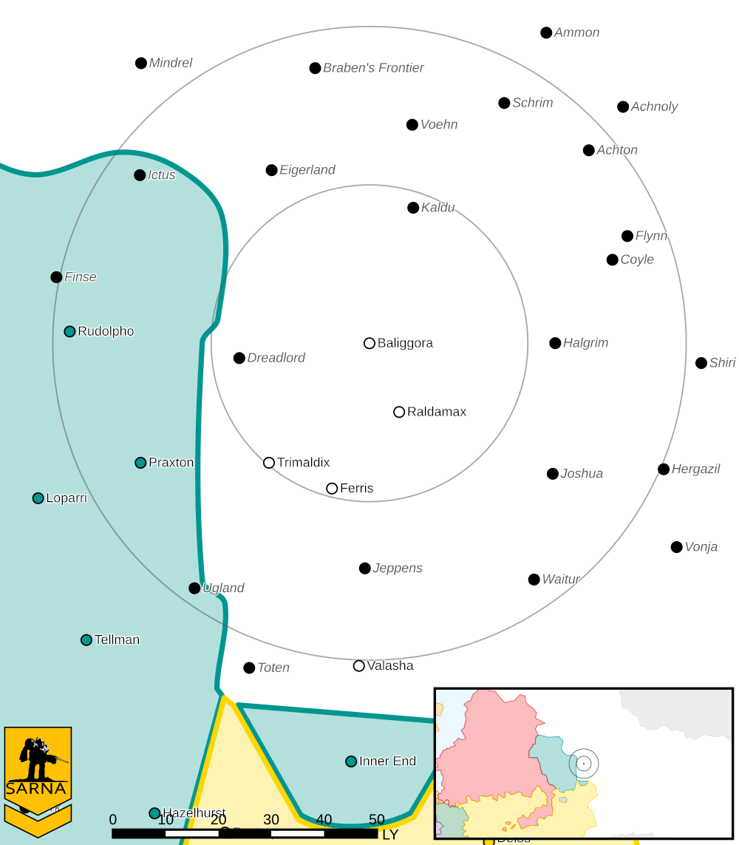

BALIGGORA I PLANETARY READOUT

STAR TYPE : M4V (205 HOURS RECHARGE TIME)
POSITION IN SYSTEM : 1 OF 1
NATURAL SATELLITES : NONE
TIME TO JUMP POINT : 2.58 DAYS
SURFACE GRAVITY : 0.97 G
DAY LENGTH : 18.0 HOURS
ATMOSPHERIC PRESSURE : STANDARD (BREATHABLE)
EQUATORIAL TEMPERATURE : 17*C
SURFACE WATER : 41 PERCENT
CAPITAL : NEW DAVISTOWN
POPULATION : 23,288,370
HPG : NONE
SOCIO-INDUSTRIAL LEVELS : D-D-B-F-D
TECHNOLOGICAL SOPHISTICATION : D (LOWER-TECH WORLD)
INDUSTRIAL DEVELOPMENT : D (LOW INDUSTRIALIZATION)
RAW MATERIAL DEPENDENCE : B (MOSTLY SELF-SUFFICIENT)
INDUSTRIAL OUTPUT : F (NONE)
AGRICULTURAL DEPENDENCE : D (POOR AGRICULTURE)

MISSION 1: RECON THE RUINS

WE HAVE LOCATED A FACILITY ON BALIGGORA THAT WAS ABANDONED WHEN COMSTAR'S EXPLORER CORPS WENT DEFUNCT. WE BELIEVE SOME SUPPLIES REMAIN IN THIS FACILITY. ACCESS THE MANIFEST TO DETERMINE WHAT SUPPLIES REMAIN AND SECURE THE AREA UNTIL OUR RECOVERY TEAM ARRIVES.

PRIMARY OBJECTIVES:
DOWNLOAD FACILITY MANIFEST
SECURE SUPPLY WAREHOUSES

SECONDARY OBJECTIVES:
DESTROY PIRATE FORCES

ADDITIONAL RULES:
ONLY INFANTRY/BATTLE ARMOR UNITS CAN SECURE BUILDINGS

OPPOSITION FORCES:
PIRATE FORCES ON PLANET ARE 1 COMPANY IN STRENGTH, WITH COMBINED ARMS
INCLUDING MECHS, INFANTRY, AND HEAVY TANKS

MISSION 2: ESCORT THE CONVOY

WE ARE TRANSPORTING THE RECOVERED SUPPLIES VIA CONVOY. OUR SUPPLY CONVOY NEEDS TO REACH THE NEARBY AIRFIELD FOR EXTRACTION. EXPECT A PIRATE AMBUSH.

PRIMARY OBJECTIVES:
PROTECT THE CONVOY
REACH EDGE OF CONFLICT ZONE

SECONDARY OBJECTIVES:
DESTROY PIRATE FORCES

ADDITIONAL RULES:
CONVOY VEHICLES CAN CARRY FRIENDLY INFANTRY/BATTLE ARMOR UNITS

OPPOSITION FORCES:
PIRATE FORCES ON PLANET ARE 1 COMPANY IN STRENGTH, WITH COMBINED ARMS
INCLUDING MECHS, INFANTRY, AND HEAVY TANKS

MISSION 3: SECURE THE LZ

WE HAVE LOCATED A FACILITY ON BALIGGORA THAT WAS ABANDONED WHEN COMSTAR'S EXPLORER CORPS WENT DEFUNCT. WE BELIEVE SOME SUPPLIES REMAIN IN THIS FACILITY. ACCESS THE MANIFEST TO DETERMINE WHAT SUPPLIES REMAIN AND SECURE THE AREA UNTIL OUR RECOVERY TEAM ARRIVES.

PRIMARY OBJECTIVES:
ACTIVATE AIRFIELD DEFENSES
REPEL PIRATES UNTIL AIRLIFT ARRIVES

SECONDARY OBJECTIVES:
DESTROY PIRATE FORCES

ADDITIONAL RULES:
INFANTRY/BATTLE ARMOR UNITS CAN OPERATE AIRFIELD DEFENSES

OPPOSITION FORCES:
PIRATE FORCES ON PLANET ARE 1 COMPANY IN STRENGTH, WITH COMBINED ARMS
INCLUDING MECHS, INFANTRY, AND HEAVY TANKS

MISSION 4: BASE RAID

WE TRACED MISSING SUPPLIES FROM THE EXPLORER CORPS FACILITY BACK TO THE PIRATE BASE. RECOVER THE SUPPLIES. DESTROY AS MUCH OF THE BASE AS POSSIBLE.

PRIMARY OBJECTIVES:
DESTROY PIRATE BASE
RECOVER SUPPLIES

SECONDARY OBJECTIVES:
DESTROY PIRATE FORCES

ADDITIONAL RULES:
NIGHTTIME RAID, DARKNESS CONDITION MODIFIERS APPLY
INFANTRY/BATTLE ARMOR UNITS CAN CAPTURE ENEMY BUILDINGS
INCREASE DROPSHIP CAPACITY TO 5, ADD UP TO 2,000 BV TO YOUR FORCE

OPPOSITION FORCES:
PIRATE FORCES ON PLANET ARE 1 COMPANY IN STRENGTH, WITH COMBINED ARMS
INCLUDING MECHS, INFANTRY, AND HEAVY TANKS

---------------------------- END TRANSMISSION -----------------------------
--------------------------- START TRANSMISSION ----------------------------

INTELLIGENCE HAS PROVIDED SATELLITE IMAGERY OF THE COMSTAR FACILITY.

ADMINISTRATIVE BUILDING SUPPLY WAREHOUSE
|-- FRIENDLY DEPLOYMENT ZONE --|
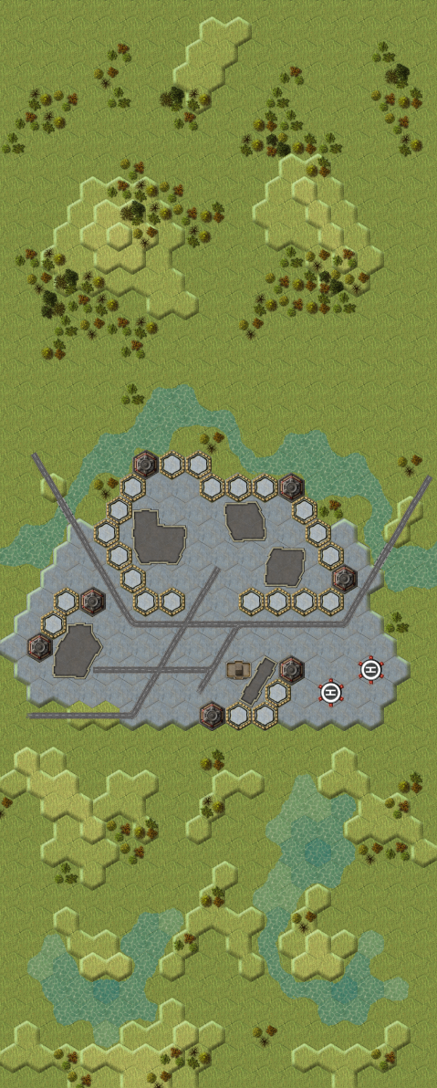

---------------------------- END TRANSMISSION -----------------------------
--------------------------- START TRANSMISSION ----------------------------

INTELLIGENCE HAS PROVIDED SATELLITE IMAGERY OF THE CONVOY ROUTE.

|-- FRIENDLY DEPLOYMENT ZONE --|

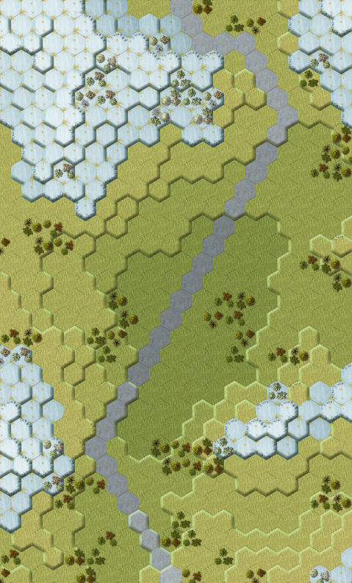

---------------------------- END TRANSMISSION -----------------------------
--------------------------- START TRANSMISSION ----------------------------

INTELLIGENCE HAS PROVIDED SATELLITE IMAGERY OF THE AIRFIELD.

STATIC DEFENSES
|-- FRIENDLY DEPLOYMENT ZONE --|

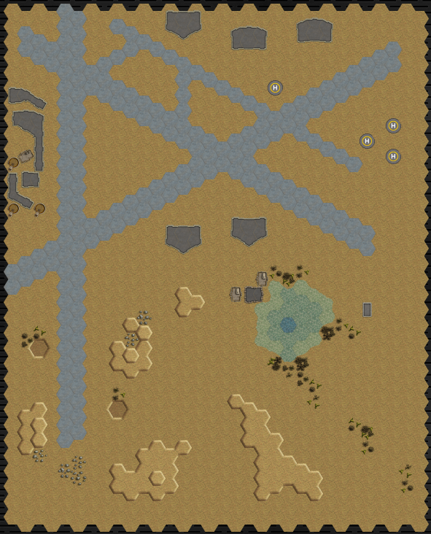
---------------------------- END TRANSMISSION -----------------------------
--------------------------- START TRANSMISSION ----------------------------

INTELLIGENCE HAS PROVIDED SATELLITE IMAGERY OF THE PIRATE BASE.

STATIC DEFENSES SUPPLY WAREHOUSE HEADQUARTERS
|-- FRIENDLY DEPLOYMENT ZONE --|

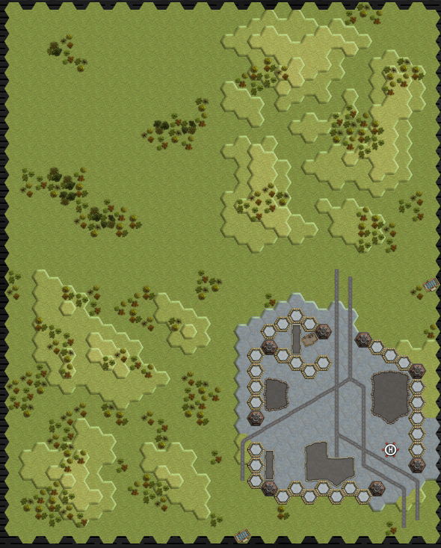

---------------------------- END TRANSMISSION -----------------------------
--------------------------- START TRANSMISSION ----------------------------

MISSION BOUNTIES

THE FOLLOWING BOUNTIES HAVE BEEN ISSUED FOR THIS MISSION.

PAYMENT | ACTIVITY
100,000 | DAMAGE ENEMY UNIT (PER UNIT)
100,000 | CRITICAL OR MOTIVE DAMAGE (PER UNIT)
100,000 | COMPLETE A PHYSICAL ATTACK
100,000 | COMPLETE AN ANTI-MECH ATTACK
100,000 | DAMAGE A UNIT WITH INDIRECT FIRE
100,000 | SKID A UNIT WITHOUT DESTROYING IT
250,000 | KNOCK 'MECH PILOT UNCONSCIOUS
250,000 | REDUCE A COMBAT VEHICLE TO 0 MP
250,000 | KILL ALL BUT 1 TROOP IN AN INFANTRY UNIT
250,000 | HAVE A UNIT SCORE A HIT AT ALL 3 RANGES
250,000 | COMPLETE A CHARGE ATTACK
250,000 | COMPLETE A DEATH FROM ABOVE ATTACK
500,000 | SHOOT DOWN A VTOL WITH A TMM OF 5+
500,000 | SHOOT A 'MECH IN THE HEAD
500,000 | PHYSICAL ATTACK A 'MECH IN THE HEAD
500,000 | CAPTURE A VEHICLE CREW OR 'MECH PILOT

---------------------------- END TRANSMISSION -----------------------------
BATTLETECH: OUTWORLDS WASTES

RESUPPLY - GM Notes

Mission 1
Maps: Grasslands Pack, Lakes, River CommCenter, Woodland
Scoring: 1M for admin building, 0.33M for each supply warehouse

Pirates: Pirates will try to claim buildings until they start losing infantry forces, and then
they will exit the sides of the map.

Mission 2
Maps: Tukayyid Pack, Pozoristu Mountains
Scoring: 0.25M for each convoy vehicle, 1M for reaching far edge

Trucks: Trucks have 10 points of structure.

Pirates: Pirates will use hidden infantry spotters to launch attacks over the hills onto the
trucks on the roadways. The pirates leave once the trucks are destroyed or their
spotters are found.

Mission 3
Maps: Deserts Pack, AeroBase #1, AeroBase #2, Desert Runway, Oasis
Scoring: 0.2M for each defense building, 0.25M for each vehicle airlifted

Trucks: Trucks have 10 points of structure.

Reinforcements: roll 1d6 during each end phase for each group of units not deployed.
Deploy them during the next movement phase if your roll meets the values below.
Airlift VTOLs: 1-2 round 4; 1-4 round 5; 1-6 round 6

Pirates: Pirates will try to rush the trucks as soon as the VTOLs arrive.

Mission 4
Maps: Grasslands Pack, Open Terrain #2, Rolling Hills #2,
Rolling Hills #2, Forward Base
Scoring: 1M for headquarters destroyed, 1M for warehouse captured

Pirates: Pirates will fracture and one group will try to escape once the players approach
the base.

The GM selects the construction factor for all buildings.

BTTLETECH
OUTWORLDS WASTES

