---------------------------- START TRANSMISSION ---------------------------
YOUR FORCE IS ORDERED TO THE RENORSAL SYSTEM TO RECOVER STAR LEAGUE DEFENSE FORCE EQUIPMENT. RENORSAL WAS PART OF THE TRADERS DOMAIN 2730 LAND RUSH FOR RARE METALS. THE SLDF SENT THE 61ST ROYAL JUMP INFANTRY DIVISION TO GARRISON TRADERS DOMAIN TO MONITOR THE RESOURCES. 61 RJID WAS DEPLOYED TO SUPPORT THE SLDF RESPONSE TO THE AMARIS CIVIL WAR. FOLLOWING THE AMARIS CIVIL WAR THE 61 RJID LEFT THE INNER SPHERE AS PART OF OPERATION EXODIUS. LOCAL SCAVENGERS REPORTEDLY ARE WILLING TO SELL INFORMATION ON THE LOCATION OF 61 RIJD HIDDEN SUPPLY CACHES. YOUR FORCE IS ORDERED TO RECOVER AS MUCH SLDF EQUIPMENT AS POSSIBLE.
----------------------------- END TRANSMISSION ----------------------------

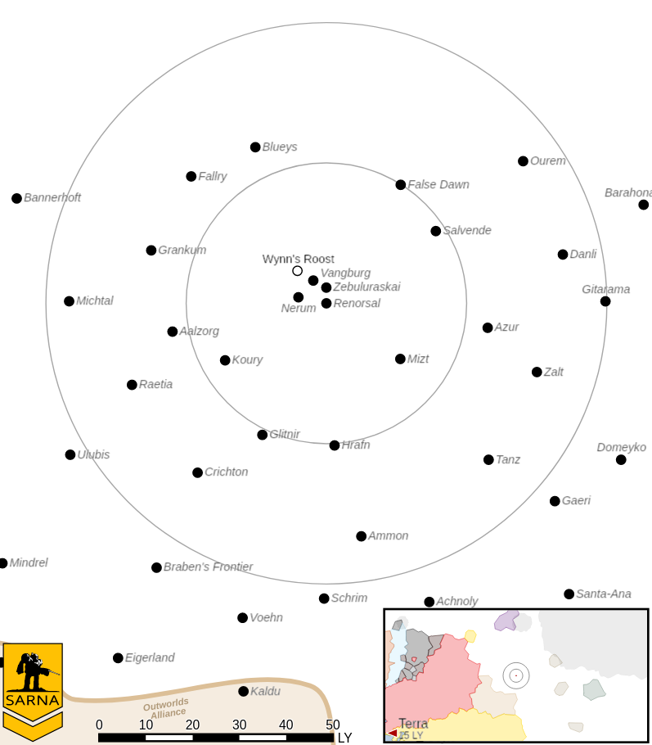
---------------------------- START TRANSMISSION ---------------------------
THE LEADER OF A GROUP OF LOCAL SCAVENGERS ON RENORSAL III IS WILLING TO EXCHANGE INFORMATION ON THE LOCATION OF 61 RJID SUPPLY CACHES FOR EMPLOYMENT AND TRANSPORTATION OFF WORLD. EXTRACTION WILL BE IN THE EQUATORIAL FORESTS. THE FINAL LOCATION WILL BE CONFIRMED BY RADIO TRANSMISSION WHEN YOUR FORCE REACHES THE AREA.
----------------------------- END TRANSMISSION ----------------------------

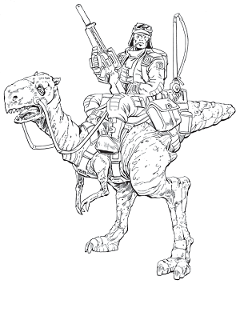

Unit Limits: 6K BV for 1v1, 10K for 2v2.

Map: One mapsheet per player, with flat desert terrain. The attacker selects one hex for extraction, per the rules for the Extraction scenario in Battletech: Total Warfare.

Primary Objective: The attacker’s primary objective is to extract the scavenger leader by having a unit carry them to the attacker's home edge. The defender's primary objective is to steal the scavenger leader by having a unit carry them to the defender's home edge.

Secondary Objective: Cripple or destroy an enemy mech. 3M C-bills per commander on a side if this objective is accomplished.

Base Pay: 1.2M (1v1) or 1.0M (2v2) C-bills per commander if no objectives are completed.
---------------------------- START TRANSMISSION ---------------------------
AN ABANDONED STAR LEAGUE BASE USED BY 61 RJID HAS BEEN LOCATED ON RENORSAL III. THEIR COMPUTERS MAY STILL HAVE INTACT DATA. YOUR BATTLE ARMOR AND INFANTRY UNITS HAVE BEEN EQUIPPED WITH SPECIAL COMM GEAR AND CAN COPY DATA FROM THESE COMPUTERS. RECOVER AS MUCH DATA AS POSSIBLE AND DETER ANY ENEMY FORCES IN THE AREA.
----------------------------- END TRANSMISSION ----------------------------

Unit Limits: 6K BV for 1v1, 9K for 2v2. Max 2 (1v1) or 3 (2v2) BA/infantry units per side.

Map: One mapsheet per player, with flat desert terrain. Place 2 buildings 1/3 the map length from one home edge, 3 buildings along the map center, and 2 buildings 1/3 the map length from the other home edge. These buildings are level 1 light buildings for the purposes of targeting infantry inside of them. Additional ruined buildings and infrastructure are placed as desired for effect.

Primary Objective: 1M C-bills per commander on a side for each building successfully reconed. Each building can only be scored once, with a maximum of 7 buildings to score. BA/infantry roll a 5+ when inside of the building to copy the data. In contested buildings, the higher roll wins. Recon occurs during the Weapon Attack Phase and the unit can make no other attacks during this phase. The unit must survive to the End Phase to score. Buildings are buildings are Light for movement and damage purposes. Buildings cannot be destroyed.

Secondary Objective: Cripple an enemy mech to deter enemy activity. 3M C-bills per commander on a side if this objective is accomplished.

Base Pay: 1.2M (1v1) or 0.9M (2v2) C-bills per commander if no objectives are completed.
---------------------------- START TRANSMISSION ---------------------------
RECOVERED DATA HAS LOCATED A DOWNED DROPSHIP WITH A LANCE OF BATTLEMECHS THAT THE 61 RIJD ABANDONED DURING THE RUSH TO JOIN SLDF FORCES FOR OPERATION CHIEFTAIN. RECOVER AS MANY SLDF BATTLEMECHS AS POSSIBLE.
----------------------------- END TRANSMISSION ----------------------------

Unit Limits: 6K BV for 1v1, 10K for 2v2.

Map: One mapsheet per player, with hilly forested terrain. Place 4 mechs evenly along the diagonal across each pair of two maps from one home edge to the other. 1v1 will have 4 mechs and 2v2 will have 8.

Primary Objective: 1.75M (1v1) or 0.875M (2v2) C-bills per commander on a side for each mech successfully recovered. On the first diagonal, the SLDF battlemechs are 2x Spector SPR-4F and 2x Exterminator EXT-4C. On the second diagonal, the SLDF mechs are 2x Ostscout OTT-7Jb and 2x Phoenix Hawk PXH-1b "Special". The heavier mechs are closest to the center of the map.

Dragging: A SLDF battlemech can be secured by dragging it to your home map edge. A mech of the same or higher weight class can drag a SLDF mech. The dragging mech must end its Movement Phase in the same hex as the SLDF mech and declare that it is dragging the SLDF mech during the End Phase. The dragging mech may not run or jump while dragging a SLDF mech. The dragging mech must have a hand actuator and cannot fire weapons mounted on the arm it is using to drag a SLDF mech. A mech can only drag one SLDF mech at a time. A secured SLDF battlemech can be salvaged to be added to your TOE.

Secondary Objective: Secure two matching SLDF battlemechs. 3M C-bills per commander on a side if this objective is accomplished. The 3M C-bills is only awarded once. For each matching pair, one commander on a side may choose to forgo the 3M C-bills and use the pair to salvage a single SLDF mech at no cost. The other commander may still use the remaining parts to salvage an additional mech at the usual cost.

Base Pay: 1.2M (1v1) or 1.0M (2v2) C-bills per commander if no objectives are completed.

