BATTLETECH: OUTWORLDS WASTES
RENORSAL CASTLE BRIAN

---------------------------- START TRANSMISSION ---------------------------
YOUR FORCE IS ORDERED TO THE RENORSAL SYSTEM TO RECOVER STAR LEAGUE DEFENSE FORCE EQUIPMENT. RENORSAL WAS PART OF THE TRADERS DOMAIN 2730 LAND RUSH FOR RARE METALS. THE SLDF SENT THE 61ST ROYAL JUMP INFANTRY DIVISION TO GARRISON TRADERS DOMAIN TO MONITOR THE RESOURCES. 61 RJID WAS DEPLOYED TO SUPPORT THE SLDF RESPONSE TO THE AMARIS CIVIL WAR. FOLLOWING THE AMARIS CIVIL WAR THE 61 RJID LEFT THE INNER SPHERE AS PART OF OPERATION EXODIUS. LOCAL SCAVENGERS REPORTEDLY ARE WILLING TO SELL INFORMATION ON THE LOCATION OF 61 RIJD HIDDEN SUPPLY CACHES. YOUR FORCE IS ORDERED TO RECOVER AS MUCH SLDF EQUIPMENT AS POSSIBLE.
----------------------------- END TRANSMISSION ----------------------------

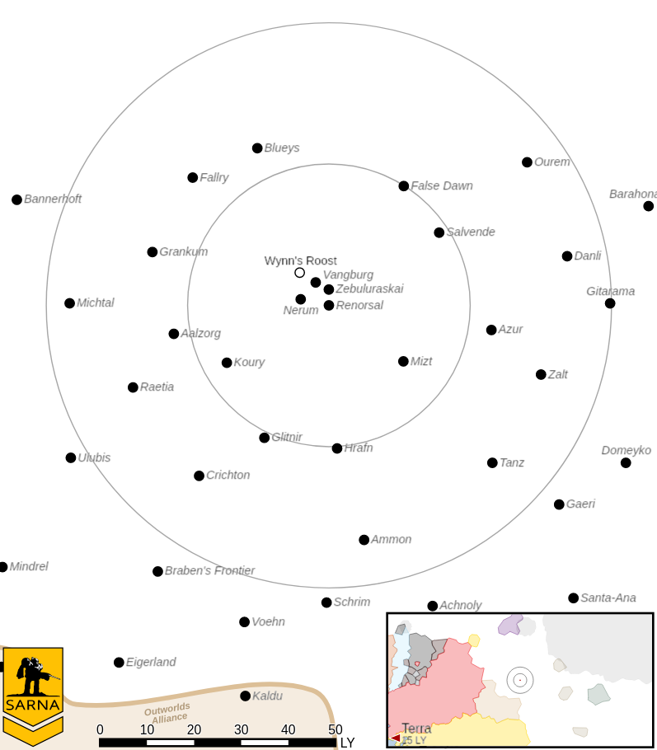
---------------------------- START TRANSMISSION ---------------------------
THE LEADER OF A GROUP OF LOCAL SCAVENGERS ON RENORSAL III IS WILLING TO EXCHANGE INFORMATION ON THE LOCATION OF 61 RJID SUPPLY CACHES FOR EMPLOYMENT AND TRANSPORTATION OFF WORLD. EXTRACTION WILL BE IN THE EQUATORIAL FORESTS. THE FINAL LOCATION WILL BE CONFIRMED BY RADIO TRANSMISSION WHEN YOUR FORCE REACHES THE AREA.
----------------------------- END TRANSMISSION ----------------------------

Unit Limits: 6K BV for 1v1, 10K for 2v2.

Map: One mapsheet per player, with flat desert terrain. The attacker selects one hex for extraction, per the rules for the Extraction scenario in Battletech: Total Warfare.

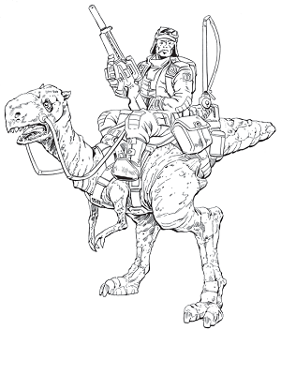

Primary Objective: The attacker’s primary objective is to extract the scavenger leader by having a unit carry them to the attacker's home edge. The defender's primary objective is to steal the scavenger leader by having a unit carry them to the defender's home edge.

Secondary Objective: Cripple or destroy an enemy mech. 3M C-bills per commander on a side if this objective is accomplished.

Base Pay: 1.2M (1v1) or 1.0M (2v2) C-bills per commander if no objectives are completed.
---------------------------- START TRANSMISSION ---------------------------
AN ABANDONED STAR LEAGUE BASE USED BY 61 RJID HAS BEEN LOCATED ON RENORSAL III. THEIR COMPUTERS MAY STILL HAVE INTACT DATA. YOUR BATTLE ARMOR AND INFANTRY UNITS HAVE BEEN EQUIPPED WITH SPECIAL COMM GEAR AND CAN COPY DATA FROM THESE COMPUTERS. RECOVER AS MUCH DATA AS POSSIBLE AND DETER ANY ENEMY FORCES IN THE AREA.
----------------------------- END TRANSMISSION ----------------------------

Unit Limits: 6K BV for 1v1, 9K for 2v2. Max 2 (1v1) or 3 (2v2) BA/infantry units per side.

Map: One mapsheet per player, with flat desert terrain. Place 2 buildings 1/3 the map length from one home edge, 3 buildings along the map center, and 2 buildings 1/3 the map length from the other home edge. These buildings are level 1 light buildings for the purposes of targeting infantry inside of them. Additional ruined buildings and infrastructure are placed as desired for effect.

Primary Objective: 1M C-bills per commander on a side for each building successfully reconed. Each building can only be scored once, with a maximum of 7 buildings to score. BA/infantry roll a 5+ when inside of the building to copy the data. In contested buildings, the higher roll wins. Recon occurs during the Weapon Attack Phase and the unit can make no other attacks during this phase. The unit must survive to the End Phase to score. Buildings are buildings are Light for movement and damage purposes. Buildings cannot be destroyed.

Secondary Objective: Cripple an enemy mech to deter enemy activity. 3M C-bills per commander on a side if this objective is accomplished.

Base Pay: 1.2M (1v1) or 0.9M (2v2) C-bills per commander if no objectives are completed.
---------------------------- START TRANSMISSION ---------------------------
RECOVERED DATA HAS LOCATED A DOWNED DROPSHIP WITH A LANCE OF BATTLEMECHS THAT THE 61 RIJD ABANDONED DURING THE RUSH TO JOIN SLDF FORCES FOR OPERATION CHIEFTAIN. RECOVER AS MANY SLDF BATTLEMECHS AS POSSIBLE.
----------------------------- END TRANSMISSION ----------------------------

Unit Limits: 6K BV for 1v1, 10K for 2v2.

Map: One mapsheet per player, with hilly forested terrain. Place 4 mechs evenly along the diagonal across each pair of two maps from one home edge to the other. 1v1 will have 4 mechs and 2v2 will have 8.

Primary Objective: 1.75M (1v1) or 0.875M (2v2) C-bills per commander on a side for each mech successfully recovered. On the first diagonal, the SLDF mechs are 2x Spector SPR-4F and 2x Exterminator EXT-4C. On the second diagonal, the SLDF mechs are 2x Ostscout OTT-7Jb and 2x Phoenix Hawk PXH-1b "Special". The heavier mechs are closest to the center of the map.

Dragging: Secure a SLDF battlemech by dragging it to your home map edge with a unit of the same or higher weight class. The dragging unit must end the Movement Phase in the same hex as the SLDF mech and make no weapon or physical attacks. A dragging combat vehicle or mech without hand actuators must have a friendly infantry or BA unit in the hex and take an additional turn not moving or attacking to secure the SLDF mech. A dragging mech cannot fire weapons mounted on the arm used to drag a SLDF mech. A dragging unit may not jump or make physical attacks. Reduce the dragging unit’s walking MP by 3 or half, whichever is less.

Secondary Objective: Secure two matching SLDF mechs. 3M C-bills per commander on a side if this objective is accomplished.

Salvage: For each SLDF mech secured, a commander may forgo the primary objective payment to salvage the mech at the usual cost. For each matching pair, a commander may forgo the primary and secondary objective payments to salvage a single mech at no cost. Each commander’s decisions are separate.

Base Pay: 1.2M (1v1) or 1.0M (2v2) C-bills per commander if no objectives are completed.
---------------------------- START TRANSMISSION ---------------------------
BATTLEROM FOOTAGE SHOWS AN UNDERGROUND SLDF BASE NEAR A CAVE SYSTEM ON RENORSAL. SCANS OF THE SURFACE HAVE IDENTIFIED A LIKELY CANDIDATE FOR THE CAVE SYSTEM. SCAN THE CAVE SYSTEM SO WE CAN MATCH THE RECOVERED BATTLEROM FOOTAGE AND LOCATE THE SLDF BASE.
----------------------------- END TRANSMISSION ----------------------------

Unit Limits: 6K BV for 1v1, 10K for 2v2. No VTOL units. Units may mount a searchlight (BattleTech: BattleMech Manual p62).

Map: One mapsheet per player, with underground caves. The Ishiyama maps from MapPack: Solaris VII are ideal for this scenario. Note that the Ishiyama maps are double sized, so one sheet is the approximately same size as two standard mapsheets. Mechs may not use jump movement inside the caves. Pitch Black condition rules apply (BattleTech: Tactical Operations Advanced Rules p56). Each side selects a home edge, as normal. However, units may elect to enter on the two sides adjacent to their home edge, as well as their home edge.



Primary Objective: Scan as many intersections as possible. Each intersection may only be scanned once. During the end phase, any unit in an intersection may attempt to scan the cave system. Any unit attempting to scan the cave system rolls 2d6, subtracting 2 from the result if they made a weapon attack this turn, subtracting 2 from the result if they made a physical attack this turn, adding 2 to the result if the unit is using a searchlight, and adding 3 to the result if the unit has an active probe system. The scan is successful on a 6+. The scanning unit must exit the map on their side’s home edge to score. C-bills are awarded proportionally for the number of intersections scanned.

Secondary Objective: Destroy an enemy unit to recover its scanned data. 3M C-bills per commander on a side if this objective is accomplished.

Base Pay: 1.2M (1v1) or 1.0M (2v2) C-bills per commander if no objectives are completed.

---------------------------- START TRANSMISSION ---------------------------
TECHS HAVE RECOVERED THE LOCATION OF THE SLDF FACILITY. THE CAVES LEADING TO THE FACILITY HAVE COLLAPSED, CREATING A RAVINE YOU MUST TRAVERSE TO REACH THE FACILITY. DEFENSES ARE UNKNOWN, BUT EXPECT RESISTANCE.
----------------------------- END TRANSMISSION ----------------------------

Unit Limits: 6K BV for 1v1, 10K for 2v2.

Map: Three mapsheets, arranged as shown below. Each side selects a home edge on the ends of the perpendicular map. Units may only exit on their home edge or the final edge of the map. The two ravine maps contain command detonated minefields. During the End Phase, roll 1D6 for each hex containing a ground unit. On a 4+, the hex contains a minefield. The mines are density 20 and detonate during the End Phase. The detonation clears that hex of mines. A unit with an active probe may detect mines, out to the range of the probe, on a roll of 10+ at the end of its movement. Mines may be cleared, such as via LRM-20, artillery, or infantry. See BattleTech: Tactical Operations Advanced Rules, p176 for full minefield rules.

Four bunkers are spaced in the ravine as shown below. Mines in the same quadrant as the bunker will not target friendly mechs if you control the bunker. Each bunker has a construction factor of 100. If the bunker is destroyed, the mines in that quadrant cannot be disabled.

Primary Objective: Exit the highest amount of BV in mechs across the final edge of the map. Roll 2D6 on the RAT below per 1K in BV of mechs that cross the final edge. Add +5 if your mech is first across, +4 if your mech is second, ect.

Secondary Objective: Secure a one bunker while traversing an area. 3M C-bills per commander on a side if this objective is accomplished.

Base Pay: 1.2M (1v1) or 1.0M (2v2) C-bills per commander if no objectives are completed.

Result | Unit
2 | Nighthawk PA(L) Mk. XXII
3 | Jump Platoon (Rifle, Ballistic)
4 | Jump Platoon (SRM)
5 | Vector Combat Support VTOL
6 | Thor Artillery Vehicle
7 | Nightshade ECM VTOL (Royal)
8 | Lightning Attack Hovercraft (Royal)
9 | Cyrano Gunship (Royal)
10 | Kanga Medium Hovertank
11 | Zephyr Hovertank (Royal)
12 | Mobile Long Tom Artillery LT-MOB-25
13 | Von Luckner Heavy Tank (Royal)
14 | Panther PNT-9R
15 | Wolverine II WVR-7H
16 | Grasshopper GHR-5H
17 | Atlas II AS7-D-H2

Castle Brian Random Assignment Table

