BATTLETECH
OUTWORLDS WASTES

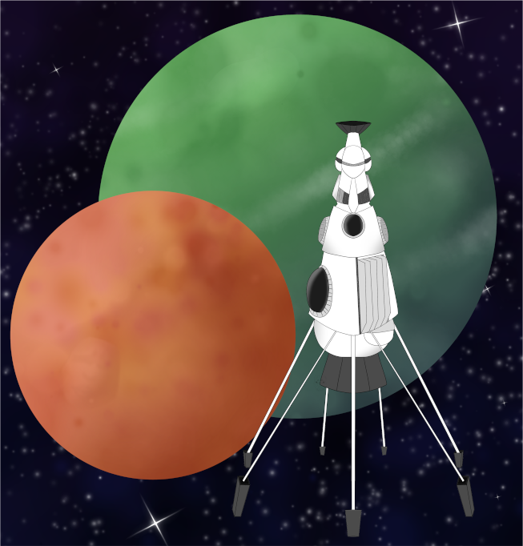

Event Scenario Pack
BATTLETECH: OUTWORLDS WASTES

FOX PATROL ORIGINS

--------------------------- START TRANSMISSION ----------------------------
PLAY THROUGH THE ORIGINS OF THE FOX PATROL! FORM YOUR MERCENARY FORCE AND PROTECT THE CITIZENS OF JERANGLE FROM THE RED STRIPE RAIDERS. FIND AND DESTROY THE RAIDERS BASE TO CEMENT YOUR REPUTATION AS A TRUSTED MERCENARY!
---------------------------- END TRANSMISSION -----------------------------

These are player-vs-GM scenarios for BattleTech: Outworlds Wastes with combined arms and simplified campaign logistics rules.

Each player may bring 2,000 BV of 'Mechs from a single faction in the Dark Age or ilClan eras on the Master Unit List, following the BattleTech: Outworlds Wastes event list building rules. The list should have at least 2 'Mechs, one of which is piloted by your force commander.

After the first scenario, you may add up to 1,500 BV of units to your force. You must have at least one Battle Armor unit and one unit capable of carrying Battle Armor.

Players use BattleTech: Outworlds Wastes Force Maintenance event rules to improve their force between scenarios. Players can improve their force up to 5,000 BV. The enemy force uses the full BattleTech: Outworlds Wastes Force Maintenance rules for repair between scenarios.

The following optional rules are recommended:
- Initiative Deck: Initiative is determined by playing cards.
Each player receives one card; their whole force activates together.
The Movement Phase is resolved from lowest value to highest.
The Attack Phases are resolved from highest value to lowest.
- Fire for Effect: Attack declaration and resolution occur simultaneously.
- High Gravity: Divide default MPs by 1.28 and round to compute the unit’s new MPs.
Add +1 to-hit for all Missile and Direct-Fire Ballistic weapon attacks.

BattleTech Outworlds Wastes:
Web: https://outworlds-wastes.jeremylt.org/event-play
PDF: https://outworlds-wastes.jeremylt.org/downloads?event

BattleTech: Outworlds Wastes is fan-made and based upon the official BattleTech rules from Catalyst Game Labs. BattleTech is a registered trademark of The Topps Company, Inc. in the United States and other countries.

Era: Succession Wars or later

Editor: Jeremy L Thompson
--------------------------- START TRANSMISSION ----------------------------

MISSION BACKGROUND

JERANGLE IS A SMALL, BACKWATER PLANET ON THE FRINGES OF THE LYRAN COMMONWEALTH. THE MAYOR OF GOTHENBURG, REIF BECKER, HAS HIRED YOU TO FIND AND DESTROY THE JERANGLE RAIDERS.

REGION BACKGROUND

JERANGEL WAS PART OF THE APOLLO PROVINCE OF THE RIM WORLDS REPUBLIC, BUT THE LYRAN COMMONWEALTH CLAIMED THE PLANET DURING REPUBLIC-COMMONWEALTH WAR BURING THE AMARIS COUP.

JERANGEL JOINED THE COVENTRY PROVINCE OF THE LYRAN COMMONWEALTH. DESPITE BEING RELATIVELY CLOSE TO THE BORDER OF THE JADE FALCON OCCUPATION ZONE DURING THE DARK AGES, JERANGLE WAS A RELATIVELY QUIET PLANET WITH MINIMAL MILITARY ENGAGEMENT. INFREQUENT PIRATE RAIDS REPRESENT THE BIGGEST THREAT TO CITIZENS ON JERANGLE.

LOCAL AREA STAR MAP

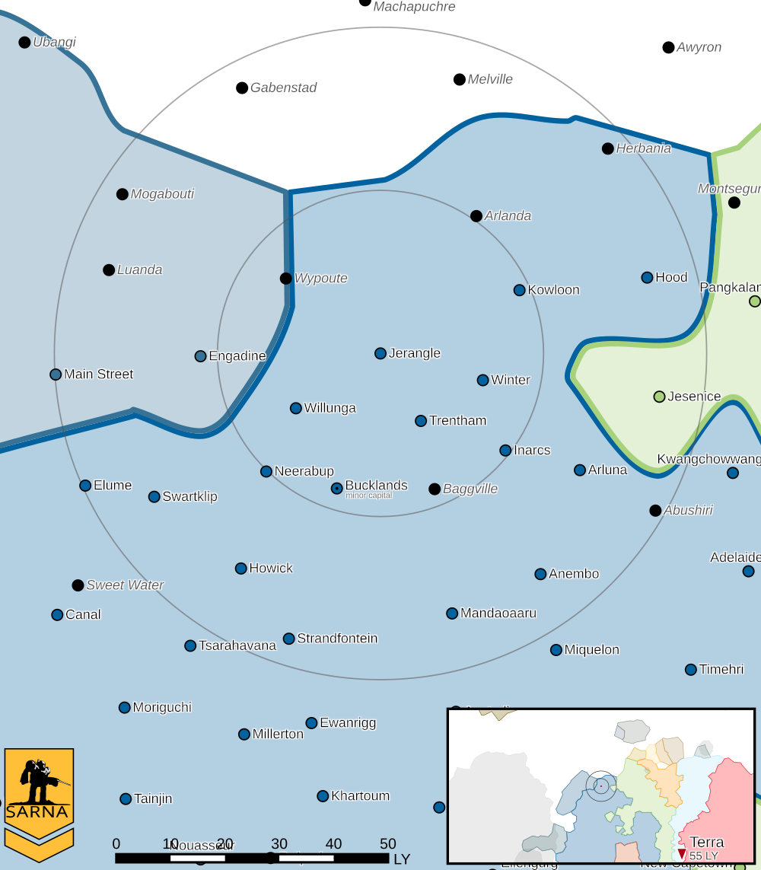

JERANGLE III PLANETARY READOUT

STAR TYPE : G0V (181 HOURS RECHARGE TIME)
POSITION IN SYSTEM : 3 OF 8
NATURAL SATELLITES : 2
TIME TO JUMP POINT : 10.48 DAYS
SURFACE GRAVITY : 1.28 G
DAY LENGTH : 25.0 HOURS
ATMOSPHERIC PRESSURE : STANDARD (BREATHABLE)
EQUATORIAL TEMPERATURE : 38*C
SURFACE WATER : 100 PERCENT
CAPITAL : Burianova Town
POPULATION : 95,540,464
HPG : NONE
SOCIO-INDUSTRIAL LEVELS : D-F-A-D-D
TECHNOLOGICAL SOPHISTICATION : D (LOWER TECH WORLD)
INDUSTRIAL DEVELOPMENT : F (NO INDUSTRIALIZATION)
RAW MATERIAL DEPENDENCE : A (FULLY SELF-SUFFICIENT PRODUCTION)
INDUSTRIAL OUTPUT : D (NEGLIGIBLE INDUSTRIAL OUTPUT)
AGRICULTURAL DEPENDENCE : D (POOR AGRICULTURE)

MISSION 1: FIRST CONTACT

YOU ARE AMBUSHED WHILE PATROLLING IN GOTHENBURG. DRIVE OFF OR DESTROY THE ENEMY FORCES WITHOUT DAMAGING ANY FRIENDLY BUILDINGS.

PRIMARY OBJECTIVES:
DRIVE AWAY ENEMY FORCES
PREVENT DAMAGE TO FRIENDLY BUILDINGS

SECONDARY OBJECTIVES:
DESTROY ENEMY FORCES

OPPOSITION FORCES:
INITIAL RAIDER FORCES CONSISTING OF AT MOST 2 'MECHS

MISSION 2: SEEK AND DESTROY

THE JERANGLE RAIDERS HAVE OFFERED TO DUEL YOUR MERCENARY FORCE OUTSIDE OF THE CITY. MEET AND DESTROY THEIR FORCES TO STOP THEIR THREAT TO THE CITY.

PRIMARY OBJECTIVES:
DESTROY RAIDER FORCES

SECONDARY OBJECTIVES:
PREVENT DAMAGE TO FRIENDLY BUILDINGS

OPPOSITION FORCES:
MULTIPLE ENEMY 'MECHS, INCLUDING A MARAUDER, NIGHT HAWK, AND COMMANDOS

---------------------------- END TRANSMISSION -----------------------------
--------------------------- START TRANSMISSION ----------------------------

INTELLIGENCE HAS PROVIDED SATELLITE IMAGERY OF GOTHENBURG.

|-- FRIENDLY DEPLOYMENT ZONE --|

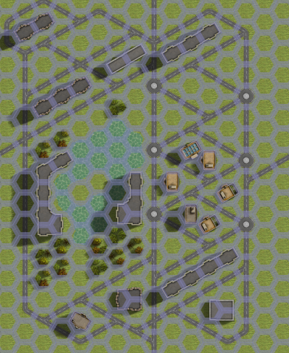

---------------------------- END TRANSMISSION -----------------------------
--------------------------- START TRANSMISSION ----------------------------
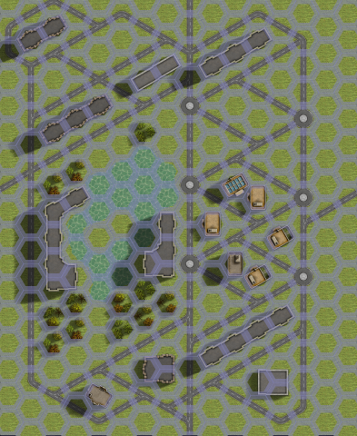
INTELLIGENCE HAS PROVIDED SATELLITE IMAGERY OF THE DUEL SITE.

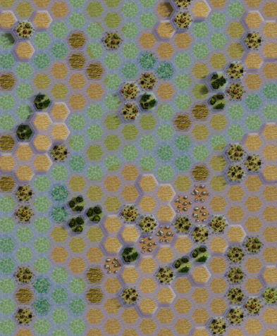
|-- FRIENDLY DEPLOYMENT ZONE --|

---------------------------- END TRANSMISSION -----------------------------
--------------------------- START TRANSMISSION ----------------------------

MISSION BOUNTIES

THE FOLLOWING BOUNTIES HAVE BEEN ISSUED FOR THIS MISSION.

PAYMENT | ACTIVITY
100,000 | DAMAGE ENEMY UNIT (PER UNIT)
100,000 | CRITICAL OR MOTIVE DAMAGE (PER UNIT)
100,000 | COMPLETE A PHYSICAL ATTACK
100,000 | COMPLETE AN ANTI-MECH ATTACK
100,000 | DAMAGE A UNIT WITH INDIRECT FIRE
100,000 | SKID A UNIT WITHOUT DESTROYING IT
250,000 | KNOCK 'MECH PILOT UNCONSCIOUS
250,000 | REDUCE A COMBAT VEHICLE TO 0 MP
250,000 | KILL ALL BUT 1 TROOP IN AN INFANTRY UNIT
250,000 | HAVE A UNIT SCORE A HIT AT ALL 3 RANGES
250,000 | COMPLETE A CHARGE ATTACK
250,000 | COMPLETE A DEATH FROM ABOVE ATTACK
500,000 | SHOOT DOWN A VTOL WITH A TMM OF 5+
500,000 | SHOOT A 'MECH IN THE HEAD
500,000 | PHYSICAL ATTACK A 'MECH IN THE HEAD
500,000 | CAPTURE A VEHICLE CREW OR 'MECH PILOT

---------------------------- END TRANSMISSION -----------------------------
--------------------------- START TRANSMISSION ----------------------------

SAMPLE FORCE

THE FOLLOWING IS A SAMPLE FORCE THAT IS SIMILAR TO THE FOX PATROL:

FIRST MISSION:
KIT FOX F 1,219 BV
LOCUST LCT-5M 719 BV
--------------------------
TOTAL 1,938 BV

SECOND MISSION:
KIT FOX F 1,219 BV
LOCUST LCT-5M 719 BV
QUICKDRAW QKD-5M 1,237 BV
IS STANDARD (LAS) 231 BV
--------------------------
TOTAL 3,406 BV

---------------------------- END TRANSMISSION -----------------------------
BATTLETECH: OUTWORLDS WASTES

FOX PATROL ORIGINS - GM Notes

Mission 1
Maps: Cities Pack, Any Map
Scoring: 0.5M if enemy driven off, 0.5M if enemy destroyed
1M if no buildings are damaged, subtract 0.33 M for each building damaged

Raiders: The raiders will try to damage at least one building but will try to retreat before
being destroyed. Any enemy ‘mechs destroyed in this mission will not be in the second.
Recommend Commando COM-2D and Night Hawk NTK-2Q

Mission 2
Maps: Cities Pack, same as Mission 1, Tukayyid Pack, Racice River Delta
Scoring: 1.5M if enemy destroyed
0.5M if no buildings are damaged, subtract 0.25 M for each building damaged

Raiders: The raiders will deploy two dummy heavy ‘mechs alongside the Marauder. Once
the players realize the other heavy ‘mechs are dummies, the light mechs will attack
from the city map.
Recommend Marauder MAD-3R, Commando COM-2D (2x), Night Hawk NTK-2Q

BATTLETECH
OUTWORLDS WASTES

