BATTLETECH: OUTWORLDS WASTES
SNOW RAVEN RAID

--------------------------- START TRANSMISSION ----------------------------
CARSPHAIRN III PLANETARY GOVERNMENT OFFICIAL ANNOUNCEMENT: CLAN SNOW RAVEN FORCES IDENTIFYING THEMSELVES AS PART OF ILKAHN WARD'S STAR LEAGUE ARE BURNING TOWARDS CARSPAHAIRN III. THE GOVERNOR HAS AUTHORIZED IMMEDIATE AND GENEROUS CONTRACTS FOR ALL MERCENARY FORCES ON PLANET.
---------------------------- END TRANSMISSION -----------------------------

These are player-vs-GM scenarios with combined arms and optional simplified campaign logistics rules.

Each player may bring 3,000 BV of combined arms, following the BattleTech: Outworlds Wastes event list building rules. A link to the rules is below. Players must select a single ilClan era faction on the Master Unit List.

Players attending multiple scenarios may use BattleTech: Outworlds Wastes Force Maintenance event rules to improve their force between scenarios. Players can improve their force up to 5,000 BV. Players may instead choose to use a new 3,000 BV force for each scenario. The enemy force will use the full BattleTech: Outworlds Wastes Force Maintenance rules for repair between scenarios.

The following optional rules will be used:
Initiative Deck: Initiative is determined by playing cards.
Each player receives one card; their whole force activates together.
The Movement Phase is resolved from lowest value to highest.
The Attack Phases are resolved from highest value to lowest.
Fire for Effect: Attack declaration and resolution occur simultaneously.
Multiple Attack Rolls: Make separate attack rolls for each point of
damage. (Alpha Strike only)

Scenarios:
Contested Landing
Militia Resupply
Base Defense

BattleTech: Outworlds Wastes:
Web Format - https://outworlds-wastes.jeremylt.org/event-play
PDF Format - https://raw.githubusercontent.com/Eudicods/outworlds-wastes/rules-pdf/battletech-outworlds-wastes-event.pdf

Colorado BattleTech Discord:
https://discord.gg/dbCSXbJspc
--------------------------- START TRANSMISSION ----------------------------
THE CARSPHAIRN SYSTEM WAS PART OF THE LYRAN COMMONWEALTH AND LATER THE LYRAN ALLIANCE UNTIL 3081 WHEN THE REPUBLIC OF THE SPHERE WAS FORMED. CARSPHAIRN WAS ABANDONED WHEN THE FORTRESS REPUBLIC WAS FORMED, AND BY 3145 CARSPHAIRN HAD REJOINED THE LYRAN COMMONWEALTH.

CLAN WOLF LEAD BY KAHN ALARIC WARD CAPTURED TERRA IN 3151 AND DISSOLVED THE REPUBLIC OF THE SPHERE. ILKAHN WARD REFORMED THE STAR LEAGUE WITH MILITARY FORCES FROM CLAN WOLF, CLAN JADE FALCON, CLAN SMOKE JAGUAR, AND CLAN SNOW RAVEN.

PLANETARY LEADERSHIP ON CARSPHAIRN IS EAGER TO AVOID MORE DISRUPTION AND IS WILLING TO PAY MERCENARY FORCES GENEROUSLY TO REPEL CLAN SNOW RAVEN FORCES OPERATING AS PART OF THE NEW STAR LEAGUE MILITARY.
LOCAL AREA STAR MAP:

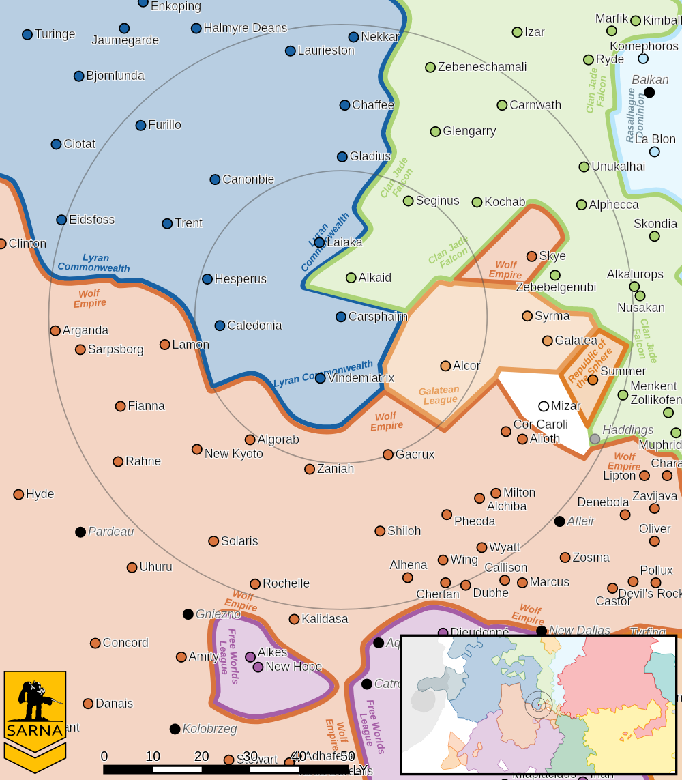

CARSPHAIRN III PLANETARY READOUT:

STAR TYPE : KIV (192 HOURS RECHARGE TIME)
POSITION IN SYSTEM : 3 OF 8
NATURAL SATELLITES : 3
TIME TO JUMP POINT : 5.2 DAYS
SURFACE GRAVITY : 1.13 G
DAY LENGTH : 22.0 HOURS
ATMOSPHERIC PRESSURE : STANDARD (BREATHABLE)
EQUATORIAL TEMPERATURE : 33*C
SURFACE WATER : 77 PERCENT
CAPITAL : NARCISSE
POPULATION : 3,013,000,000
HPG : NONE
SOCIO-INDUSTRIAL LEVELS : B-B-C-B-A
TECHNOLOGICAL SOPHISTICATION : B (ADVANCED WORLD)
INDUSTRIAL DEVELOPMENT : B (MODERATELY INDUSTRIALIZED)
RAW MATERIAL DEPENDENCE : C (LIMITED RAW MATERIAL PRODUCTION)
INDUSTRIAL OUTPUT : B (GOOD INDUSTRIAL OUTPUT)
AGRICULTURAL DEPENDENCE : A (BREADBASKET)

MISSION 1: CONTESTED LANDING

SNOW RAVEN FORCES WILL BE THE MOST VULNERABLE DURING LANDING OPERATIONS. DESTROY AS MANY SNOW RAVEN FORCES AS POSSIBLE, BUT FOCUS ON DESTROYING LANDING PORT INFRASTRUCTURE. IF POSSIBLE, SHOOT DOWN AN ENEMY DROPSHIP.

PRIMARY OBJECTIVES:
DESTROY LANDING PORT INFRASTRUCTURE
SHOOT DOWN ENEMY DROPSHIP

SECONDARY OBJECTIVES:
DESTROY SNOW RAVEN FORCES

ADDITIONAL RULES:
ONLY INFANTRY/BATTLE ARMOR UNITS CAN DESTROY BUILDINGS

OPPOSITION FORCES:
INITIAL SNOW RAVEN FORCES CONSIST OF ONE LIGHT STAR

MISSION 2: MILITIA RESUPPLY

WE HAVE LOCATED AN OLD MILITIA REPAIR FACILITY IN AN ABANDONED MINE. THIS FACILITY IS ESSENTIAL FOR MAINTAINING THE STRENGTH OF OUR MILITIA FORCES. SECURE THE REPAIR FACILITY AND ACTIVATE THE MINEFIELD AROUND THE FACILITY TO PROTECT THIS VALUABLE ASSET.

PRIMARY OBJECTIVES:
SECURE REPAIR FACILITIES
CAPTURE ENEMY COMBATANT

SECONDARY OBJECTIVES:
DESTROY SNOW RAVEN FORCES

ADDITIONAL RULES:
ONLY INFANTRY/BATTLE ARMOR UNITS CAN SECURE THE ENTRANCES

OPPOSITION FORCES:
SNOW RAVEN NOVA CONSISTING OF OMNIMECHS AND BATTLE ARMOR

MISSION 3: BASE DEFENSE

THE SNOW RAVENS HAVE ASSEMBLED A STAR CONSISTING OF ASSAULT OMNIMECHS AND SUPPORTING UNITS. THIS ATTACK WILL BE INTENSE. COORDINATE THE DEFENSE OF THE BASE AND THE USE OF SUPPORT ASSETS SUCH AS AIRSTRIKES AND ARTILLERY STRIKES.

PRIMARY OBJECTIVES:
MINIMIZE DAMAGE TO FRIENDLY BUILDINGS

SECONDARY OBJECTIVES:
DESTROY SNOW RAVEN FORCES

ADDITIONAL RULES:
EACH COMMANDER RECEIVES 10 BSP POINTS

OPPOSITION FORCES:
SNOW RAVEN ASSAULT NOVA CONSISTING OF OMNIMECHS AND BATTLE ARMOR

---------------------------- END TRANSMISSION -----------------------------
--------------------------- START TRANSMISSION ----------------------------

INTELLIGENCE HAS PROVIDED SATELLITE IMAGERY OF THE LANDING PORT.
PORT INFRASTRUCTURE DROPSHIP LANDING PAD
|-- FRIENDLY DEPLOYMENT ZONE --|
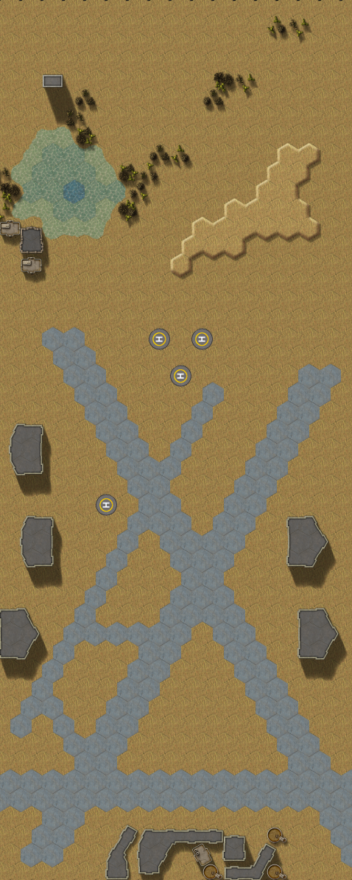
---------------------------- END TRANSMISSION -----------------------------
--------------------------- START TRANSMISSION ----------------------------

INTELLIGENCE HAS PROVIDED SATELLITE IMAGERY OF THE ABANDONED MINE.

MINE ENTRANCE
|-- FRIENDLY DEPLOYMENT ZONE --|

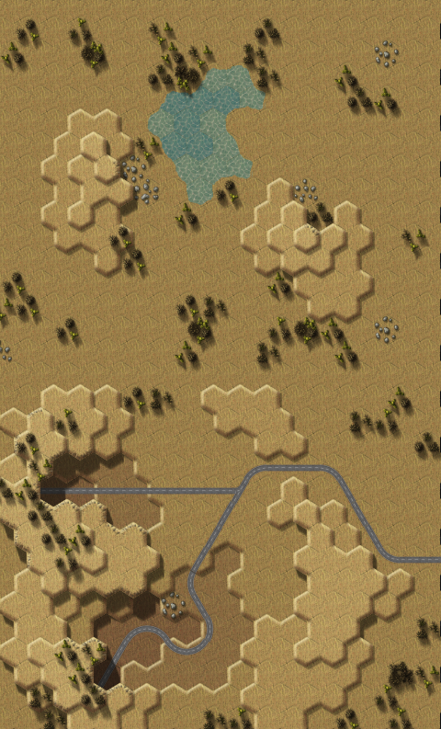

---------------------------- END TRANSMISSION -----------------------------
--------------------------- START TRANSMISSION ----------------------------

INTELLIGENCE HAS PROVIDED SATELLITE IMAGERY OF THE AIRFIELD.

STATIC DEFENSES BASE BUILDINGS HELIPADS
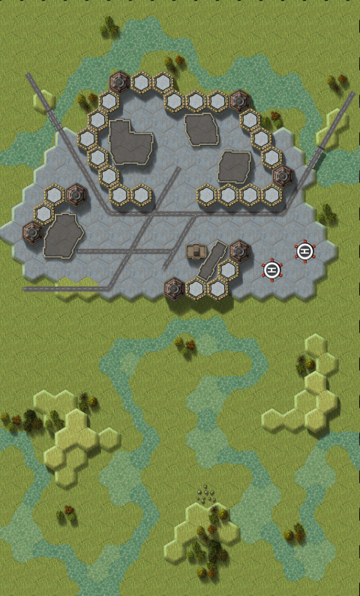
---------------------------- END TRANSMISSION -----------------------------
--------------------------- START TRANSMISSION ----------------------------

THE FOLLOWING BOUNTIES HAVE BEEN ISSUED FOR THIS MISSION.

PAYMENT | ACTIVITY
100,000 | DAMAGE ENEMY UNIT (PER UNIT)
100,000 | DAMAGE ENEMY DROPSHIP (PER DROPSHIP)
100,000 | CRITICAL OR MOTIVE DAMAGE (PER UNIT)
100,000 | COMPLETE A PHYSICAL ATTACK
100,000 | COMPLETE AN ANTI-MECH ATTACK
100,000 | DAMAGE A UNIT WITH INDIRECT FIRE
100,000 | SKID A UNIT WITHOUT DESTROYING IT
250,000 | KNOCK 'MECH PILOT UNCONSCIOUS
250,000 | REDUCE A COMBAT VEHICLE TO 0 MP
250,000 | KILL ALL BUT 1 TROOP IN AN INFANTRY UNIT
250,000 | HAVE A UNIT SCORE A HIT AT ALL 3 RANGES
250,000 | COMPLETE A CHARGE ATTACK
250,000 | COMPLETE A DEATH FROM ABOVE ATTACK
500,000 | SHOOT DOWN A VTOL WITH A TMM OF 5+
500,000 | SHOOT A 'MECH IN THE HEAD
500,000 | PHYSICAL ATTACK A 'MECH IN THE HEAD
500,000 | CAPTURE A VEHICLE CREW OR 'MECH PILOT

---------------------------- END TRANSMISSION -----------------------------
GM Notes

--------------------------- START TRANSMISSION ----------------------------

Mission 1:
Maps: Deserts Pack, AeroBase #1, AeroBase #2, Oasis
Scoring: 0.33M for each infrastructure location, 1M for dropship

Snow Ravens: Mechs start deployed on the airfield and focus first on infantry.

Dropship: The Snow Raven dropship will land on round 4. Players may target the 7 hexes of the dropship landing pad to target the dropship. Damage is tracked independently per hex. Snow Raven dropship will be unable to fire until the round it lands.

Buildings: Infantry may rig a building with explosives. If they detonate the explosives while in the hex, they take the damage from the explosives.

Mission 2:
Maps: Deserts Pack, Mines #1, Mines #2
Scoring: 0.5M for each entrance secured, 1M for capturing unit

Snow Ravens: Snow Ravens will focus on securing the mine entrances with 2 points of Battle Armor and then try to swarm enemy Mechs.

Mission 3:
Maps: Grasslands Pack, River CommCenter, Streams
Scoring: 0.25M for each building surviving, 0.5M for each helipad

Turrets: Each turret is 2 large lasers, with a base gunnery of 5.

BSP: Each defender receives 10 BSP that they can use throughout the game.

Snow Ravens: The primary objective of the Snow Ravens is to destroy buildings and exit.

---------------------------- END TRANSMISSION -----------------------------

