BATTLETECH
OUTWORLDS WASTES

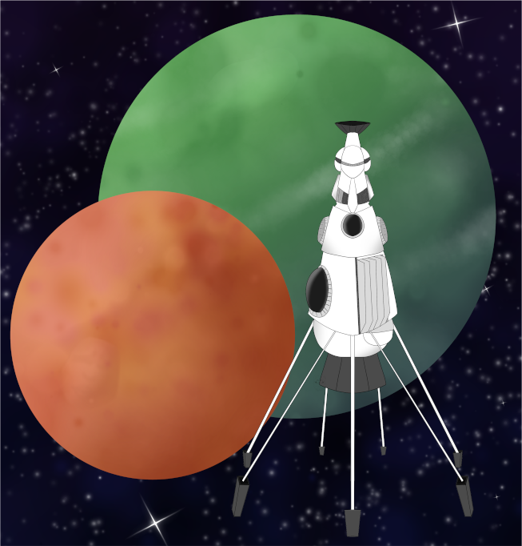

League Scenario Pack
BATTLETECH: OUTWORLDS WASTES

INTERSTELLAR EXPEDITIONS 'CONVOY'

INTERSTELLAR EXPEDITIONS FACTION CONTACT



---------------------------- START TRANSMISSION ---------------------------
CONGRATULATIONS ON YOUR PERFORMANCE IN THE TOURNAMENT! I'M COL BROOKLYN RIVIERA, INTERSTELLAR EXPEDITIONS' MERCENARY COORDINATOR FOR THIS MISSION. DON'T WORRY – I AM NOT JUST A PENCIL PUSHER. MY UNIT, DIE LEIBWACHEREN, PROVIDES INFANTRY SUPPORT TO GUARD DIG SITES AND PROTECT IE PERSONNEL.

I'M LOOKING FOR UNITS THAT CAN HELP ME KEEP THE PEACE IN THIS FLEET. WITH COMPETING BENEFACTORS, THERE WILL BE CONFLICT AND SOME AMMUNITION THROW AROUND, BUT I WANT TO KEEP ALL THE FIGHTING PURELY PLANETSIDE. IF YOU HELP ME KEEP THE FIGHTING AWAY FROM THE JUMPSHIPS AND KEEP ME UP TO DATE ON WHAT IS HAPPENING, I CAN GIVE YOUR FORCE PRIORITY ACCESS TO IE SUPPLIES FOR REPAIR AND REFIT.

JUST LET ME KNOW. IE ISN'T FLUSH, BUT I WILL TRY TO LOOK OUT FOR YOUR FORCE AS BEST I CAN IF YOU HELP ME OUT.
----------------------------- END TRANSMISSION ----------------------------
---------------------------- START TRANSMISSION ---------------------------
YOUR FORCES HAVE KEPT CONFLICTS OUT OF THE FLEET, WHICH WE GREATLY APPRECIATE. I HAVE BEEN AUTHORIZED TO RELEASE SOME OLD COMSTAR GEAR TO YOU AS THANKS FOR YOUR EFFORTS.

CONTINUE TO COLLECT ADDITIONAL INFORMATION AND KEEP THE FIGHTING PLANETSIDE INSTEAD OF IN THE FLEET AND I WILL SEE WHAT I CAN DO ABOUT GETTING YOU ADDITIONAL RESOURCES.
----------------------------- END TRANSMISSION ----------------------------

The following rule changes are available if you have positive reputation with IE.

Game Rule Updates:
- Scanning: Earn 1M C-bills if you scan at least half of the enemy units
in a mission against forces aligned with Faction A or B. To
successfully scan an enemy unit, it must be within range of a
friendly unit with an active probe or adjacent to a friendly
unit without an active probe.

- Special Supplies: The following units are available at cost. They are
considered on your faction list for the purposes of force
management as long as you have positive reputation with IE.

- Raptor (any variant)
- Sprint Scout Helicopter (VTOL) [any variant]

BATTLETECH
OUTWORLDS WASTES

