BATTLETECH
OUTWORLDS WASTES

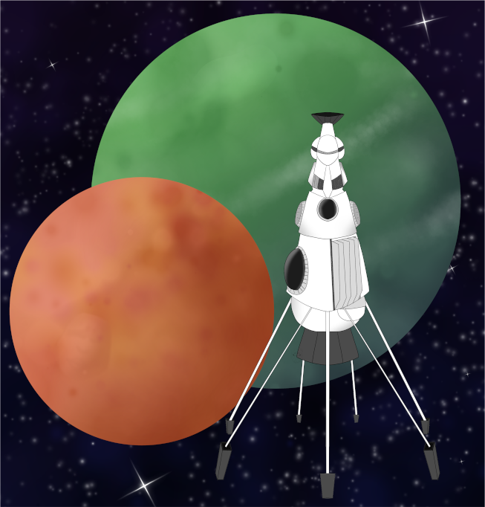

League Scenario Pack
BATTLETECH: OUTWORLDS WASTES

INTERSTELLAR EXPEDITIONS 'CONVOY'

FACTION ALPHA CONTACT



---------------------------- START TRANSMISSION ---------------------------
YOUR FORCES APPEARS TO NOT BE FULLY INEPT. I HOPE THIS IS INDEED TRUE.

YOU MAY REFER TO ME AS DORIAN. I REPRESENT AN ORGANIZATION THAT IS LOOKING FOR COMPETENT FORCES TO EMPLOY. YOUR FORCE MAY BE ADEQUATE.

CONTACT ME IF YOU WISH TO UNDERTAKE EMPLOYMENT. OPERATING COUNTER TO OUR PURPOSES WILL BE DANGEROUS FOR YOUR FORCE.
----------------------------- END TRANSMISSION ----------------------------

BATTLETECH
OUTWORLDS WASTES

