BATTLETECH
OUTWORLDS WASTES

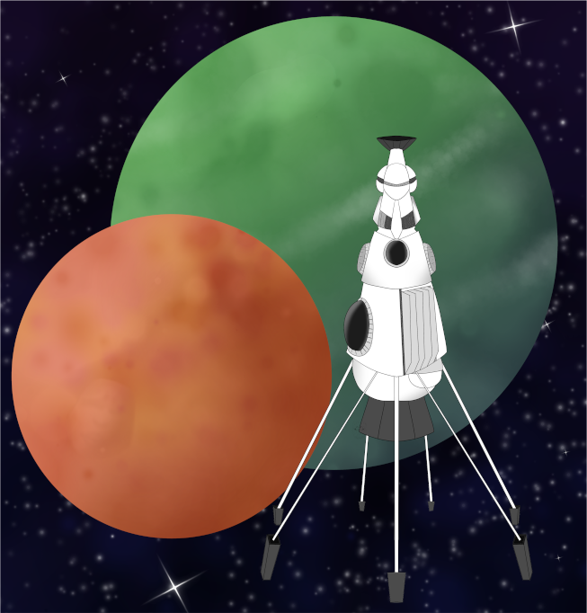

League Scenario Pack
BATTLETECH: OUTWORLDS WASTES

INTERSTELLAR EXPEDITIONS 'CONVOY'

FACTION BRAVO CONTACT

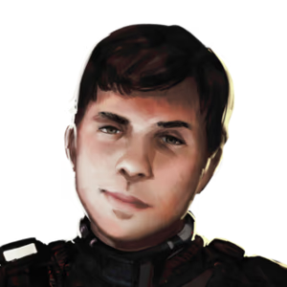

---------------------------- START TRANSMISSION ---------------------------
FANTASTIC WORK OUT THERE! YOUR MATCH WAS INTERESTING TO WATCH IN THE CTF TOURNAMENT. I'M BEATRICE HUARD, BUT EVERYONE CALLS ME TRIX. CONTRACT BROKER EXTRAORDINAIRE AT YOUR SERVICE.

MY BOSS IS LOOKING FOR SOME NEW CONTACTS ON THIS TRIP, BUT I UNFORTUNATELY CANNOT INTRODUCE YOU TO MY BOSS YET. WE'VE GOT SOME WORK WE WANT TO ACCOMPLISH ALONG THE WAY TO WYNN'S ROOST, BUT WE NEED TO BUILD SOME TRUST BEFORE DIVING RIGHT INTO THE HEAVY CONTRACTS. I'VE GOT SOME EASY WORK I CAN OFFER YOU RIGHT NOW IF YOU ARE INTERESTED.

IF YOU WANT THE WORK, REACH OUT. IF THIS PANS OUT, WE MAY BE ABLE TO CONTINUE THIS ARRANGEMENT WHEN WE GET BACK TO THE ALLIANCE.
----------------------------- END TRANSMISSION ----------------------------

BATTLETECH
OUTWORLDS WASTES

