BATTLETECH
OUTWORLDS WASTES

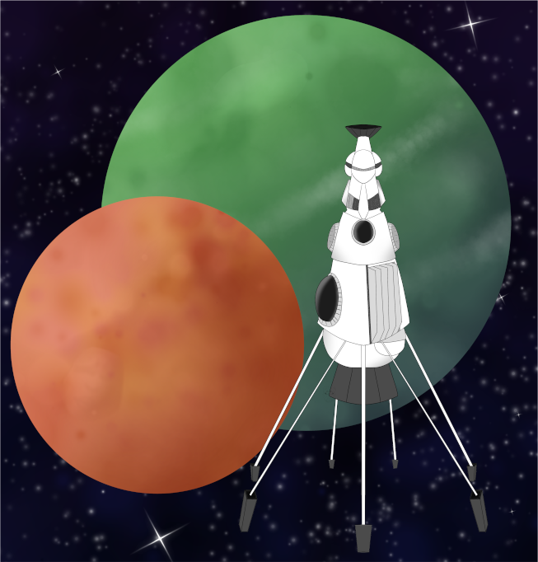

Event Scenario Pack
BATTLETECH: OUTWORLDS WASTES

PRIDE MONTH 2026

--------------------------- START TRANSMISSION ----------------------------
A WORD OF BLAKE SPLINTER GROUP CALLING THEMSELVES 'RED CELL' HAS BEEN PURCHASING SLAVE LABOR FROM MARIAN HEGEMONY MARKETS. THE LOTHIAN LEAGUE HAS ISSUED A BOUNTY ON 'RED CELL' FORCES PURCHASING SLAVES FROM MARIAN HEGEMONY MARKETS, SEEKING TO DETER THIS VIOLENT FACTION FROM GAINING A FOOTHOLD IN THEIR REGION. A TRANSFER IS OCCURRING ON BLANTLEFF.
---------------------------- END TRANSMISSION -----------------------------

These are player-vs-GM scenarios for BattleTech: Outworlds Wastes with combined arms and simplified campaign logistics rules.

Each player may bring 3,000 BV of combined arms from a single faction in the ilClan era on the Master Unit List, following the BattleTech: Outworlds Wastes event list building rules. Each force must have at least 1 'Mech, but it is recommended that each force also has a vehicle with an infantry bay.

The following optional rules are recommended:
- Initiative Deck: Initiative is determined by playing cards.
Each player receives one card; their whole force activates together.
The Movement Phase is resolved from lowest value to highest.
The Attack Phases are resolved from highest value to lowest.
- Fire for Effect: Attack declaration and resolution occur simultaneously.
- Multiple Attack Rolls: Separate attack rolls for each point of damage. (Alpha Strike)

BattleTech Outworlds Wastes:
Web: https://outworlds-wastes.jeremylt.org/event-play
PDF: https://outworlds-wastes.jeremylt.org/downloads?event

BattleTech: Outworlds Wastes is fan-made and based upon the official BattleTech rules from Catalyst Game Labs. BattleTech is a registered trademark of The Topps Company, Inc. in the United States and other countries.

Era: Dark Age or later

Editor: Jeremy L Thompson
--------------------------- START TRANSMISSION ----------------------------

MISSION BACKGROUND

'RED CELL' IS A VIOLENT SPLINTER GROUP FORMED FROM WORD OF BLAKE REMNANTS. THEY MANDATE STRICT ADHERENCE TO THEIR INTERPRETATION OF BLAKEIST IDEOLOGY AND RESTRICT LOCAL POPULATIONS THEY CONTROL.

BLANTLEFF IS A SYSTEM IN THE MARIAN HEGEMONY NEAR THE FREE WORLDS LEAGUE. THE SYSTEM HAS TRADED HANDS BETWEEN THE LOTHIAN LEAGUE, CIRCINUS FEDERATION, AND MARIAN HEGEMONY SEVERAL TIMES OVER ITS HISTORY.

'RED CELL' FORCES HAVE ARRIVED ON PLANET TO TAKE SLAVES FROM LOCAL MARIAN FORCES. YOUR MERCENARY FORCES HAVE ELECTED TO ATTACK THE 'RED CELL' FORCES AS THEY MEET THE MARIAN SLAVERS AND FREE THE SLAVES.

LOCAL AREA STAR MAP

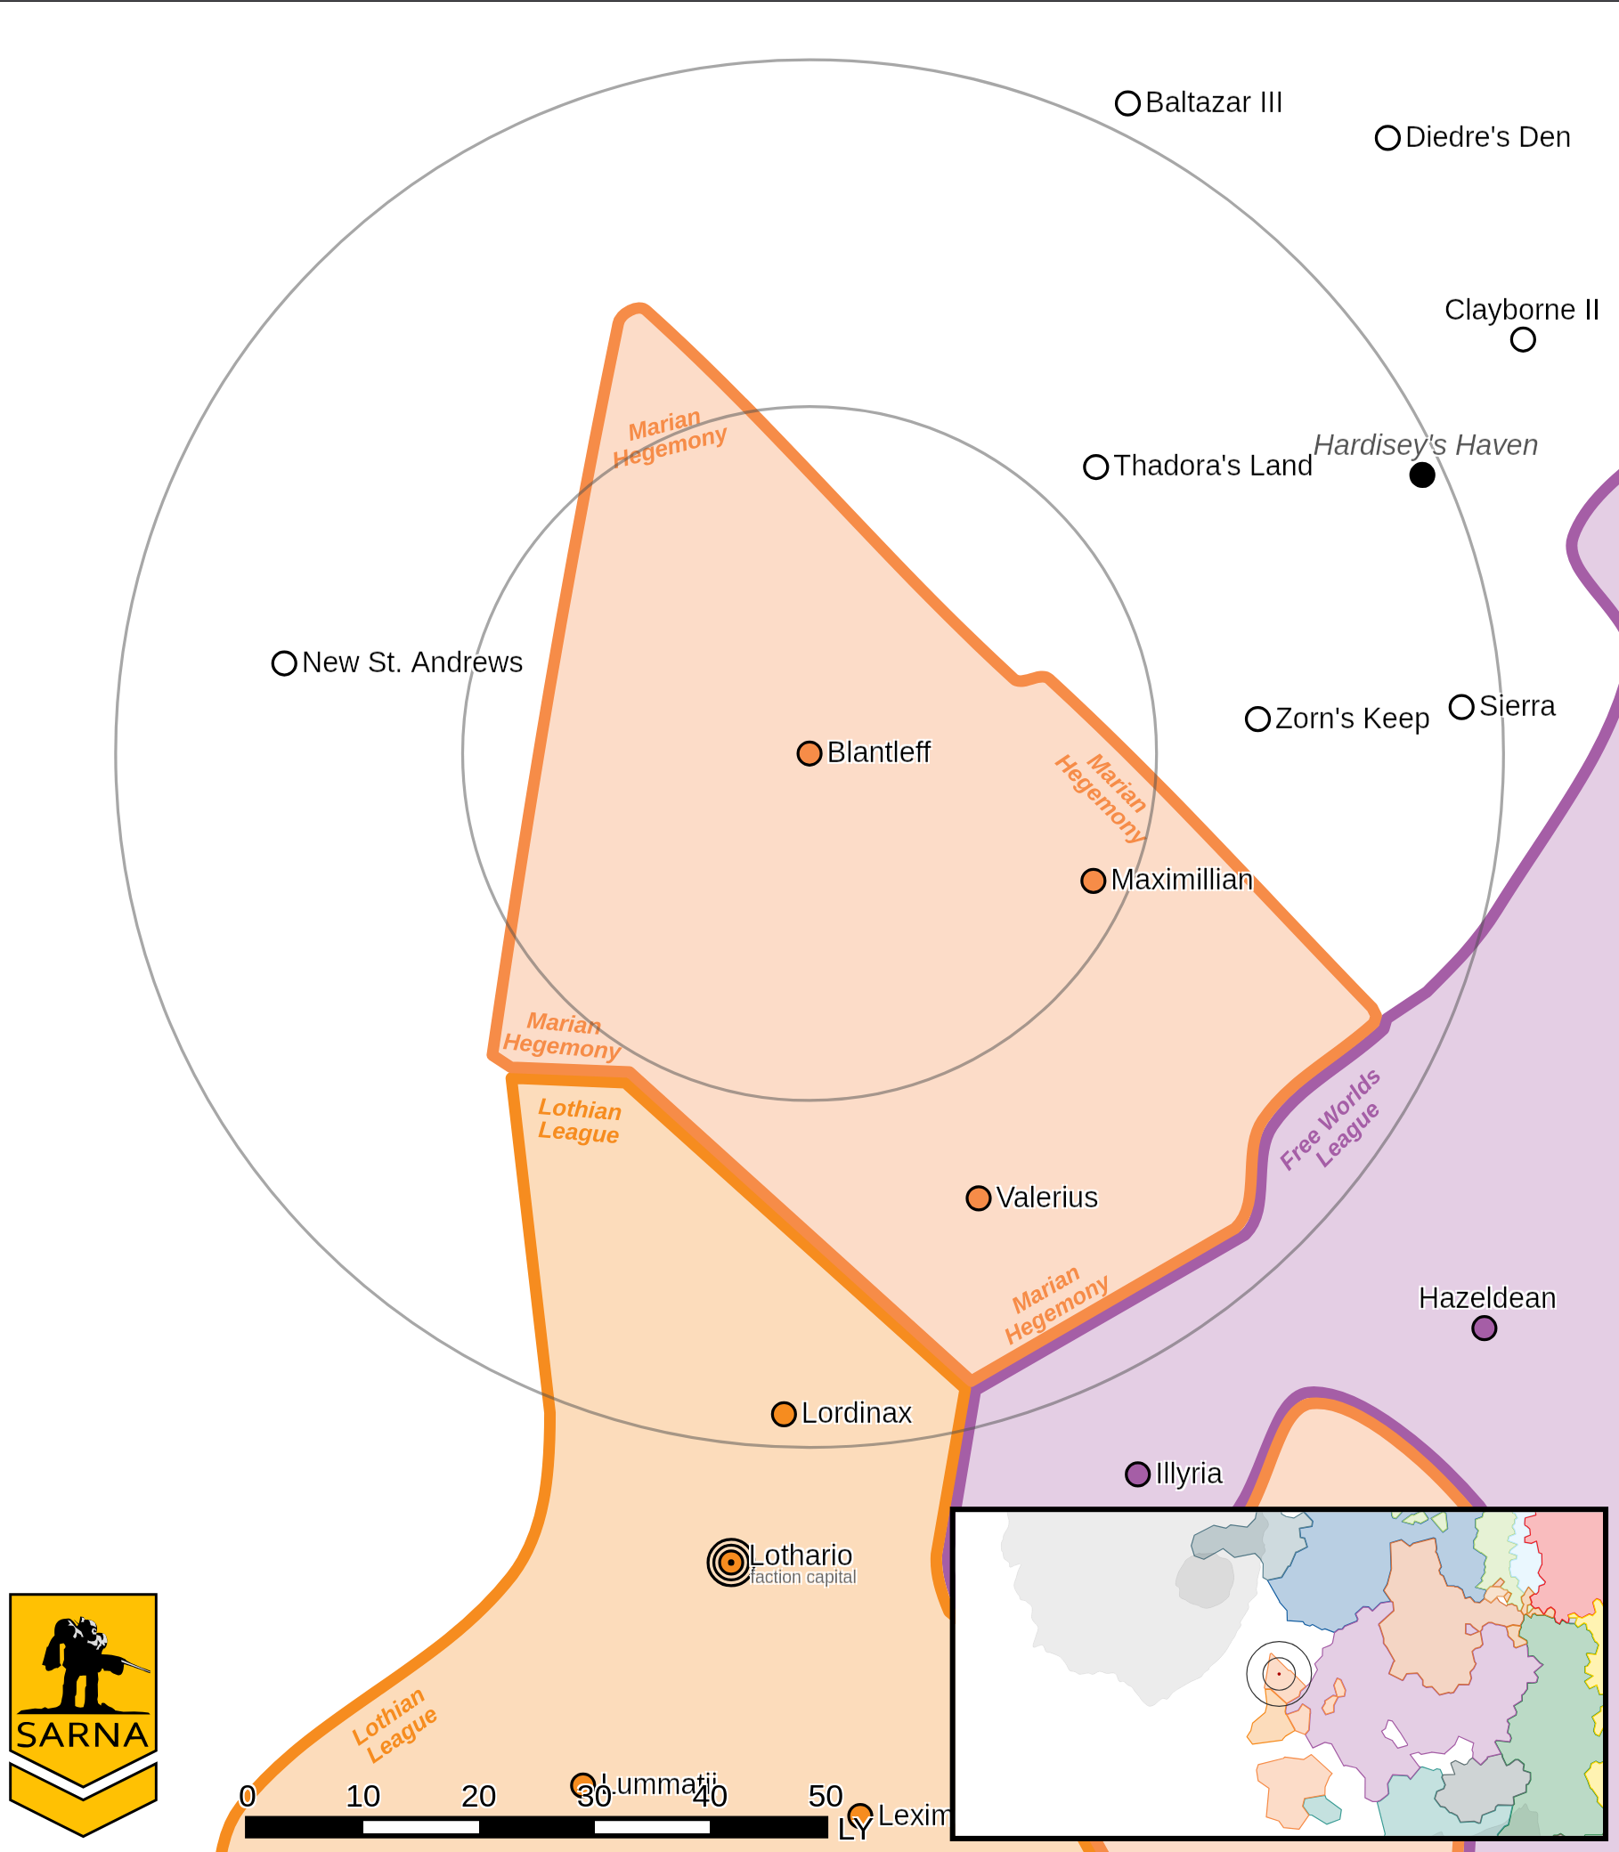

BLANTLEFF I PLANETARY READOUT

STAR TYPE : K9V (200 HOURS RECHARGE TIME)
POSITION IN SYSTEM : 1 OF 11
NATURAL SATELLITES : 0
TIME TO JUMP POINT : 3.32 DAYS
SURFACE GRAVITY : 0.70 G
DAY LENGTH : 19.0 HOURS
ATMOSPHERIC PRESSURE : THIN (BREATHABLE)
EQUATORIAL TEMPERATURE : 29*C
SURFACE WATER : 38 PERCENT
CAPITAL : NEW RED FISH
POPULATION : 26,749,909
HPG : NONE
SOCIO-INDUSTRIAL LEVELS : F-D-C-D-D
TECHNOLOGICAL SOPHISTICATION : F (PRIMITIVE WORLD)
INDUSTRIAL DEVELOPMENT : D (LOW INDUSTRIALIZATION)
RAW MATERIAL DEPENDENCE : C (SELF SUSTAINING)
INDUSTRIAL OUTPUT : D (NEGLIGIBLE INDUSTRY)
AGRICULTURAL DEPENDENCE : D (POOR AGRICULTURE)

----------------------------- END TRANSMISSION ----------------------------

UNCHAINED

---------------------------- START TRANSMISSION ---------------------------
'RED CELL' FORCES ARE MOVING TO COLLECT SLAVES FROM MARIAN FORCES ON BLANTLEFF. INTERCEPT AND DESTROY THE 'RED CELL' FORCES AND FREE THE SLAVES. ANY COLLATERAL DAMAGE TO MARIAN FORCES IS ACCEPTABLE.
----------------------------- END TRANSMISSION ----------------------------

Unit Limits: 3K BV for each player force and a corresponding 1.5K BV each of Red Cell and Marian forces.

Map: One central mapsheet with a large base and 8 adjoining mapsheets with grasslands or forest terrain. Marian forces start inside of the base along with 4 markers for each player indicating the location of slaves. Multiple markers may be placed in the same hex if necessary. All Red Cell forces start on the outer edge of one of the mapsheets immediately adjacent to the center mapsheet (immediately north, south, east, or west, but not the corner mapsheets).

Primary Objective: Destroy all Red Cell units. Earn a portion of 3M C-bills based upon the percentage of Red Cell units destroyed.

Secondary Objectives:
Break chains. Enter any hex (be within 2") containing a marker indicating the location of slaves with a unit equipped with an infantry bay. If the hex is not contested (no enemy units within 2") during the End Phase, then you may load the slaves into the infantry bay of your unit. Remove the marker from the board. If you are in an uncontested hex on the edge of the map (no enemy units within 2") during the End Phase of a subsequent turn, then you may free these slaves by unloading them. A unit may only carry one group of slaves per infantry bay at a time. If the carrying unit is destroyed, then the group perishes. Earn 500,000 C-bills for each group of slaves freed, up to 2M C-bills.
--------------------------- START TRANSMISSION ----------------------------

MISSION BOUNTIES

THE FOLLOWING BOUNTIES HAVE BEEN ISSUED FOR THIS MISSION.

PAYMENT | ACTIVITY
100,000 | DAMAGE ENEMY UNIT (PER UNIT)
100,000 | CRITICAL OR MOTIVE DAMAGE (PER UNIT)
100,000 | COMPLETE A PHYSICAL ATTACK
100,000 | COMPLETE AN ANTI-MECH ATTACK
100,000 | DAMAGE A UNIT WITH INDIRECT FIRE
100,000 | SKID A UNIT WITHOUT DESTROYING IT
100,000 | DESTROY ENEMY UNIT (PER UNIT)
250,000 | KNOCK 'MECH PILOT UNCONSCIOUS
250,000 | REDUCE A COMBAT VEHICLE TO 0 MP
250,000 | KILL ALL BUT 1 TROOP IN AN INFANTRY UNIT
250,000 | HAVE A UNIT SCORE A HIT AT ALL 3 RANGES
250,000 | COMPLETE A CHARGE ATTACK
250,000 | COMPLETE A DEATH FROM ABOVE ATTACK
500,000 | SHOOT DOWN A VTOL WITH A TMM OF 5+
500,000 | SHOOT A 'MECH IN THE HEAD
500,000 | PHYSICAL ATTACK A 'MECH IN THE HEAD
500,000 | CAPTURE A VEHICLE CREW OR 'MECH PILOT

---------------------------- END TRANSMISSION -----------------------------
BATTLETECH: OUTWORLDS WASTES

PRIDE MONTH 2026 - GM Notes

Notes:
GM forces should consist of Word of Blake ‘mechs and vehicles with infantry bays for Red Cell and Marian Hegemony ‘mechs designed for anti-infantry attacks. The Marian Hegemony force should include at least one Centurion.

The mission bounties assume a combined arms force for the defenders, but the bounties
may be adjusted to reflect the personal preferences of the GM and the players.
PesudoTech is a good place to look for additional bounties to add to the scenario.

This scenario is intended to be inclusive of all players. It is important to ensure a friendly
and welcoming environment for this event.

BATTLETECH
OUTWORLDS WASTES

