BATTLETECH
OUTWORLDS WASTES

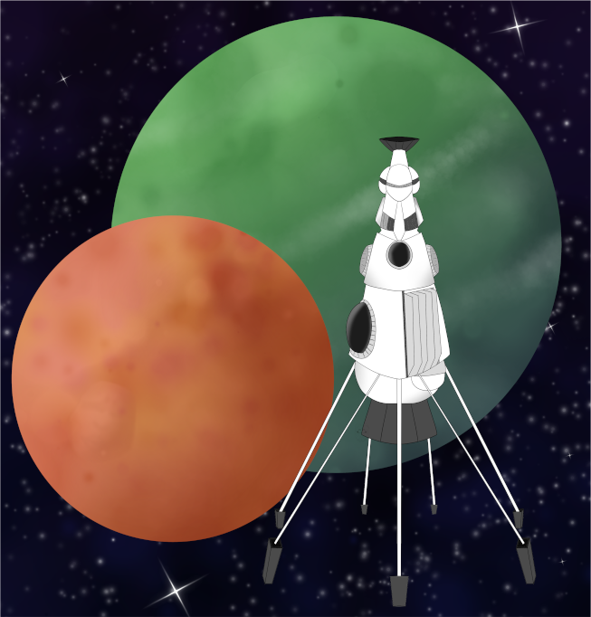

Event Scenario Pack
BATTLETECH: OUTWORLDS WASTES

PRIDE MONTH 2025

--------------------------- START TRANSMISSION ----------------------------
AURIGAN COALITION HAS AN IMMEDIATE JOB FOR ALL AVAILABLE MERCENARY UNITS! A WORD OF BLAKE SPLINTER GROUP CALLING THEMSELVES 'RED CELL' HAS BEEN IMPOSING MARTIAL LAW ON AURIGAN WORLDS. RED CELL FORCES HAVE TAKEN HOSTAGES IN THE ARTRU SYSTEM.
---------------------------- END TRANSMISSION -----------------------------

These are player-vs-GM scenarios for BattleTech: Outworlds Wastes with combined arms and simplified campaign logistics rules.

Each player may bring 3,000 BV of combined arms from a single faction in the ilClan era on the Master Unit List, following the BattleTech: Outworlds Wastes event list building rules. Each force must have at least 1 'Mech, but it is recommended that each force has at least 2 'Mechs.

The following optional rules are recommended:
- Initiative Deck: Initiative is determined by playing cards.
Each player receives one card; their whole force activates together.
The Movement Phase is resolved from lowest value to highest.
The Attack Phases are resolved from highest value to lowest.
- Fire for Effect: Attack declaration and resolution occur simultaneously.
- Multiple Attack Rolls: Separate attack rolls for each point of damage. (Alpha Strike)

BattleTech Outworlds Wastes:
Web: https://outworlds-wastes.jeremylt.org/event-play
PDF: https://outworlds-wastes.jeremylt.org/downloads?event

BattleTech: Outworlds Wastes is fan-made and based upon the official BattleTech rules from Catalyst Game Labs. BattleTech is a registered trademark of The Topps Company, Inc. in the United States and other countries.

Era: Dark Age or later

Editor: Jeremy L Thompson
--------------------------- START TRANSMISSION ----------------------------

MISSION BACKGROUND

'RED CELL' IS A VIOLENT SPLINTER GROUP FORMED FROM WORD OF BLAKE REMNANTS. THEY MANDATE STRICT ADHERENCE TO THEIR INTERPRETATION OF BLAKEIST IDEOLOGY AND RESTRICT LOCAL POPULATIONS THEY CONTROL.

ARTRU IS A SYSTEM IN THE AURIGAN COALITION. THE SLDF FACILITY CASTLE NAUTILUS WAS IMPORTANT IN PROVIDING LOSTECH TO LADY KAMEA ARANO'S FORCES IN HER CAMPAIGN TO RETAKE THE THRONE AFTER HOUSE ESPINOSA LAUNCHED A COUP AND INSTALLED AN AUTOCRATIC DIRECTORATE AS THE NATIONAL LEADERSHIP.

MEMBERS OF SEVERAL MERCENARY FORCES WERE ON PLANET WHEN 'RED CELL' FORCES TOOK OVER THE PLANET AND IMPOSED MARTIAL LAW. MEMBERS OF THE MERCENARY FORCES WERE CELEBRATING TOGETHER AT THE TIME AS PART OF A CELEBRATION HOSTED BY STONEWALL INN, A TRAVELING PLEASURE CIRCUS HOUSED ON A DROPSHIP OF THE SAME NAME. THESE MERCENARY MECHWARRIORS WERE CAPTURED BY 'RED CELL' POLICE FORCES.

LOCAL AREA STAR MAP

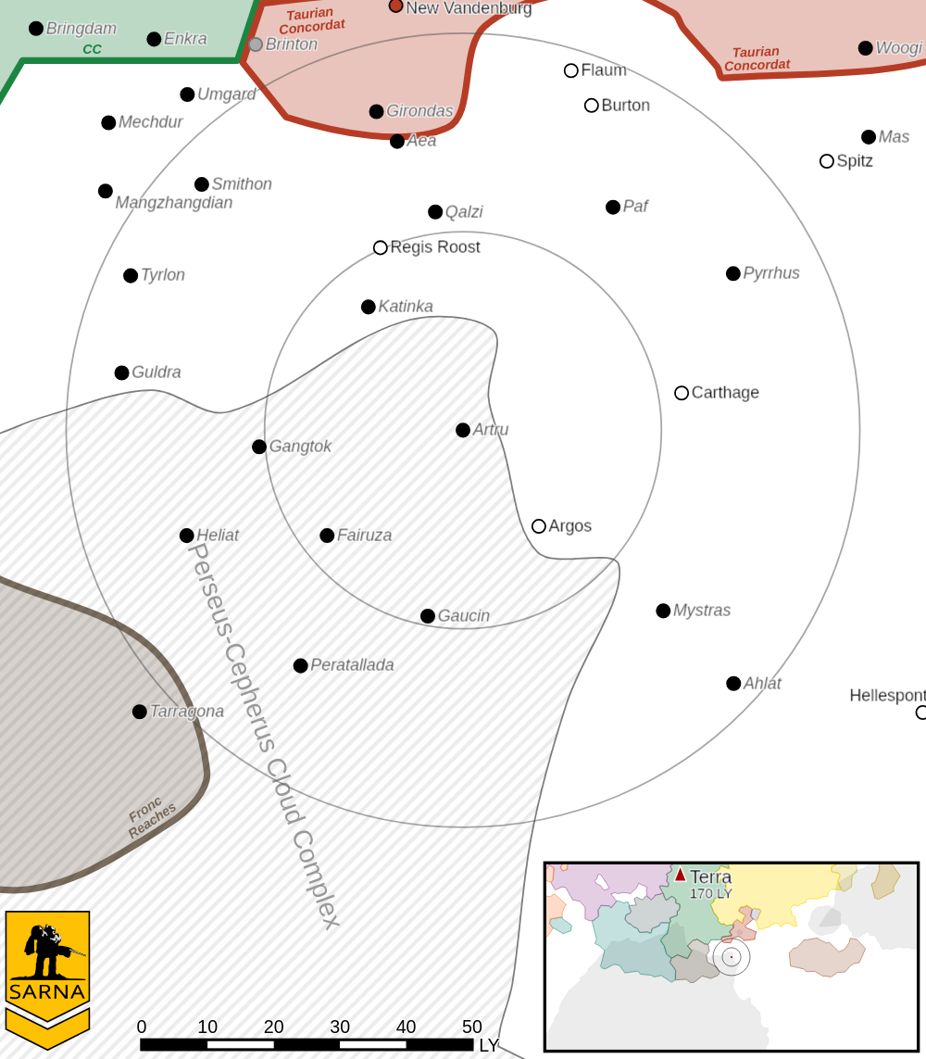

ARTRU III PLANETARY READOUT

STAR TYPE : G6V (187 HOURS RECHARGE TIME)
POSITION IN SYSTEM : 3 OF 10
NATURAL SATELLITES : 0
TIME TO JUMP POINT : 7.05 DAYS
SURFACE GRAVITY : 1.08 G
DAY LENGTH : 24.0 HOURS
ATMOSPHERIC PRESSURE : THIN (BREATHABLE)
EQUATORIAL TEMPERATURE : 20*C
SURFACE WATER : 79 PERCENT
CAPITAL : NEW SAINT-PIERRE
POPULATION : 11,924
HPG : NONE
SOCIO-INDUSTRIAL LEVELS : F-D-B-D-D
TECHNOLOGICAL SOPHISTICATION : F (PRIMITIVE WORLD)
INDUSTRIAL DEVELOPMENT : D (LOW INDUSTRIALIZATION)
RAW MATERIAL DEPENDENCE : B (MOSTLY SELF-SUFFICIENT)
INDUSTRIAL OUTPUT : D (NEGLIGIBLE INDUSTRY)
AGRICULTURAL DEPENDENCE : D (POOR AGRICULTURE)

----------------------------- END TRANSMISSION ----------------------------

LET'S RIOT

---------------------------- START TRANSMISSION ---------------------------
'RED CELL' IS HOLDING MECHWARIOR MERCENARIES HOSTAGE IN A MAKESHIFT BASE NEXT TO THE STONEWALL INN AS THEY PREPARE TO TRANSPORT THE HOSTAGES OFF PLANET. FREE THE CAPTURED MECHWARRIORS. THIS ENEMY MUST BE STOPPED.
----------------------------- END TRANSMISSION ----------------------------

Unit Limits: 3K BV for each player force and a corresponding 3K BV of defending forces. 1 'Mech from each player force starts the scenario inside of the Red Cell base and unable to participate until recovered.

Map: One central mapsheet with a large base and 8 adjoining mapsheets with flat desert terrain. Captured 'Mechs are arrayed inside the base with the Red Cell forces. All other player forces may enter on any outer map edge. The DropShip Stonewall Inn may be placed on the center mapsheet, but it has no significant weapons and can only provide cover or block line of sight.

Primary Objective: Recover all captured 'Mechs. Destroy all enemy forces. Captured 'Mechs may be recovered in the End Phase if a friendly unit is adjacent to them. Infantry units cannot recover captured 'Mechs the turn they deploy from a carrier. Recovered 'Mechs power up immediately and may participate in the next turn. Enemy units are not salvageable. Earn a portion of 3M C-bills based upon the percentage of enemy units destroyed.

Secondary Objectives:
Throw bricks. The area is littered with debris due to the destruction of Castle Nautilus. If a 'Mech with hand actuators has not fired weapons in an arm with a hand actuator during the Weapon Attack Phase, this 'Mech may use debris to make ranged attacks during the Physical Attack Phase. This attack is considered short range at 1 hex (2"), medium range at 2 hexes (4"), and long range at 3 hexes (6"). Earn 500,000 C-bills for each successful attack with a brick, up to 2M C-bills.
--------------------------- START TRANSMISSION ----------------------------

MISSION BOUNTIES

THE FOLLOWING BOUNTIES HAVE BEEN ISSUED FOR THIS MISSION.

PAYMENT | ACTIVITY
100,000 | DAMAGE ENEMY UNIT (PER UNIT)
100,000 | CRITICAL OR MOTIVE DAMAGE (PER UNIT)
100,000 | COMPLETE A PHYSICAL ATTACK
100,000 | COMPLETE AN ANTI-MECH ATTACK
100,000 | DAMAGE A UNIT WITH INDIRECT FIRE
100,000 | SKID A UNIT WITHOUT DESTROYING IT
100,000 | DESTROY ENEMY UNIT (PER UNIT)
250,000 | KNOCK 'MECH PILOT UNCONSCIOUS
250,000 | REDUCE A COMBAT VEHICLE TO 0 MP
250,000 | KILL ALL BUT 1 TROOP IN AN INFANTRY UNIT
250,000 | HAVE A UNIT SCORE A HIT AT ALL 3 RANGES
250,000 | COMPLETE A CHARGE ATTACK
250,000 | COMPLETE A DEATH FROM ABOVE ATTACK
500,000 | SHOOT DOWN A VTOL WITH A TMM OF 5+
500,000 | SHOOT A 'MECH IN THE HEAD
500,000 | PHYSICAL ATTACK A 'MECH IN THE HEAD
500,000 | CAPTURE A VEHICLE CREW OR 'MECH PILOT

---------------------------- END TRANSMISSION -----------------------------
BATTLETECH: OUTWORLDS WASTES

PRIDE MONTH 2025 - GM Notes

Notes:
GM forces consist of a single Atlas and a mix of Urbanmechs and combined arms units to reach BV/PV parity with the players. These forces may be adjusted to prevent an unwieldy swarm of GM units, but the GM force should largely stick to the ‘cop’ theme, as this scenario is designed to reflect the Stonewall riots.

The mission bounties assume a combined arms force for the defenders, but the bounties
may be adjusted to reflect the personal preferences of the GM and the players.
PesudoTech is a good place to look for additional bounties to add to the scenario.

This scenario is intended to be inclusive of all players. It is important to ensure a friendly
and welcoming environment for this event.

BATTLETECH
OUTWORLDS WASTES

