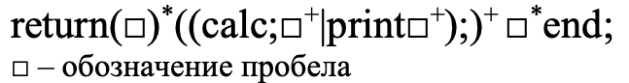Вариант 15, Шумский Евгений Сергеевич

**1.**

1. return ((calc;);) end;
2. return ((calc; print );) end;
3. return () ((calc; );) end;
4. return () ((calc; print );) end;
5. return () ((calc; );) end;
6. return () ((calc; );) end;
7. return () ((calc; print );) end;

**2.** return ((calc;);) end;

|  |  |  |  |  |
| --- | --- | --- | --- | --- |
| a | b | c | d | f |
| return |  | calc | ; | end |

1. a c d b d f d {S1}
2. c d b d f d {S2}
3. d b d f d {S3}
4. b d f d {S4}
5. d f d {S5}
6. f d {S6}
7. d {S6}
8. d {Sf}

Конечный автомат:

M{{S0, S1, S2, S3, S4, S5, S6, S7, S8, S9}, {a, b, c, d, e, f}, δ, S0, Sf}

**3.**



|  |  |  |  |  |  |  |  |
| --- | --- | --- | --- | --- | --- | --- | --- |
|  | a | b | c | d | e | f | λ |
|  | return |  | calc | ; | print | end |  |
| S0 | S1 |  |  |  |  |  |  |
| S1 |  | S1, S2 |  |  |  |  |  |
| S2 |  |  | S3 |  |  |  |  |
| S3 |  |  |  | S4 |  |  |  |
| S4 |  | S4, S5 |  |  | S5 |  |  |
| S5 |  | S5, S6 |  |  |  |  |  |
| S6 |  |  |  | S7 |  |  |  |
| S7 |  | S7, S8 |  |  |  |  |  |
| S8 |  |  |  |  |  | S9 |  |
| S9 |  |  |  | Sf |  |  |  |

λ

f

b

d

b

b

d

c

b

a

b

b

e

b

b