Міністерство освіти і науки України Національний університет «Львівська політехніка»

Кафедра ЕОМ



Звіт

до лабораторної роботи № 3

з дисципліни «Моделювання комп’ютерних систем» на тему:

«Поведінковий опис цифрового автомата Перевірка роботи автомата за допомогою стенда Elbert V2 – Spartan 3A FPGA»

Варіант №19

Виконав: ст. гр. КІ-201

М’якішев Є.М.

Прийняв:

ст. викладач каф. ЕОМ Козак Н. Б.

Львів 2024

**Мета роботи:** На базі стенда реалізувати цифровий автомат для обчислення значення виразів.

**Завдання:**





**Задані числа:**

OP1= 0000 0001(2) = 1(10)

OP2= 0000 0010(2) = 2(10)

**Результат** = 0001 0110 (2) = 20(10)

**Виконання завдання:**

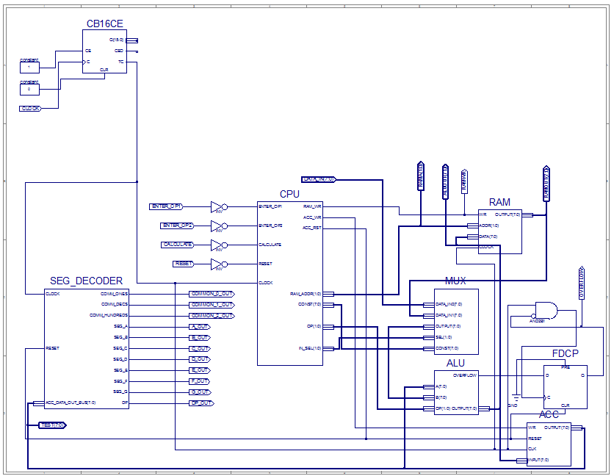

*Рис.1 – Top Level*

**Файл ACC.vhd**

library IEEE;

use IEEE.STD_LOGIC_1164.ALL;

entity ACC is

Port ( WR : in STD_LOGIC;

RESET : in STD_LOGIC;

CLK : in STD_LOGIC;

INPUT : in STD_LOGIC_VECTOR (7 downto 0);

OUTPUT : out STD_LOGIC_VECTOR (7 downto 0));

end ACC;

architecture ACC_arch of ACC is

signal DATA : STD_LOGIC_VECTOR (7 downto 0);

begin

process (CLK)

begin

if rising_edge(CLK) then

if RESET = '1' then

DATA <= (others => '0');

elsif WR = '1' then

DATA <= INPUT;

end if;

end if;

end process;

OUTPUT <= DATA;

end ACC_arch;

**Файл ALU.vhd**

library IEEE;

use IEEE.STD_LOGIC_1164.ALL;

use IEEE.NUMERIC_STD.ALL;

use IEEE.STD_LOGIC_UNSIGNED.ALL;

entity ALU is

Port ( A : in STD_LOGIC_VECTOR(7 downto 0);

B : in STD_LOGIC_VECTOR(7 downto 0);

OP : in STD_LOGIC_VECTOR(1 downto 0);

OUTPUT : out STD_LOGIC_VECTOR(7 downto 0);

OVERFLOW: out STD_LOGIC);

end ALU;

architecture ALU_Behavioral of ALU is

signal ALUR: STD_LOGIC_VECTOR(15 downto 0) := (others => '0');

signal Carry: STD_LOGIC := '0';

begin

process(A, B, OP)

begin

case (OP) is

when "01" => ALUR <= ("00000000" & A) + ("00000000" & B);

when "10" => ALUR <= std_logic_vector(to_unsigned((to_integer(unsigned(("00000000" & A))) * to_integer(unsigned(("00000000" & B)))),16));

when "11" => ALUR <= std_logic_vector(unsigned(("00000000" & A)) sll to_integer(unsigned(B))) and x"00FF";

when others => ALUR <= ("00000000" & B);

end case;

end process;

OUTPUT <= ALUR(7 downto 0);

OVERFLOW <= ALUR(8) OR ALUR(9) OR ALUR(10) OR ALUR(11) OR ALUR(12) OR ALUR(13) OR ALUR(14) OR ALUR(15);

end ALU_Behavioral;

**Файл MUX.vhd**

library IEEE;

use IEEE.STD_LOGIC_1164.ALL;

entity MUX is

PORT(

SEL: in STD_LOGIC_VECTOR(1 downto 0);

CONST: in STD_LOGIC_VECTOR(7 downto 0);

DATA_IN0: in STD_LOGIC_VECTOR(7 downto 0);

DATA_IN1: in STD_LOGIC_VECTOR(7 downto 0);

OUTPUT: out STD_LOGIC_VECTOR(7 downto 0)

);

end MUX;

architecture Behavioral of MUX is

begin

process (SEL, DATA_IN0, DATA_IN1, CONST)

begin

if (SEL = "00") then

OUTPUT <= DATA_IN0;

elsif (SEL = "01") then

OUTPUT <= DATA_IN1;

else

OUTPUT <= CONST;

end if;

end process;

end Behavioral;

**Файл RAM.vhd**

library IEEE;

use IEEE.STD_LOGIC_1164.ALL;

use IEEE.NUMERIC_STD.ALL;

use IEEE.STD_LOGIC_UNSIGNED.ALL;

entity RAM is

port(

WR : IN STD_LOGIC;

ADDR : IN STD_LOGIC_VECTOR(1 DOWNTO 0);

DATA : IN STD_LOGIC_VECTOR(7 DOWNTO 0);

CLOCK: IN STD_LOGIC;

OUTPUT : OUT STD_LOGIC_VECTOR(7 DOWNTO 0)

);

end RAM;

architecture RAM_arch of RAM is

type ram_type is array (3 downto 0) of STD_LOGIC_VECTOR(7 downto 0);

signal UNIT : ram_type;

begin

process(ADDR, CLOCK, UNIT)

begin

if(rising_edge(CLOCK)) then

if (WR = '1') then

UNIT(conv_integer(ADDR)) <= DATA;

end if;

end if;

OUTPUT <= UNIT(conv_integer(ADDR));

end process;

end RAM_arch;

**Файл SEG_DECODER.vhd**

library IEEE;

use IEEE.STD_LOGIC_1164.ALL;

use IEEE.STD_LOGIC_ARITH.ALL;

use IEEE.STD_LOGIC_UNSIGNED.ALL;

entity SEG_DECODER is

port( CLOCK : IN STD_LOGIC;

RESET : IN STD_LOGIC;

ACC_DATA_OUT_BUS : IN STD_LOGIC_VECTOR(7 DOWNTO 0);

COMM_ONES : OUT STD_LOGIC;

COMM_DECS : OUT STD_LOGIC;

COMM_HUNDREDS : OUT STD_LOGIC;

SEG_A : OUT STD_LOGIC;

SEG_B : OUT STD_LOGIC;

SEG_C : OUT STD_LOGIC;

SEG_D : OUT STD_LOGIC;

SEG_E : OUT STD_LOGIC;

SEG_F : OUT STD_LOGIC;

SEG_G : OUT STD_LOGIC;

DP : OUT STD_LOGIC);

end SEG_DECODER;

architecture Behavioral of SEG_DECODER is

signal ONES_BUS : STD_LOGIC_VECTOR(3 downto 0) := "0000";

signal DECS_BUS : STD_LOGIC_VECTOR(3 downto 0) := "0001";

signal HONDREDS_BUS : STD_LOGIC_VECTOR(3 downto 0) := "0000";

begin

BIN_TO_BCD : process (ACC_DATA_OUT_BUS)

variable hex_src : STD_LOGIC_VECTOR(7 downto 0) ;

variable bcd : STD_LOGIC_VECTOR(11 downto 0) ;

begin

bcd := (others => '0') ;

hex_src := ACC_DATA_OUT_BUS;

for i in hex_src'range loop

if bcd(3 downto 0) > "0100" then

bcd(3 downto 0) := bcd(3 downto 0) + "0011" ;

end if ;

if bcd(7 downto 4) > "0100" then

bcd(7 downto 4) := bcd(7 downto 4) + "0011" ;

end if ;

if bcd(11 downto 8) > "0100" then

bcd(11 downto 8) := bcd(11 downto 8) + "0011" ;

end if ;

bcd := bcd(10 downto 0) & hex_src(hex_src'left) ; -- shift bcd + 1 new entry

hex_src := hex_src(hex_src'left - 1 downto hex_src'right) & '0' ; -- shift src + pad with 0

end loop ;

HONDREDS_BUS <= bcd (11 downto 8);

DECS_BUS <= bcd (7 downto 4);

ONES_BUS <= bcd (3 downto 0);

end process BIN_TO_BCD;

INDICATE : process(CLOCK)

type DIGIT_TYPE is (ONES, DECS, HUNDREDS);

variable CUR_DIGIT : DIGIT_TYPE := ONES;

variable DIGIT_VAL : STD_LOGIC_VECTOR(3 downto 0) := "0000";

variable DIGIT_CTRL : STD_LOGIC_VECTOR(6 downto 0) := "0000000";

variable COMMONS_CTRL : STD_LOGIC_VECTOR(2 downto 0) := "000";

begin

if (rising_edge(CLOCK)) then

if(RESET = '0') then

case CUR_DIGIT is

when ONES =>

DIGIT_VAL := ONES_BUS;

CUR_DIGIT := DECS;

COMMONS_CTRL := "001";

when DECS =>

DIGIT_VAL := DECS_BUS;

CUR_DIGIT := HUNDREDS;

COMMONS_CTRL := "010";

when HUNDREDS =>

DIGIT_VAL := HONDREDS_BUS;

CUR_DIGIT := ONES;

COMMONS_CTRL := "100";

when others =>

DIGIT_VAL := ONES_BUS;

CUR_DIGIT := ONES;

COMMONS_CTRL := "000";

end case;

case DIGIT_VAL is --abcdefg

when "0000" => DIGIT_CTRL := "1111110";

when "0001" => DIGIT_CTRL := "0110000";

when "0010" => DIGIT_CTRL := "1101101";

when "0011" => DIGIT_CTRL := "1111001";

when "0100" => DIGIT_CTRL := "0110011";

when "0101" => DIGIT_CTRL := "1011011";

when "0110" => DIGIT_CTRL := "1011111";

when "0111" => DIGIT_CTRL := "1110000";

when "1000" => DIGIT_CTRL := "1111111";

when "1001" => DIGIT_CTRL := "1111011";

when others => DIGIT_CTRL := "0000000";

end case;

else

DIGIT_VAL := ONES_BUS;

CUR_DIGIT := ONES;

COMMONS_CTRL := "000";

end if;

COMM_ONES <= not COMMONS_CTRL(0);

COMM_DECS <= not COMMONS_CTRL(1);

COMM_HUNDREDS <= not COMMONS_CTRL(2);

SEG_A <= not DIGIT_CTRL(6);

SEG_B <= not DIGIT_CTRL(5);

SEG_C <= not DIGIT_CTRL(4);

SEG_D <= not DIGIT_CTRL(3);

SEG_E <= not DIGIT_CTRL(2);

SEG_F <= not DIGIT_CTRL(1);

SEG_G <= not DIGIT_CTRL(0);

DP <= '1';

end if;

end process INDICATE;

end Behavioral;

**Файл CPU.vhd**

library IEEE;

use IEEE.STD_LOGIC_1164.ALL;

entity CPU is

port( ENTER_OP1 : IN STD_LOGIC;

ENTER_OP2 : IN STD_LOGIC;

CALCULATE : IN STD_LOGIC;

RESET : IN STD_LOGIC;

CLOCK : IN STD_LOGIC;

RAM_WR : OUT STD_LOGIC;

RAM_ADDR : OUT STD_LOGIC_VECTOR(1 DOWNTO 0);

CONST : OUT STD_LOGIC_VECTOR(7 DOWNTO 0);

ACC_WR : OUT STD_LOGIC;

ACC_RST : OUT STD_LOGIC;

IN_SEL : OUT STD_LOGIC_VECTOR(1 downto 0);

OP : OUT STD_LOGIC_VECTOR(1 DOWNTO 0));

end CPU;

architecture CPU_arch of CPU is

type STATE_TYPE is (RST, IDLE, LOAD_OP1, LOAD_OP2, RUN_CALC0, RUN_CALC1, RUN_CALC2, RUN_CALC3, RUN_CALC4, FINISH);

signal CUR_STATE : STATE_TYPE;

signal NEXT_STATE : STATE_TYPE;

begin

SYNC_PROC: process (CLOCK)

begin

if (rising_edge(CLOCK)) then

if (RESET = '1') then

CUR_STATE <= RST;

else

CUR_STATE <= NEXT_STATE;

end if;

end if;

end process;

NEXT_STATE_DECODE: process (CLOCK, ENTER_OP1, ENTER_OP2, CALCULATE)

begin

NEXT_STATE <= CUR_STATE;

case(CUR_STATE) is

when RST =>

NEXT_STATE <= IDLE;

when IDLE =>

if (ENTER_OP1 = '1') then

NEXT_STATE <= LOAD_OP1;

elsif (ENTER_OP2 = '1') then

NEXT_STATE <= LOAD_OP2;

elsif (CALCULATE = '1') then

NEXT_STATE <= RUN_CALC0;

else

NEXT_STATE <= IDLE;

end if;

when LOAD_OP1 =>

NEXT_STATE <= IDLE;

when LOAD_OP2 =>

NEXT_STATE <= IDLE;

when RUN_CALC0 =>

NEXT_STATE <= RUN_CALC1;

when RUN_CALC1 =>

NEXT_STATE <= RUN_CALC2;

when RUN_CALC2 =>

NEXT_STATE <= RUN_CALC3;

when RUN_CALC3 =>

NEXT_STATE <= RUN_CALC4;

when RUN_CALC4 =>

NEXT_STATE <= FINISH;

when FINISH =>

NEXT_STATE <= FINISH;

when others =>

NEXT_STATE <= IDLE;

end case;

end process;

OUTPUT_DECODE: process (CUR_STATE)

begin

case (CUR_STATE) is

when RST =>

RAM_WR <= '0';

RAM_ADDR <= "00";

CONST <= "00000000";

ACC_WR <= '0';

ACC_RST <= '1';

IN_SEL <= "00";

OP <= "00";

when LOAD_OP1 =>

RAM_WR <= '1';

RAM_ADDR <= "00";

CONST <= "00000000";

ACC_WR <= '0';

ACC_RST <= '1';

IN_SEL <= "00";

OP <= "00";

when LOAD_OP2 =>

RAM_WR <= '1';

RAM_ADDR <= "01";

CONST <= "00000000";

ACC_WR <= '0';

ACC_RST <= '1';

IN_SEL <= "00";

OP <= "00";

when RUN_CALC0 =>

RAM_WR <= '0';

RAM_ADDR <= "00";

CONST <= "00000000";

ACC_WR <= '1';

ACC_RST <= '0';

IN_SEL <= "01";

OP <= "00";

when RUN_CALC1 =>

RAM_WR <= '0';

RAM_ADDR <= "00";

CONST <= "00000010";

ACC_WR <= '1';

ACC_RST <= '0';

IN_SEL <= "10";

OP <= "11";

when RUN_CALC2 =>

RAM_WR <= '0';

RAM_ADDR <= "01";

CONST <= "00000000";

ACC_WR <= '1';

ACC_RST <= '0';

IN_SEL <= "01";

OP <= "10";

when RUN_CALC3 =>

RAM_WR <= '0';

RAM_ADDR <= "01";

CONST <= "00000000";

ACC_WR <= '1';

ACC_RST <= '0';

IN_SEL <= "01";

OP <= "01";

when RUN_CALC4 =>

RAM_WR <= '0';

RAM_ADDR <= "00";

CONST <= "00001010";

ACC_WR <= '1';

ACC_RST <= '0';

IN_SEL <= "10";

OP <= "01";

when IDLE =>

RAM_WR <= '0';

RAM_ADDR <= "00";

CONST <= "00000000";

ACC_WR <= '0';

ACC_RST <= '0';

IN_SEL <= "00";

OP <= "00";

when others =>

RAM_WR <= '0';

RAM_ADDR <= "00";

CONST <= "00000000";

ACC_WR <= '0';

ACC_RST <= '0';

IN_SEL <= "00";

OP <= "00";

end case;

end process;

end CPU_arch;

**Часові діаграми:**

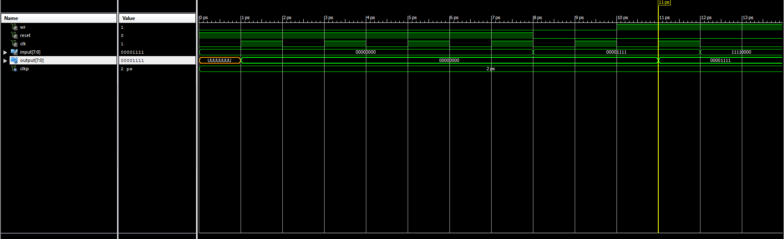

*Рис. 2 – Часова діаграма ACC*

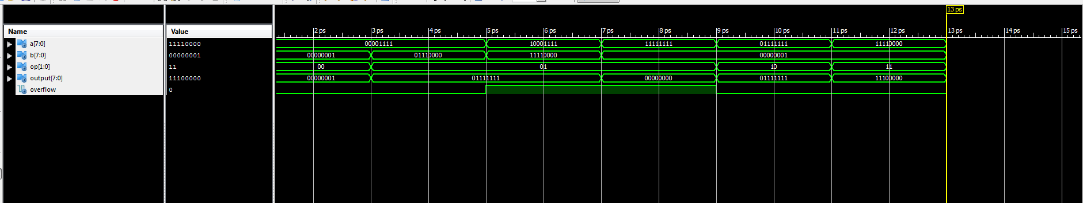

*Рис. 3 – Часова діаграма ALU*

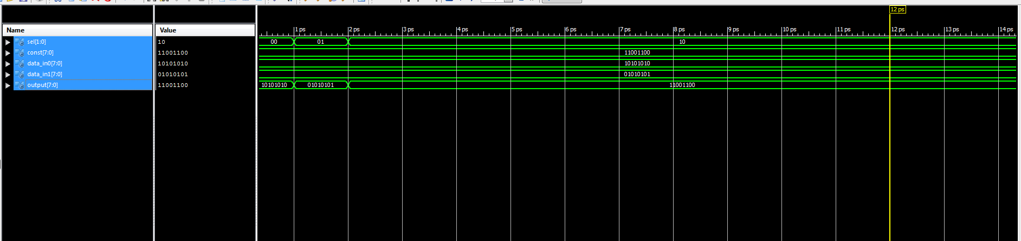

*Рис. 4 – Часова діаграма MUX*

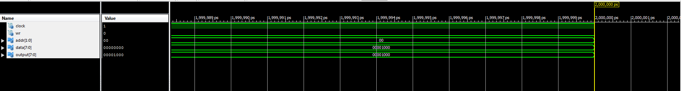

*Рис. 5 – Часова діаграма RAM*

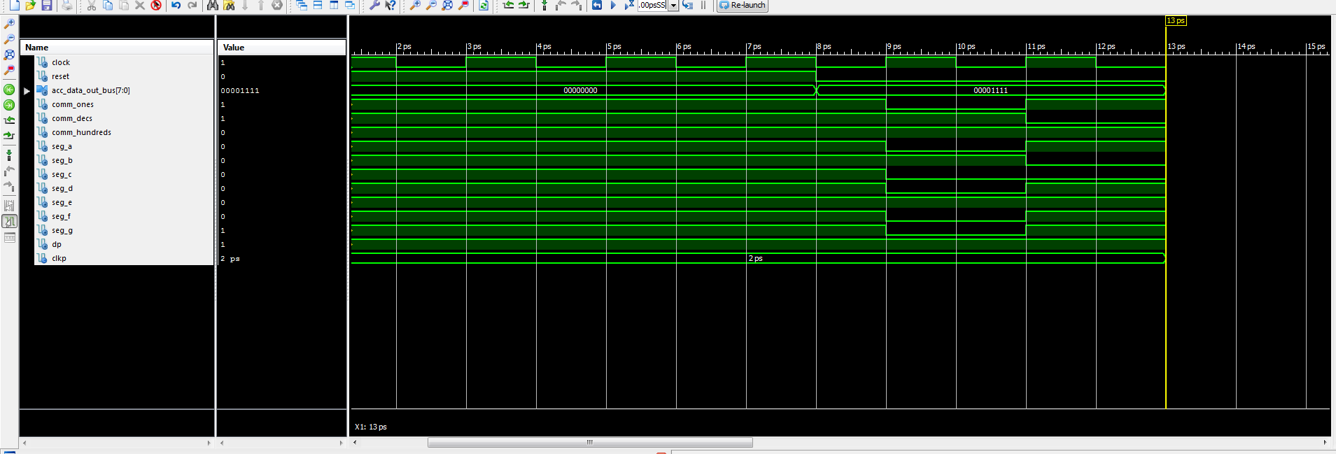

*Рис. 6 – Часова діаграма SEG_DECODER*

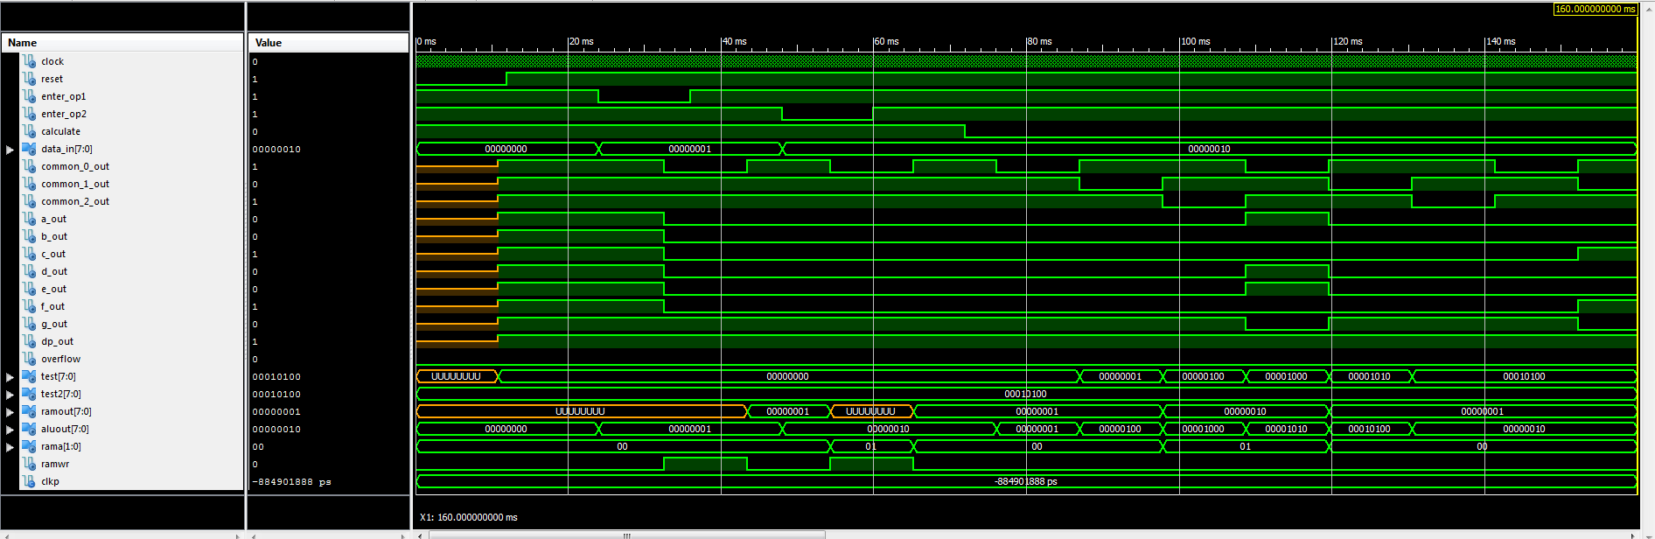

*Рис. 7 – Часова діаграма TopLevel*

**Файл TopLevelTest.vhd**

LIBRARY ieee;

USE ieee.std_logic_1164.ALL;

USE ieee.numeric_std.ALL;

LIBRARY UNISIM;

USE UNISIM.Vcomponents.ALL;

ENTITY TopLevel_TopLevel_sch_tb IS

END TopLevel_TopLevel_sch_tb;

ARCHITECTURE behavioral OF TopLevel_TopLevel_sch_tb IS

COMPONENT TopLevel

PORT( CLOCK : IN STD_LOGIC;

RESET : IN STD_LOGIC;

ENTER_OP1 : IN STD_LOGIC;

ENTER_OP2 : IN STD_LOGIC;

CALCULATE : IN STD_LOGIC;

DATA_IN : IN STD_LOGIC_VECTOR (7 DOWNTO 0);

COMMON_0_OUT : OUT STD_LOGIC;

COMMON_1_OUT : OUT STD_LOGIC;

COMMON_2_OUT : OUT STD_LOGIC;

TEST: OUT STD_LOGIC_VECTOR(7 downto 0);

A_OUT : OUT STD_LOGIC;

B_OUT : OUT STD_LOGIC;

C_OUT : OUT STD_LOGIC;

D_OUT : OUT STD_LOGIC;

E_OUT : OUT STD_LOGIC;

F_OUT : OUT STD_LOGIC;

G_OUT : OUT STD_LOGIC;

DP_OUT : OUT STD_LOGIC;

RAMOUT: OUT STD_LOGIC_VECTOR(7 downto 0);

ALUOUT: OUT STD_LOGIC_VECTOR(7 downto 0);

RAMA: OUT STD_LOGIC_VECTOR(1 downto 0);

RAMWR: OUT STD_LOGIC;

OVERFLOW : OUT STD_LOGIC);

END COMPONENT;

SIGNAL CLOCK : STD_LOGIC := '0';

SIGNAL RESET : STD_LOGIC;

SIGNAL ENTER_OP1 : STD_LOGIC;

SIGNAL ENTER_OP2 : STD_LOGIC;

SIGNAL CALCULATE : STD_LOGIC;

SIGNAL DATA_IN : STD_LOGIC_VECTOR (7 DOWNTO 0);

SIGNAL COMMON_0_OUT : STD_LOGIC;

SIGNAL COMMON_1_OUT : STD_LOGIC;

SIGNAL COMMON_2_OUT : STD_LOGIC;

SIGNAL A_OUT : STD_LOGIC;

SIGNAL B_OUT : STD_LOGIC;

SIGNAL C_OUT : STD_LOGIC;

SIGNAL D_OUT : STD_LOGIC;

SIGNAL E_OUT : STD_LOGIC;

SIGNAL F_OUT : STD_LOGIC;

SIGNAL G_OUT : STD_LOGIC;

SIGNAL DP_OUT : STD_LOGIC;

SIGNAL OVERFLOW : STD_LOGIC;

SIGNAL TEST: STD_LOGIC_VECTOR(7 downto 0);

SIGNAL TEST2: STD_LOGIC_VECTOR(7 downto 0);

signal RAMOUT: STD_LOGIC_VECTOR(7 downto 0);

signal ALUOUT: STD_LOGIC_VECTOR(7 downto 0);

signal RAMA: STD_LOGIC_VECTOR(1 downto 0);

signal RAMWR: STD_LOGIC;

-- constant CLOCK_period : time := 166ns;

constant CLKP: time := 12ms;--24ms;

BEGIN

UUT: TopLevel PORT MAP(

CLOCK => CLOCK,

RESET => RESET,

ENTER_OP1 => ENTER_OP1,

ENTER_OP2 => ENTER_OP2,

CALCULATE => CALCULATE,

DATA_IN => DATA_IN,

COMMON_0_OUT => COMMON_0_OUT,

COMMON_1_OUT => COMMON_1_OUT,

COMMON_2_OUT => COMMON_2_OUT,

A_OUT => A_OUT,

B_OUT => B_OUT,

C_OUT => C_OUT,

D_OUT => D_OUT,

E_OUT => E_OUT,

F_OUT => F_OUT,

G_OUT => G_OUT,

DP_OUT => DP_OUT,

OVERFLOW => OVERFLOW,

TEST => TEST,

RAMOUT => RAMOUT,

ALUOUT => ALUOUT,

RAMA => RAMA,

RAMWR => RAMWR

);

CLOCK_process: process

begin

CLOCK <= '0';

wait for 83ns;

CLOCK <= '1';

wait for 83ns;

end process;

-- *** Test Bench - User Defined Section ***

tb : PROCESS

BEGIN

lp1: for i in 1 to 1 loop

lp2: for j in 2 to 2 loop

TEST2 <= std_logic_vector(to_unsigned(to_integer(to_unsigned(i, 8) sll 2) * j + j + 10, 8));

ENTER_OP1 <= '1';

ENTER_OP2 <= '1';

CALCULATE <= '1';

DATA_IN <= (others => '0');

RESET <= '0';

wait for CLKP;

RESET <= '1';

wait for CLKP;

DATA_IN <= std_logic_vector(to_unsigned(i, 8)); -- A

ENTER_OP1 <= '0';

wait for CLKP;

ENTER_OP1 <= '1';

wait for CLKP;

DATA_IN <= std_logic_vector(to_unsigned(j, 8)); -- B

ENTER_OP2 <= '0';

wait for CLKP;

ENTER_OP2 <= '1';

wait for CLKP;

CALCULATE <= '0'; -- START CALCULATION

wait for CLKP* 7;

assert TEST = TEST2 severity FAILURE;

wait for CLKP;

end loop;

end loop;

WAIT; -- will wait forever

END PROCESS;

-- *** End Test Bench - User Defined Section ***

END;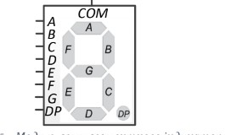

*Рис.8 – 7-сегментний індикатор*

Переглянемо часову діаграму 7seg decoder.

Бачимо, що для вхідного числа 0001 0110 (2) = 20(10)

Ми отримуємо такі значення(якщо значення не вказане, вважаюмо його за одиницю):

COMM_ONES = 0: F, B, C,A,E,D = 0, що відповідає числу 0 COMM_DECS = 0: F,C = 0, що відповідає числу 2 COMM_HUNDREDS = 0: F, B, C,A,E,D = 0, що відповідає числу 0

Отримуємо значення 104, що збігається з даним йому.

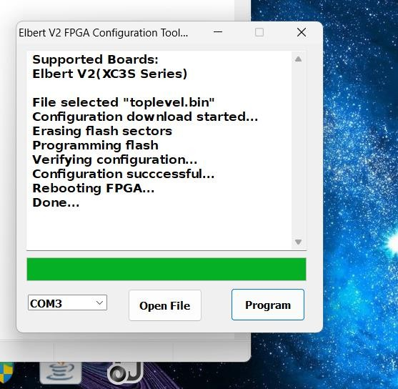

*Рис.9 – Успішна прошивка*

**Висновок:** Виконуючи дану лабораторну роботу я навчився реалізовувати цифровий автомат для обчислення значення виразів використовуючи засоби VHDL.