# How to use the simulation of OpenSVP

**Prepared by:**  
Eugène Desjardins Couture

**Present to:**  
Open SVP users

Date: September 30, 2020

**Disclaimer**

Natural Resources Canada (NRCan) is not responsible for the accuracy or completeness of the information contained in the reproduced material. NRCan shall at all times be indemnified and held harmless against any and all claims whatsoever arising out of negligence or other fault in the use of the information contained in this publication or product.

**Third-Party Materials**

Some of the information contained in this publication or product may be subject to copyrights held by other individuals or organizations. To obtain information concerning copyright ownership and restrictions, contact us by:

E-mail:

Telephone:

Facsimile:

Note: The two texts above are optional and may be added to the mandatory text set forth above. You have the option of either adding both or any one of the two.

**Copyright**

Information contained in this publication or product may be reproduced, in part or in whole, and by any means, for personal or public non-commercial purposes, without charge or further permission, unless otherwise specified.

You are asked to:

* exercise due diligence in ensuring the accuracy of the materials reproduced;
* indicate the complete title of the materials reproduced, and the name of the author organization; and
* indicate that the reproduction is a copy of an official work that is published by Natural Resources Canada (NRCan) and that the reproduction has not been produced in affiliation with, or with the endorsement of, NRCan.

Commercial reproduction and distribution is prohibited except with written permission from NRCan. For more information, contact NRCan at copyright.droitdauteur@nrcan-rncan.gc.ca.

*© Her Majesty the Queen in Right of Canada, as represented by the Minister of Natural Resources Canada, [year of publication].*

Summary

This report shows how to use the simulation mode of OpenSVP which allows the user to do tests on their computer without any other equipment. Moreover, it can be used to validate coding in the script and the library in its random submode. Otherwise, it can be used to help developing criteria validation functions by accessing to previous test results files.

Table of Content

How to use the simulation of OpenSVP 0

Table of Figures 3

Introduction 5

Getting Started 6

Simulation mode Introduction 7

How to use the simulation mode in Random mode 8

How to use the simulation mode in csv-based mode 11

## Table of Figures

Figure 1: Test and EUT parameters editing through edit Test window of Volt-Var test. 8

Figure 2: Other equipment parameters editing through edit Test window of Volt-Var test. 9

Figure 3: DAS Simulation parameters random mode set up through edit Test window of Volt-Var test. 9

Figure 4: OpenSVP directory folder (Results folder indicated in red rectangle) 11

Figure 5: Previous test log file (The original script version in red rectangle). 12

Figure 6: A previous test specific result folder (Log file in red rectangle) 12

Figure 7: Example of a result excel file disposition of the event column (Indication about where to find the event column in red rectangles). 13

Figure 8: Previous test log file (Parameters to enter in the current test editing in red rectangle). 14

Figure 9: Configuration of Test and EUT parameters for csv mode through edit Test window (Important parameters to edit in red rectangle). 15

Figure 10: Configuration of Other equipment parameters for csv mode through edit Test window. 16

Figure 11: Results folder of the current directory (Name of the previous test result in a red rectangle). 17

## Introduction

The purpose of this report is to inform users of OpenSVP on how to use the simulation mode feature.

## Getting Started

To get started, the corresponding files need to be downloaded. Therefore, the simulation mode is included in the most recent version of the [library](https://github.com/sunspec/svp_energy_lab/tree/dev37) and is compatible with the [IEEE 1547.1 std](https://github.com/jayatsandia/svp_1547.1/tree/master3.7) and the [DR-AS-NZS 4777.2 2020 draft std](https://github.com/BuiMCanmet/DR_AS-NZS-Scripts/tree/master). Moreover, if not already downloaded the application part of [OpenSVP](https://github.com/sunspec/svp) needs to be downloaded also.

Next, OpenSVP needs to be set up correctly and some information can be found in the wiki of the SVP Github.

## Simulation mode Introduction

The simulation mode consists of a way to very rudimentary simulate the test bench connected to OpenSVP. Therefore, this simulation mode produces data through simple processes and interacts with OpenSVP as if it was connected to a real test bench. It can be used to test the software coding and to see if the scripts are convenient for the purpose of testing standards. Therefore, it is more of a development tool than an add-on to testing procedures. Moreover, in the simulation mode, there are two submode, the random mode and the csv-based mode. The difference between those two modes is the way the data is produced. In fact, the random mode produces his data via simple random functions. On the other hand, the csv-based mode produces his data via csv files. Therefore, with the csv-based mode, a previous test could be reproduced with his csv result files.

## How to use the simulation mode in Random mode

This mode is pretty straight forward to use, but it needs specific requirements in editing a test.

1. 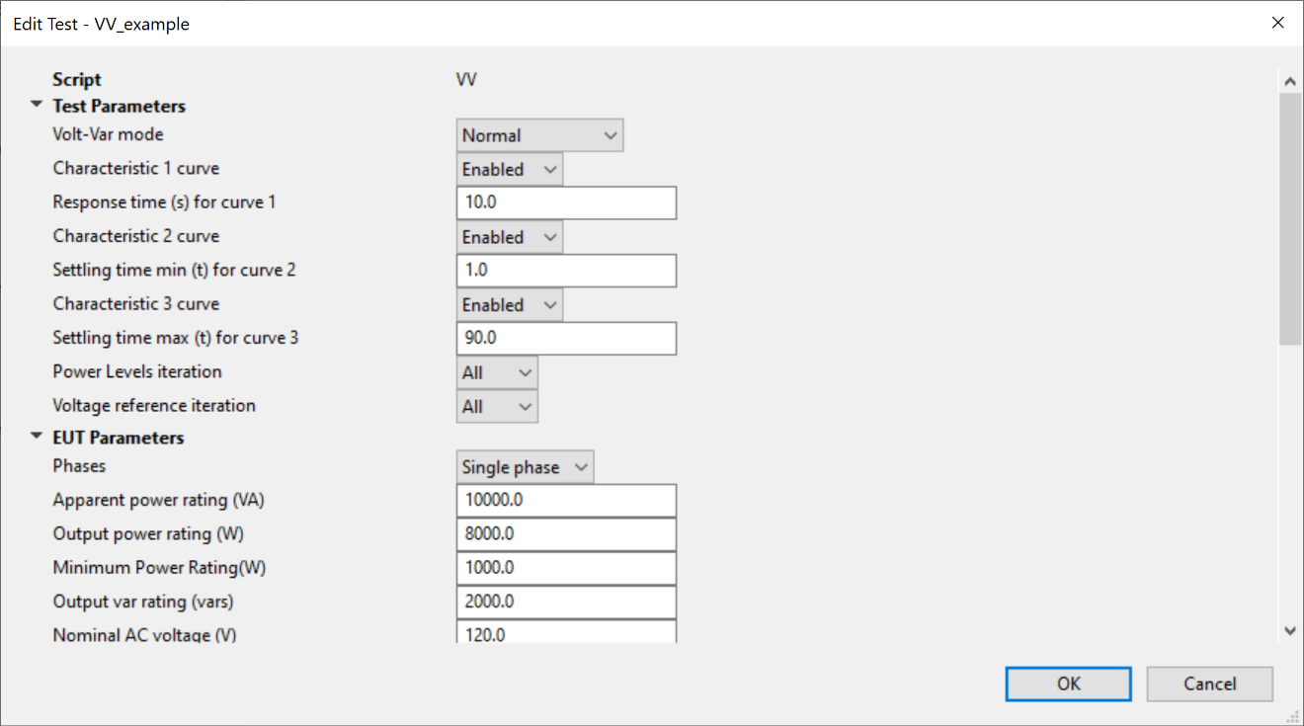Therefore, the first step is to set up the test parameters as wanted:

Figure 1: Test and EUT parameters editing through edit Test window of Volt-Var test.

As it can be seen in the edit Test window of Volt-Var tests above, the Test and EUT parameters can be adjusted as wanted. However, there are important facts to point out. First, the different response time (in the red rectangle) will induce extra unnecessary time. Therefore, it is recommended setting them up at really low value (example: 0.00001). Second, in random mode the number of phases (in the blue rectangle) is important to remember since it is considered in the set up of the mode.

1. The second step is to put all the equipment other than the HIL, which stays disabled, to his respective Simulation mode.

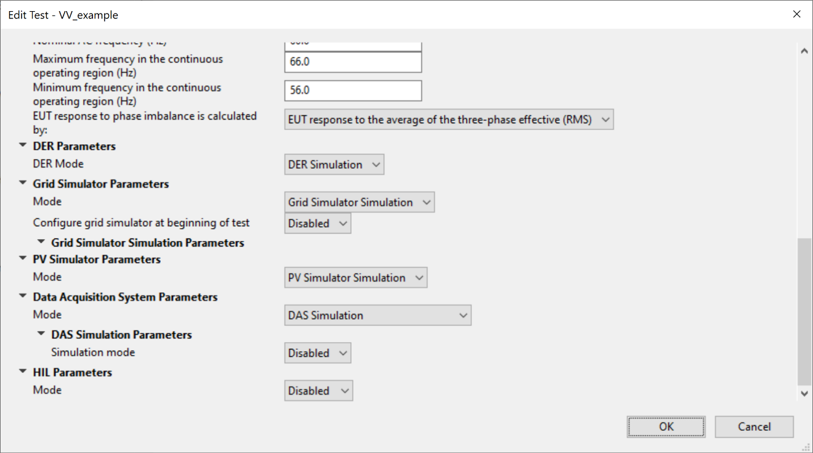

Figure 2: Other equipment parameters editing through edit Test window of Volt-Var test.

1. 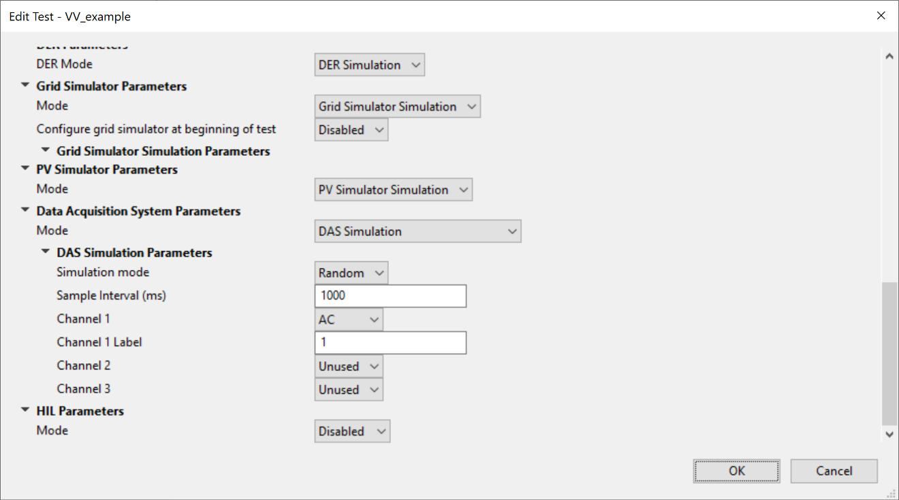Set up the Random mode, by first selecting “Random” under the DAS Simulation Parameters

Figure 3: DAS Simulation parameters random mode set up through edit Test window of Volt-Var test.

1. Then open the number of required channels depending on the number of phases used or if DC measurement needs to be done. To open a channel, just change his state from “Unused” to “AC” or “DC” (Blue rectangle in the figure above).
2. The editing of the test under simulation is finished. The only thing to do now is to click the “OK” button and run the test.

## How to use the simulation mode in csv-based mode

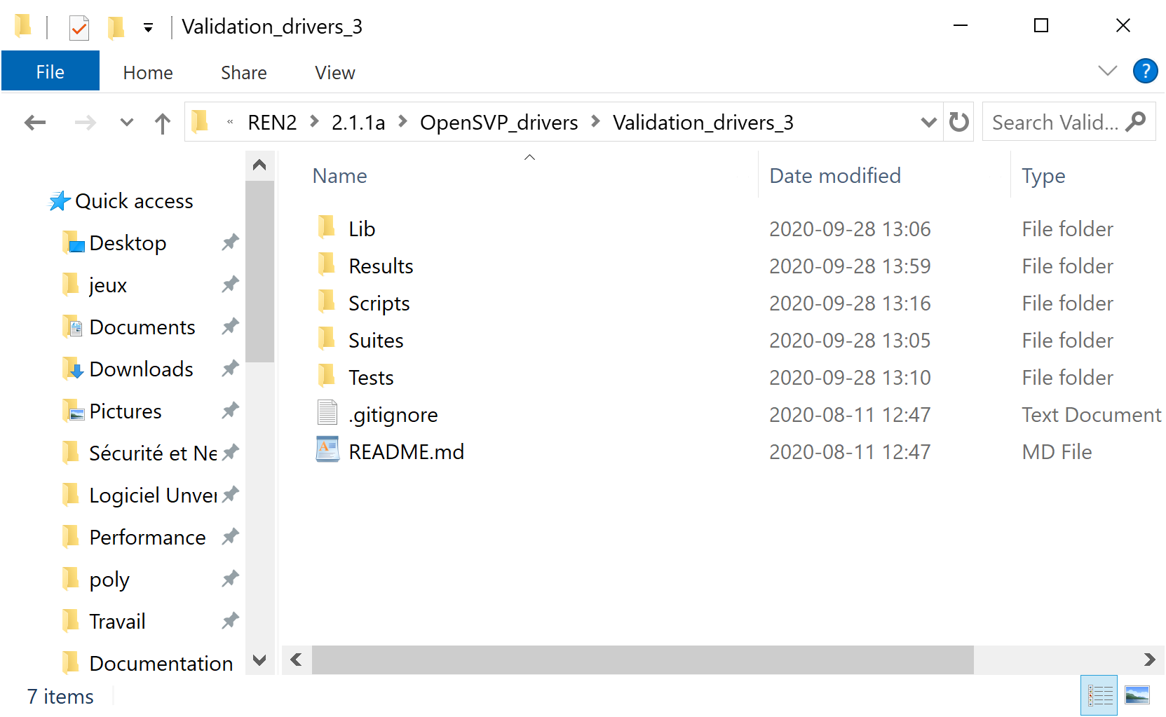This mode is more complex to use than the random mode, since it requires a specific set up to work. Indeed, when basing a test execution on csv files, it is important to make sure that everything can work together. Moreover, the csv files come from previous test results. Then, those result files need to be put into the Results folder of the current directory used for doing the tests (see Figure below).

Figure 4: OpenSVP directory folder (Results folder indicated in red rectangle).

1. The first thing to do is to make sure that the script logic is conformed to the result csv files. To do so, there are multiple options:
   1. 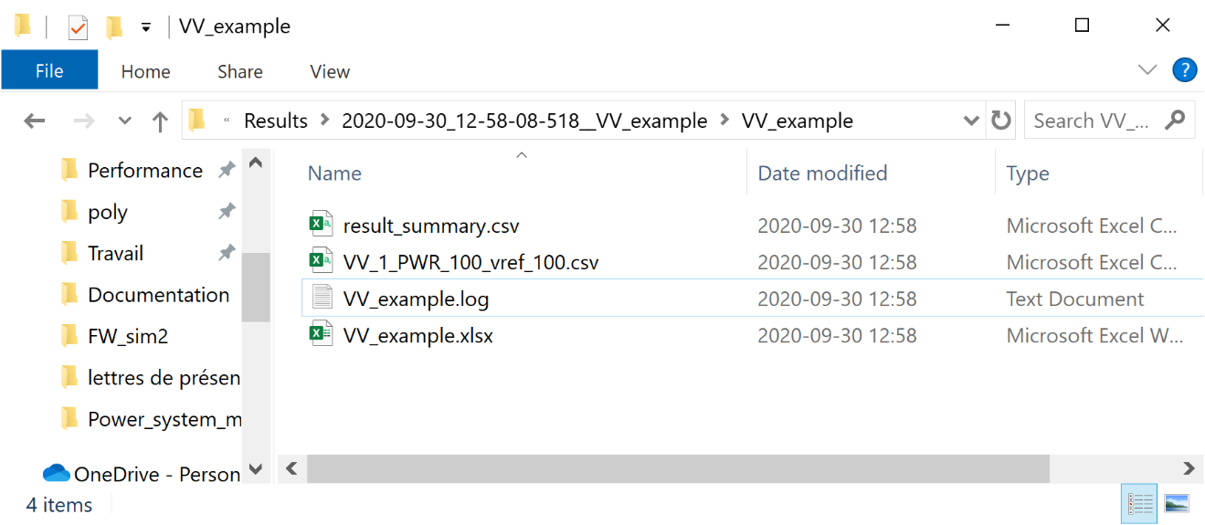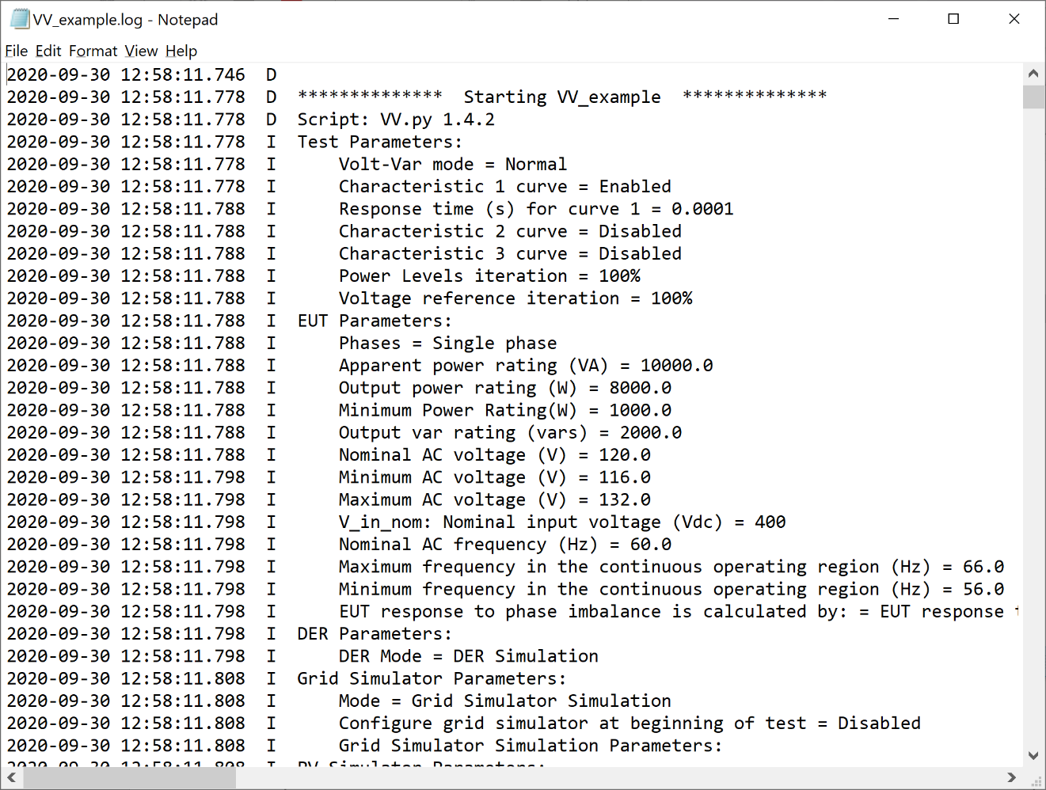Search for the used script version into his python code (look for the appropriate script used under the Scripts folder in the Figure above). Then, look into the test result log file to replicate, which is in the test result folder. Then, if the script version is the same as the one in script, the script used is supposed to be compatible with the result files. (See two Figures below)

Figure 5: Previous test log file (The original script version in red rectangle).

Figure 6: A previous test specific result folder (Log file in red rectangle)

* 1. Make sure that the event pattern in the csv file follows the same pattern as the script used.
     1. If not already done, run a test with the script in the current configuration. The simulation random mode can be useful for that.
     2. Compare the event column from comparable result csv files. (The xlsx file contains all the csv file and it is easier to parse through it.)
     3. 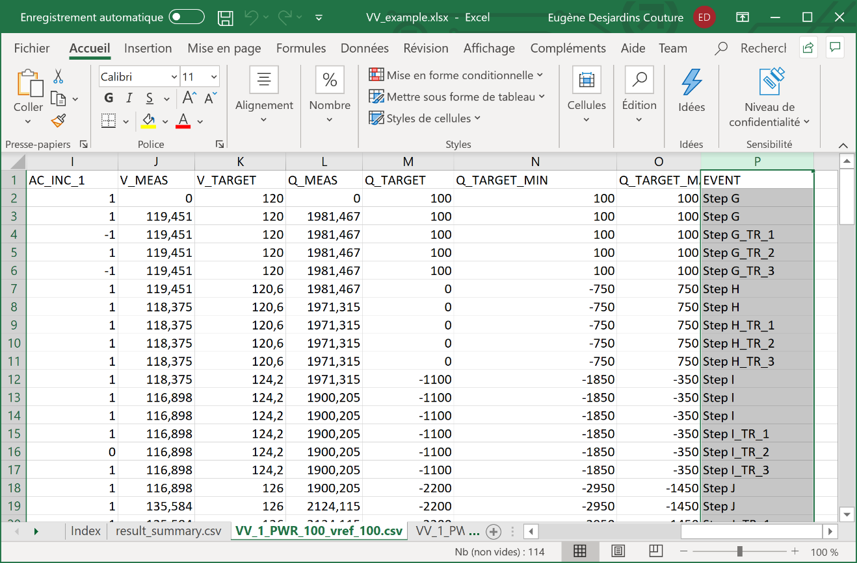Look if the two tests are using the same steps and number of specific events (Example: it has a “_TR1”, “_TR2” and “_TR3” for IEEE1547 tests).

Figure 7: Example of a result excel file disposition of the event column (Indication about where to find the event column in red rectangles).

* 1. Continue without checking, but if the format is not compatible it won’t work or the results won’t be valid.

1. If the script and the result folder to reproduce are compatible, the next step is to put the result folder in the current directory “Results” folder.
2. Next, a new test can be configured, but not in any way. It is not only the script that needs to be compatible, but also the test configuration. To do so:
   1. 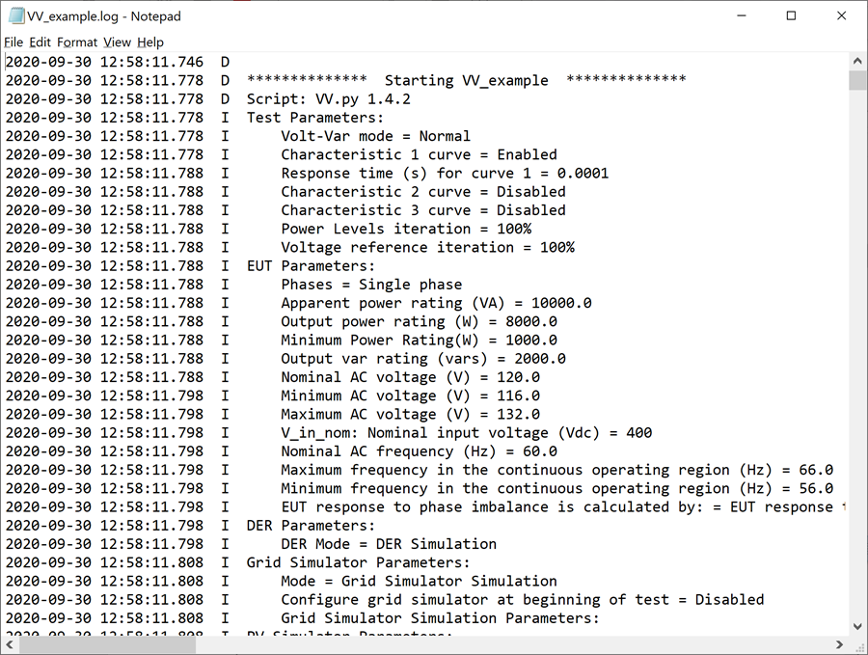Edit the test parameters and the number of phases in the EUT parameters the same way as the previous test to replicate. Moreover, those settings can be accessed through the previous test result log file.

Figure 8: Previous test log file (Parameters to enter in the current test editing in red rectangle).

* 1. Therefore, those parameters need to be the same for the current test. However, anything that is related to time can be significantly reduced to accelerating the run process. Moreover, the other EUT parameters does not have any impact on the data since it is provided through the csv files.
  2. 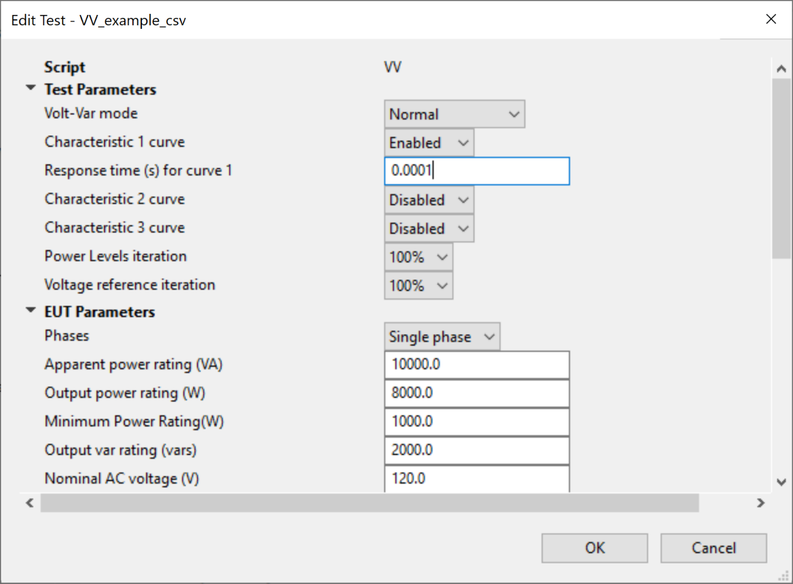As the random mode, every other equipment, other than the HIL, needs to be set at their respective simulation mode.

Figure 9: Configuration of Test and EUT parameters for csv mode through edit Test window (Important parameters to edit in red rectangle).

* 1. Next, the DAS Simulation mode needs to be set at csv.
  2. 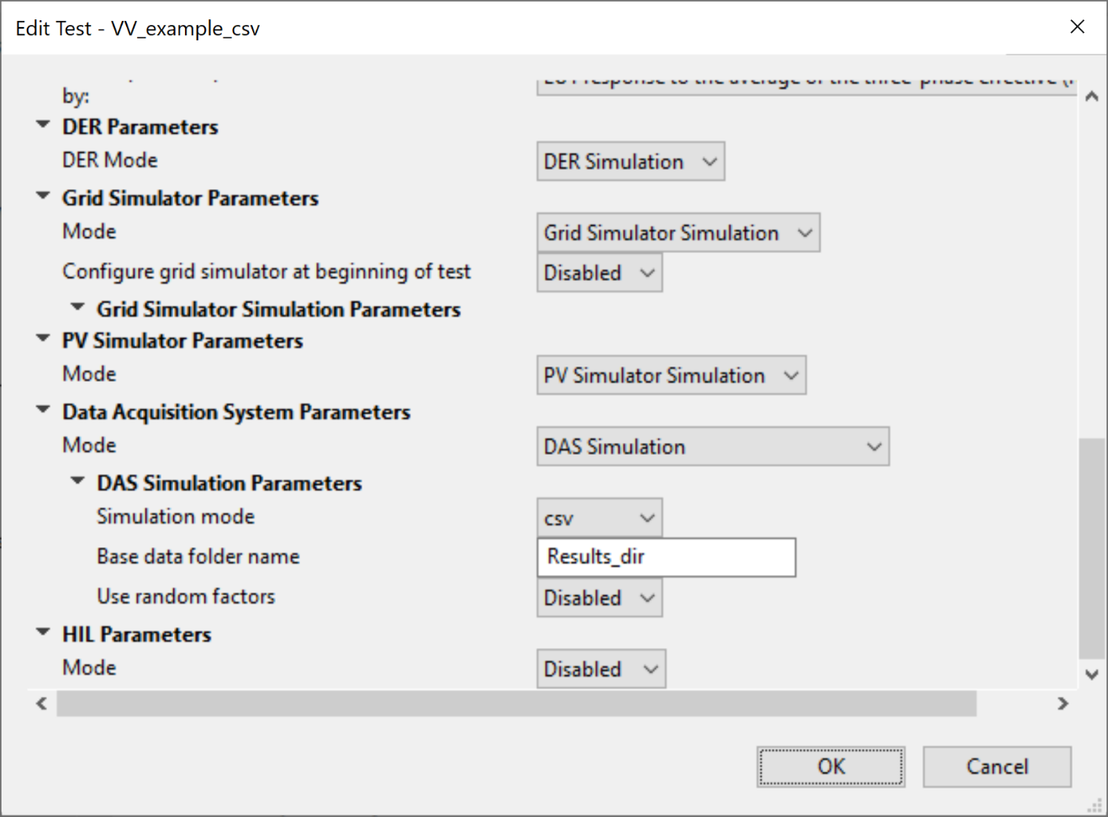Then, the csv mode needs to be set up and here are the steps:

Figure 10: Configuration of Other equipment parameters for csv mode through edit Test window.

* + 1. Enter the result folder name to replicate in the “Base data folder name” under DAS Simulation Parameters. The result folder name is the name of the test results folder to replicate under the “Results” folder of the current directory (See Figure below).
    2. 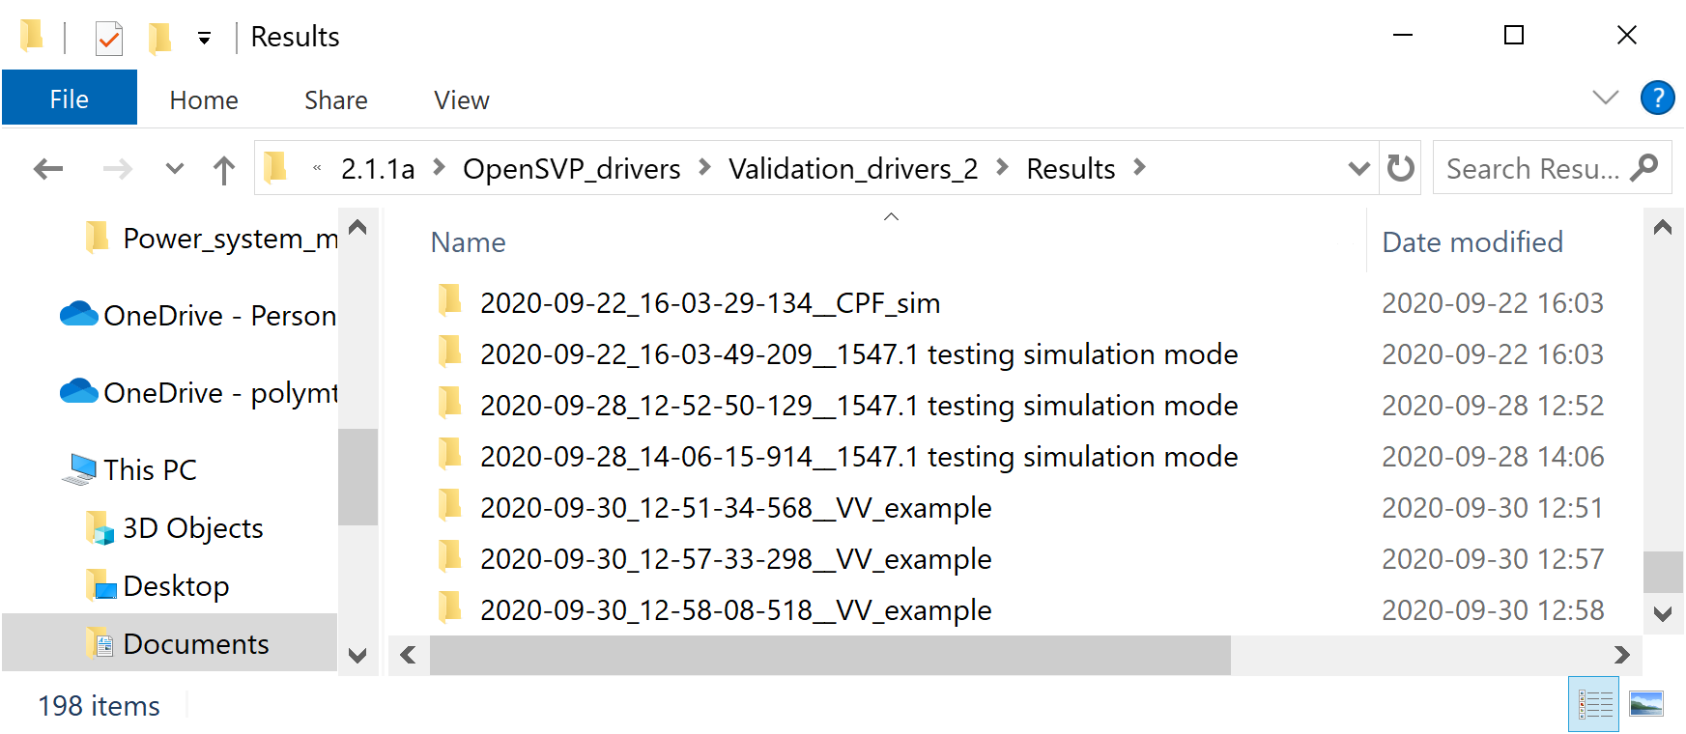Activate the “Use random factors” if needed. It applies random factors to the csv data and then provide a more “realistic” random mode.

Figure 11: Results folder of the current directory (Name of the previous test result in a red rectangle).

* 1. Finally, click on the “OK” button.

1. Run the test.