# How to initiate Open SVP

**Prepared by:**  
Eugène Desjardins Couture

**Present to:**  
Open SVP users

Date: May 31, 2019

**Disclaimer**

Natural Resources Canada (NRCan) is not responsible for the accuracy or completeness of the information contained in the reproduced material. NRCan shall at all times be indemnified and held harmless against any and all claims whatsoever arising out of negligence or other fault in the use of the information contained in this publication or product.

**Third-Party Materials**

Some of the information contained in this publication or product may be subject to copyrights held by other individuals or organizations. To obtain information concerning copyright ownership and restrictions, contact us by:

E-mail:

Telephone:

Facsimile:

Note: The two texts above are optional and may be added to the mandatory text set forth above. You have the option of either adding both or any one of the two.

**Copyright**

Information contained in this publication or product may be reproduced, in part or in whole, and by any means, for personal or public non-commercial purposes, without charge or further permission, unless otherwise specified.

You are asked to:

* exercise due diligence in ensuring the accuracy of the materials reproduced;
* indicate the complete title of the materials reproduced, and the name of the author organization; and
* indicate that the reproduction is a copy of an official work that is published by Natural Resources Canada (NRCan) and that the reproduction has not been produced in affiliation with, or with the endorsement of, NRCan.

Commercial reproduction and distribution is prohibited except with written permission from NRCan. For more information, contact NRCan at copyright.droitdauteur@nrcan-rncan.gc.ca.

*© Her Majesty the Queen in Right of Canada, as represented by the Minister of Natural Resources Canada, [year of publication].*

Summary

This report shows how to setup a good Python environment to be able to use open SVP properly. It describes all the steps necessary to initialise the software.

Table of Contents

Introduction 3

Getting Started 4

Setup PATH for python 4

Setup environment variable PATH with admin rights 4

Setup environment variable PATH without admin rights 4

Open a cmd window 5

Go to the directory of Open SVP with a cd command 5

Use pip to install virtual env 5

Create a new environment with virtualenv 6

Activate the new environment 6

Use pip to install all the required libraries in the new environment 7

Initialise Open SVP by compiling the ui.py module 7

Use Open SVP 8

## Introduction

The purpose of this report is to inform user of Open SVP on how to properly initialise it. In fact, it will be explain how to create a good environment for working on Open SVP.

## Getting Started

In this section, we will see how to setup the environment for Open SVP.

These are broad view of the steps you need to follow to setup an environment for Open SVP (there are more explanation for each step further in the report) :

* setup Path for python
* Open a cmd window
* Go to the directory of Open SVP with a cd command
* Use pip to install virtual env
* Create a new environment with virtualenv
* Activate the new environment
* Use pip to install all the required libraries in the new environment
* Initialise open SVP by compiling the ui.py module

Something important to know is that, if you have already setup the environment by following these steps before and you want to use Open SVP again. You only have to do these steps :

* setup Path for python (if you don’t have admin rights)
* Open a cmd window
* Go to the directory of Open SVP with a cd command
* Activate the new environment
* Initialise open SVP by compiling the ui.py module

### Setup PATH for python

If you are a beginner in python programming there are essential things that need to be set before continuing to the next step.

For using python properly and to make things easy for us. It is important to **add** the C:\Python27 directory and C:\python27/Scripts directory to the windows PATH Environment variable. To do this, you normally need the admin rights of your computer, but there is an other way around which will be explain.

#### Setup environment variable PATH with admin rights

1. 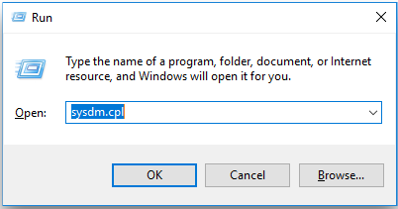Press **crtl** and **R** key at the same to open the Run window and search for **sysdm.cpl.**
2. 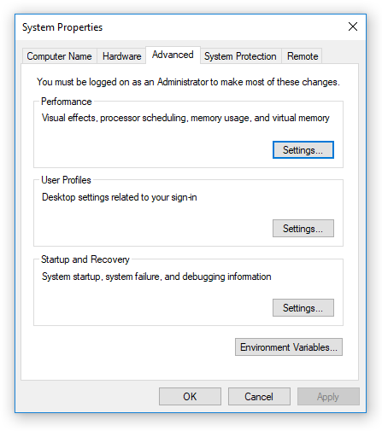The following is supposed to appear and go to the advanced tab. You should see an Environment Variable option. Click on it.
3. 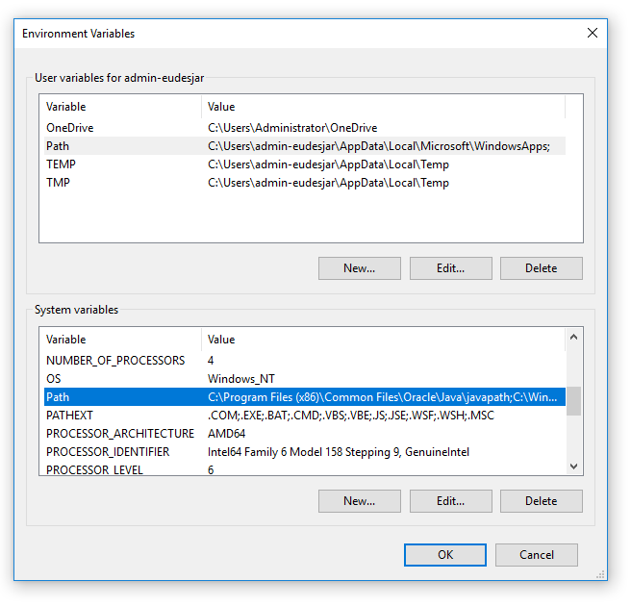In the next window, you select the Path variable in the system variables section and edit it by clicking on edit afterwards
4. 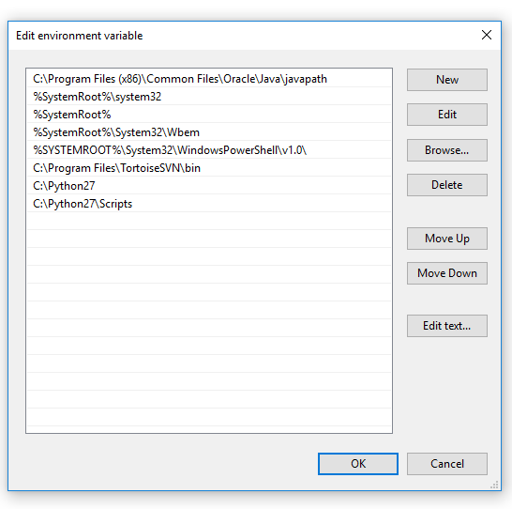The next part is to add the path to the Python27 directory and the Python27 scripts directory. To do this you need to click on New and then enter the corresponding paths.

This is how you set the Path Environment variable to be able to use python effectively

#### Setup environment variable PATH without admin rights

First, you need to open Windows PowerShell by searching windows PowerShell in the search bar.

Next, you can type $env:Path to see the different paths already in the environment variable.

To add the two directory you can use to command:

$env:Path += ";C:\Python27\Scripts;C:\Python27 "

As you can the two directory path are split by ; .

### Open a cmd window

To open the cmd window, go to the research bar and type «cmd» and it should be the first one. If you are using Windows PowerShell, instead of opening a new cmd window, just type cmd in your Windows PowerShell session.

### Go to the directory of Open SVP with a cd command

To be able to run Open SVP, you are suppose to already have a directory with all the necessary modules. The files that you are suppose to see are:

* ui.py
* app.y
* script.py
* result.py
* svptreectrl.py
* README.md
* Images (folder)
* Svp_requirements.txt

If you find all these files then continue. If not, then you should check if you have correctly download Open SVP

Next, to access the directory of Open SVP in the cmd window, you only this simple command:

> cd path\to\Directory\of\Open\SVP

Note that without admin rights you will have to do this step every time you close the windows PowerShell app.

### Use pip to install virtual env

Now that we are in the directory of Open SVP, we can create a virtual environment that will help us better manage Open SVP.

It is important to create a virtual environment, because if you work on multiple projects at the same time that requires different versions of a library, you cannot have the same environment. This is why it is better to works with a virtual environment that is specific for Open SVP.

To be able to create our virtual environment, we need virtualenv and to install virtual env, we will pip. Pip is a tool for installing Python packages from the PyPI. Then, you just need to enter this command in the cmd window:

> pip install virtualenv

### Create a new environment with virtualenv

To create the new virtual environment, you only have to use this command:

> virtualenv env

This simple command will create a new folder named env that will contain all the basic libraries of the python instance on your computer including pip.

### Activate the new environment

Now, your new environment has been created, but you are still working in the original python environment of your computer. Therefore, to correct this problem you need to activate the new environment.

If you want to know if you are using the correct environment, you can use the command : > which python

It indicates the path of the python directory being used.

To activate the new environment, use this line:

> env\Scripts\activate

Now the python directory being used should have change and the path should lead to …\env\Scripts\Python.

### Use pip to install all the required libraries in the new environment

Now that we are working in the new virtual environment that we created, we will need to install the required libraries that Open SVP needs to be working properly in the new environment. To do so, we will be using pip again in a different way. Indeed, in the directory of Open SVP, there is a text file named svp_requirements.txt that contains all the information on each library needed to be install. The version of these libraries are important. Then, to install these libraries, you have to enter this command:

> pip install -r svp_requirements.txt

### Initialise Open SVP by compiling the ui.py module

Now that everything has been installed, Open SVP is ready to be initialise. To do so you only need to compile the ui.py module by entering this line of command in the cmd window:

> ui.py

Then you should see the Open SVP program being open and now you will be ready to use it.

## Use Open SVP