# **CSC 431** IT JOB FORUM System Architecture Specification (SAS)

**<Team number>**

|  |  |
| --- | --- |
| yuxin song | <Role> |
| zilin xu | <Role> |
| siyuan chen | <Role> |
| <Member Name> | <Role> |

# Version History

|  |  |  |  |
| --- | --- | --- | --- |
| Version | Date | Author(s) | Change Comments |
| 1.0.0 | 4.1 |  | First Draft |
|  |  |  |  |
|  |  |  |  |
|  |  |  |  |

# Table of Contents

1. System Analysis 6

1.1 System Overview 6

1.2 System Diagram 6

1.3 Actor Identification 6

1.4 Design Rationale 6

1.4.1 Architectural Style 6

1.4.2 Design Pattern(s) 6

1.4.3 Framework 6

2. Functional Design 7

2.1 Diagram Title 7

3. Structural Design 8

4. Behavioral Design 9

# Table of Tables

<Generate table here>

# Table of Figures

<Generate table here>

### System Analysis

#### 1.1 System Overview

*<Describe the system in brief and your architecture choice>*

*The system will include parts: 1. posts 2. homepage 3. calendar. These three parts are corresponding to several basic functions of our website. 1. For the post part, it will include three basic parts: “like”, “create post”, and “comment and reply”. For the data of like, we will use redis(nosql), so in this way, it will help the website to count the number of likes. For the create post, we will firstly give our user an interface for entering the title and the content. Then, it will send everything to our database. And for the comment and reply part, it will basically be the same. 2. For the homepage, we need to use js and css to design. 3. For calendar, we decide to control it manually, which means that we will collect the data of dates, then allocate these data by each user’s preference.*

#### 1.2 System Diagram

*<Insert System Diagram>*

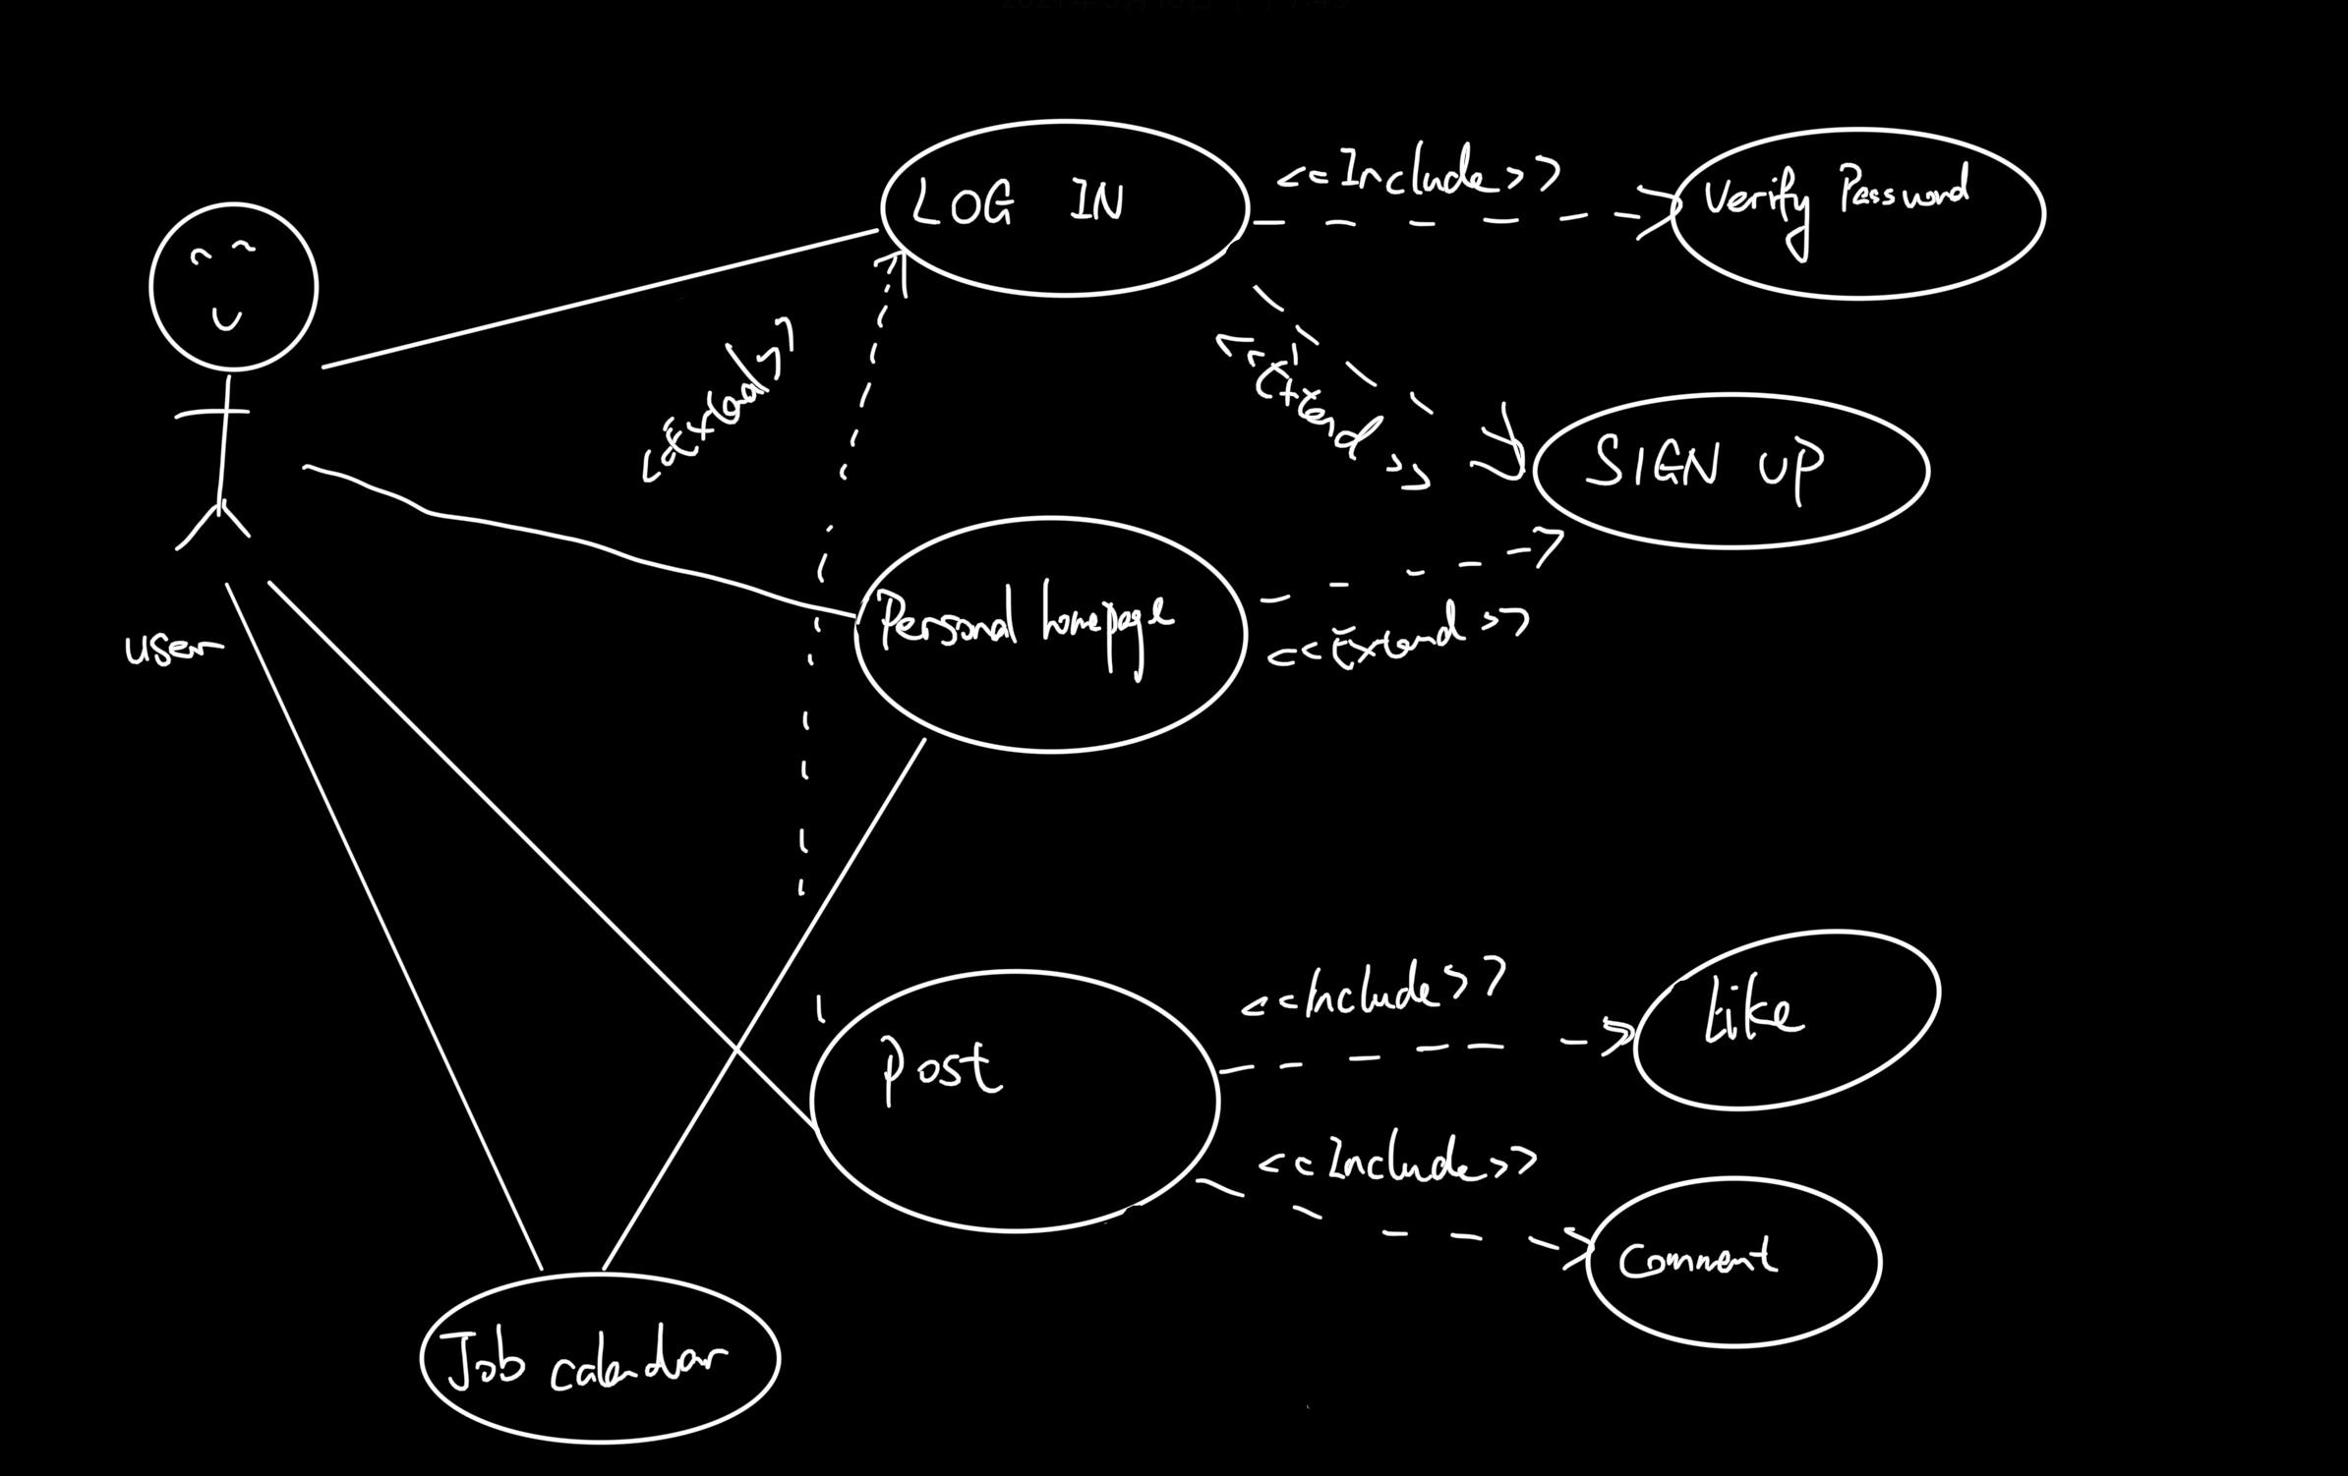

#### 1.3 Actor Identification

*<Identify all actors interacting with the system>*

#### 1.4 Design Rationale

##### 1.4.1 Architectural Style

*<Identify and briefly explain the architectural style e.g. 3-tier architecture>*

##### 1.4.2 Design Pattern(s)

*<Identify the design pattern(s) you have deemed applicable to this architecture>*

##### 1.4.3 Framework

*<Identify and briefly explain the frameworks you are using, if any. Also specify the rationale behind selecting this framework>*

*We try to use NodeBB which is very modern and fast on Node.js based forum software, which is highly different from a classic forum, similar to Discourse.*

### Functional Design

*<Identify all significant workflows as sequence diagrams using the following format>*

#### 2.1 Diagram Title

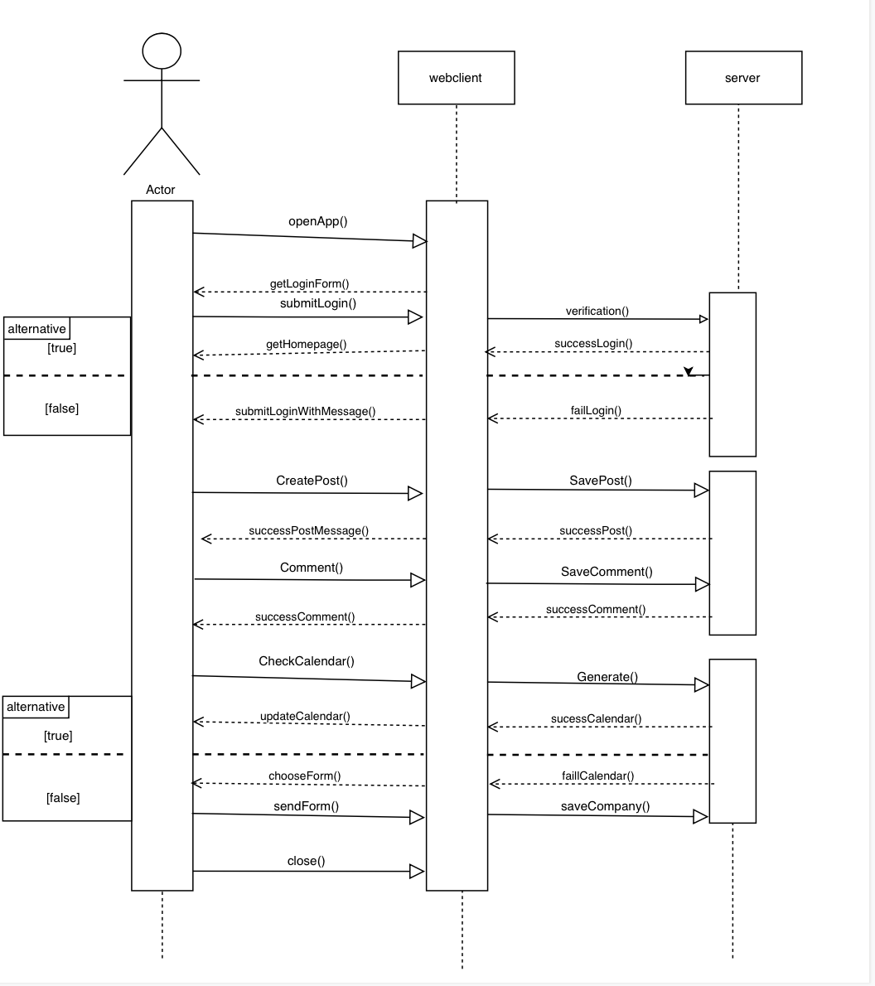

1. If people open our website, the client will send them a form for entering login info.
2. The client will send the user's username and password to the server, and do matching with the data in our server.
   1. if find the matched info, it will send back a successful message. Then send the homepage to the user.
   2. if cannot find the matched info, it will send back a failure message. Then ask the user to check their username and password.
3. If a user successfully login his or her account, he or she can choose to create a post.
4. After the user chooses to comment/reply, the client will send the content to the server.
5. If a user successfully login his or her account, he or she can choose their preferred companies to their calendars.
6. the application will close automatically.

### 2.2 Structural Design

*<Identify all components and model them using class diagrams>*

