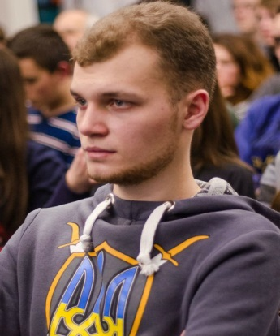**Evgeniy Deyneka**

|  |  |
| --- | --- |
| **Location:** | Kiev, Ukraine |
| **Phone:** | +38(093)190-77-18 |
| **Email:** | [deyneko55@gmail.com](mailto:deyneko55@gmail.com) |
| **Skype:** | legendary_eugene |
| **GitHub:** | <https://github.com/Mankunianeth> |

**Objective:**

To obtain a position of Trainee / Junior Java Developer.

**Skills:**

Java Core, Spring Framework, Hibernate, SQL, JDBC, JSP, JSTL, Servlets, HTML5, CSS3, Bootstrap, JUnit, Maven, Git, IntelliJ IDEA, Tomcat.

**Projects:**

**CRUD web application (**<https://github.com/Mankunianeth/Simple-CRUD-web-app>**)**

**I developed a web project with CRUD operations. For this project, i used the following technologies, frameworks and tools: Spring Framework, HIbernate, HTML, CSS, JSP, JSTL, MySQL, Maven, JUnit, Tomcat.**

**Additional education:**

|  |  |
| --- | --- |
| March 2015 – November 2015 | WebCamp Java Basic and Advanced courses. |
| November 2015 – present | WebCamp Java Starter course mentor. |

**Education:**

|  |  |
| --- | --- |
| 2010 - 2015 | National Aviation University  Institute of information and diagnostic systems  Master’s degree with honor in “Information security systems and automation of information processing”. |

**Experience:**

|  |  |
| --- | --- |
| October 2014 – December 2015 | “ASG” (services and consulting in the field of security)  Position: security systems installer. |

**Additional information:**

Languages:

* Ukrainian – native;
* Russian – native;
* English – intermediate.

Hobbies: programming, football, guitar playing, fishing.

Martial status: not married.