Hard Planetary Shadow Solution
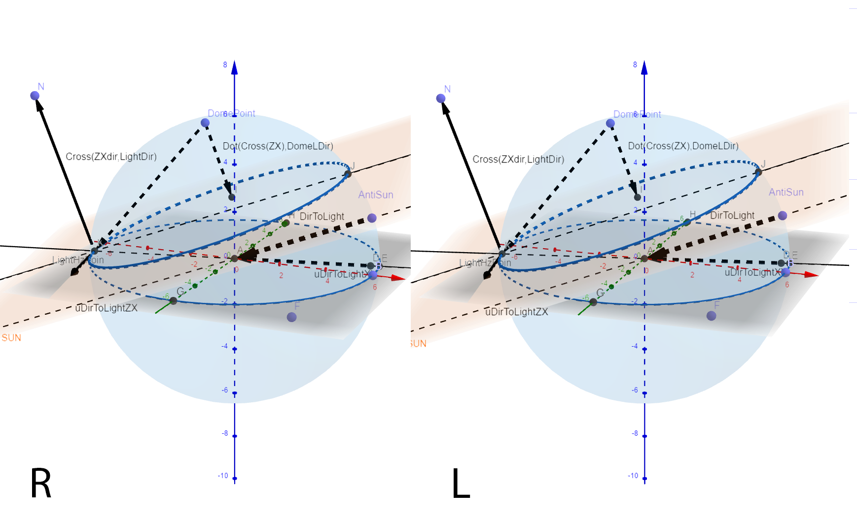

We will need:
Radius of a sphere(distance to horizon)
float horizonDist=200;

Define point on a sphere.
float3 domePoint = horizonDist*fragDir;

Projection of direction to light onto planetary plane:
float3 dirToHzLight=normalize(float3(dirToLight.x,0,dirToLight.z));

Define offset because planet is not infinite plane,and because when light is in perigee it causes shadow artefacts.
float3 shadowPlaneOffset=float3(0,-50,0);

define point where sun sets on horizon.
float3 lightHzPoint = dirToHzLight*horizonDist+shadowPlaneOffset;

float planetShadow =1;
if(dirToLight.y<0){
Define vector perpendicular to horizon direction.
float3 planarVec=float3 (-dirToHzLight.z,0,dirToHzLight.x);

Define shadow plane Up vector
float3 shadowPlaneUp = (cross(dirToLight,planarVec));

Distance to the plane is projection of vector from domepoint to horizon point on shadowplane up vector.
float planarDistance = -dot(shadowPlaneUp,(domePoint-lightHzPoint));
planetShadow=(planarDistance/horizonDist)*8;
planetShadow=clamp(planetShadow,0,1);
}

