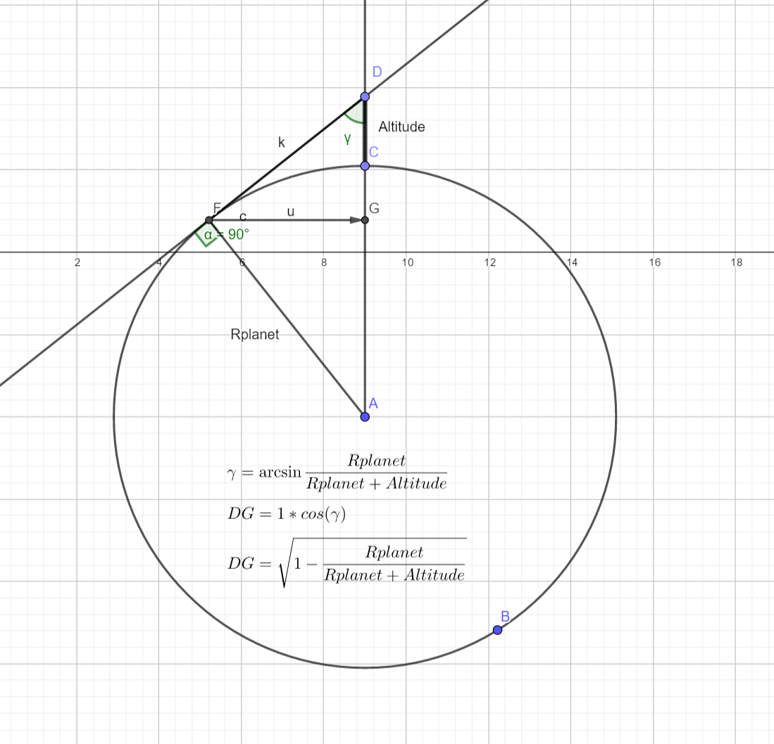
To calculate mask we can do check direction to dome point vs DG, projection of tangent on gravity vector.

float surfaceMask=0;
{

float viewAlt=1/1000.0; //km, as planet radius
float arg=Rp/(Rp+viewAlt);
float ylim = sqrt(1-arg*arg);
//for negative altitude make -ylim

Basically check if Y vector is bigger than DG. For mask generation.
surfaceMask= step(fragDir.y+ylim,0);

