**Personal Blog on IBM cloud static Web APP**

Phase 2 Submission Document

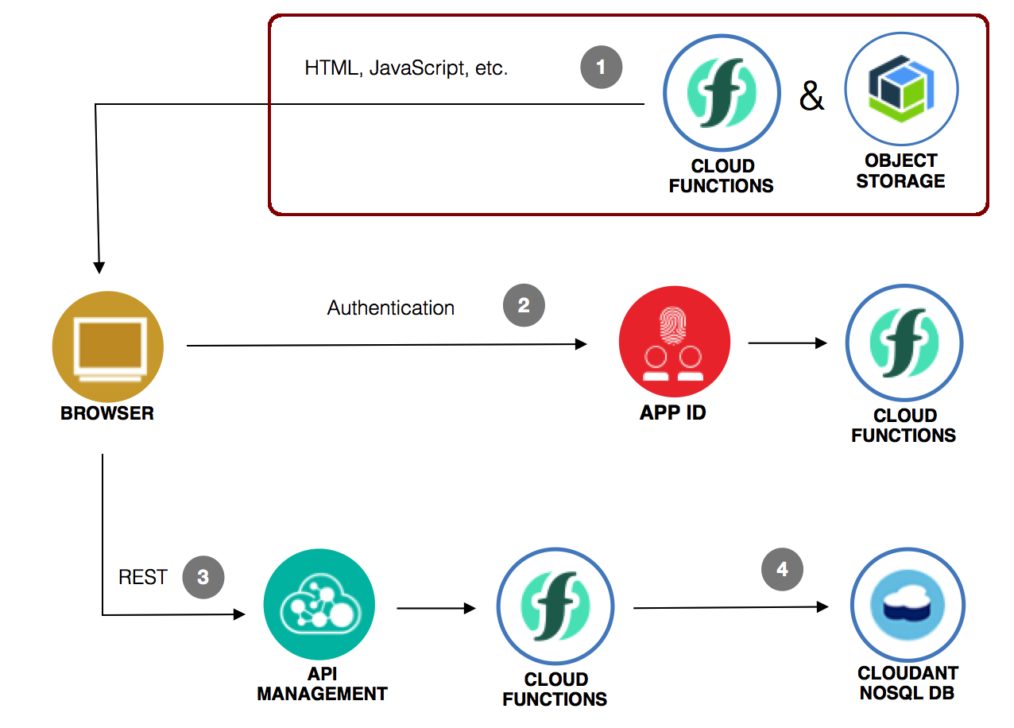

**Abstract**:

In an era marked by rapid digital transformation, the need for web applications that are fast, secure, and highly scalable has become paramount. IBM Cloud Static Web Apps, a cutting-edge offering from IBM, has emerged as a game-changer in the realm of web development. This personal blog takes you on an abstract journey into the world of IBM Cloud Static Web Apps, offering insights into its key features, benefits, and the exciting possibilities it presents for developers and businesses alike.

**Introduction**

The advent of cloud computing has revolutionized the way web applications are developed and deployed. IBM Cloud, a formidable player in the cloud computing domain, has introduced a powerful tool known as Static Web Apps. This blog delves into the essence of IBM Cloud Static Web Apps, exploring its fundamental concepts and practical applications.

**Key Features of IBM Cloud Static Web Apps**

**Static Web Apps offer a unique set of features that cater to the modern web development landscape**:

**Simplicity in Deployment**: Developers can deploy web applications with ease, thanks to the straightforward deployment process provided by Static Web Apps.

**Serverless Architecture**: Harness the power of serverless computing, which eliminates the need for managing server infrastructure and allows developers to focus on code.

**Continuous Integration/Continuous Deployment (CI/CD)**: Leverage CI/CD pipelines for automated testing, deployment, and version control, ensuring efficient and error-free updates.

**Scalability**: Static Web Apps are highly scalable, allowing applications to handle increased traffic without compromising on performance.

**Security**: Benefit from built-in security features, including authentication and authorization, to safeguard your web applications and data.

**Benefits of IBM Cloud Static Web Apps**

**The adoption of Static Web Apps offers several compelling advantages:**

**Cost-Efficiency**: Eliminate the need for provisioning and managing servers, reducing operational costs.

**Performance**: Static web apps load quickly, providing an exceptional user experience and boosting SEO rankings.

**Global Reach**: Host applications in multiple geographic regions, ensuring low latency and global accessibility.

**Simplified Development**: Developers can focus on coding and innovation rather than infrastructure management.

**Use Cases**

**IBM Cloud Static Web Apps find relevance in various use cases:**

**Personal Blogs**: Create and host personal blogs with ease, focusing on content rather than complex backend infrastructure.

**E-commerce Websites**: Build high-performing e-commerce platforms that can handle traffic spikes during sales and promotions.

**Company Websites**: Develop and deploy corporate websites with enhanced security and scalability.

**Startups**: Launch startups quickly and cost-effectively, bringing ideas to market faster.

**Web Portfolios**: Showcase your web development skills and projects in an elegant and responsive portfolio.

**Innovating Your Personal Blog on IBM Cloud**

In the world of personal blogging, innovation might not be the first thing that comes to mind. However, embracing innovation can take your blog to new heights, enhance your online presence, and create a more engaging experience for your readers. Here are some innovative ideas and strategies to consider when hosting your personal blog on an IBM Cloud static web app:

**Interactive Content**

Traditionally, blogs consist of text and images, but you can innovate by incorporating interactive elements. Consider adding quizzes, polls, surveys, or interactive infographics to make your content more engaging. Tools like interactive maps or data visualizations can help convey information in unique ways.

**Voice Search Optimization**

As voice assistants like Siri, Google Assistant, and Alexa become more prevalent, optimizing your blog for voice search is an innovative way to stay ahead. Ensure your content is structured to answer voice-based queries effectively. Think about how people might phrase questions when using voice search and tailor your content accordingly.

**Artificial Intelligence (AI)**

Leveraging AI can streamline various aspects of your blog. Implement chatbots for instant customer support or recommendations based on user behavior. AI-driven content generation tools can assist in creating relevant and personalized content for your readers.

**Progressive Web Apps (PWAs)**

Consider turning your static blog into a Progressive Web App. PWAs offer a seamless, app-like experience for mobile users and can improve site performance. They also allow for offline access, enhancing user engagement.

**Blockchain for Trust**

If your blog deals with sensitive topics like finance or data privacy, consider implementing blockchain technology. It can be used to verify the authenticity of your content, ensuring trust and transparency in your blog's information.

**Personalization**

Innovate by offering personalized experiences to your readers. Implement algorithms that recommend content based on user preferences and browsing history. Personalized content enhances user engagement and loyalty.

**Accessibility**

Ensure your blog is accessible to all users, including those with disabilities. Innovate by going beyond compliance with accessibility standards and providing exceptional accessibility features, such as voice-activated navigation or screen reader compatibility.

**Collaborations and Guest Posts**

Invite guest bloggers or collaborate with experts in your niche. This can bring fresh perspectives and diverse voices to your blog, increasing its appeal to a broader audience.

**Visual Storytelling**

Embrace visual storytelling by incorporating videos, animations, and immersive visuals into your blog posts. Visual content often captures attention more effectively and can convey complex ideas in a digestible manner.

**Analytics and Data-Driven Insights**

Innovation also involves continuous improvement. Utilize advanced analytics tools to gather insights about your blog's performance. Data-driven decisions can help you refine your content strategy and better understand your audience's preferences.

Remember that innovation is an ongoing process. Experiment with these ideas, adapt them to your niche, and stay open to new technologies and trends. By consistently seeking innovative ways to improve your blog, you can keep your readers engaged and make your mark in the ever-evolving world of blogging.

Incorporating these innovative strategies into your personal blog hosted on an IBM Cloud static web app can set you apart from the competition, enhance your blog's value, and create a more enjoyable and interactive experience for your audience. Stay curious, stay creative, and keep innovating!

**SOURCE CODE**

**INDEX.html**

<html>

<head>

<title>Files hosted in Cloud Object Storage and accessible through a Content Delivery Network</title>

<link rel="stylesheet" href="a-css-file.css"></link>

</head>

<body>

<div class="container">

<section>

<h2>A picture</h2>

<div class="section-content">

<img src="a-picture.png" width="640" height="360"/>

</div>

</section>

<section>

<h2>A video</h2>

<div class="section-content">

<video src="a-video.mp4" width="640" height="480" controls autoplay loop>

Oh, it looks like your web browser does not support the <code>video</code> tag.

You can still download the video <a href="a-video.mp4">here</a>.

</video>

</div>

</section>

</div>

</body>

</html>

**CDN.html**

<html>

<head>

<title>Files hosted in Cloud Object Storage and accessible through a Content Delivery Network</title>

<link rel="stylesheet" href="CDN/a-css-file.css"></link>

</head>

<body>

<div class="container">

<section>

<h2>A picture</h2>

<div class="section-content">

<img src="CDN/a-picture.png" width="640" height="360"/>

</div>

</section>

<section>

<h2>A video</h2>

<div class="section-content">

<video src="CDN/a-video.mp4" width="640" height="480" controls autoplay loop>

Oh, it looks like your web browser does not support the <code>video</code> tag.

You can still download the video <a href="CDN/a-video.mp4">here</a>.

</video>

</div>

</section>

</div>

</body>

</html>

**a-css-file.css**

body {

font-family: "Helvetica Neue", "Helvetica", "Arial", sans-serif;

}

.container {

max-width: 960px;

margin: 0 auto;

}

h2 {

font-size: 20px;

border-bottom: 1px solid gray;

padding-bottom: 10px;

}

.section-content {

text-align: center;

}

**App.js**

const fs = require('fs');

const express = require('express');

const app = express();

app.get('*', (req, res) => {

fs.readFile('./public/index.html', (err, data) => {

const page = data.toString()

.split('_CDN_URL_')

.join(https://${process.env.CDN_CNAME});

res.setHeader('Content-Type', 'text/html');

res.send(page);

});

});

const port = process.env.PORT || 8080;

app.listen(port, function(){

console.info(server listening on http://localhost:${port}/);

});

**Conclusion**

IBM Cloud Static Web Apps epitomize the modern approach to web development, offering simplicity, scalability, and security. In a world where web applications are at the forefront of digital engagement, embracing this technology can be a strategic move for developers and businesses alike. Join me on this abstract journey into the realm of IBM Cloud Static Web Apps, where the future of web development unfolds.