LOYALTY MANAGEMENT

Loyalty Customer Table
The code below is for the implementation of the main customer loyalty table with searching, pagination and sorting.
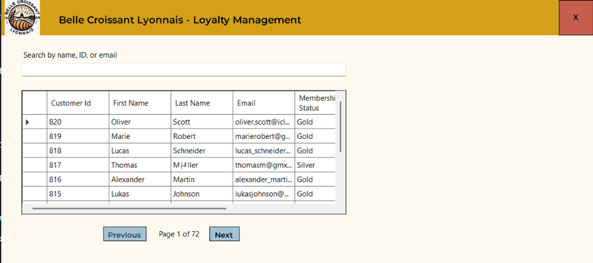
private List<Customer> customers = new List<Customer>();
private List<LoyaltyProgram> loyaltyPrograms = new List<LoyaltyProgram>();

private int maxPages;
private int currentPage = 0;

public LoyaltyManagementPage()
{
InitializeComponent();
LoadData();
}

private void LoadData()
{
loyaltyPrograms = Helper.db.LoyaltyPrograms.ToList();
customers = Helper.db.Customers.Include(x => x.Orders).ToList();

LoadTable();
}

private void LoadTable()
{
dataGridView1.Enabled = false;
dataGridView1.DataSource = null;
dataGridView1.Rows.Clear();

var query = textBox1.Text.Trim().ToLower();
var temp = customers.Where(x => $"{x.FirstName} {x.LastName}".ToLower().Contains(query) ||
x.Email.ToLower().Contains(query) ||
x.CustomerId.ToString().Contains(query))
.OrderByDescending(x => x.CustomerId)
.ToList();

maxPages = (int)Math.Ceiling(temp.Count / 10.0);
currentPage = 0;

foreach (var c in temp)
{
dataGridView1.Rows.Add(
c.CustomerId,
c.FirstName,
c.LastName,
c.Email,
loyaltyPrograms.FirstOrDefault(x => x.CustomerId == c.CustomerId).MembershipTier,
loyaltyPrograms.FirstOrDefault(x => x.CustomerId == c.CustomerId).Points,
c.TotalSpending
);
dataGridView1.Rows[^1].Tag = c;
}

LoadPage();

dataGridView1.ClearSelection();
dataGridView1.Enabled = true;
}

private void LoadPage()
{
var firstRow = currentPage * 10;
var lastRow = firstRow + 10;

foreach (DataGridViewRow row in dataGridView1.Rows)
{
row.Visible = row.Index >= firstRow && row.Index <= lastRow;
}

label3.Text = $"Page {currentPage + 1} of {maxPages}";
UpdateButtonState();
}

private void UpdateButtonState()
{
button2.Enabled = currentPage != 0;
button3.Enabled = currentPage != maxPages - 1;
}

// previous button
private void button2_Click(object sender, EventArgs e)
{
currentPage--;
currentPage = Math.Max(0, Math.Min(maxPages - 1, currentPage));
LoadPage();
}
// next button
private void button3_Click(object sender, EventArgs e)
{
currentPage++;
currentPage = Math.Max(0, Math.Min(maxPages - 1, currentPage));
LoadPage();
}

private async void textBox1_TextChanged(object sender, EventArgs e)
{
await Task.Delay(200);
LoadTable();
}

private void dataGridView1_Sorted(object sender, EventArgs e)
{
currentPage = 0;
LoadPage();
}

Customer Details Section
The code below shows the implementation of the customer details section including the implementation for Save Changes and Cancel button.
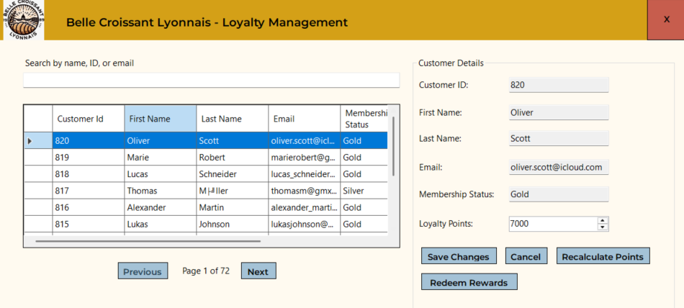

private void LoadTable()
{
dataGridView1.Enabled = false;
dataGridView1.DataSource = null;
dataGridView1.Rows.Clear();

var query = textBox1.Text.Trim().ToLower();
var temp = customers.Where(x => $"{x.FirstName} {x.LastName}".ToLower().Contains(query) ||
x.Email.ToLower().Contains(query) ||
x.CustomerId.ToString().Contains(query))
.OrderByDescending(x => x.CustomerId)
.ToList();

maxPages = (int)Math.Ceiling(temp.Count / 10.0);
currentPage = 0;

foreach (var c in temp)
{
dataGridView1.Rows.Add(
c.CustomerId,
c.FirstName,
c.LastName,
c.Email,
loyaltyPrograms.FirstOrDefault(x => x.CustomerId == c.CustomerId).MembershipTier,
loyaltyPrograms.FirstOrDefault(x => x.CustomerId == c.CustomerId).Points,
c.TotalSpending
);
dataGridView1.Rows[^1].Tag = c;
}

LoadPage();

dataGridView1.ClearSelection();
groupBox1.Hide();
dataGridView1.Enabled = true;
}

private void dataGridView1_SelectionChanged(object sender, EventArgs e)
{
groupBox1.Show();
customerBindingSource1.ResetCurrentItem();
loyaltyProgramBindingSource.ResetCurrentItem();

if (dataGridView1.SelectedRows.Count > 0 && dataGridView1.Enabled)
{
var customer = dataGridView1.SelectedRows[0].Tag as Customer;
customerBindingSource1.DataSource = customer;
loyaltyProgramBindingSource.DataSource = loyaltyPrograms.FirstOrDefault(x => x.CustomerId == customer.CustomerId);
}
}

// cancel button
private void button5_Click(object sender, EventArgs e)
{
Helper.db.ChangeTracker.Entries().ToList().ForEach(x => x.State = Microsoft.EntityFrameworkCore.EntityState.Unchanged);
dataGridView1.ClearSelection();
groupBox1.Hide();
}

// save button
private void button4_Click(object sender, EventArgs e)
{
var loyaltyProgram = loyaltyProgramBindingSource.Current as LoyaltyProgram;
Helper.db.LoyaltyPrograms.Entry(loyaltyProgram).State = EntityState.Modified;
Helper.db.SaveChanges();
MessageBox.Show("Changes saved successfully.", "Success", MessageBoxButtons.OK);
dataGridView1.ClearSelection();
groupBox1.Hide();
LoadTable();
}

Recalculate Points Section and Redeem Rewards Button
The code shows the implementation for the table to display orders, the implementation of total points and bonus points. It also includes some code for the redeem rewards button.

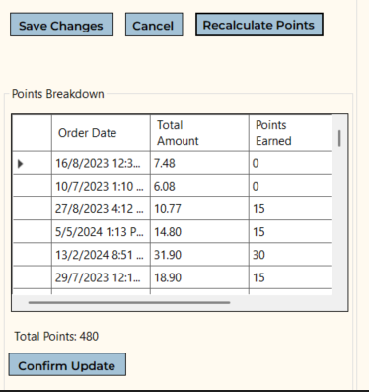
private int points = 0;

public LoyaltyManagementPage()
{
InitializeComponent();
LoadData();
button8.Visible = false;
}

private void LoadTable()
{
dataGridView1.Enabled = false;
dataGridView1.DataSource = null;
dataGridView1.Rows.Clear();

var query = textBox1.Text.Trim().ToLower();
var temp = customers.Where(x => $"{x.FirstName} {x.LastName}".ToLower().Contains(query) ||
x.Email.ToLower().Contains(query) ||
x.CustomerId.ToString().Contains(query))
.OrderByDescending(x => x.CustomerId)
.ToList();

maxPages = (int)Math.Ceiling(temp.Count / 10.0);
currentPage = 0;

foreach (var c in temp)
{
dataGridView1.Rows.Add(
c.CustomerId,
c.FirstName,
c.LastName,
c.Email,
loyaltyPrograms.FirstOrDefault(x => x.CustomerId == c.CustomerId).MembershipTier,
loyaltyPrograms.FirstOrDefault(x => x.CustomerId == c.CustomerId).Points,
c.TotalSpending
);
dataGridView1.Rows[^1].Tag = c;
}

LoadPage();

dataGridView1.ClearSelection();
groupBox1.Hide();
groupBox2.Hide();
dataGridView1.Enabled = true;
}

// recalculate points button
private void button6_Click(object sender, EventArgs e)
{
groupBox2.Show();
var customer = dataGridView1.SelectedRows[0].Tag as Customer;
int bonus;
int pointsPer10Euros = customer.MembershipStatus switch
{
"Basic" => 10,
"Silver" => 12,
"Gold" => 15,
_ => 0
};

points = 0;

dataGridView2.DataSource = null;
dataGridView2.ClearSelection();

foreach (var order in customer.Orders)
{
int amount = (int)(order.TotalAmount - order.DiscountAmount) / 10;
bonus = 0;

if (order.PromotionId != null)
{
bonus += 5;
}

if ((customer.JoinDate?.Month, customer.JoinDate?.Day) == (order.OrderDate.Month, order.OrderDate.Day))
{
bonus += 25;
}

dataGridView2.Rows.Add(order.OrderDate, order.TotalAmount, amount * pointsPer10Euros, bonus);

points += amount * pointsPer10Euros + bonus;
}

label10.Text = $"Total Points: {points}";
}

// confirm update button under order table
private void button7_Click(object sender, EventArgs e)
{
var loyaltyProgram = loyaltyProgramBindingSource.Current as LoyaltyProgram;
loyaltyProgram.Points = points;
numericUpDown1.Value = points;
MessageBox.Show("Points updated successfully.", "Success", MessageBoxButtons.OK);
groupBox2.Hide();
}

private void numericUpDown1_ValueChanged(object sender, EventArgs e)
{
button8.Visible = numericUpDown1.Value >= 1000;
}

// redeem rewards button
private void button8_Click(object sender, EventArgs e)
{
var customer = dataGridView1.SelectedRows[0].Tag as Customer;
var loyalty = loyaltyPrograms.FirstOrDefault(x => x.CustomerId == customer.CustomerId);
new RedeemRewardsPage(customer, loyalty).ShowDialog();
loyaltyProgramBindingSource.ResetCurrentItem();
loyaltyProgramBindingSource.DataSource = loyalty;
LoadTable();
}

Redeem Rewards Section
This code is for the redeem rewards modal after the user clicks on the redeem rewards button.
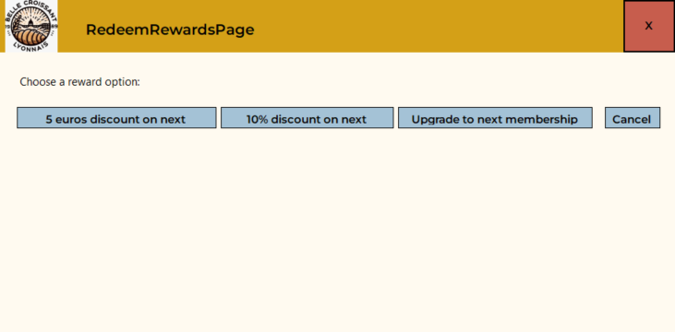
public partial class RedeemRewardsPage : Form1
{
private Customer customer;
private LoyaltyProgram loyaltyProgram;

public RedeemRewardsPage(Customer customer, LoyaltyProgram loyaltyProgram)
{
InitializeComponent();
this.customer = customer;
this.loyaltyProgram = loyaltyProgram;

if (customer.MembershipStatus == "Gold")
{
button4.Visible = false;
}
}

private void button5_Click(object sender, EventArgs e)
{
this.Close();
}

// 5 euros discount button
private void button2_Click(object sender, EventArgs e)
{
var newPromotion = new Promotion()
{
PromotionName = "5 euros discount on next purchase",
DiscountType = "FixedAmount",
DiscountValue = 5,
ApplicableProducts = string.Join(",", Helper.db.Products.Select(x => x.ProductName).ToList()),
StartDate = DateOnly.FromDateTime(DateTime.Today),
EndDate = DateOnly.FromDateTime(DateTime.Today.AddDays(30)),
MinimumOrderValue = 0,
Priority = 99,
QuantityBasedRules = null
};

this.loyaltyProgram.Points -= 1000;
Helper.db.Promotions.Add(newPromotion);
Helper.db.SaveChanges();

MessageBox.Show("5 euros discount applied to next purchase.", "Success", MessageBoxButtons.OK);
MessageBox.Show("Changes saved successfully.", "Success", MessageBoxButtons.OK);

this.Close();
}

// 10% discount button
private void button3_Click(object sender, EventArgs e)
{
var newPromotion = new Promotion()
{
PromotionName = "10% discount on next purchase",
DiscountType = "Percentage",
DiscountValue = 10,
ApplicableProducts = string.Join(",", Helper.db.Products.Select(x => x.ProductName).ToList()),
StartDate = DateOnly.FromDateTime(DateTime.Today),
EndDate = DateOnly.FromDateTime(DateTime.Today.AddDays(30)),
MinimumOrderValue = 0,
Priority = 99,
QuantityBasedRules = null
};

this.loyaltyProgram.Points -= 1000;
Helper.db.Promotions.Add(newPromotion);
Helper.db.SaveChanges();

MessageBox.Show("10% discount applied to next purchase.", "Success", MessageBoxButtons.OK);
MessageBox.Show("Changes saved successfully.", "Success", MessageBoxButtons.OK);

this.Close();
}

// upgrade membership tier button
private void button4_Click(object sender, EventArgs e)
{
var tierUpgrade = this.loyaltyProgram.MembershipTier switch
{
"Basic" => "Silver",
"Silver" => "Gold",
_ => ""
};

customer.MembershipStatus = tierUpgrade;
loyaltyProgram.MembershipTier = tierUpgrade;

loyaltyProgram.Points -= 1000;
Helper.db.Entry(this.customer).State = Microsoft.EntityFrameworkCore.EntityState.Modified;
Helper.db.Entry(this.loyaltyProgram).State = Microsoft.EntityFrameworkCore.EntityState.Modified;
Helper.db.SaveChanges();

MessageBox.Show("Membership tier upgraded.", "Success", MessageBoxButtons.OK);
MessageBox.Show("Changes saved successfully.", "Success", MessageBoxButtons.OK);

this.Close();
}
}

