PROMOTIONS MANAGEMENT APP

Promotion Table Display
The code shows the implementation for displaying the promotions in a data grid view using binding source.
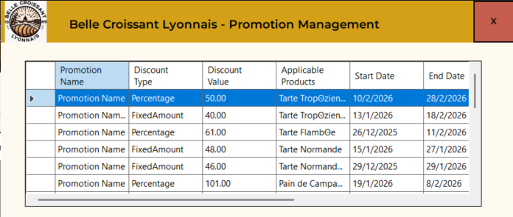
private List<Promotion> promotions = new List<Promotion>();
private List<Product> products = new List<Product>();

public PromotionManagementPage()
{
InitializeComponent();
LoadProducts();
LoadData();
}

private void LoadProducts()
{
products = Helper.db.Products.ToList();
}

private void LoadData()
{
promotions = Helper.db.Promotions.ToList();
LoadTable();
}

private void LoadTable()
{
dataGridView1.DataSource = null;
dataGridView1.Rows.Clear();
dataGridView1.ClearSelection();

foreach (var promotion in promotions)
{
var productIds = promotion.ApplicableProducts.Split(",").ToList();

var productsInPromotion = string.Join(",", products.Where(x => productIds.Contains(x.ProductId.ToString())).Select(x => x.ProductName).ToList());

dataGridView1.Rows.Add(
promotion.PromotionName,
promotion.DiscountType == "FixedAmount" ? "Fixed Amount" : promotion.DiscountType,
promotion.DiscountValue,
productsInPromotion,
promotion.StartDate,
promotion.EndDate,
promotion.MinimumOrderValue,
promotion.Priority
);

dataGridView1.Rows[^1].Tag = promotion;
}
}

private void dataGridView1_CellFormatting(object sender, DataGridViewCellFormattingEventArgs e)
{
if (e.ColumnIndex == 8)
{
e.Value = "Edit";
}
else if (e.ColumnIndex == 9)
{
e.Value = "Delete";
}
}

Add New Promotion and Edit Promotion Section
This code shows the implementation for add or edit promotion form as well as saving the changes.

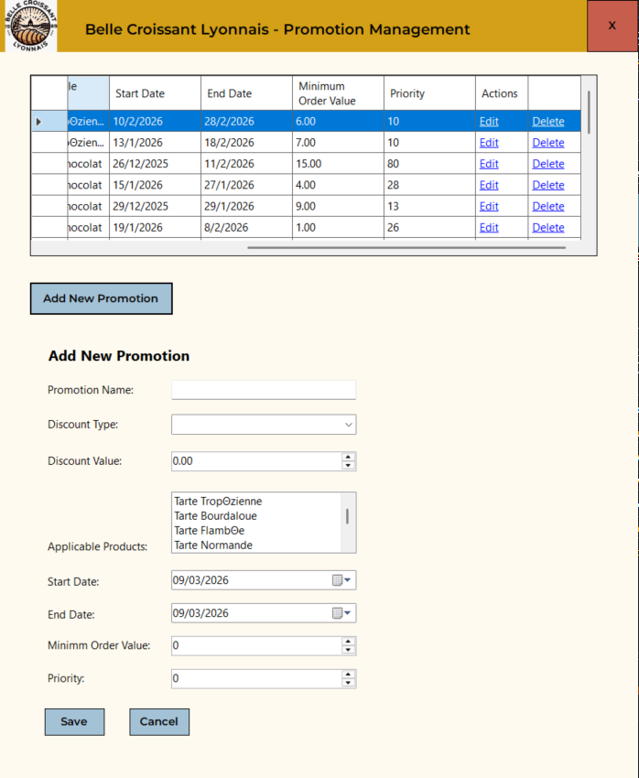

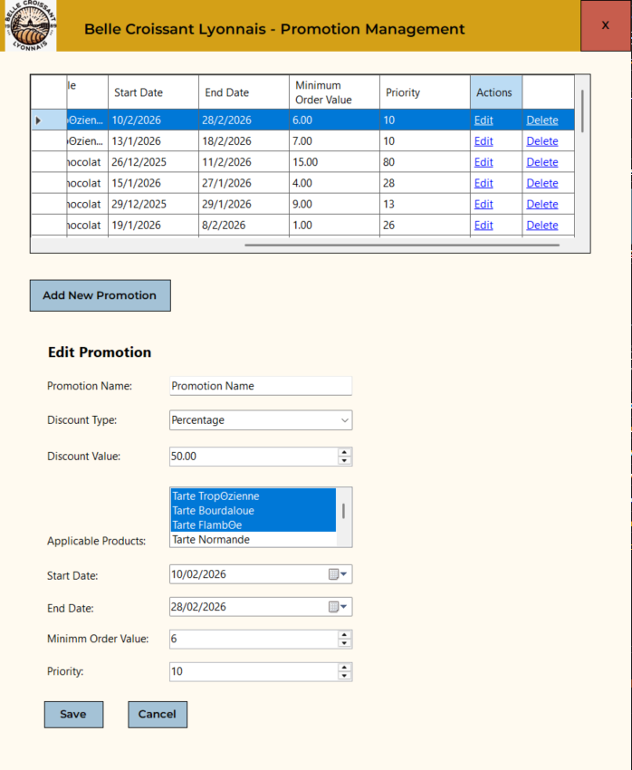
public PromotionManagementPage()
{
InitializeComponent();
LoadProducts();
LoadData();

comboBox1.Items.Clear();
comboBox1.Items.Add("");
comboBox1.Items.Add("Percentage");
comboBox1.Items.Add("Fixed Amount");
}

private void LoadProducts()
{
products = Helper.db.Products.ToList();
listBox1.DataSource = products;
listBox1.DisplayMember = "ProductName";
listBox1.ValueMember = "ProductId";
}

private void LoadData()
{
promotions = Helper.db.Promotions.ToList();
panel2.Hide();
LoadTable();
}

private void ResetForm()
{
listBox1.ClearSelected();
dateTimePicker1.Value = DateTime.Now;
dateTimePicker2.Value = DateTime.Now;
}

private void dataGridView1_CellContentClick(object sender, DataGridViewCellEventArgs e)
{
ResetForm();

if (e.RowIndex < 0) return;

var promotionSelected = dataGridView1.Rows[e.RowIndex].Tag as Promotion;

if (e.ColumnIndex == 8)
{
// edit button clicked
panel2.Show();
label2.Text = "Edit Promotion";

promotionBindingSource1.ResetCurrentItem();
promotionBindingSource1.DataSource = promotionSelected;
dateTimePicker1.Value = promotionSelected.StartDate.ToDateTime(TimeOnly.MinValue);
dateTimePicker2.Value = promotionSelected.EndDate.ToDateTime(TimeOnly.MinValue);
comboBox1.SelectedItem = promotionSelected.DiscountType == "FixedAmount" ? "Fixed Amount" : "Percentage";

for (int i = 0; i < listBox1.Items.Count; i++)
{
var item = listBox1.Items[i] as Product;
var productId = item.ProductId;

if (promotionSelected.ApplicableProducts.Split(",").ToList().Contains(productId.ToString()))
{
listBox1.SelectedItems.Add(item);
}
}
}
}

// add new promotion button
private void button2_Click(object sender, EventArgs e)
{
ResetForm();

var newPromotion = new Promotion()
{
PromotionId = 0,
DiscountValue = 0,
StartDate = DateOnly.FromDateTime(DateTime.Now),
EndDate = DateOnly.FromDateTime(DateTime.Now),
MinimumOrderValue = 0,
Priority = 0
};

promotionBindingSource1.ResetCurrentItem();
promotionBindingSource1.DataSource = newPromotion;
comboBox1.SelectedIndex = 0;
panel2.Show();
label2.Text = "Add New Promotion";
}

// Save button clicked
private void button3_Click(object sender, EventArgs e)
{
if (string.IsNullOrEmpty(textBox1.Text) || comboBox1.SelectedIndex == 0 || numericUpDown1.Value <= 0)
{
return;
}

var promotion = (Promotion)promotionBindingSource1.Current;

promotion.DiscountType = comboBox1.SelectedItem.ToString();

promotion.ApplicableProducts = string.Join(",", listBox1.SelectedItems.Cast<Product>().Select(x => x.ProductId.ToString()).ToList());

promotion.StartDate = DateOnly.FromDateTime(dateTimePicker1.Value);
promotion.EndDate = DateOnly.FromDateTime(dateTimePicker2.Value);

if (promotion.StartDate > promotion.EndDate)
{
MessageBox.Show("Invalid date range.", "Warning", MessageBoxButtons.OK);
return;
}

if (promotion.DiscountType == "Fixed Amount")
{
promotion.DiscountType = "FixedAmount";
}

if (promotion.PromotionId == 0)
{
Helper.db.Add(promotion);
}
else
{
Helper.db.Entry(promotion).State = Microsoft.EntityFrameworkCore.EntityState.Modified;
}

Helper.db.SaveChanges();

LoadData();
}

// cancel button
private void button4_Click(object sender, EventArgs e)
{
Helper.db.ChangeTracker.Entries().ToList().ForEach(x => x.State = Microsoft.EntityFrameworkCore.EntityState.Unchanged);
dataGridView1.ClearSelection();
panel2.Hide();
}

Delete Promotion
This code shows the implementation of delete promotion function.
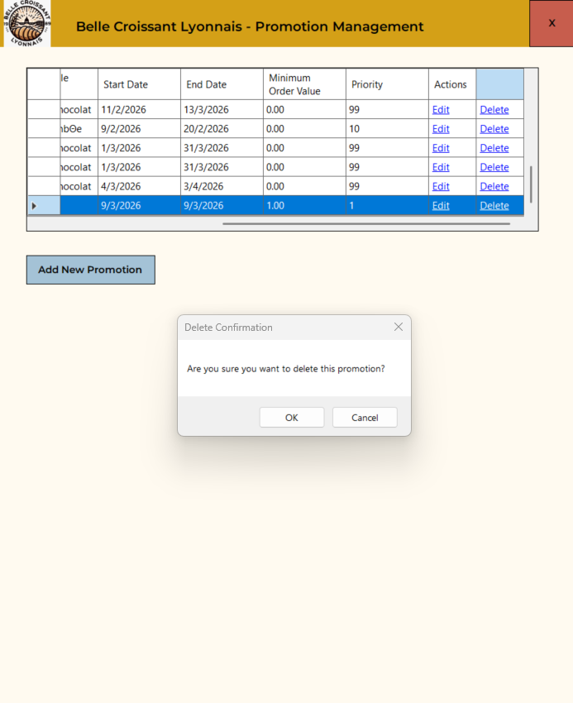
private void dataGridView1_CellContentClick(object sender, DataGridViewCellEventArgs e)
{
ResetForm();

if (e.RowIndex < 0) return;

var promotionSelected = dataGridView1.Rows[e.RowIndex].Tag as Promotion;

if (e.ColumnIndex == 8)
{
// edit button clicked
panel2.Show();
label2.Text = "Edit Promotion";

promotionBindingSource1.ResetCurrentItem();
promotionBindingSource1.DataSource = promotionSelected;
dateTimePicker1.Value = promotionSelected.StartDate.ToDateTime(TimeOnly.MinValue);
dateTimePicker2.Value = promotionSelected.EndDate.ToDateTime(TimeOnly.MinValue);
comboBox1.SelectedItem = promotionSelected.DiscountType == "FixedAmount" ? "Fixed Amount" : "Percentage";

for (int i = 0; i < listBox1.Items.Count; i++)
{
var item = listBox1.Items[i] as Product;
var productId = item.ProductId;

if (promotionSelected.ApplicableProducts.Split(",").ToList().Contains(productId.ToString()))
{
listBox1.SelectedItems.Add(item);
}
}
}
else if (e.ColumnIndex == 9)
{
// delete button clicked
if (MessageBox.Show("Are you sure you want to delete this promotion?", "Delete Confirmation", MessageBoxButtons.OKCancel) == DialogResult.OK)
{
Helper.db.Promotions.Remove(promotionSelected);
Helper.db.SaveChanges();
LoadData();
dataGridView1.ClearSelection();
}
}
}

Conflict Resolution Wizard Step 1
This code shows the full implementation of step 1 of the conflict resolution wizard for conflicted products and priority. This also includes the bottom navigation buttons, specifically the cancel, back and next button.
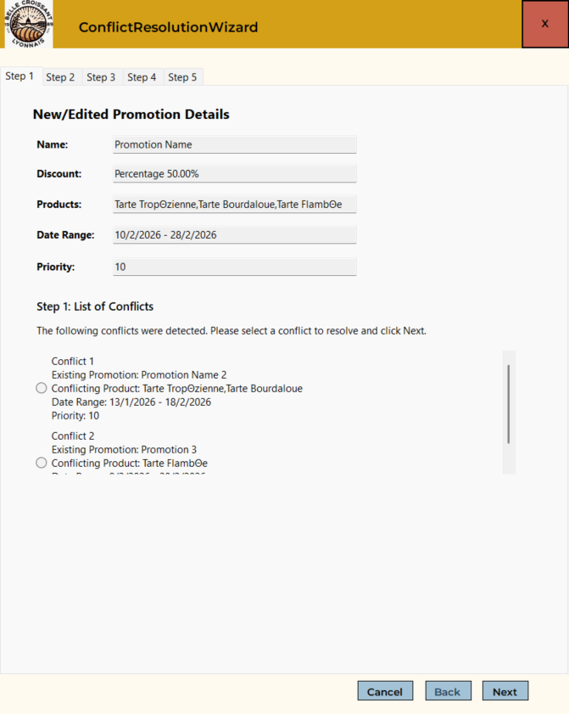
// This code is in the PromotionManagementPage

// Save button clicked
private void button3_Click(object sender, EventArgs e)
{
if (string.IsNullOrEmpty(textBox1.Text) || comboBox1.SelectedIndex == 0 || numericUpDown1.Value <= 0)
{
return;
}

var promotion = (Promotion)promotionBindingSource1.Current;

promotion.DiscountType = comboBox1.SelectedItem.ToString();

promotion.ApplicableProducts = string.Join(",", listBox1.SelectedItems.Cast<Product>().Select(x => x.ProductId.ToString()).ToList());

promotion.StartDate = DateOnly.FromDateTime(dateTimePicker1.Value);
promotion.EndDate = DateOnly.FromDateTime(dateTimePicker2.Value);

if (promotion.StartDate > promotion.EndDate)
{
MessageBox.Show("Invalid date range.", "Warning", MessageBoxButtons.OK);
return;
}

if (promotion.DiscountType == "Fixed Amount")
{
promotion.DiscountType = "FixedAmount";
}

if (promotion.PromotionId == 0)
{
Helper.db.Add(promotion);
}
else
{
Helper.db.Entry(promotion).State = Microsoft.EntityFrameworkCore.EntityState.Modified;
}

Helper.db.SaveChanges();

Dictionary<Promotion, string> conflictedPromotions = getConflictProducts(promotion);

while (conflictedPromotions.Count > 0)
{
this.Hide();
new ConflictResolutionWizard(promotion, conflictedPromotions).ShowDialog();
this.Show();
promotion = Helper.db.Promotions.ToList().First(x => x.PromotionId == promotion.PromotionId);
conflictedPromotions = getConflictProducts(promotion);
}

LoadData();
}

private Dictionary<Promotion, string> getConflictProducts(Promotion promotion)
{
var applicableProducts = promotion.ApplicableProducts.Split(",");
var allPromotions = Helper.db.Promotions.ToList();

Dictionary<Promotion, string> conflictedPromotions = new Dictionary<Promotion, string>();

foreach (var promo in allPromotions)
{
var products = promo.ApplicableProducts.Split(",");

if (promo.PromotionId != promotion.PromotionId && products.Any(x => applicableProducts.Contains(x)) &&
promo.StartDate <= promotion.EndDate && promotion.StartDate <= promo.EndDate && promo.Priority == promotion.Priority)
{
var productConflicted = products.Intersect(applicableProducts).ToList();
conflictedPromotions[promo] = string.Join(",", productConflicted);
}
}

return conflictedPromotions;
}
// This code is in the ConflictResolutionWizard

private Dictionary<Promotion, string> allConflictedPromotions;
private Promotion currentPromotion;
private Promotion selectedConflictPromo;
private string conflictedProducts;
private const int maxStepIndex = 4;
private int currentStep = 0;

public ConflictResolutionWizard(Promotion currentPromotion, Dictionary<Promotion, string> allConflictedPromotions)
{
InitializeComponent();
this.currentPromotion = currentPromotion;
this.allConflictedPromotions = allConflictedPromotions;
tabControl1.SelectedIndex = 0;
UpdatePage();
button3.Enabled = false;
}

private void ResetAll()
{
flowLayoutPanel1.Controls.Clear();
UpdatePage();
button3.Enabled = false;
}

private string GetProductNames(string applicableProductsIds)
{
var productIds = applicableProductsIds.Split(",").ToList();
var productNamesList = Helper.db.Products.Where(x => productIds.Contains(x.ProductId.ToString())).Select(x => x.ProductName).ToList();
var productNames = string.Join(",", productNamesList);
return productNames;
}

private void LoadStep1()
{
if (flowLayoutPanel1.Controls.Count == 0)
{
promotionBindingSource.DataSource = currentPromotion;
textBox2.Text = $"{currentPromotion.DiscountType} {currentPromotion.DiscountValue}{(currentPromotion.DiscountType == "Percentage" ? "%" : " euros")}";
textBox4.Text = $"{currentPromotion.StartDate} - {currentPromotion.EndDate}";

// load product's names
var currentPromoProductNames = GetProductNames(currentPromotion.ApplicableProducts);
textBox3.Text = string.Join(",", currentPromoProductNames);

flowLayoutPanel1.FlowDirection = FlowDirection.TopDown;
flowLayoutPanel1.WrapContents = false;
flowLayoutPanel1.AutoScroll = true;

for (int i = 0; i < allConflictedPromotions.Count(); i++)
{
var promo = allConflictedPromotions.ToList()[i];
var productNames = GetProductNames(promo.Key.ApplicableProducts);

RadioButton radioButton = new RadioButton();
radioButton.Tag = promo;
radioButton.AutoSize = true;
radioButton.MaximumSize = new Size(500, 0);
radioButton.Text = $"Conflict {i + 1}\n" +
$"Existing Promotion: {promo.Key.PromotionName}\n" +
$"Conflicting Product: {productNames}\n" +
$"Date Range: {promo.Key.StartDate} - {promo.Key.EndDate}\n" +
$"Priority: {promo.Key.Priority}\n";
flowLayoutPanel1.Controls.Add(radioButton);
}
}
}

private void UpdateButton()
{
button2.Enabled = tabControl1.SelectedIndex != maxStepIndex;
button3.Enabled = tabControl1.SelectedIndex != 0;
}

private void UpdatePage()
{
switch (tabControl1.SelectedIndex)
{
case 0:
LoadStep1();
break;
default:
break;
}
}

// next button clicked
private void button2_Click(object sender, EventArgs e)
{
if (tabControl1.SelectedIndex == 0)
{
var selectedRadioButton = flowLayoutPanel1.Controls.OfType<RadioButton>().FirstOrDefault(x => x.Checked);

if (selectedRadioButton != null)
{
var selected = (KeyValuePair<Promotion, string>)selectedRadioButton.Tag;
selectedConflictPromo = selected.Key;
conflictedProducts = selected.Value;
}
else
{
return;
}
}

currentStep++;
currentStep = Math.Max(0, Math.Min(maxStepIndex, currentStep));
UpdatePage();
UpdateButton();
}

// back button clicked
private void button3_Click(object sender, EventArgs e)
{
currentStep--;
currentStep = Math.Max(0, Math.Min(maxStepIndex, currentStep));
UpdatePage();
UpdateButton();
}

// cancel nav button clicked
private void button4_Click(object sender, EventArgs e)
{
ResetAll();
currentStep = 4;
UpdatePage();
UpdateButton();
}

private void tabControl1_Selecting(object sender, TabControlCancelEventArgs e)
{
if (currentStep != tabControl1.SelectedIndex)
{
tabControl1.SelectedIndex = currentStep;
}
}

Conflict Resolution Wizard Step 2
This code shows the full implementation of step 2 of the conflict resolution process, which is mainly about UI and less on features and functionality.

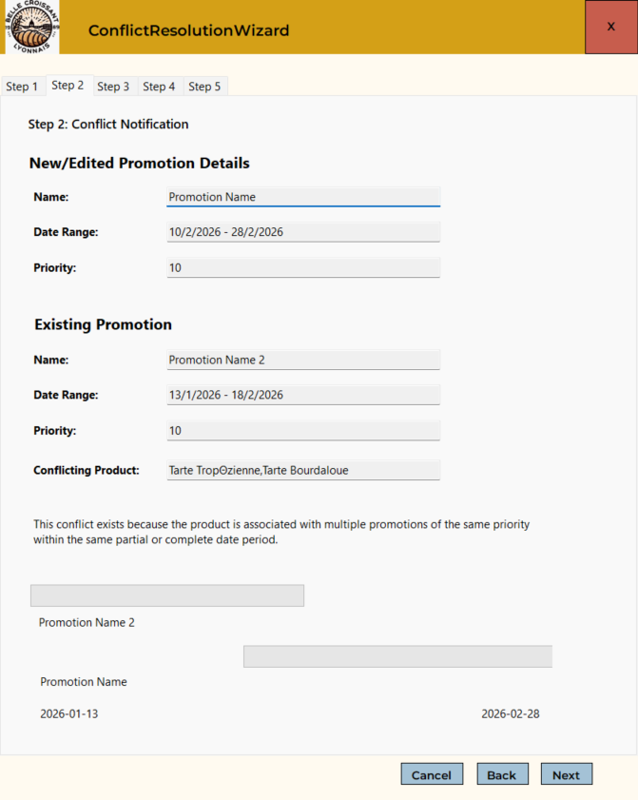
private int pixelsPerDay = 10;

private void LoadStep2()
{
promotionBindingSource1.DataSource = selectedConflictPromo;
textBox7.Text = GetProductNames(conflictedProducts);
textBox8.Text = $"{selectedConflictPromo.StartDate} - {selectedConflictPromo.EndDate}";
textBox11.Text = $"{currentPromotion.StartDate} - {currentPromotion.EndDate}";

var earliestStartDate = Math.Min(currentPromotion.StartDate.DayNumber, selectedConflictPromo.StartDate.DayNumber);

var currPromotionDateDiff = currentPromotion.EndDate.DayNumber - currentPromotion.StartDate.DayNumber;
var conflictedPromotionDateDiff = selectedConflictPromo.EndDate.DayNumber - selectedConflictPromo.StartDate.DayNumber;

var conflictPromoXPos = (selectedConflictPromo.StartDate.DayNumber - earliestStartDate) * pixelsPerDay;
var currPromoXPos = (currentPromotion.StartDate.DayNumber - earliestStartDate) * pixelsPerDay;
progressBar1.Location = new System.Drawing.Point(conflictPromoXPos, 20);
progressBar2.Location = new System.Drawing.Point(currPromoXPos, 100);

if (selectedConflictPromo.EndDate > currentPromotion.EndDate)
{
progressBar2.Width = (currPromotionDateDiff) * pixelsPerDay;
}
else
{
progressBar1.Width = (conflictedPromotionDateDiff) * pixelsPerDay;
}

progressBar1.BackColor = Color.Gray;
progressBar2.BackColor = Color.Gray;

label38.Text = selectedConflictPromo.PromotionName;
label37.Text = currentPromotion.PromotionName;

label36.Text = currentPromotion.StartDate > selectedConflictPromo.StartDate ? $"{selectedConflictPromo.StartDate:yyyy-MM-dd}" : $"{currentPromotion.StartDate:yyyy-MM-dd}";
label35.Text = currentPromotion.EndDate > selectedConflictPromo.EndDate ? $"{currentPromotion.EndDate:yyyy-MM-dd}" : $"{selectedConflictPromo.EndDate:yyyy-MM-dd}";
}

private void UpdatePage()
{
button2.Text = "Next";
tabControl1.SelectedIndex = currentStep;

switch (tabControl1.SelectedIndex)
{
case 0:
LoadStep1();
break;
case 1:
LoadStep2();
break;
default:
break;
}
}

Conflict Resolution Wizard Step 3
This code shows the implementation for step 3 of the conflict resolution wizard, specifically used for setting a new priority number.

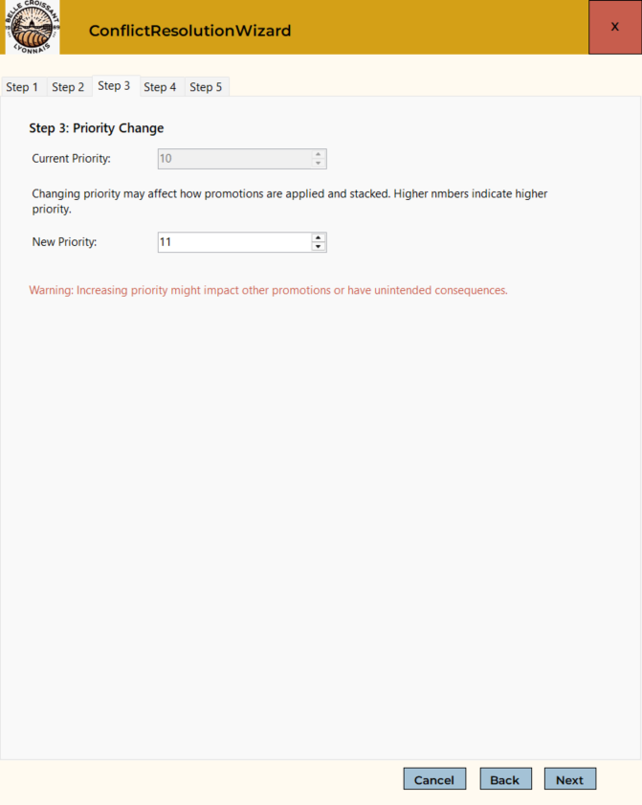
private int? priorityChanged = 0;

public ConflictResolutionWizard(Promotion currentPromotion, Dictionary<Promotion, string> allConflictedPromotions)
{
InitializeComponent();
this.currentPromotion = currentPromotion;
this.allConflictedPromotions = allConflictedPromotions;
tabControl1.SelectedIndex = 0;
UpdatePage();
button3.Enabled = false;
label40.ForeColor = ColorTranslator.FromHtml("#c75d4d");
label40.Visible = false;
}

private void numericUpDown1_ValueChanged(object sender, EventArgs e)
{
priorityChanged = (int)numericUpDown1.Value;

if (priorityChanged > currentPromotion.Priority)
{
label40.Visible = true;
}
else
{
label40.Visible = false;
}
}

Conflict Resolution Wizard Step 4
This code shows the implementation for step 4 of the conflict resolution wizard, used for setting a new start and end date for the promotion as well as removing conflicted products.
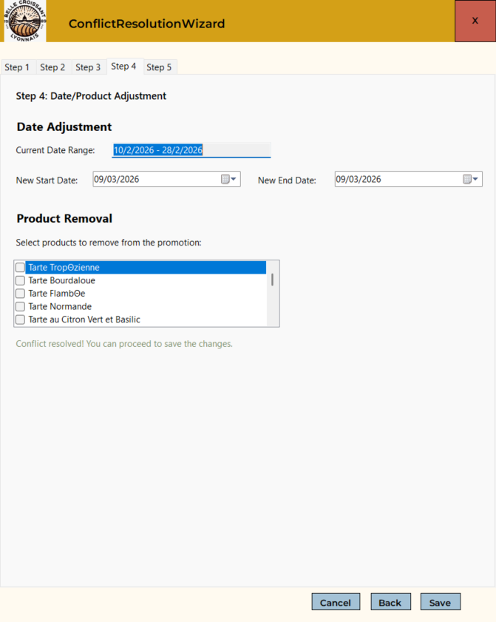
private Dictionary<Promotion, string> allConflictedPromotions;
private Promotion currentPromotion;
private Promotion selectedConflictPromo;
private string conflictedProducts;
private const int maxStepIndex = 4;
private int? priorityChanged = 0;
private DateOnly? startDate;
private DateOnly? endDate;
private bool dateValid = false;
private bool itemsValid = false;
private List<string> productsToRemove;
private int pixelsPerDay = 10;
private int currentStep = 0;

public ConflictResolutionWizard(Promotion currentPromotion, Dictionary<Promotion, string> allConflictedPromotions)
{
InitializeComponent();
this.currentPromotion = currentPromotion;
this.allConflictedPromotions = allConflictedPromotions;
tabControl1.SelectedIndex = 0;
UpdatePage();
button3.Enabled = false;
label24.Visible = false;
label24.ForeColor = ColorTranslator.FromHtml("#7a8c69");
label40.ForeColor = ColorTranslator.FromHtml("#c75d4d");
label40.Visible = false;
}

private void ResetAll()
{
flowLayoutPanel1.Controls.Clear();
UpdatePage();
button3.Enabled = false;
label24.Visible = false;
checkedListBox1.DataSource = null;
checkedListBox1.Items.Clear();
dateValid = false;
startDate = null;
endDate = null;
}

private void GetNewDate()
{
dateValid = false;
label24.Visible = false;
button2.Enabled = false;
startDate = DateOnly.FromDateTime(dateTimePicker1.Value);
endDate = DateOnly.FromDateTime(dateTimePicker2.Value);

if (startDate > endDate)
{
endDate = startDate;
dateTimePicker2.Value = dateTimePicker1.Value;
}

if (startDate <= currentPromotion.EndDate && currentPromotion.StartDate <= endDate && !itemsValid)
{
return;
}

label24.Visible = true;
button2.Enabled = true;
dateValid = true;
}

private void UpdatePage()
{
button2.Text = "Next";
tabControl1.SelectedIndex = currentStep;

switch (tabControl1.SelectedIndex)
{
case 0:
LoadStep1();
break;
case 1:
LoadStep2();
break;
case 3:
LoadStep4();
break;
default:
break;
}
}

private void LoadStep4()
{
textBox13.Text = $"{currentPromotion.StartDate} - {currentPromotion.EndDate}";

var products = Helper.db.Products.ToList();

if (checkedListBox1.Items.Count == 0)
{
checkedListBox1.DataSource = products;
checkedListBox1.DisplayMember = "ProductName";
checkedListBox1.ValueMember = "ProductId";
}

button2.Enabled = false;
button2.Text = "Save";

GetNewDate();
}

private void dateTimePicker1_ValueChanged(object sender, EventArgs e)
{
GetNewDate();
}

private void dateTimePicker2_ValueChanged(object sender, EventArgs e)
{
GetNewDate();
}

private void checkedListBox1_SelectedIndexChanged(object sender, EventArgs e)
{
button2.Enabled = false;
label24.Visible = false;
itemsValid = false;

var selectedConflictProducts = conflictedProducts.Split(",");

for (int i = 0; i < checkedListBox1.Items.Count; i++)
{
var item = checkedListBox1.Items[i] as Product;

if (!checkedListBox1.CheckedItems.Cast<Product>().Select(x => x.ProductId).ToList().Contains(item.ProductId) && selectedConflictProducts.Contains(item.ProductId.ToString()) && !dateValid)
{
return;
}
}

productsToRemove = checkedListBox1.CheckedItems.Cast<Product>().Select(x => x.ProductId.ToString()).ToList();

label24.Visible = true;
button2.Enabled = true;
itemsValid = true;
}

Conflict Resolution Wizard Step 5
This code shows the implementation for step 5 of the conflict resolution wizard, used for saving changes and discarding changes.

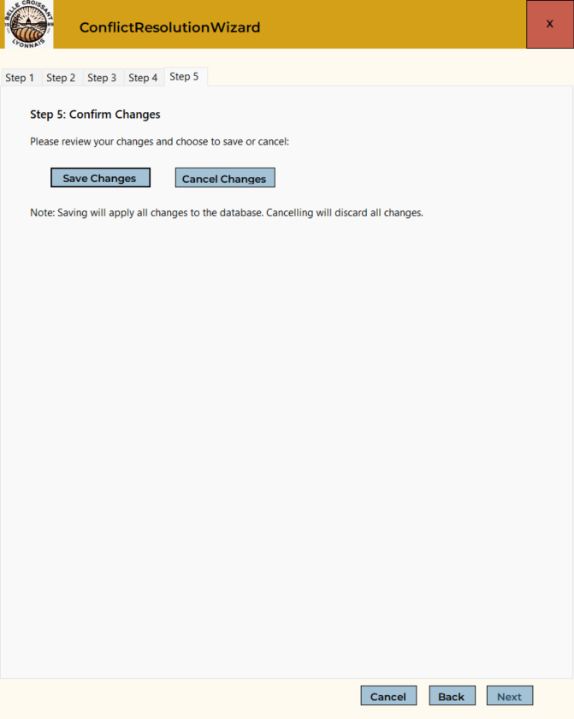
// cancel button in step 5 clicked
private void button6_Click(object sender, EventArgs e)
{
if (MessageBox.Show("Are you sure you want to cancel the new/modified promotion? No changes will be made to the database.", "Cancel Confirmation", MessageBoxButtons.OKCancel) == DialogResult.OK)
{
Helper.db.ChangeTracker.Entries().ToList().ForEach(x => x.State = Microsoft.EntityFrameworkCore.EntityState.Unchanged);

MessageBox.Show("Changes cancelled. No modifications were made.", "Cancelled", MessageBoxButtons.OK);

ResetAll();
this.Close();
}
}

// save changes button in step 5 clicked
private void button5_Click(object sender, EventArgs e)
{
if (priorityChanged != null && startDate != null && endDate != null)
{
currentPromotion.StartDate = startDate ?? currentPromotion.StartDate;
currentPromotion.EndDate = endDate ?? currentPromotion.EndDate;
currentPromotion.Priority = priorityChanged ?? 0;

if (productsToRemove != null && productsToRemove.Count > 0)
{
var currProducts = currentPromotion.ApplicableProducts.Split(",").ToList();
productsToRemove.ForEach(x => currProducts.Remove(x));
currentPromotion.ApplicableProducts = string.Join(",", currProducts);
}

Helper.db.Promotions.Entry(currentPromotion).State = Microsoft.EntityFrameworkCore.EntityState.Modified;
}

Helper.db.SaveChanges();

MessageBox.Show("Changes saved successfully", "Success", MessageBoxButtons.OKCancel);

ResetAll();
this.Close();
}

