September 13th, 2016 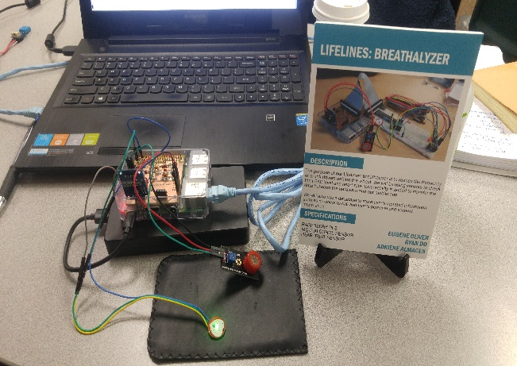

***Proposal for the development of   
Lifelines: Portable Breathalyzer***

Prepared by Eugene Oliver, Ryan Do, Adriene Almacen

*Computer Engineering Technology Student*

EugeneHasJeans.github.io

# Executive Summary

As students in the Computer Engineering Technology program, we will be integrating the knowledge and skills we have learned from our program into this Internet of Things themed capstone project. This proposal requests the approval to build the hardware portion that will connect to a database as well as to a mobile device application. The internet connected hardware will include a custom PCB with sensors and actuators for testing and finding a user’s alcohol level. The database will store information on past alcohol levels of the user, and information on the legal alcohol levels in the province/state. The mobile device functionality will include information, based on the found alcohol level, of friends or taxis to call, GPS location to find the closest hotel and other features. This will be further detailed in the mobile application proposal. We plan to collaborate with the HRT – Hospitality, Recreation and Tourism department here at Humber college.

The hardware was completed in CENG 317 Hardware Production Techniques independently and the application will be completed in CENG 319 Software Project. These will be integrated together in the subsequent term in CENG 355 Computer Systems Project as a member of a 2 or 3 student group.

# Background

The problem solved by project is the frequency of people that drink and drive and endanger their lives and the lives of others. Using the alcoholic level tester, people can realize how much alcohol is actually in their system and from that can create a solution for their safety instead of going into a bad path. Every year there is a call of help for people to stop drinking and driving, but yet every year there are accidents that always lead to a common problem of alcohol consumption. Studies have shown that out of all the young drinking drivers who cause harm on the road, the largest age group is 19 years of age, which is also a big age group for the use of technology and phones/gadgets. I believe that the more people who use this project will lower the rate of this problem and bring us one step closer to a solution for drinking and driving.

We have searched for prior art via Humber’s IEEE subscription selecting “My Subscribed Content” and have found and read three which provides insight into similar efforts.

In the Computer Engineering Technology program we have learned about the following topics from the respective relevant courses:

* Java Docs from CENG 212 Programming Techniques In Java,
* Construction of circuits from CENG 215 Digital And Interfacing Systems,
* Rapid application development and Gantt charts from CENG 216 Intro to Software Engineering,
* Micro computing from CENG 252 Embedded Systems,
* SQL from CENG 254 Database With Java,
* Web access of databases from CENG 256 Internet Scripting; and, • Wireless protocols such as 802.11 from TECH152 Telecom Networks.

This knowledge and skill set will enable me to build the subsystems and integrate them together as my capstone project.

# Methodology

This proposal is assigned in the first week of class and is due at the beginning of class in the second week of the fall semester. My coursework will focus on the first two of the 3 phases of this project:

Phase 1 Hardware build.

Phase 2 System integration.

Phase 3 Demonstration to future employers.

## Phase 1 Hardware build

The hardware build will be completed in the fall term. It will fit within the CENG Project maximum dimensions of 12 13/16" x 6" x 2 7/8" (32.5cm x 15.25cm x 7.25cm) which represents the space below the tray in the parts kit. The highest AC voltage that will be used is 16Vrms from a wall adaptor from which +/- 15V or as high as 45 VDC can be obtained. Maximum power consumption will be 20 Watts.

*Phase 2 System integration*

The system integration will be completed in the fall term.

## Phase 3 Demonstration to future employers

This project will showcase the knowledge and skills that I have learned to potential employers.

The tables below provide rough effort and non-labour estimates respectively for each phase. A Gantt chart will be added by week 3 to provide more project schedule details and a more complete budget will be added by week 4. It is important to start tasks as soon as possible to be able to meet deadlines.

|  |  |  |
| --- | --- | --- |
| **Labour Estimates** | **Hrs** | **Notes** |
| **Phase 1** |  |  |
| a) Writing proposal. | 9 | Tech identification quiz. |
| b) Creating project schedule. Initial project team meeting. | 9 | Proposal due. |
| c) Creating budget. Status Meeting. | 9 | Project Schedule due. |

|  |  |  |
| --- | --- | --- |
| d) Acquiring components and writing progress report. | 9 | Budget due. |
| e) Mechanical assembly and writing progress report. Status Meeting. | 9 | Progress Report due (components acquired milestone). |
| f) PCB fabrication. | 9 | Progress Report due (Mechanical Assembly milestone). |
| g) Interface wiring, Placard design, Status Meeting. | 9 | PCB Due (power up milestone). |
| h) Preparing for demonstration. | 9 | Placard due. |
| i) Writing progress report and demonstrating project. | 9 | Progress Report due  (Demonstrations at Open House Saturday, November 7, 2015 from 10 a.m. - 2 p.m.). |
| j) Editing build video. | 9 | Peer grading of demonstrations due. |
| k) Incorporation of feedback from demonstration and writing progress report.  Status Meeting. | 9 | 30 second build video due. |
| l) Practice presentations | 9 | Progress Report due. |
| m) 1st round of  Presentations,  Collaborators present. | 9 | Presentation PowerPoint file due. |
| n) 2nd round of  Presentations | 9 | Build instructions up due. |
| o) Project videos, Status Meeting. | 9 | 30 second script due. |
| **Phase 1 Total** | **135** |  |
| **Phase 2** |  |  |
| a) Meet with collaborators | 9 | Status Meeting |
| b) Initial integration. | 9 | Progress Report |
| c) Meet with collaborators | 9 | Status Meeting |
| d) Testing. | 9 | Progress Report |
| e) Meet with collaborators | 9 | Status Meeting |
| f) Meet with collaborators | 9 | Status Meeting |
| g) Incorporation of feedback. | 9 | Progress Report |
| h) Meet with collaborators | 9 | Status Meeting |
| i) Testing. | 9 | Progress Report |
| j) Meet with collaborators | 9 | Status Meeting |
| k) Prepare for demonstration. | 9 | Progress Report |
| l) Complete presentation. | 9 | Demonstration at Open House Saturday, April 9, 2016 10 a.m. to 2 p.m. |
| m) Complete final report.  1st round of  Presentations. | 9 | Presentation PowerPoint file due. |
| n) Write video script. 2nd round of Presentations, delivery of project. | 9 | Final written report including final budget and record of expenditures, covering both this semester and the previous semester. |
| o) Project videos. | 9 | Video script due |
| **Phase 2 Total** | **135** |  |
| **Phase 3** |  |  |
| a) Interviews | TBD |  |
| **Phase 3 Total** | **TBD** |  |

|  |  |  |
| --- | --- | --- |
| **Material Estimates** | **Cost** | **Notes** |
| **Phase 1** |  |  |
| Raspberry Pi 3 Starter Kit | $119.99 | (Canakit) Amazon –B01CCF9BYG |
| Electronics Parts Kit | $119.99 | Humber – SKU #163 |
| MQ-3 Sensor | $11.95 | Amazon.ca – B01ISMV6G8 |
| XD-58C Sensor | $18.99 | Amazon.ca – B01AUVMFIS |
| Solder Kit | ~ $40.00 | Humber |
| Soldering Iron | ~ $20.00 | Humber |
| **Phase 1 Total** | **~ $330.92** |  |
| **Phase 2** |  |  |
| a) Materials to improve  functionality, fit, and finish of project. |  |  |
| **Phase 2 Total** | **TBD** |  |
| **Phase 3** |  |  |
| a) Off campus colocation | <$100.00 | An example: [4]. |
| *Shipping* | *TBD* |  |
| *Tax* | *TBD* |  |
| *Duty* | *TBD* |  |
| **Phase 3 Total** | **TBD** |  |

# Concluding remarks

This proposal presents a plan for providing an IoT solution for the abnormal amount of people that dangerously drink and drive above the alcohol limit. This is an opportunity to integrate the knowledge and skills developed in our program to create a collaborative IoT capstone project demonstrating my ability to learn how to support projects. I request approval of this project.

# References