Mid Term Final Report
Machine Learning Foundations
Eugene Ho, Matthew Lawlor, Jonah Zembower
Professor Ben Collier

Decision Context and Why It Matters
The opioid epidemic remains one of the most significant public health challenges facing Boston. In addition to overdose deaths and healthcare costs, opioid use creates visible public health concerns such as discarded syringes, which pose risks to community safety and environmental health. The City of Boston has developed a coordinated response to address opioid use through harm reduction, treatment access, outreach services, and public sanitation initiatives led primarily by the Boston Public Health Commission (BPHC). These programs aim to reduce overdose deaths, connect individuals to treatment, and mitigate the public health impacts of substance use across the city (City of Boston, 2025).

Boston invests substantial resources in opioid-related prevention, treatment, and response efforts. The Boston Public Health Commission operates with an annual operating budget exceeding $145 million, supporting public health programs that include harm reduction, substance use treatment coordination, and outreach services (City of Boston, 2025). In addition to this core funding, Boston receives opioid settlement funding from pharmaceutical litigation. As of 2025, the city has received over $15 million in opioid settlement funds, with additional annual payments expected through 2039. These funds have been allocated toward housing support, overdose prevention, clinical services, community grants, and workforce development programs addressing substance use disorder (Boston Public Health Commission, 2025a).

Boston also receives federal funding for opioid response initiatives. Through the Centers for Disease Control and Prevention’s Overdose Data to Action (OD2A) program, Boston receives approximately $1.3 million annually to support overdose surveillance, naloxone distribution, and substance use navigation services in community health centers (Boston Public Health Commission, 2024). These investments reflect the city’s emphasis on using data-driven approaches to respond to overdose risk and improve access to treatment.

Despite these efforts, responding to opioid-related public health concerns requires significant operational coordination. The city deploys multiple response mechanisms, including outreach teams, harm reduction programs, treatment navigation services, and sanitation efforts to remove discarded syringes. Boston maintains a Mobile Sharps Team that responds to syringe disposal requests submitted through the city’s 311 service system, while outreach workers simultaneously engage individuals experiencing substance use disorder and connect them to treatment or shelter services (Boston Public Health Commission, 2025b). In addition, the city operates syringe disposal kiosks and conducts proactive sweeps in areas where needle debris is commonly reported.

These activities require careful allocation of limited public health resources. Currently, many responses to syringe disposal rely on reactive reporting through 311 service requests, meaning that the city deploys staff after a problem has already been identified. However, opioid-related activity and syringe disposal are often geographically clustered and may follow temporal patterns related to neighborhood characteristics, service availability, or seasonal factors.

Predicting where and when syringe disposal activity is likely to occur could therefore improve how Boston allocates resources. If high-risk locations or periods can be identified in advance, the city could proactively deploy outreach teams, harm reduction services, and sanitation resources before incidents escalate. This type of predictive insight could help reduce response times, improve neighborhood safety, and ensure that harm reduction services are targeted toward the communities with the greatest need.

This study seeks to address the following research question:

Can high-risk locations or time periods for discarded syringe activity be predicted in advance to support proactive resource allocation in Boston?

To investigate this question, we use Boston’s 311 service request data for needle pickup as a proxy indicator of public drug use and opioid-related harm. While discarded needle reports do not directly measure opioid use prevalence, prior research has shown that spatial patterns of syringe disposal can serve as useful indicators for identifying opioid-related risk environments and targeting harm reduction interventions (Bearnot et al., 2018).

Using this data, we develop a Random Forest classification model to analyze historical patterns in needle pickup requests and determine whether future high-risk periods or locations can be predicted. If successful, the model could support a shift from reactive response strategies toward proactive resource deployment, allowing city agencies to anticipate service needs and allocate public health resources more effectively.

Data description and preparation steps
Data Description
This project uses Boston 311 service request data from 2018–2025, compiled from multiple yearly CSV files. The dataset includes public service requests submitted by residents and city agencies and contains fields describing request timing, request category, geographic location, and case status. Key variables include the request opening and closing dates, service request category (subject, reason, and type), neighborhood identifiers, ward and precinct, geographic coordinates, and request source.

For this study, needle pickup service requests are used as a proxy indicator for opioid-related public drug use activity. Discarded syringes are frequently reported through the 311 system and represent a visible public health concern associated with injection drug use. Identifying spatial and temporal patterns in these requests allows the dataset to serve as a proxy signal for neighborhoods and time periods with elevated opioid-related risk.

Because the research objective focuses on predicting high-risk locations and periods, the analysis emphasizes variables describing request type, geographic location, and timing.

Dataset Preparation - Integration
The raw dataset consisted of separate CSV files for each year (2018–2025). Because the schema of 311 data can vary across years, the first step involved reviewing column structures across files and identifying variables that were consistently available. Only columns relevant to the research question and present across years were retained.

Each yearly dataset was then reduced to this shared column set, tagged with a year identifier, and concatenated into a unified dataset saved as master_311.csv.

Dataset Preparation - Column Selection and Cleaning
Following the initial merge, the dataset was reviewed for missingness, redundant fields, and variables with limited analytical value. Several columns were removed because they were either highly incomplete or unlikely to contribute to predictive modeling. Examples include administrative identifiers, descriptive titles, and detailed street information.

The final working dataset retained variables related to:
Service request type
Case timing (open and close dates)
Neighborhood and district identifiers
Ward and precinct
Geographic coordinates (latitude and longitude)
Request source
Latitude and longitude were prioritized over street and ZIP code fields because they provide more precise geographic information for spatial analysis.

Dataset Preparation - Geographic Validation
Latitude and longitude values were converted to numeric format and validated to ensure that coordinates fell within the geographic range of the Boston metropolitan area. A small number of rows containing invalid or malformed coordinates were removed. Rows with missing values in required fields were also dropped to produce a complete dataset for analysis.

The resulting cleaned dataset was saved as master_311_clean.csv.

Feature Preparation and Exploratory Analysis
Neighborhood Standardization
Some neighborhood labels in the original dataset contained combined or inconsistent naming conventions. To prevent fragmentation in geographic summaries, several labels were standardized into unified categories (e.g., consolidating variations of South Boston, Fenway, and Downtown).

Target Variable Definition
To identify relevant opioid-related proxy events, a binary indicator variable is_needle was created by identifying records where the service request type contained the phrase “Needle Pickup.” This variable enables the dataset to distinguish needle-related incidents from other 311 service requests.

Exploratory Data Analysis
Initial exploratory analysis examined both spatial and temporal patterns in the data. Neighborhood-level summaries were used to compare total 311 request volume with the number and share of needle-pickup requests, helping identify areas with disproportionately high needle-related activity.

Temporal analysis converted request opening dates to datetime format and evaluated monthly and yearly trends in needle pickup incidents. These patterns suggested meaningful variation across time, supporting the inclusion of temporal features such as year and month in later predictive modeling.

Additional checks were conducted to identify duplicate case identifiers, evaluate missingness in geographic fields, and review response times between request opening and closing dates. Response times were found to be highly right-skewed, suggesting that transformations would be required if this variable were included in modeling.

Final Dataset
The data preparation pipeline produced two primary datasets:
master_311.csv – the merged dataset combining all yearly files with selected columns
master_311_clean.csv – the cleaned and filtered dataset used for exploratory analysis and modeling
Overall, the preparation process transformed raw yearly 311 service request files into a consistent, geographically validated, and analysis-ready dataset suitable for modeling opioid-related risk patterns across Boston.

Method Explanation and Why It Fits The Problem

In this study, a Random Forest Classification model is used to predict whether a neighborhood-month in Boston will be a high-risk period for needle pickup activity. We chose classification rather than regression since it reflects the structure of the resource allocation decision that this analysis is made to support. City agencies don’t have to create cleanup crews and outreach workers based on the exact count of needle pickups. Instead, they make discrete deployment decisions to send a team or don’t send a team. A binary classifier that separates high-risk from low-risk neighborhood-months maps directly into this operational decision.

Random Forest was selected for several reasons, the first being that they are robust to correlated features and non-linear relationships, which are both present in the 311 service request data. The feature set includes proportions of service request categories, response time statistics, and temporal indicators that interact in complex ways. Second, Random Forest models create more interpretable feature importance rankings, which are very valuable in a policy context so that stakeholders can understand what conditions are associated with elevated risk. And third, they handle mixed feature types and skewed distributions without heavy preprocessing, which is appropriate for a dataset that combines temporal, geographic, and categorical features.

Target Variable and Features:

Request-level data was aggregated to 1,983 neighborhood-month observations. A neighborhood-month is labeled high-risk if its needle count meets or exceeds the 75th percentile, which produced 500 high-risk and 1,483 low risk observations.

A Cramér's V analysis revealed associations between subject, reason, and type (V ≈ 1.0), and high redundancy between neighborhood, neighborhood services district, and ward (V > 0.7). These findings influenced the decision to drop type (it was used to derive the target and would leak the answer) and to exclude geographic identifiers to prevent the model from memorizing location patterns.

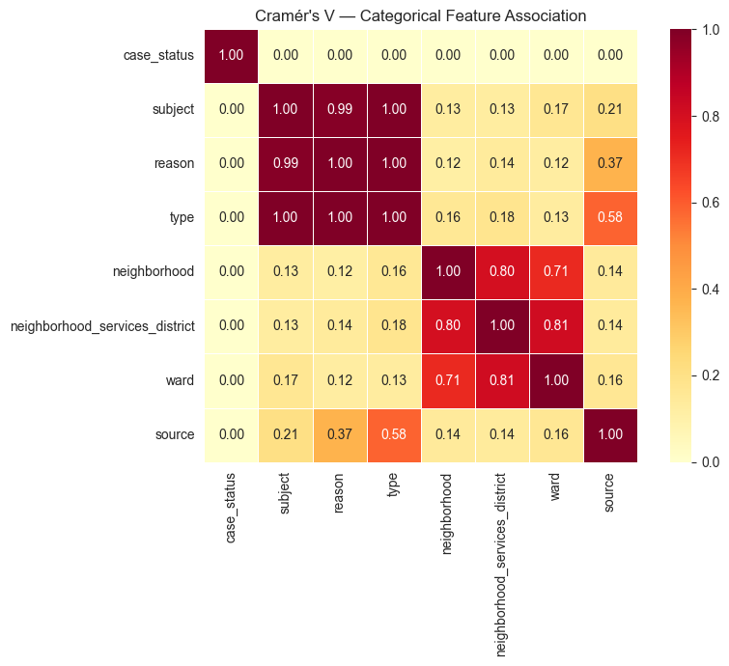
Figure 1: Cramér's V Heatmap; Multicollinearity – Categorical Features

Temporal feature selection was informed by comparing the range of needle pickup rates across three groupings. Year showed the widest variation (4.82 percentage points), followed by month (2.41 pp) and quarter (1.91 pp). Month was kept as a feature because it captures seasonal patterns relevant to opioid activity, while year was used only for the train-test split to avoid leakage.

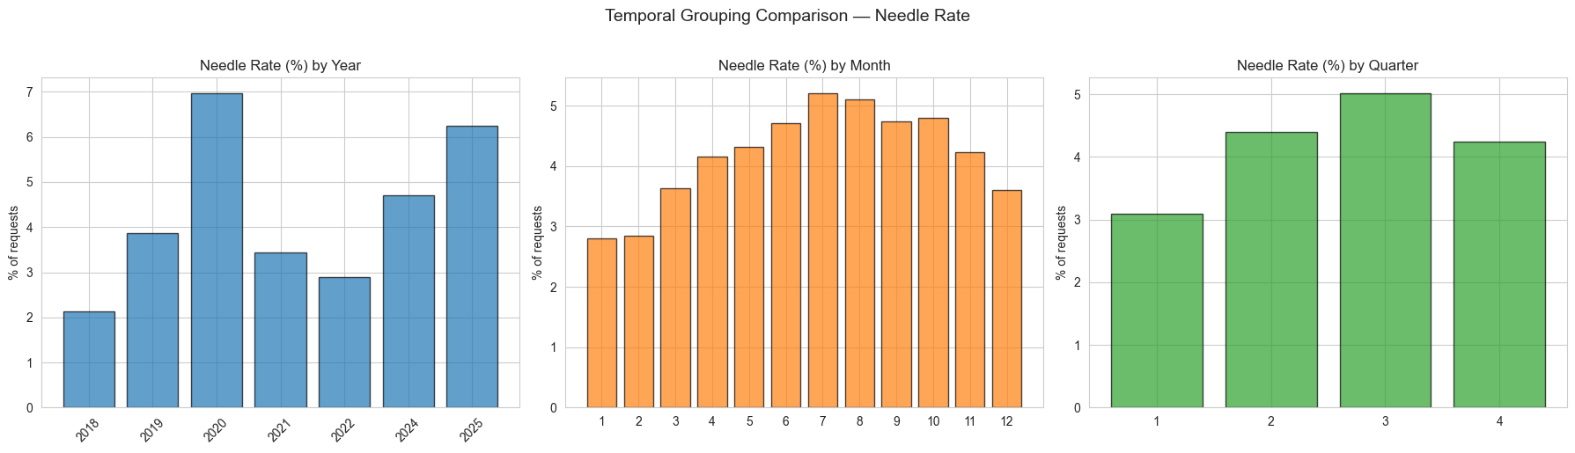
Figure 2: Temporal Features; Year, Month, and Quarter
The final 15 features span 4 categories: temporal (month), volume (total 311 requests), operational (median log response time, fast-close rate, source shares), and compositional (department and reason proportions). Neighborhood identity was intentionally excluded from the feature set. Including neighborhood as a feature would allow the model to memorize which neighborhoods have historically high needle counts rather than learning what observational conditions predict risk. By relying on measurable characteristics, the model produces insights about the drivers of risk that can generalize across locations and inform intervention.

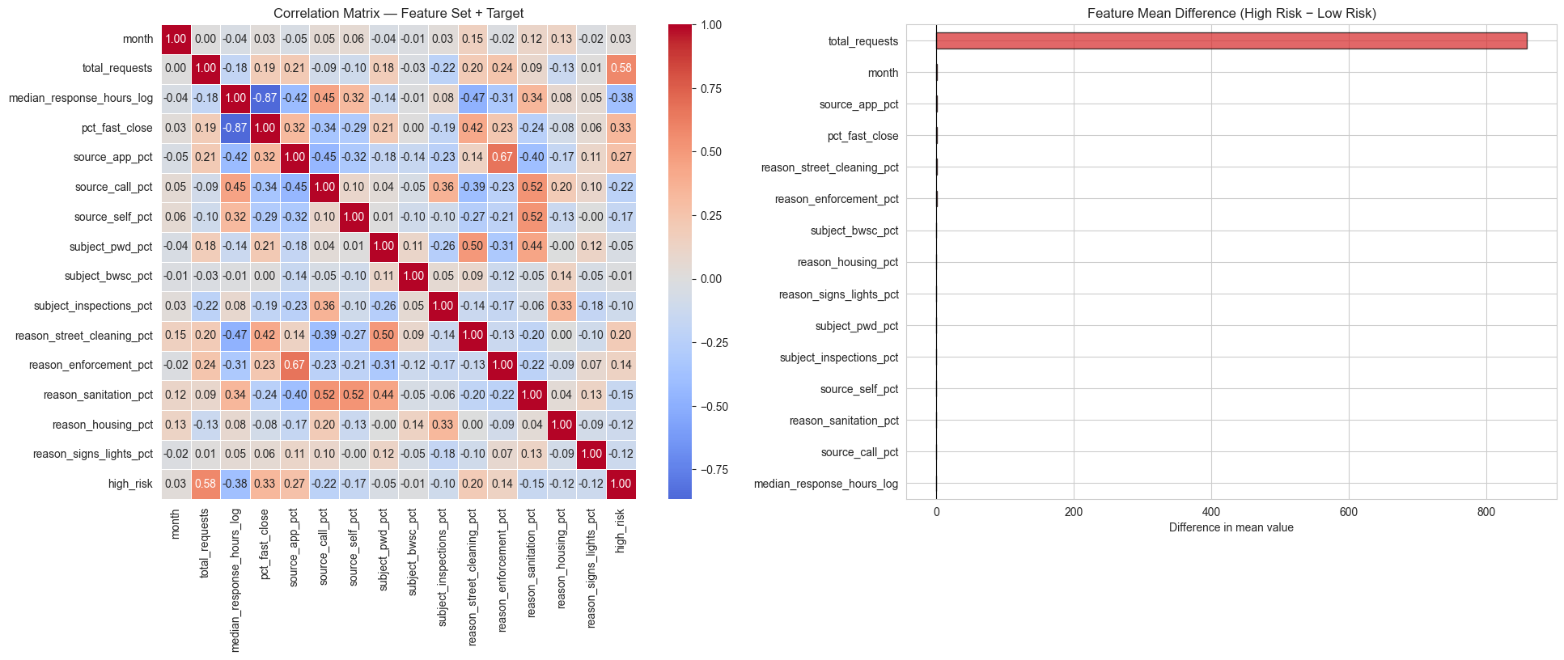
Figure 3: Feature Correlation Matrix

Validation Strategy and Model Configuration

The model was evaluated using a time-based train-test split rather than random cross-validation. The training set includes all neighborhood-months from 2018 through 2022 (1,416 observations), and the test set includes neighborhood-months from 2024 through 2025 (567 observations). This temporal split simulates a real deployment scenario.

The Random Forest classifier was configured with 500 trees, no maximum depth constraint, a minimum of 3 samples per leaf, and a minimum of 4 samples required to split an internal node. Because the target variable is imbalanced (approximately 25% high-risk), the model was trained with a class weight of 4:1 in favor of the high-risk class. This weighting penalizes missed high-risk cases more heavily during training, aligning the optimization objective with the policy priority of catching as many true high-risk periods as possible.
In addition to class weighting, the default classification threshold of 0.50 was replaced with a tuned threshold. Candidate thresholds were swept on the training set, and the lowest threshold achieving at least 95% training recall was selected, yielding a threshold of 0.30. This means a neighborhood-month is flagged as high-risk if the model’s predicted probability exceeds 30%, ensuring that the model errs on the side of caution.
Results

 | Accuracy | Precision | Recall | F1
Train | .949 | .822 | 1.0 | .902
Test | .899 | .888 | .756 | .817
Table 1: Classification Metrics (Threshold = 0.30)

The model achieves a test ROC-AUC of 0.951, which demonstrates that there is significant discriminative ability across possible thresholds. On the test set, the model was able to identify 75.6% of truly high-risk neighborhood-months (recall) while maintaining 88.8% precision, which means almost 9/10 flagged neighborhood-months are flagged high-risk. The threshold tuning curve (Figure 4) shows how reducing the threshold from 0.50 to 0.30 improves recall at a fair precision cost, which demonstrates a favorable tradeoff for a public health deployment where missing a high-risk period is more costly than a false alarm.

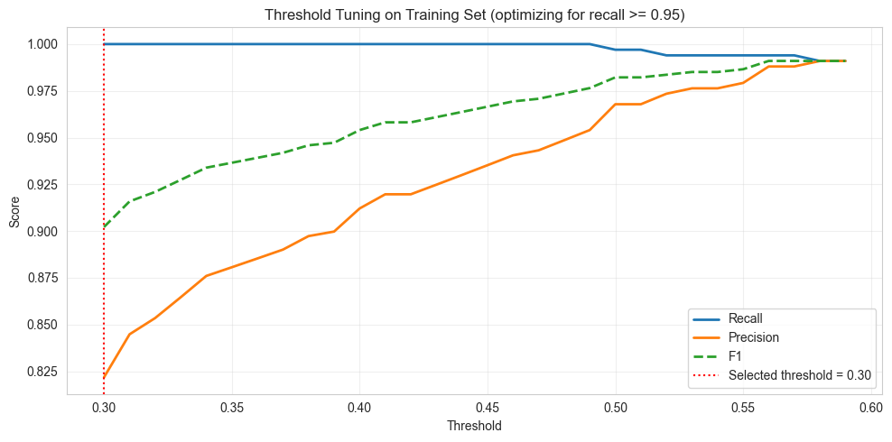
Figure 4: Threshold Tuning Curve; Recall and Precision Across Thresholds

The gap between training and test recall (1.000 vs. 0.756) is expected due to the temporal split design. The training set covers 2018–2022, while the test set covers 2024–2025, a period during which needle pickup patterns may have shifted due to changes in opioid use, policy interventions, or reporting behavior.

The confusion matrix (Figure 5) shows 127 of 168 high risk periods and only 16 false positives among 399 low-risk observations. The train test-recall gap (1.00 vs. 0.76) is a reflection of the temporal split across a missing year for 2023.

Each of the 41 false negatives represents a neighborhood-month where cleanup crews and outreach workers would not have been deployed despite genuine need — the most costly error in this public health context. The 16 false positives represent minor over-deployment, an acceptable cost given the stakes of missed high-risk periods

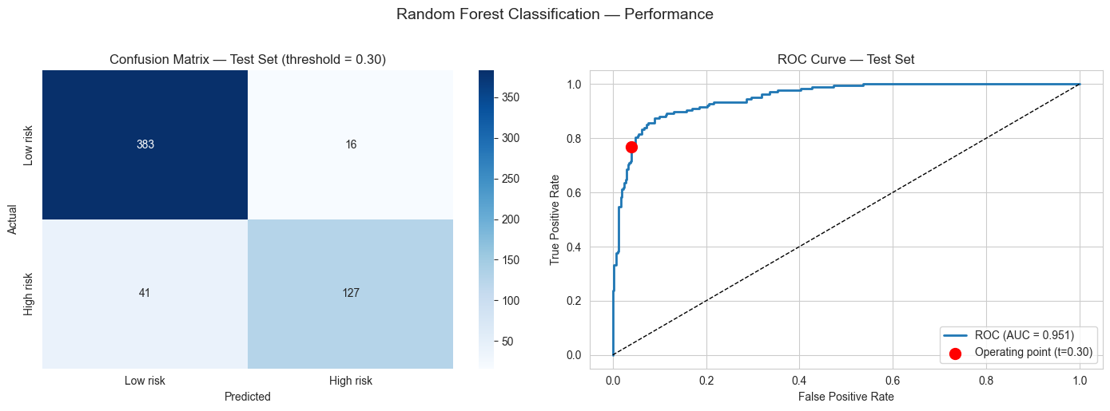

Figure 5: Test Set Confusion Matrix and ROC Curve
Feature Importance:

Total request volume dominates (26.6%), followed by Citizens Connect App share (10.1%), Public Works proportion (8.6%), and fast-close rate (8.1%). Compositional features such as the share of requests related to enforcement, sanitation, and street cleaning each contribute a decent amount of predictive power. This suggests that neighborhoods experiencing high needle activity also tend to generate a particular mix of other service demand.
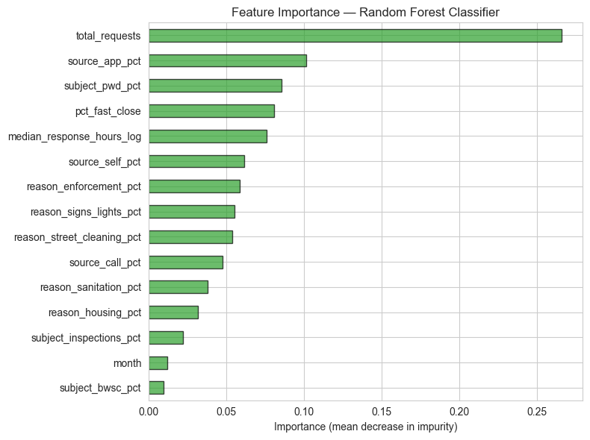
Figure 6: Feature Importance; Random Forest Classifier
Neighborhood Risk Map:

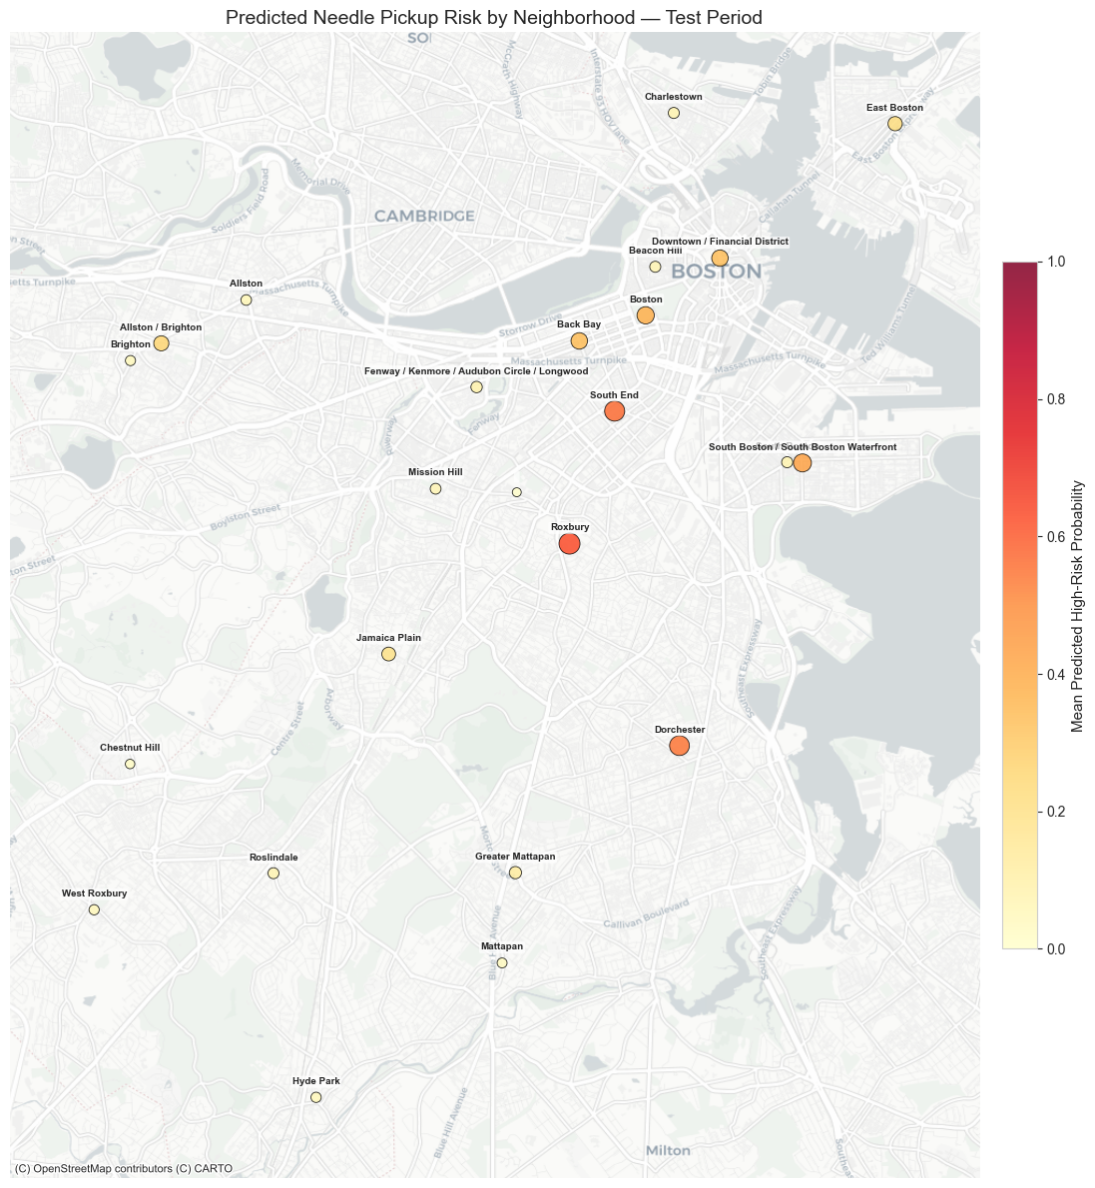
Figure 7: Predicted Needle Pickup Risk by Neighborhood, 2024-2025

Neighborhood | Risk Prob. | % Flagged | Actual HR% | Avg. Needles
Roxbury | 0.631 | 100% | 100% | 267
South End | 0.564 | 83% | 100% | 222
Dorchester | 0.546 | 92% | 100% | 71
South Boston | 0.429 | 75% | 92% | 64
Back Bay | 0.340 | 46% | 96% | 78
Downtown | 0.336 | 54% | 83% | 51
Table 2: Top Neighborhood Risk Rankings; Test Period

Roxbury, South End, and Dorchester are consistently highest-risk (predicted probabilities >0.54, 100% actual high-risk rates). Back Bay is a notable under-detection case (46% flagged vs. 96% actual), suggesting its 311 composition does not match the general high-risk signal.

Implications: What a Decision-Maker Could Do with This

Proactive Deployment: BPHC could use monthly predictions to pre-position any Mobile Sharps teams and outreach workers in high-risk areas before any incidents are reported, which can reduce response time lag and public exposure. For example, Roxbury’s predicted risk probability of 0.631 suggests that it should receive priority deployment, while neighborhoods like Jamaica Plain (0.197) may need seasonal coverage during summer months when needle activity peaks.

Targeted Harm Reduction: Roxbury, South End, and Dorchester, which are all flagged at or above 83% should receive more intense naloxone distribution and treatment navigation during predicted high-risk months, shifting from uniform to more needs-based type allocation.

Infrastructure: Persistently high-risk neighborhoods are candidates for permanent syringe kiosks, expanded clinic hours, or safe consumption sites wherever legally permitted. The model’s spatial predictions can inform long term capital investment alongside monthly operational deployment.

Performance Monitoring: Tracking predicted risk over time after new interventions is able to serve as an outcome measure for program effectiveness.

Equity: Many high-risk neighborhoods are historically underserved and under resourced communities. Predictions should guide equitable access to treatment and harm reduction, not enforcement.

Limitations, Risks, and Ethical Considerations

Proxy Measurement: 311 needle reports are an imperfect proxy for opioid risk. Reporting rates vary by neighborhood due to digital access, civic engagement, and language barriers, meaning the model may underestimate risk in under-reporting communities.

Data Gap: The missing 2023 year creates a gap between training (2018–2022) and testing (2024–2025) that likely contributes to the recall drop.

Model Scope: Lagged features were excluded to avoid location memorization, despite strong predictive signal (lag-1 correlation = 0.82 at the neighborhood-year level). A production version could incorporate lags to improve recall. The 75th percentile threshold defining high-risk is also somewhat arbitrary, a lower threshold would flag more neighborhoods but require greater deployment capacity.

Ethical Risks: If predictions drive policing rather than a public health response, the model could criminalize substance use disorder and disproportionately harm communities. Citizens Connect App share correlates with smartphone access, raising bias concerns. Neighborhood risk scores also carry stigmatization risk and should be framed as public health indicators.

Privacy and Governance: The model operates at the neighborhood-month level and does not identify individuals. Deployment should include clear use policies, community oversight, and supplementation with ground-truth outreach data.
References

Bearnot, B., Pearson, J. F., Rodriguez, J. A., & Ozonoff, A. (2018). Geospatial distribution of discarded needles in Boston, Massachusetts: A public health approach to target discarded needle collection. Public Health Reports.

Boston Public Health Commission. (2024). Boston Overdose Data to Action (OD2A) fact sheet.

Boston Public Health Commission. (2025a). Boston opioid settlements.

Boston Public Health Commission. (2025b). Recovery services and syringe response programs.

City of Boston. (2025). Boston Public Health Commission FY2026 budget.

