**Rocket Frenzy**

This app is designed to make users go on adventures and explore the world around them, while enjoying little mini games along the way!

GitHub Repository:<https://github.com/Lazer7/RocketFrenzy>

1. Task: Map, User Tracking, Markers, Marker Spawning, Game Launch, Camera Following, Camera Tilt, Mapbox API, GPS Floating Action Button
   1. Programmer: Eugene Mesina
   2. Learning Task: 20 hours (Jumping from Unity to Android)
   3. Coding Time: 20 hours(Practicing MapBox examples and Marker Spawning and Location Synch)
   4. Sources: Mapbox API, Mapbox API Documentation/Examples helped a lot in the process of learning and understanding MapBox API.
2. Task: Rocket Launch, Lottery, Game Launch, Step Sensors, Game Randomizer, Win Conditions
   1. Programmer: Eugene Mesina
   2. Learning: 5 hours
   3. Coding: 6 hours
   4. Sources: Stack OverFlow, Explosion Field API, Android Animation Library YouTube
3. Task: Database, Database Integration
   1. Programmer: Christian Blydt-Hansen
   2. Learning: 8 hours
   3. Coding Time: 20 hours
   4. Sources: SQLite API, SQLiteOpenHelper API, w3schools.com SQL Syntax
4. Task: AccGame Minigame
   1. Programmer: Christian Blydt-Hansen, Jimmy Chao
   2. Learning: 4 hours (including class time)
   3. Code Time: 5 hours
5. Task: Fragments (Profile/Shop/Inventory/Help) , XML Layout, Floating Context Menu
6. Programmer: Jimmy Chao
7. Learning: 3 hours
8. Coding Time: 35 hours (Finding appropriate design and adding a lot of components
9. Sources: Android Studio Documentation
10. Task: Expandable List Adapter/Grid Adapter
11. Programmer: Jimmy Chao
12. Learning 3 hours
13. Coding: 5 hours
14. Source: Android Studio Documentation
15. Task: Shake Game
16. Programmer: Jimmy Chao and Eugene Mesina
17. Learning: 2 hours
18. Coding 4 hours
19. Source: Android Studio Documentation
20. Task: Menu Screen UI, Menu Screen Animations, Fragment Holder, Floating Menu, Fragment Backstack
21. Programmer: Daniel Lee
22. Learning Task: 6 hours (Learning Animations, Fragments, Floating Action Buttons, Material Design, and using Paint.NET)
23. Coding Time: 14 hours (Animations, Menu, Fragment Handling)
24. Design Time (Art & UI): 20 hours (Title Screen, Fragments, Rockets)
25. Sources: Floating Action Button documentation, Animation (TranslateAnimation, RotateAnimation, FadeAnimation) documentation, stackoverflow.com, Android Studio Documentation
26. Task: Presentation
    1. Programmers: Eugene Mesina, Christian Blydt-Hansen, Jimmy Chao, Daniel Lee
    2. Total Time: 2 hours
    3. Source: PreziTask
27. Task: GitHub Merging, Reorganizing Code, & Documentation
28. Programmers: Christian Blydt-Hansen, Jimmy Chao, Daniel Lee, Eugene Mesina
29. Coding Time: 6 hours
30. Sources: GitHub

**SNAPSHOTS**

***MainActivity***

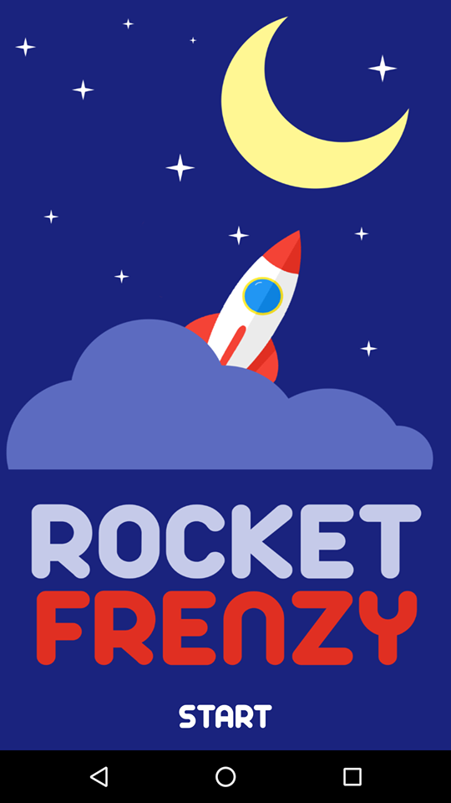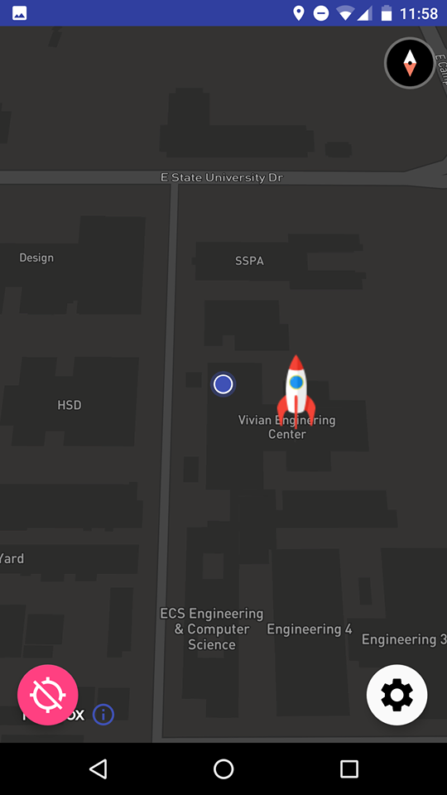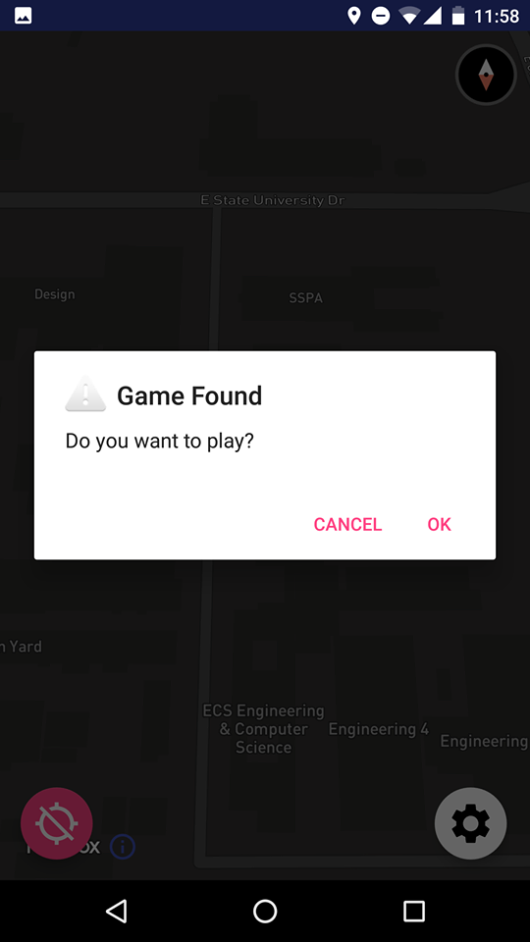

***Help Fragment***

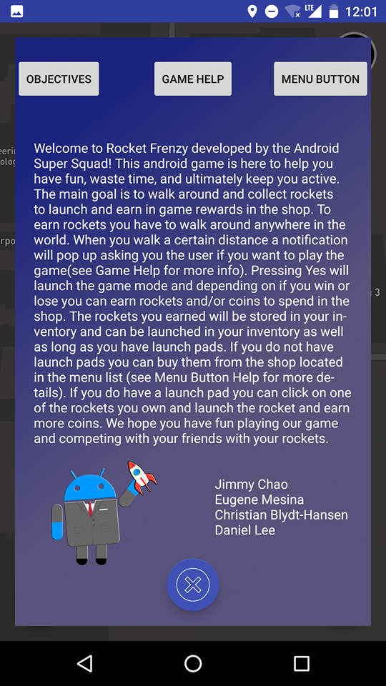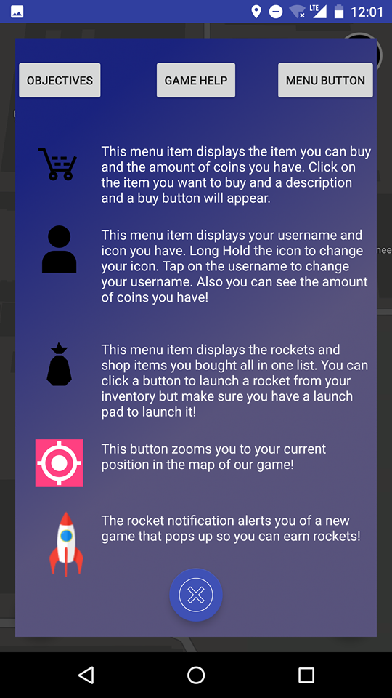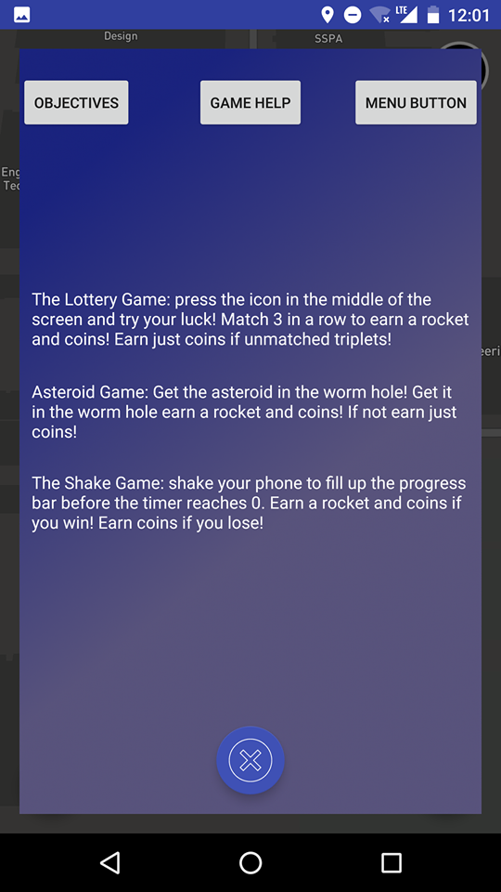

***Shop Fragment***

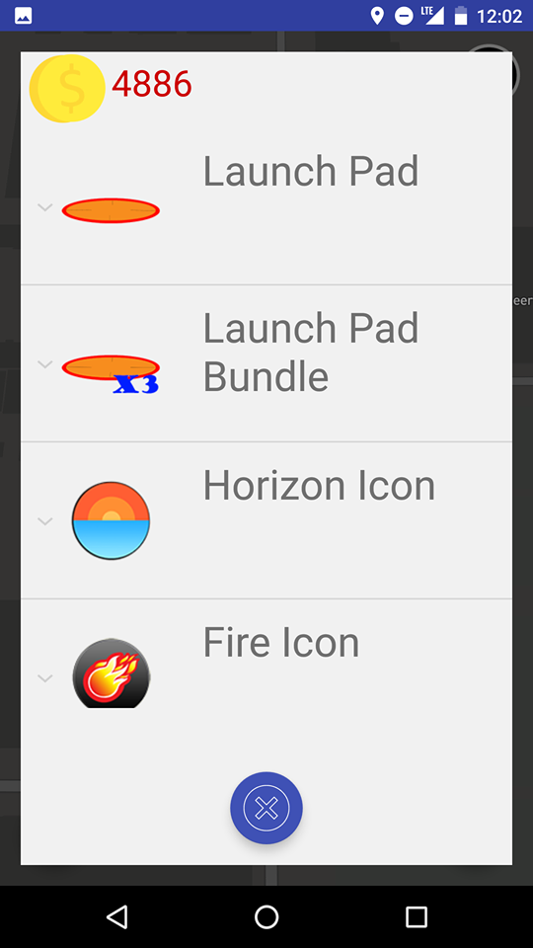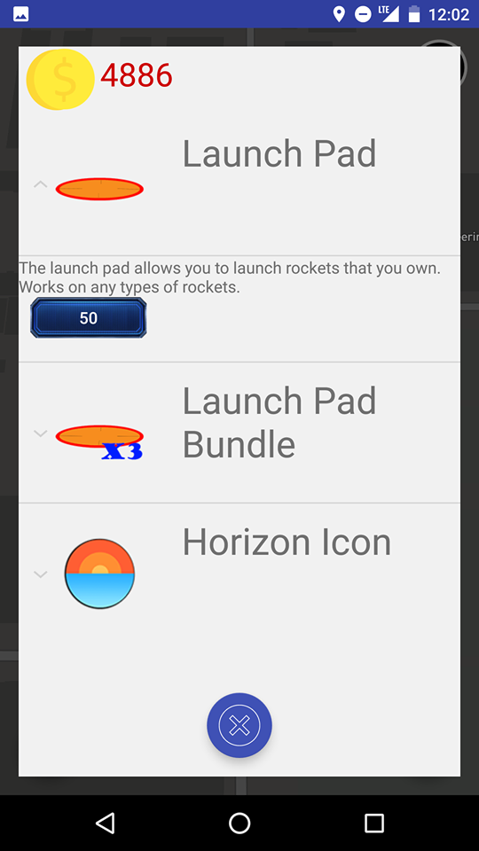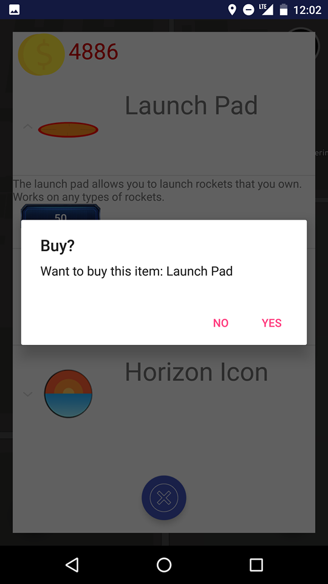

***Inventory Fragment***

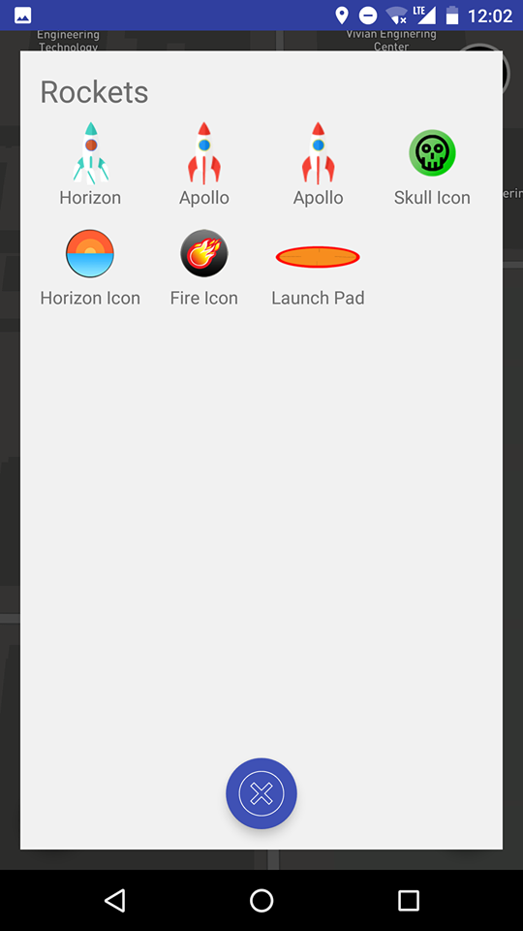

***Rocket Launch***

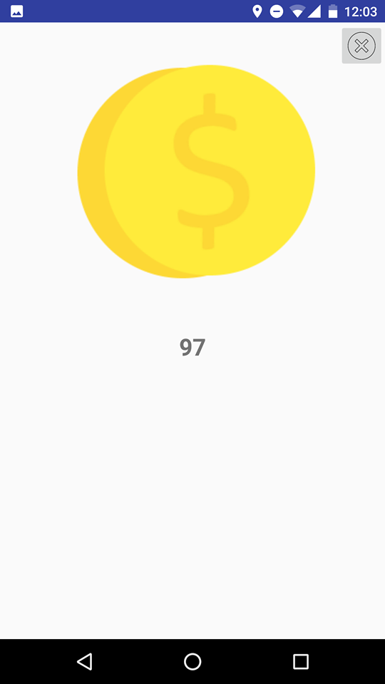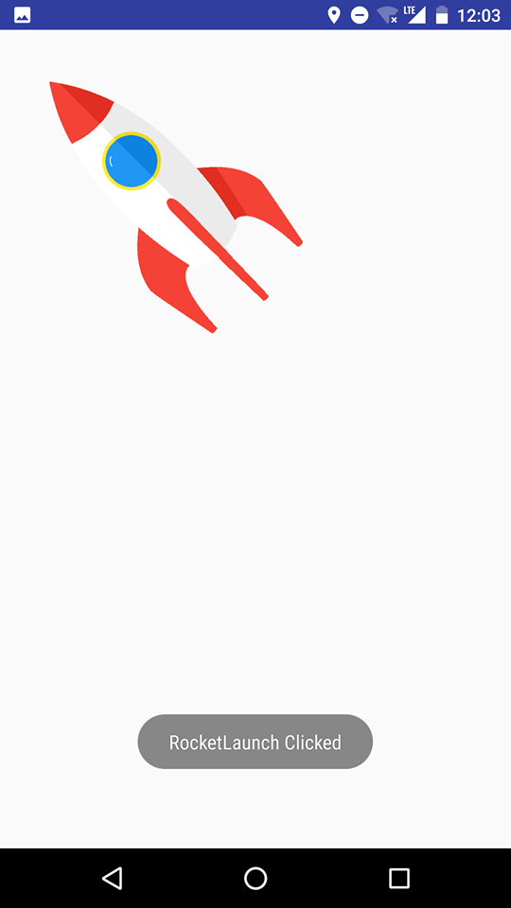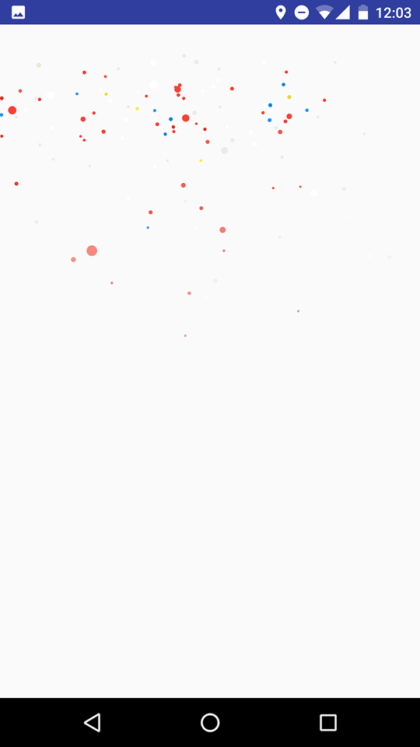

***Profile Fragment***

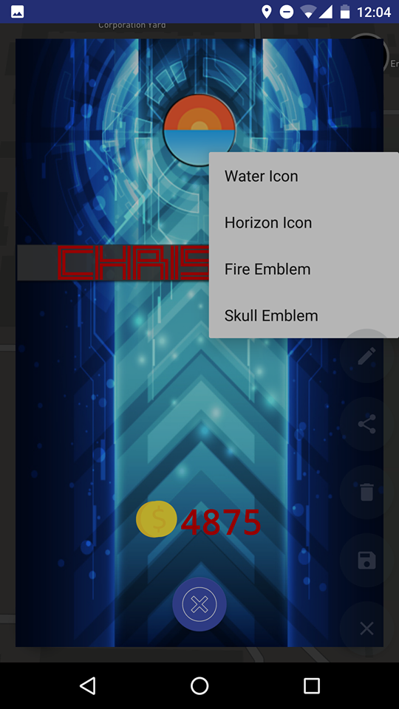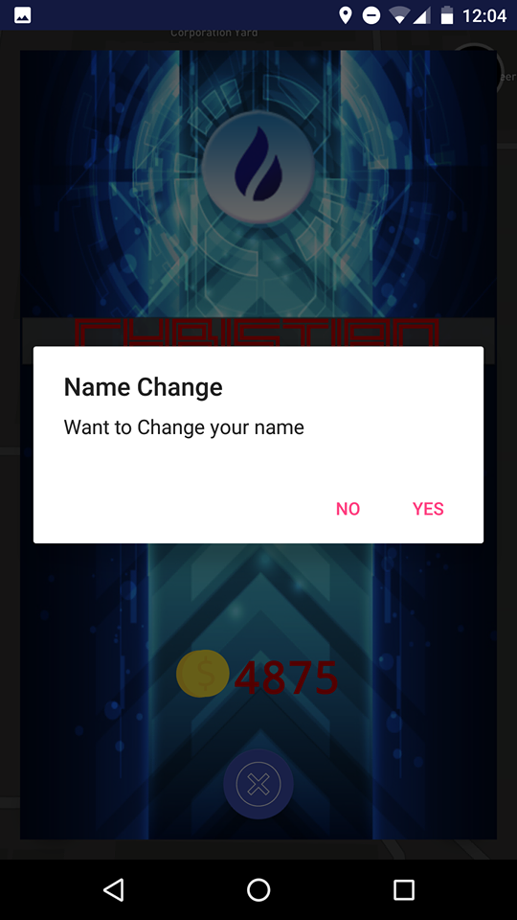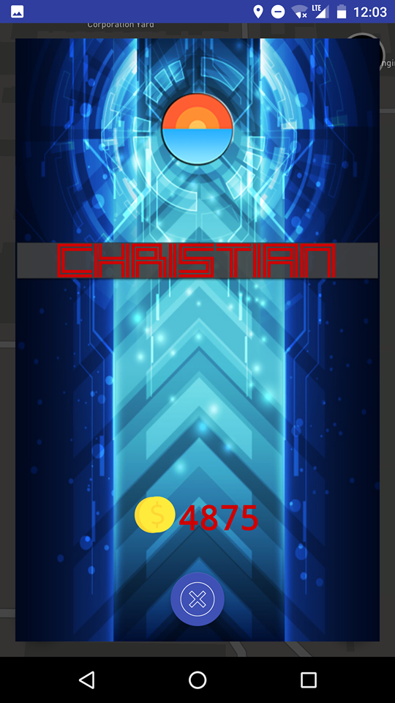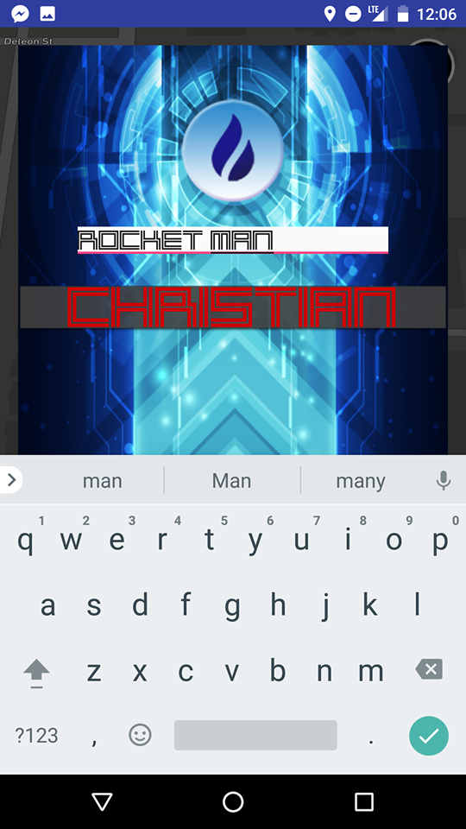

***Games***