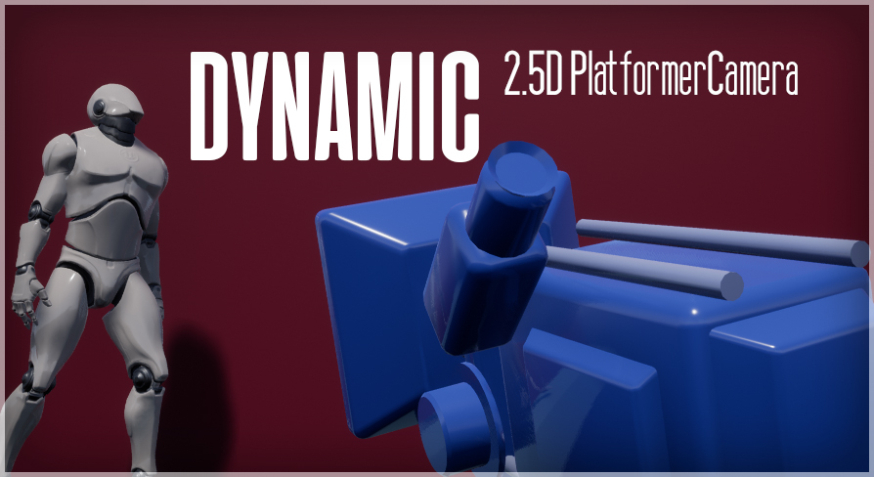
Getting Set up is simple, the main files are

Move a BP_Camera Volume onto the playable area of your level
Next add a BP_2D Camera

In the Volume set the Camera to be the camera you added
Set the tracking types and zoom distance

The SETZ & SETY is used when you set tracking type to “SetValue”

To get the camera to work with your own character blueprint
Copy over the contents of the BP_CamSideScrollerCharacter
Remember to copy the functions as well

