Asia

China

New Houses

60 Merrick Way, Miami

Apartment

Bed 2

Bath 4

Price 2500

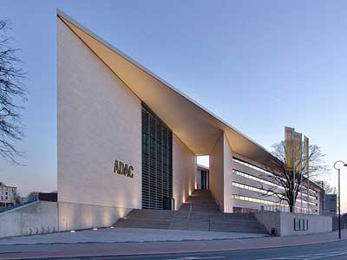

Afica

Ghana

Old Houses

Florida 5, Pinecrest, FL

Apartment

Bed 3

Bath 2

Price 4500

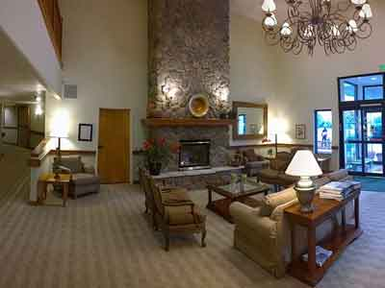

Asia

Thailand

Uncompleted

109 Bollywood Boulevard

Town Houses

Bed 5

Bath 3

Price 9500



Asia

South Korea

For rent

Florida 5, Pinecrest, FL

Villa

Bed 4

Bath 5

Price 5500



Asia

Japan

Old Houses

Florida 5, Pinecrest, FL

TownHouses

Bed 5

Bath 3

Price 7500

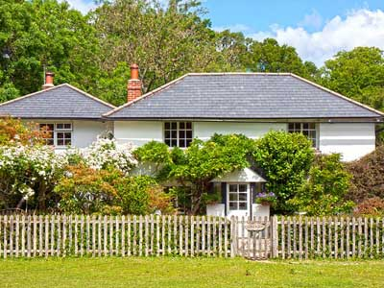

Africa

South Africa

Uncompleted

109 Bollywood Boulevard

Villa

Bed 5

Bath 4

Price 350

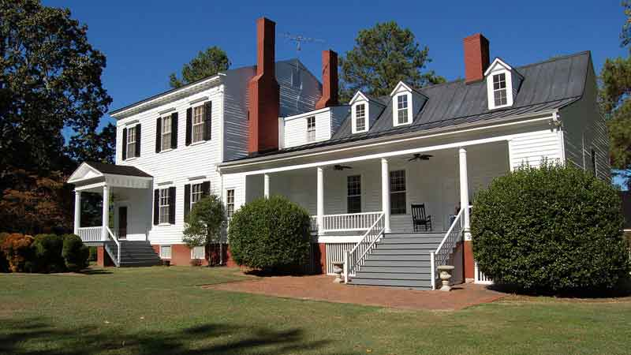

Africa

Ethiopia

New Houses

Florida 5, Pinecrest, FL

Villa

Bed 4

Bath 3

Price 5500



Australia and Oceania

Australia

Old Houses

109 Bollywood Boulevard

Apartment

Bed 3

Bath 3

Price 3500



Australia and Oceania

papua new guinea

New Houses

109 Bollywood Boulevard

TownHouses

Bed 4

Bath 5

Price 6500



Europe

Britain

Uncompleted

Florida 5, Pinecrest, FL

TownHouses

Bed 2

Bath 4

Price 6500



Europe

Germany

Old Houses

Florida 5, Pinecrest, FL

Villa

Bed 4

Bath 3

Price 5500



Europe

France

For rent

Florida 5, Pinecrest, FL

TownHouses

Bed 3

Bath 4

Price 4500



Europe

Finland

For rent

Florida 5, Pinecrest, FL

Apartment

Bed 3

Bath 3

Price 6200



North America

America

Uncompleted

Florida 5, Pinecrest, FL

TownHouses

Bed 4

Bath 3

Price 4700



North America

Canada

For rent

Florida 5, Pinecrest, FL

Villa

Bed 5

Bath 3

Price 6700



North America

Jamaica

Old HOuses

Florida 5, Pinecrest, FL

Apartment

Bed 4

Bath 3

Price 7200



South America

Brazil

For rent

Florida 5, Pinecrest, FL

Townhouses

Bed 4

Bath 3

Price 6600



SouthAmeica

Venezuela

Uncompleted

Florida 5, Pinecrest, FL

TownHOuses

Bed 4

Bath 3

Price 8500



middleEast

Dubai

New Houses

Florida 5, Pinecrest, FL

Villa

Bed 3

Bath 2

Price 6500



Middle East

Qatar

Old Houses

Florida 5, Pinecrest, FL

Apartment

Bed 5

Bath 5

Price 6500

