1. 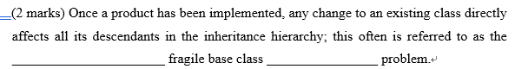
2. 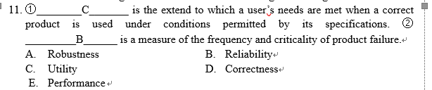
3. 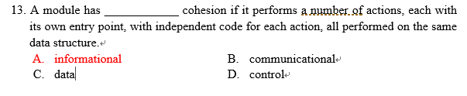
4. 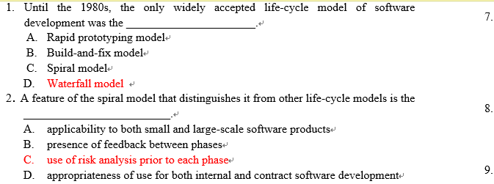
5. 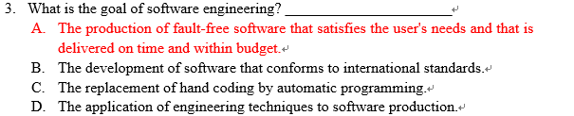
6. 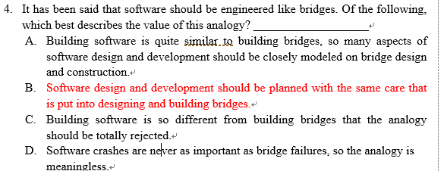
7. 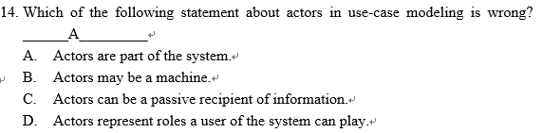
8. 
9. _____T____ The computer scientist investigates a variety of ways to produce software, some good and some bad. But the software engineer is interested in only those techniques that make sound economic sense.
10. 
11. 
12. 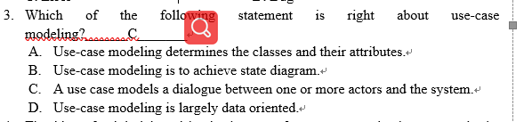
13. 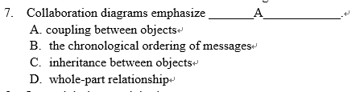
14. 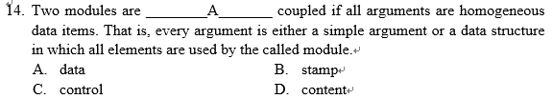
15. 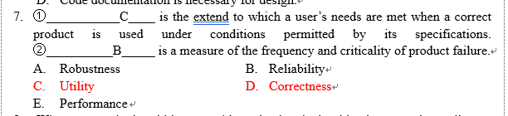
16. Any useful product is almost certain to undergo maintenance during the maintenance phase. Please explain why maintenance is necessary.

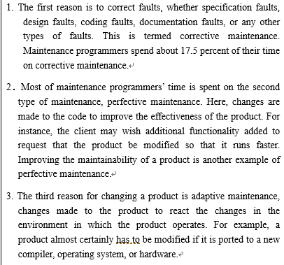

1. 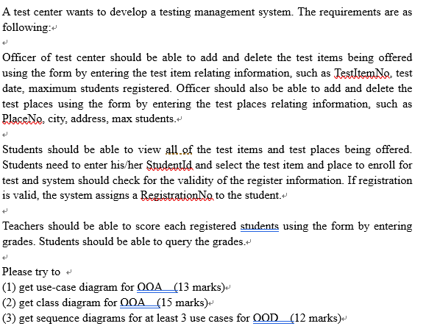
2. Use-case diagram （13 marks）

Grading standard:

1. 6 marks for the actors， 2 marks for each actor
2. 7 marks for the use cases and the relationship between cases



1. Detailed class diagram （15 marks）

Grading standard:

1. 7 marks for the basic class structure
2. 4 marks for the attributes
3. 4 marks for the relationship among classes



1. Sequence diagram （12 marks）

Grading standard:

* 1. 3 of the following sequence diagrams are required
  2. 4 marks for each diagram with 1.5 marks for the objects, 2.5 marks for the sequences respectively

A.

B.



C.



D.



E.



F.



G.



H.



I.

