EOOP – preliminary project

Date: 21.04.20203 Semester: Spring 2023

Author: Riabokin Yevhenii #330374

Subject (Keyword): Animal Shelter Management

Description of the project

Overview of the project
The Animal Shelter Management System is designed to manage various aspects of an animal shelter, including animals, staff, volunteers, adoptions, and donations. Users can add, remove, and update information about animals, staff members, volunteers, adopters, and donations. The system also provides search and display functionalities for easier data management.

Class and data structures overview
The project consists of the following classes: Animal, Adoption, Donation, Staff, Volunteer (which inherits from Staff), and AnimalShelter. The AnimalShelter class serves as the central management class, containing lists for animals, staff members, volunteers, adoptions, donations, and adopters. It provides methods for adding, removing, updating, searching, and displaying data related to each list.

The following classes will be implemented in the project:

• AnimalShelter: This class serves as the main interface for the management system. It contains methods for adding, removing, and updating animals, staff, volunteers, adoptions, and donations. It also provides search functionality for animals, adoptions, and donations, as well as methods for managing adopters.

• Animal: This class represents an individual animal within the shelter. It contains information such as ID, name, species, age, health status, and adoption status. Methods in this class allow for updating the animal's information, checking its availability for adoption, and setting the animal's attributes using setters.

• Staff: This class represents a staff member within the shelter. It includes information such as ID, name, role, and schedule. Methods in this class allow for updating staff information, managing their schedules and responsibilities, and setting the staff member's attributes using setters.

• Volunteer: This class represents a volunteer at the shelter, inheriting from the Staff class. It includes ID, name, availability, and assigned tasks. Methods in this class allow for updating volunteer information, managing their schedules and responsibilities, and setting the volunteer's attributes using setters.

• Adoption: This class represents an adoption process, including the adopter's information, the animal being adopted, and the status of the adoption. Methods in this class handle updating the adoption status, finalizing the adoption process, and setting the adoption attributes using setters.

• Donation: This class represents a monetary or material donation to the shelter. It includes information such as the donor's name, donation amount or item description, and date of donation. Methods in this class handle recording and tracking donations and setting the donation attributes using setters.

Restrictions, limits, assumptions
R1. Animal IDs, Adoption IDs, Donation IDs, and Staff IDs are unique positive integers.
R2. Animal age and Staff schedule are non-negative integers.
R3. An animal’s adoption status is boolean (true if the animal is adopted, false if not).
R4. Adopter information should be provided in the form of a string.
R5. Volunteer tasks are represented as strings in an ordered list.
R6. Adoption statuses and health statuses are represented as strings.

Case study (memory map and class relation maps)
- Class Relations map:
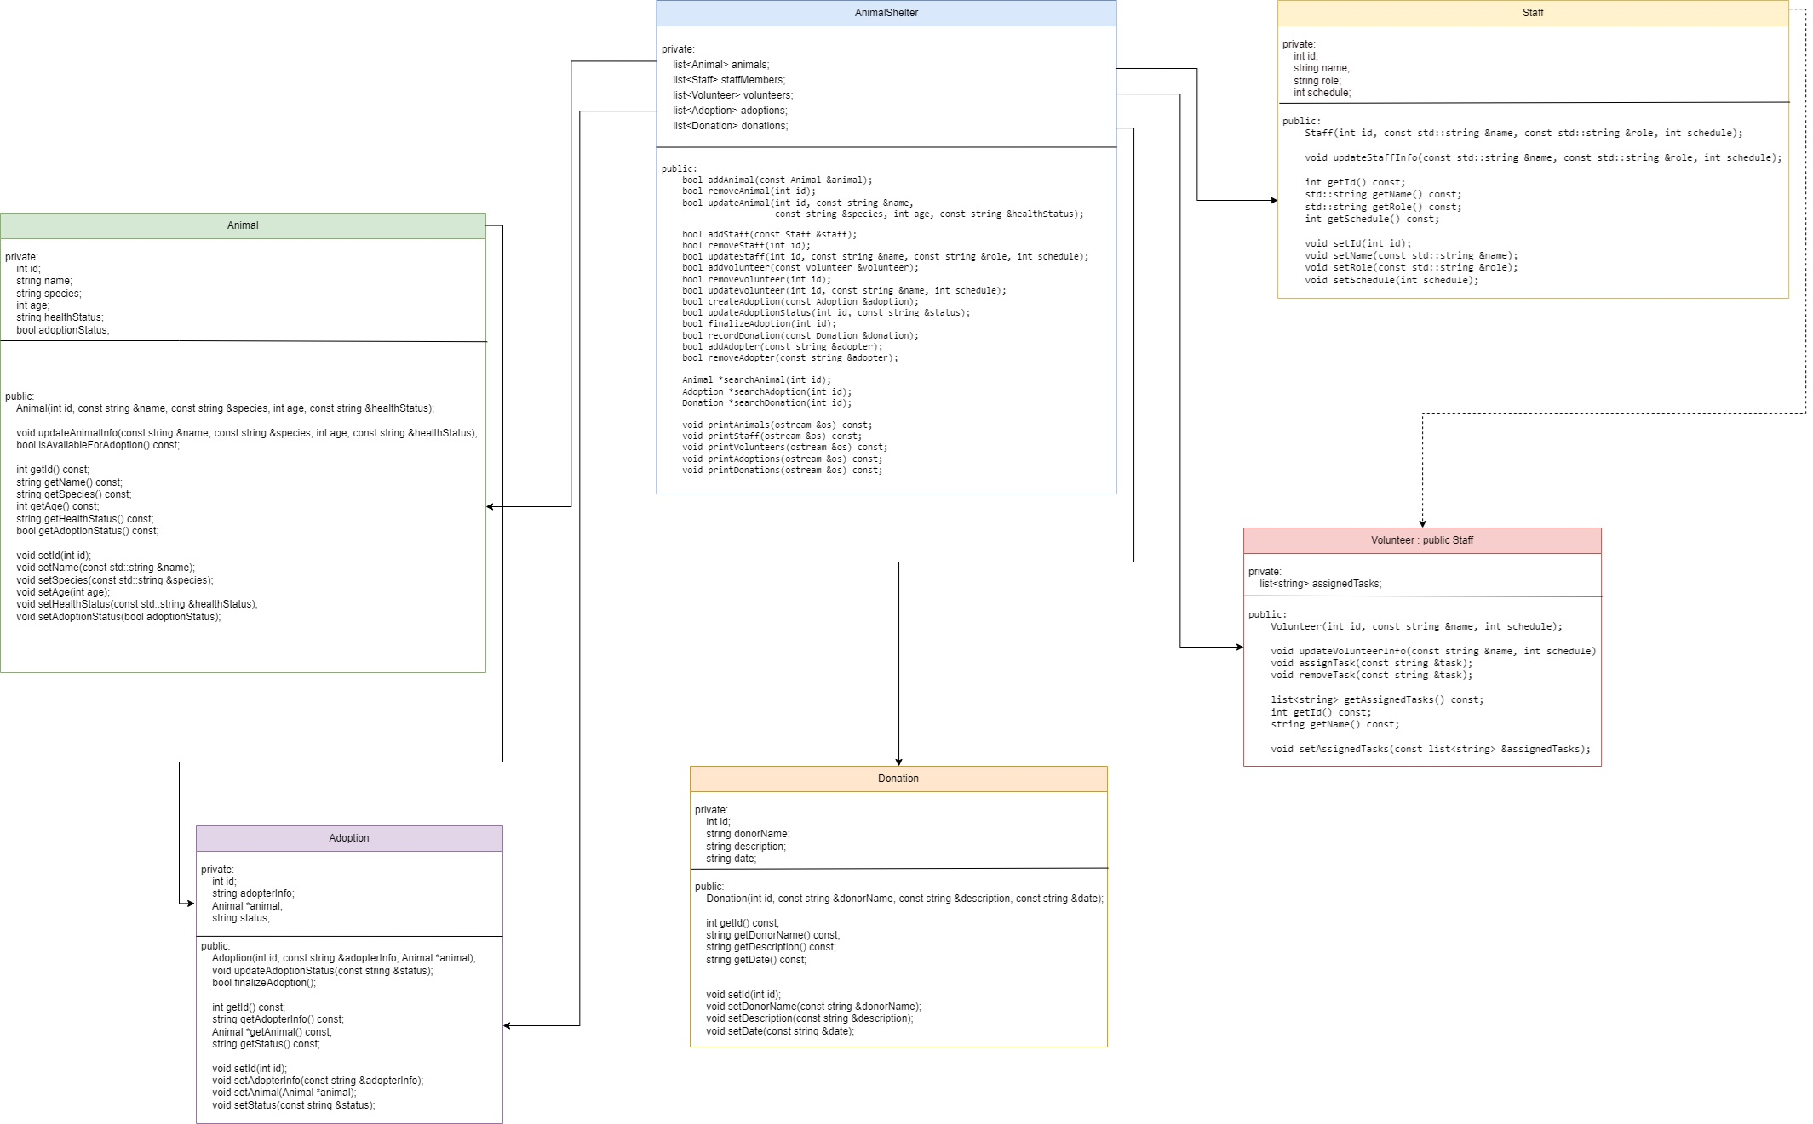

- Memory map:

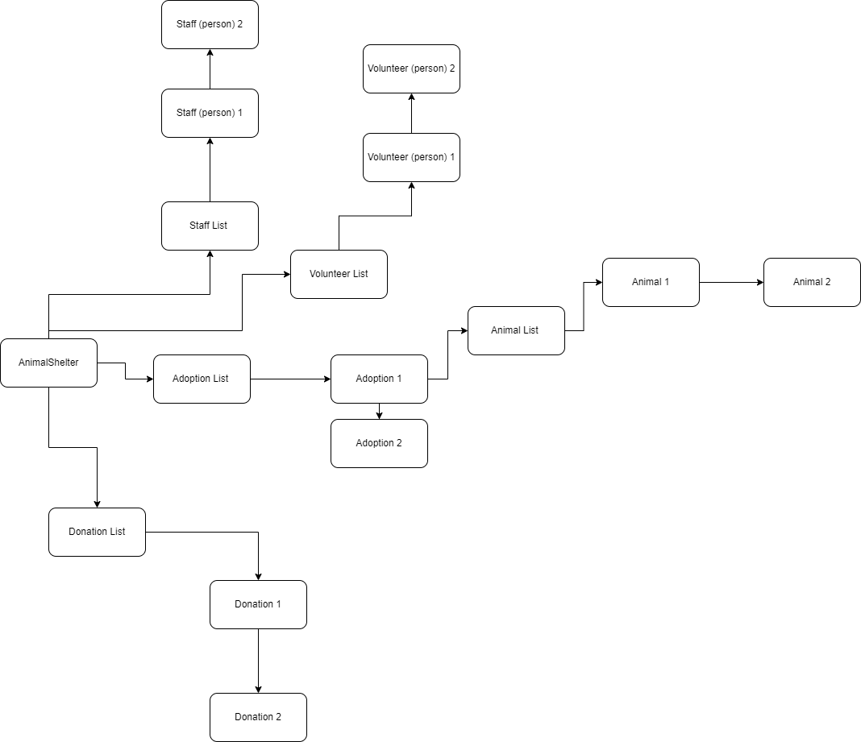

Declaration of the classes
- AnimalShelter class:
class AnimalShelter {
private:
list<Animal> animals; // List of animals in the shelter
list<Staff> staffMembers; // List of staff members working at the shelter
list<Volunteer> volunteers; // List of volunteers helping at the shelter
list<Adoption> adoptions; // List of adoption records
list<Donation> donations; // List of donation records
public:
// Add and remove methods for animals, staff, volunteers, adoptions, donations, and adopters
bool addAnimal(const Animal &animal);
bool removeAnimal(int id);
bool updateAnimal(int id, const string &name,
const string &species, int age, const string &healthStatus);
bool addStaff(const Staff &staff);
bool removeStaff(int id);
bool updateStaff(int id, const string &name, const string &role, int schedule);
bool addVolunteer(const Volunteer &volunteer);
bool removeVolunteer(int id);
bool updateVolunteer(int id, const string &name, int schedule);
bool createAdoption(const Adoption &adoption);
bool updateAdoptionStatus(int id, const string &status);
bool finalizeAdoption(int id);
bool recordDonation(const Donation &donation);
bool addAdopter(const string &adopter);
bool removeAdopter(const string &adopter);
// Search methods for animals, adoptions, and donations
Animal *searchAnimal(int id);
Adoption *searchAdoption(int id);
Donation *searchDonation(int id);
// Print methods for animals, staff, volunteers, adoptions, and donations
void printAnimals(ostream &os) const;
void printStaff(ostream &os) const;
void printVolunteers(ostream &os) const;
void printAdoptions(ostream &os) const;
void printDonations(ostream &os) const;
};

- Adoption class:
class Adoption {
friend ostream &operator<<(ostream &os, const Adoption &adoption);
private:
int id; // Unique identifier for each adoption
string adopterInfo; // Information about the adopter
Animal *animal; // Pointer to the animal being adopted
string status; // Status of the adoption (e.g., pending, finalized)
public:
Adoption(int id, const string &adopterInfo, Animal *animal); // Constructor for the Adoption class
void updateAdoptionStatus(const string &status); // Updates the adoption status
bool finalizeAdoption();// Finalizes the adoption process
// Getters
int getId() const;
string getAdopterInfo() const;
Animal *getAnimal() const;
string getStatus() const;
//Setters
void setId(int id);
void setAdopterInfo(const string &adopterInfo);
void setAnimal(Animal *animal);
void setStatus(const string &status);
};
- Donation class:
class Donation {
friend ostream &operator<<(ostream &os, const Donation &donation);
private:
int id; // Unique identifier for each donation
string donorName; // Name of the donor
string description; // Description of the donated item(s)
string date; // Date of the donation
public:
// Constructor for the Donation class
Donation(int id, const string &donorName, const string &description, const string &date);
// Getters
int getId() const;
string getDonorName() const;
string getDescription() const;
string getDate() const;
//Setters
void setId(int id);
void setDonorName(const string &donorName);
void setDescription(const string &description);
void setDate(const string &date);
};
- Staff class:
class Staff {
friend ostream &operator<<(ostream &os, const Staff &staff);
private:
int id; // Unique identifier for each staff member
string name; // Name of the staff member
string role; // Role of the staff member (e.g., manage, veterinarian)
int schedule; // Staff member's work schedule (e.g., hours per week)
public:
// Constructor for the Staff class
Staff(int id, const std::string &name, const std::string &role, int schedule);
// Updates the staff member's information
void updateStaffInfo(const std::string &name, const std::string &role, int schedule);
// Getters
int getId() const;
std::string getName() const;
std::string getRole() const;
int getSchedule() const;
// Setters
void setId(int id);
void setName(const std::string &name);
void setRole(const std::string &role);
void setSchedule(int schedule);
};

- Volunteer class:
class Volunteer : public Staff {
friend ostream &operator<<(ostream &os, const Volunteer &volunteer);
private:
list<string> assignedTasks; // List of tasks assigned to the volunteer
public:
// Constructor for the Volunteer class
Volunteer(int id, const string &name, int schedule);
// Updates the volunteer's information
void updateVolunteerInfo(const string &name, int schedule);
// Assigns a new task to the volunteer
void assignTask(const string &task);
// Removes a task from the volunteer's assigned tasks
void removeTask(const string &task);
// Getters
list<string> getAssignedTasks() const;
int getId() const;
string getName() const;
void setAssignedTasks(const list<string> &assignedTasks); //inherits from Staff.h
};

- Animal class:
class Animal {
friend ostream &operator<<(ostream &os, const Animal &animal);
private:
int id; // Unique identifier for each animal
string name; // Name of the animal
string species; // Species of the animal
int age; // Age of the animal
string healthStatus; // Health status of the animal
bool adoptionStatus; // Adoption status of the animal (true if adopted, false otherwise)
public:
Animal(int id, const string &name, const string &species, int age, const string &healthStatus); // Constructor for the Animal class
void updateAnimalInfo(const string &name, const string &species, int age, const string &healthStatus); // Updates the animal's information
bool isAvailableForAdoption() const; // Checks if the animal is available for adoption
// Getters
int getId() const;
string getName() const;
string getSpecies() const;
int getAge() const;
string getHealthStatus() const;
bool getAdoptionStatus() const;
//Setters
void setId(int id);
void setName(const std::string &name);
void setSpecies(const std::string &species);
void setAge(int age);
void setHealthStatus(const std::string &healthStatus);
void setAdoptionStatus(bool adoptionStatus);
};

Functional test cases
#include "AnimalShelter.h"
#include <iostream>
void testCase1() {
// Test case 1: Add and remove animals
std::cout << "Test case 1: Add and remove animals" << std::endl;
AnimalShelter shelter;
Animal animal1(1, "Buddy", "Dog", 3, "Healthy");
Animal animal2(2, "Molly", "Cat", 2, "Healthy");
// Add animals
shelter.addAnimal(animal1);
shelter.addAnimal(animal2);
// Print the updated list of animals
std::cout << "Animals added:" << std::endl;
shelter.printAnimals(std::cout);
// Remove an animal
shelter.removeAnimal(1);
// Print the updated list of animals
std::cout << "Animals after removal:" << std::endl;
shelter.printAnimals(std::cout);
// Attempt to remove an animal that does not exist (incorrect case)
std::cout << "Attempt to remove non-existent animal:" << std::endl;
if (!shelter.removeAnimal(3)) {
std::cout << "Animal not found, cannot remove." << std::endl;
}
}
void testCase2() {
// Test case 2: Add and remove staff
std::cout << "Test case 2: Add and remove staff" << std::endl;
AnimalShelter shelter;
Staff staff1(1, "Alice", "Veterinarian", 8);
Staff staff2(2, "Bob", "Caretaker", 5);
// Add staff
shelter.addStaff(staff1);
shelter.addStaff(staff2);
// Print the updated list of staff
std::cout << "Staff added:" << std::endl;
shelter.printStaff(std::cout);
// Remove staff
shelter.removeStaff(1);
// Print the updated list of staff
std::cout << "Staff after removal:" << std::endl;
shelter.printStaff(std::cout);
// Attempt to remove staff that does not exist (incorrect case)
std::cout << "Attempt to remove non-existent staff:" << std::endl;
if (!shelter.removeStaff(3)) {
std::cout << "Staff not found, cannot remove." << std::endl;
}
}
void testCase3() {
// Test case 3: Add and remove volunteers
std::cout << "Test case 3: Add and remove volunteers" << std::endl;
AnimalShelter shelter;
Volunteer volunteer1(1, "Cathy", 6);
Volunteer volunteer2(2, "David", 4);
// Add volunteers
shelter.addVolunteer(volunteer1);
shelter.addVolunteer(volunteer2);
// Print the updated list of volunteers
std::cout << "Volunteers added:" << std::endl;
shelter.printVolunteers(std::cout);
// Remove a volunteer
shelter.removeVolunteer(1);
// Print the updated list of volunteers
std::cout << "Volunteers after removal:" << std::endl;
shelter.printVolunteers(std::cout);
// Attempt to remove a volunteer that does not exist (incorrect case)
std::cout << "Attempt to remove non-existent volunteer:" << std::endl;
if (!shelter.removeVolunteer(3)) {
std::cout << "Volunteer not found, cannot remove." << std::endl;
}
}
void testCase4() {
// Test case 4: Add and finalize adoptions
std::cout << "Test case 4: Add and finalize adoptions" << std::endl;
AnimalShelter shelter;
Animal animal1(1, "Buddy", "Dog", 3, "Healthy");
Animal animal2(2, "Molly", "Cat", 2, "Healthy");
shelter.addAnimal(animal1);
shelter.addAnimal(animal2);
Adoption adoption1(1, "John Doe", &animal1);
Adoption adoption2(2, "Jane Doe", &animal2);
// Add adoptions
shelter.createAdoption(adoption1);
shelter.createAdoption(adoption2);
// Print the updated list of adoptions
std::cout << "Adoptions added:" << std::endl;
shelter.printAdoptions(std::cout);
// Finalize an adoption
shelter.finalizeAdoption(1);
// Print the updated list of adoptions
std::cout << "Adoptions after finalization:" << std::endl;
shelter.printAdoptions(std::cout);
// Attempt to finalize an adoption that does not exist (incorrect case)
std::cout << "Attempt to finalize non-existent adoption:" << std::endl;
if (!shelter.finalizeAdoption(3)) {
std::cout << "Adoption not found, cannot finalize." << std::endl;
}
}
void testCase5() {
// Test case 5: Record and search donations
std::cout << "Test case 5: Record and search donations" << std::endl;
AnimalShelter shelter;
Donation donation1(1, "Philanthropist", "1000 dollars", "2022-12-01");
Donation donation2(2, "Animal lover", "Cat food", "2022-12-02");
// Record donations
shelter.recordDonation(donation1);
shelter.recordDonation(donation2);
// Print the updated list of donations
std::cout << "Donations recorded:" << std::endl;
shelter.printDonations(std::cout);
// Search for a donation
Donation *foundDonation = shelter.searchDonation(1);
if (foundDonation) {
std::cout << "Found donation:" << std::endl;
std::cout << *foundDonation << std::endl;
} else {
std::cout << "Donation not found." << std::endl;
}
// Attempt to search for a donation that does not exist (incorrect case)
std::cout << "Attempt to search for non-existent donation:" << std::endl;
foundDonation = shelter.searchDonation(3);
if (!foundDonation) {
std::cout << "Donation not found." << std::endl;
}
}
int main() {
testCase1();
std::cout << std::endl;
testCase2();
std::cout << std::endl;
testCase3();
std::cout << std::endl;
testCase4();
std::cout << std::endl;
testCase5();
return 0;
}

