HW

Creating environment:

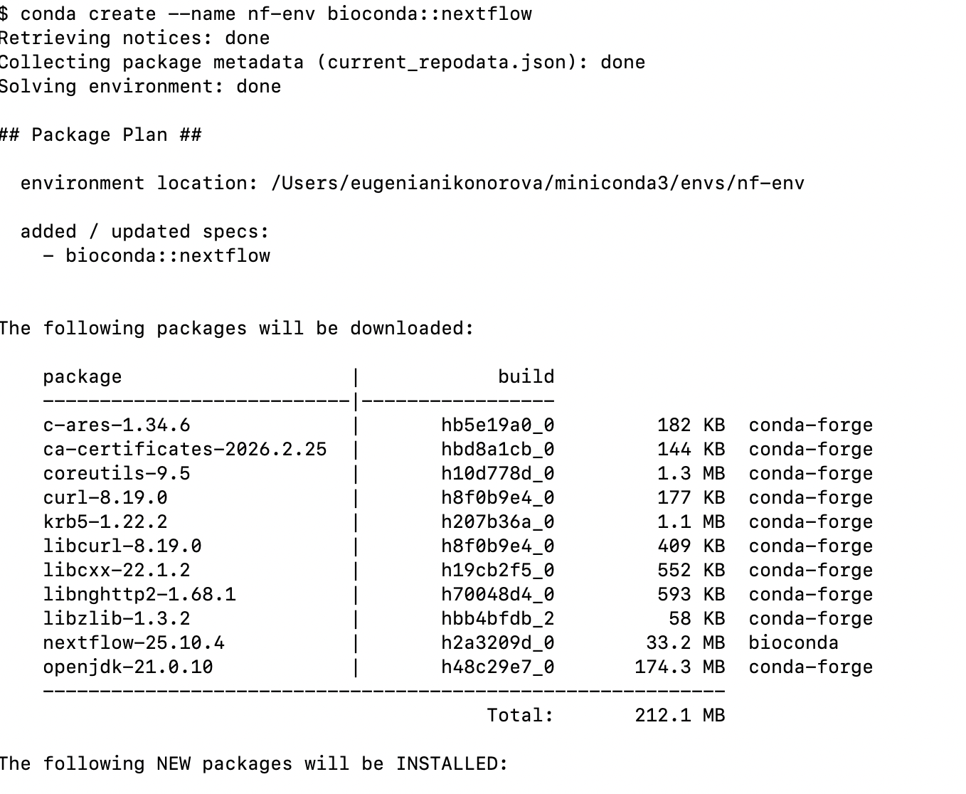

Docker has already installed

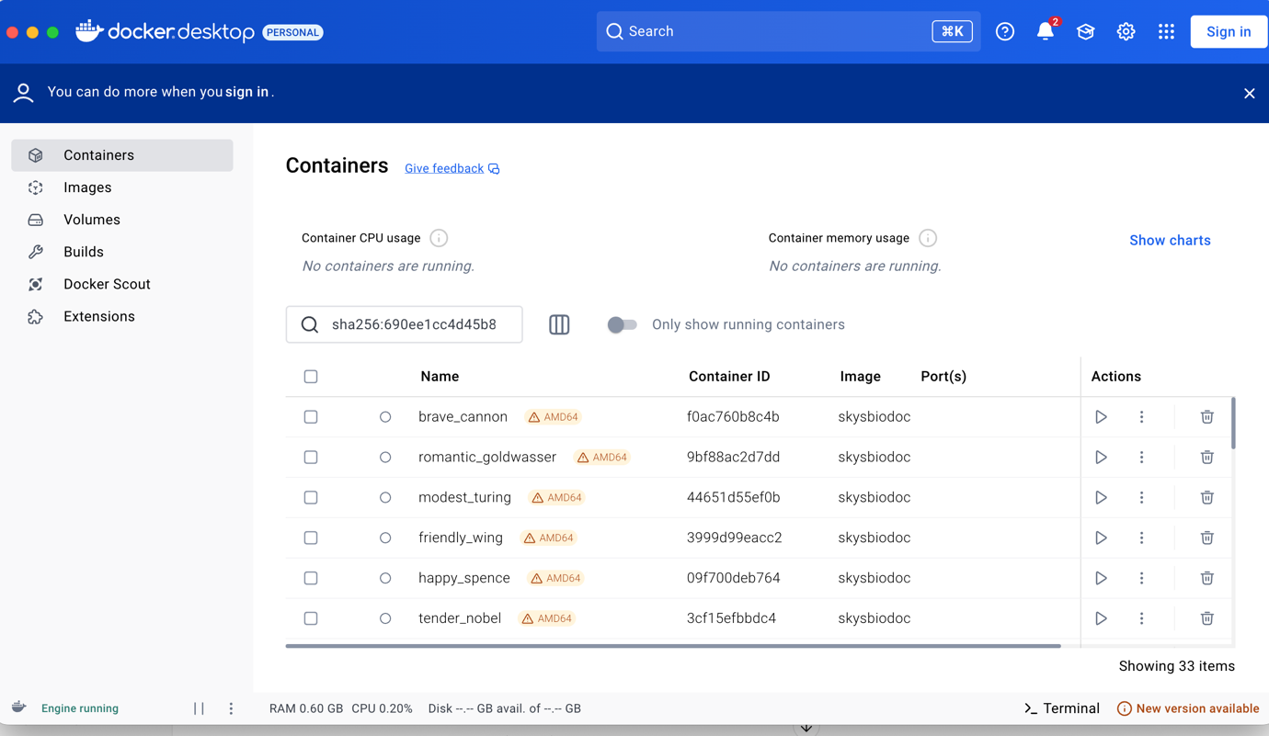

Run it in command line

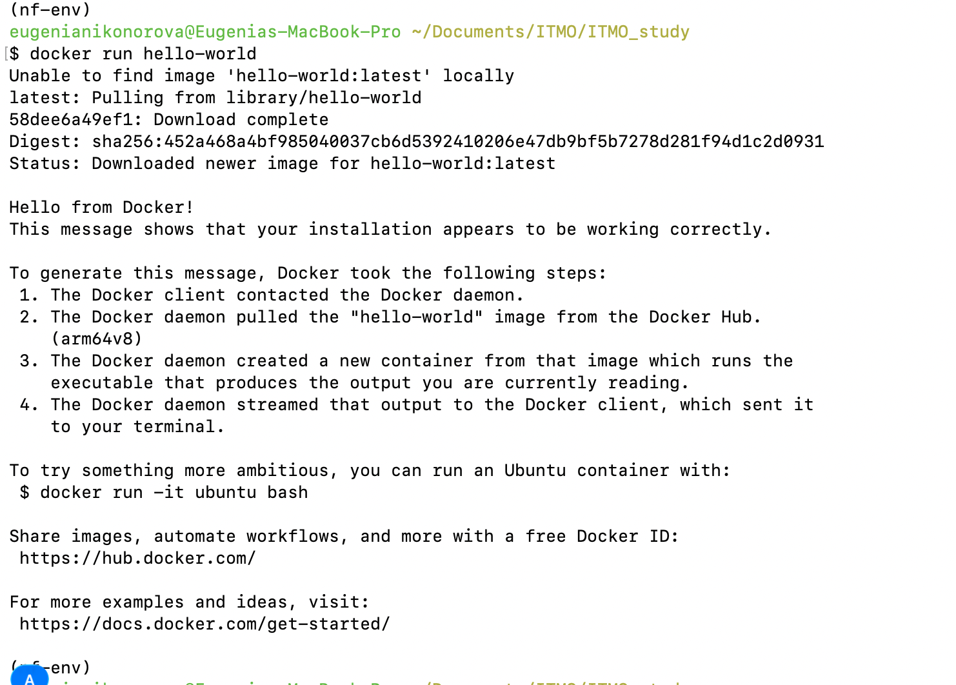

Running test

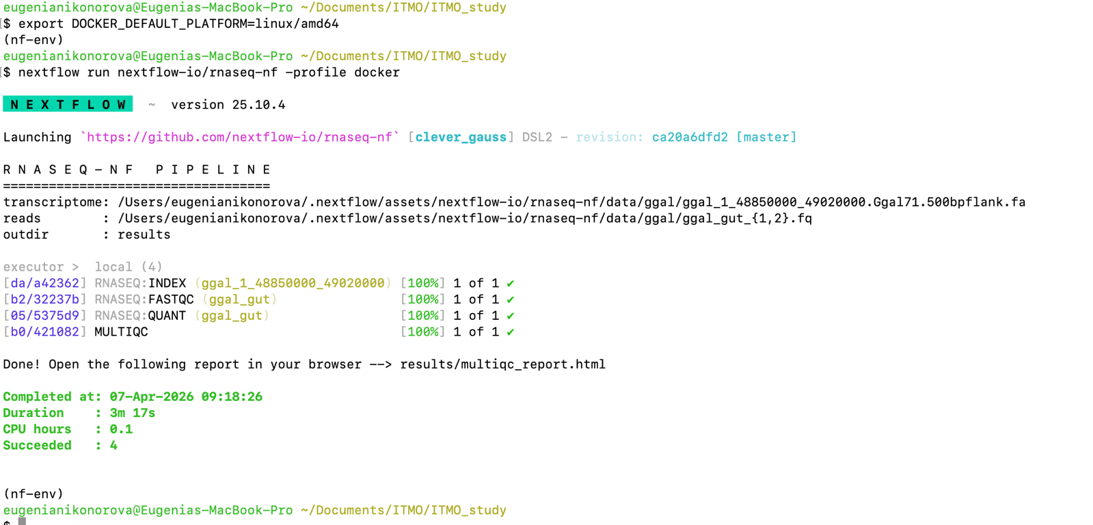

Download some set from this experiment https://www.ncbi.nlm.nih.gov/bioproject/PRJNA889026

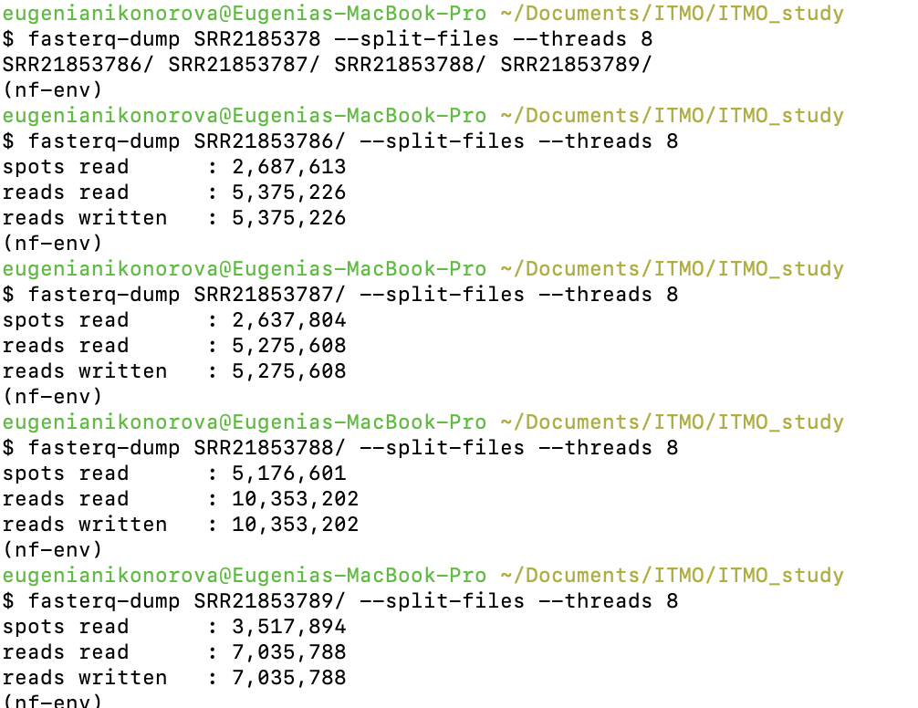

As there was not any available transcriptome assembly, I did assembly using all input fastq and spades tool in –rna mode

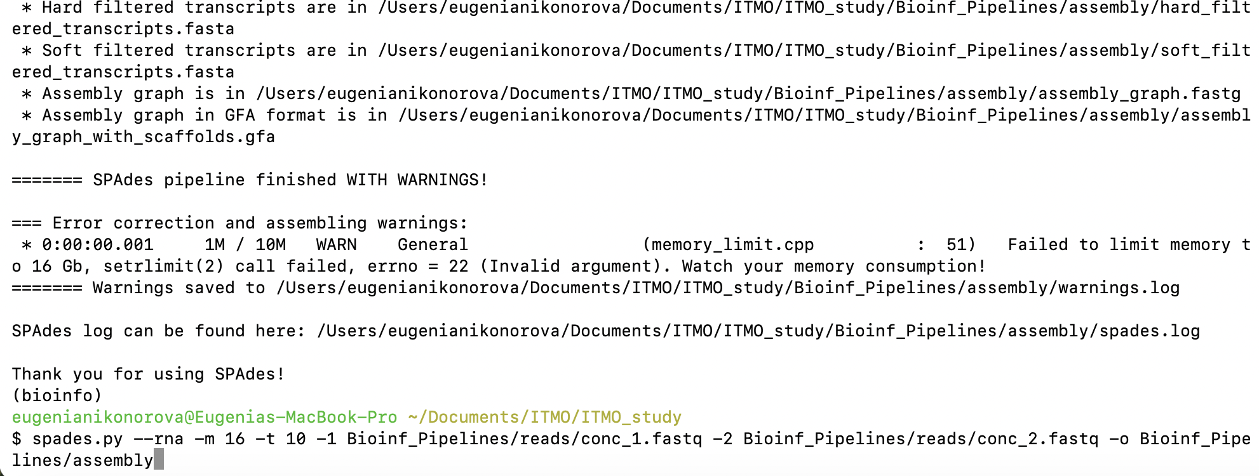

Ouput folder contains transcripts.fasta

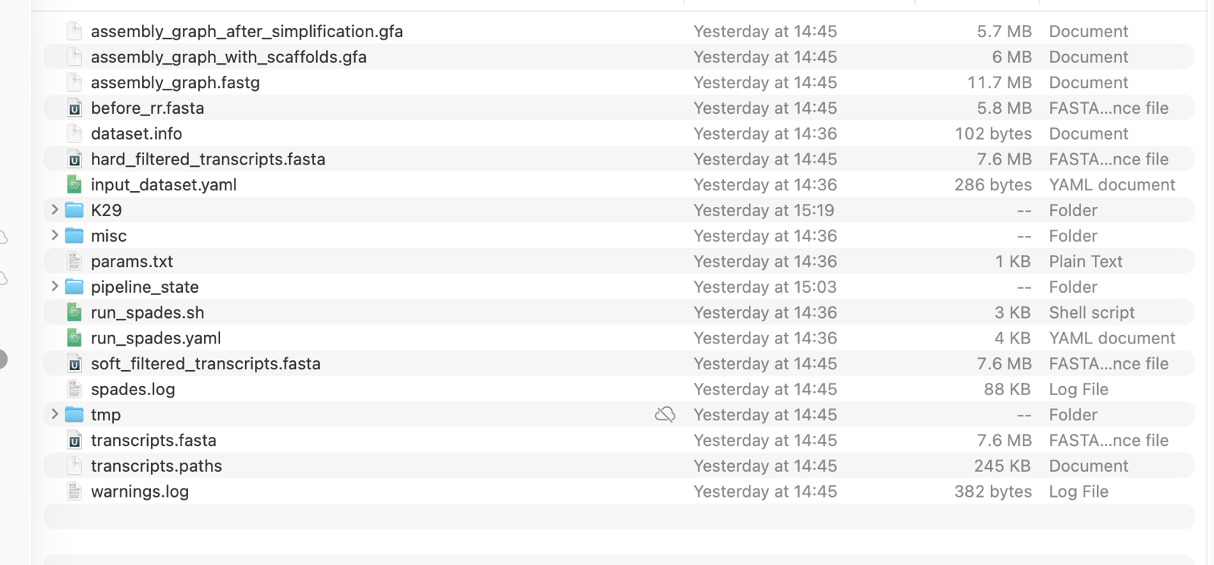

Then run

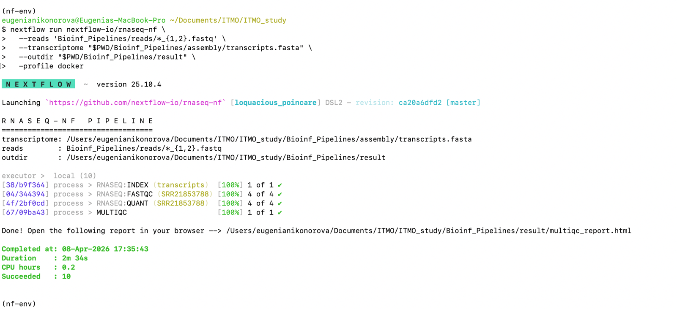

Done

