

Ankara Yıldırım Beyazıt University

Department of Computer Engineering

CENG 201 – Object Oriented Programming  
Course Project

G18: Catan Game

Analysis Report

Eren Yılmaz 22050151024,

Muhammed Enes Uğraş 23050151030,

Rasin Taha Yılmaz 22050111056,

Sühan Sarı 18050111015

**Instructor**: Muhammed Abdullah Bülbül

**Teaching Assistant:** Elif Şanlıalp, Yusuf Şevki Günaydın

**Date:** 31/10/2024

**Table of Contents**

**1. Introduction**

**2. Requirements**

**- 2.1 Functional Requirements**

**- 2.2 Non-Functional Requirements**

**3. System Models**

**- 3.1 Scenarios**

**- 3.2 Use Cases**

**- 3.3 Object and Class Model**

**- 3.4 User Interfaces**

**4. Conclusion**

**1. Introduction**

This report is about a console version of the Catan game. We are making it in C++. The game lets players build settlements, manage resources, and trade with each other. This report shows the requirements, scenarios, UML diagrams, object models, and user interface ideas for the game.

**2. Requirements**

2.1 Functional Requirements

1. Start Game: Player can start a new game.

2. Roll Dice: A random dice roll gives resources to players.

3. Build Structure: Player can build settlements, roads, or cities.

4. Trade Resources: Player can trade resources with other players.

5. Turn: Ends the player’s turn and moves to the next player.

6. Save/Load Game: Lets the player save or load a game.

7. Exit Game: Player can quit the game.

2.2 Non-Functional Requirements

1. Performance: The game should run well on most systems.

2. Usability: The interface should be simple to understand and use.

3. Reliability: The game should handle errors properly.

4. Maintainability: The code should be easy to update.

**3. System Models**

**3.1 Scenarios**

1. Game Start: The player starts the game, and the board is set up.

2. Player Turn: The player rolls the dice and decides on actions.

3. Game Save: The player saves the game to continue later.

4. Game Exit: The player exits the game.

**3.2 Use Cases**

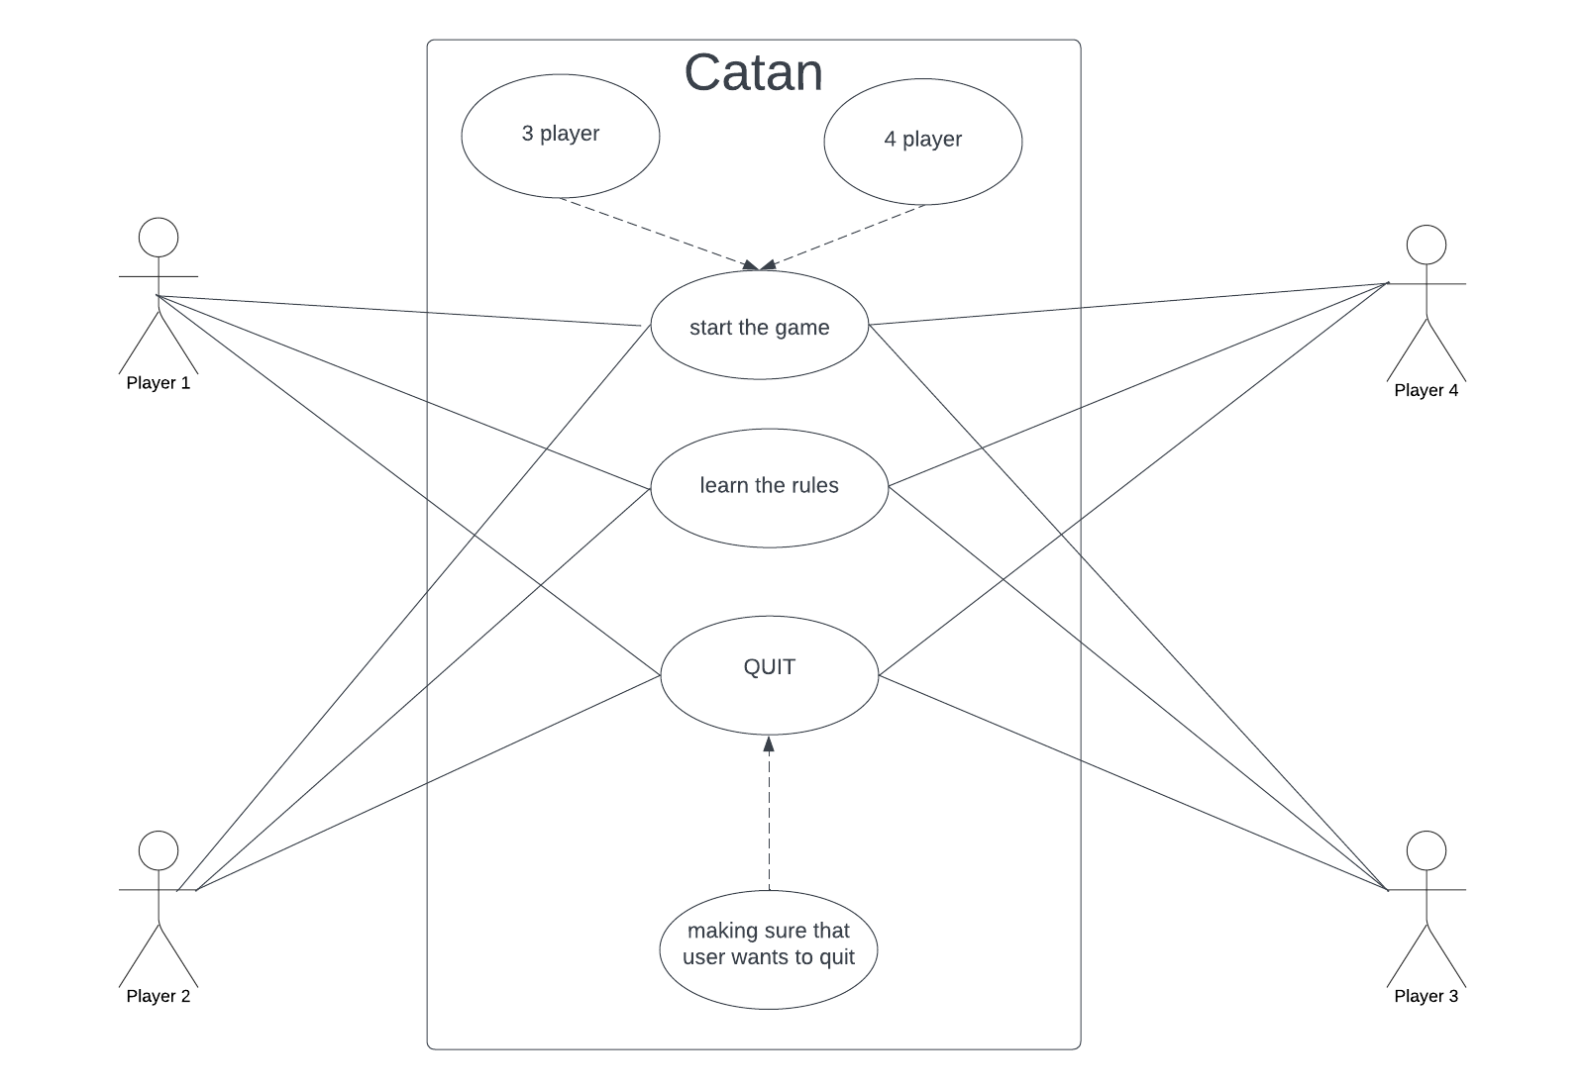

Figure 1

**3.3 Object and Class Model**

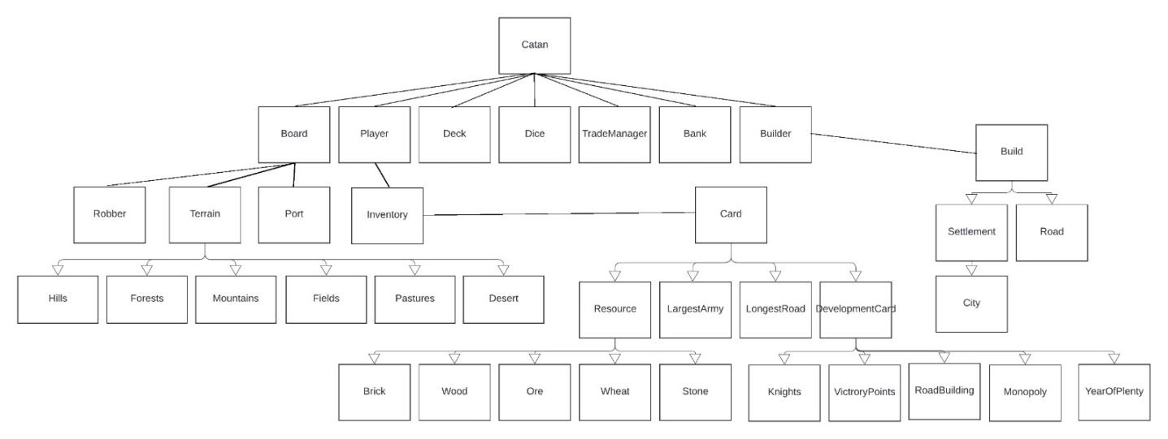

Figure 2

**3.4 User Interfaces**

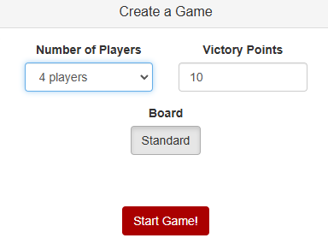

Figure 3 Login Screen

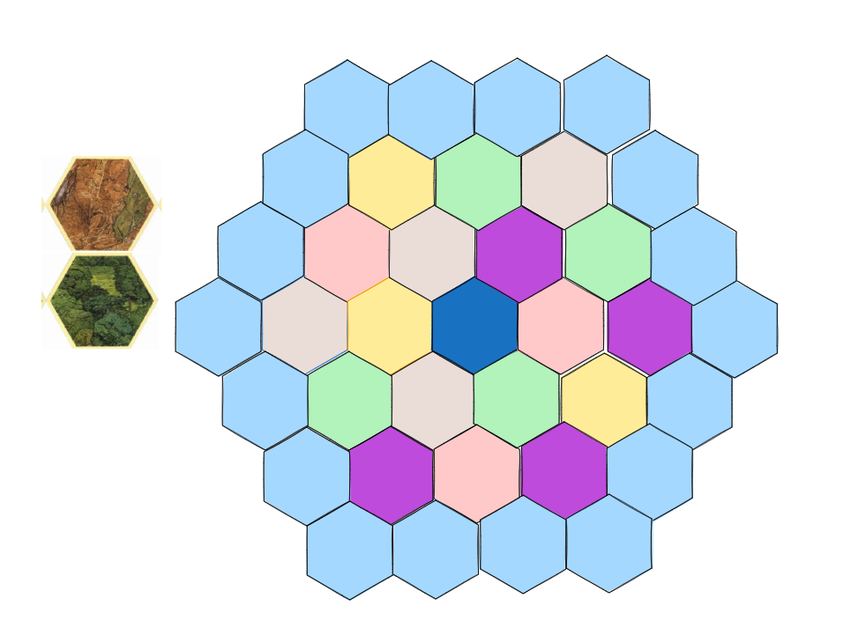

Figure 4 The Map

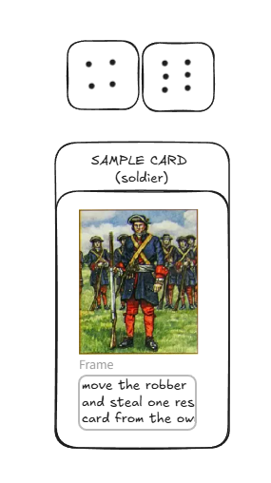

Figure 5 Dice and Sample Card

**4. Conclusion**

This report explains the plan for the Catan console game. We reviewed the requirements, scenarios, and use cases. Each team member helped with designing use cases, requirements, and models for the system. We are a team of four people and there are 8 contents here, each person was responsible for 2 contents.