**VGG_11 for CIFAR 100**

**case 1.**

Epoch : 30

batch_size = 64

init_lr = 0.01

(not using lr scheduler)

Loss : 3.3064

Best top 1 accuracy in test : 28.02

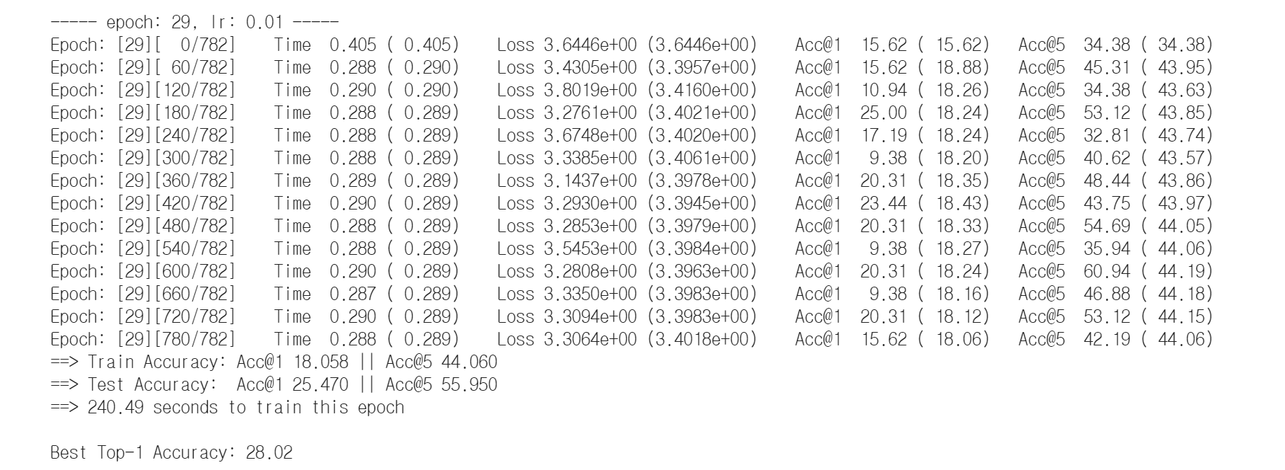

**case 2.**

Epoch : 30

batch_size = 64

init_lr = 0.01

using StepLR lr scheduler (step = 10epoch, gamma = 0.1)

Loss: 3.7614

Best top 1 accuracy in test: 24.43

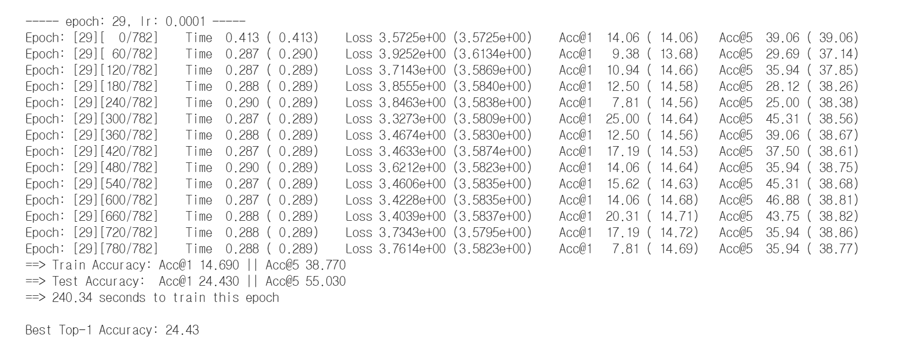

**GoogLeNet_V1 for CIFAR100**

Epoch : 100

batch_size = 64

init_lr = 0.001

using StepLr (step =8, gamma = 0.96)

opt = SGD(momentum=0.9, weight_decay = 5e-4)

Loss :

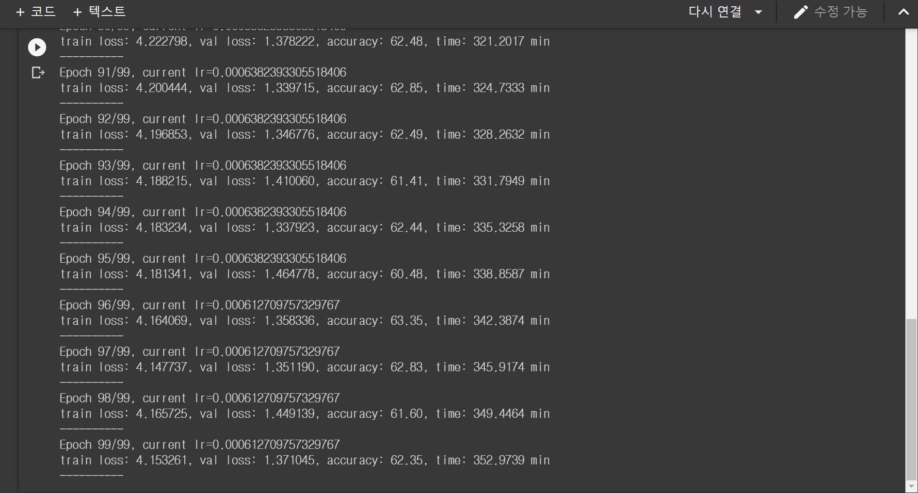

Epoch : 100

batch_size = 64

init_lr = 0.005

using StepLr(step = 8, gamma = 0.92)

opt = SGD(momentum=0.9, weight_decay = 5e-4)

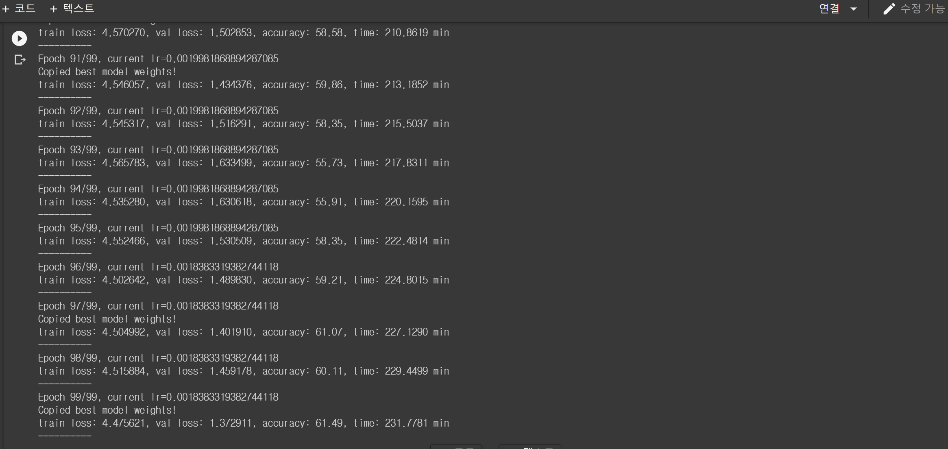

두개중 좋은 stepLR + optim = adam으로 test 하면?

opt = torch.optim.Adam(model.parameters(), lr=learning_rate, weight_decay=5e-4)

feedback : baseline코드랑 비교해서 다시 짜보자. 제대로 이해해서.