Stitchi 1.0 — User Guide
Operating the camera-based gesture-control interface

This guide is for a person standing in front of the camera and using the gesture interface. It assumes that the application has been installed and configured by a developer.

1. Before you start
- Place the camera in its calibrated position and connect it to the computer. For depth-based operation, connect the configured Intel RealSense camera.
- Stand far enough from the camera for the upper body and both arms to remain visible.
- Ask the operator to start `main.py`. Wait until the camera window and instrument interface are visible.

2. Understanding the interface
The camera image is the background for the GUI overlay. Instrument tiles can be selected and moved with hand gestures. Depending on the display mode, the window may also show body/hand landmarks, a hand region of interest (ROI), aperture information, pointing angles, frame number, and FPS. These diagnostic markings are for feedback and may be hidden in the GUI-only mode.
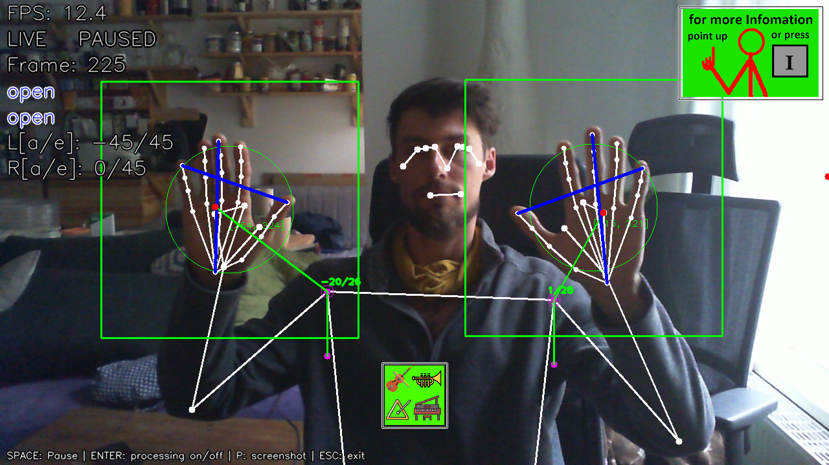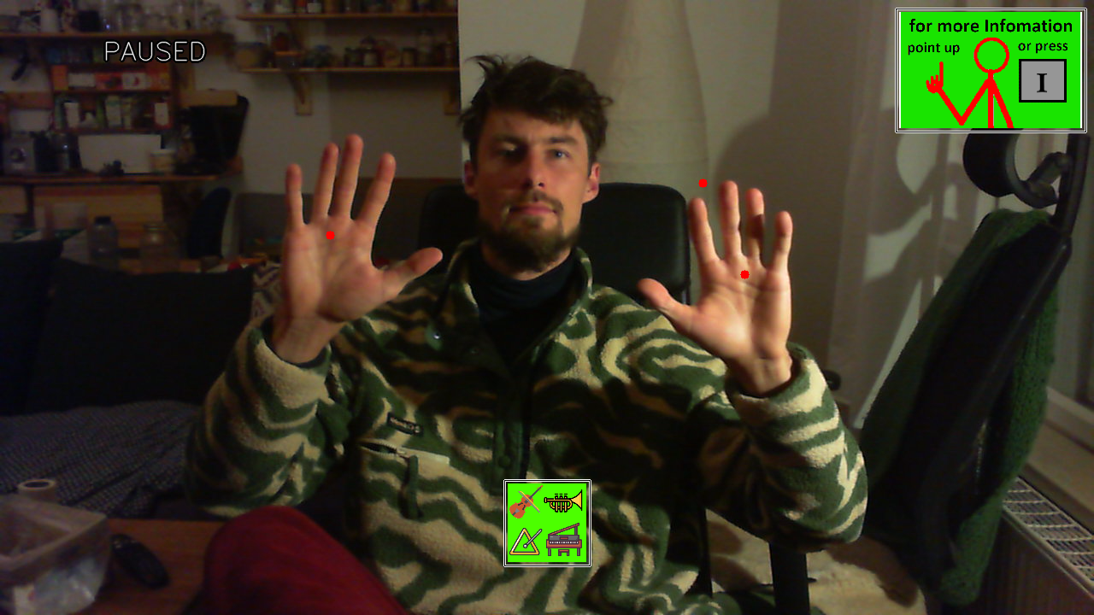

3. Select, move, and release an instrument
- Locate the green instrumentmenu.
- Move your hand so its displayed hand centre (a red dot) is over the tile.
- Are selection of instruments will show up.
- Locate the instrument tile you want to control.
- Keep the hand clearly visible to the camera.
- Close your hand to grab the tile. The application detects the transition from an open hand to a closed hand.
- While holding the closed hand, move your arm to point in the desired direction. The application calculates the arm direction from the shoulder and hand landmarks and updates the instrument's direction.
- The arm–shoulder vector determines the direction from which the instrument is heard in the physical space, while its position on the GUI serves solely as visual feedback.
- Open your hand to release the tile. The instrument remains at the position/direction reached when released.
- If both-hand mode is enabled, the application can track both hands
- You can also use the mouse if mouse_control is enabled. Then left klick is grabbing. The mouse can not change the sound direction.

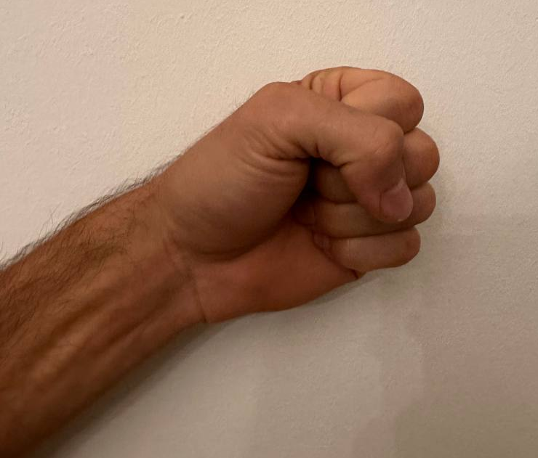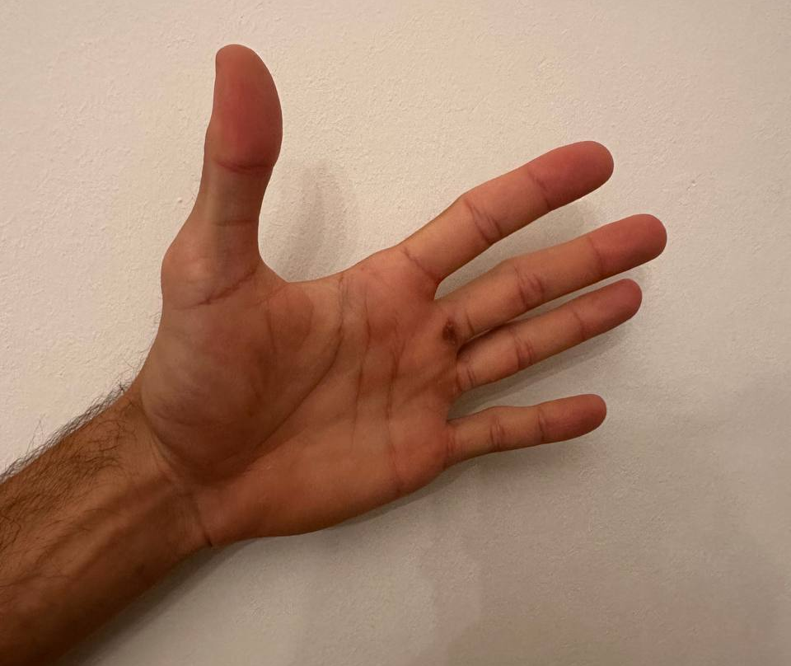
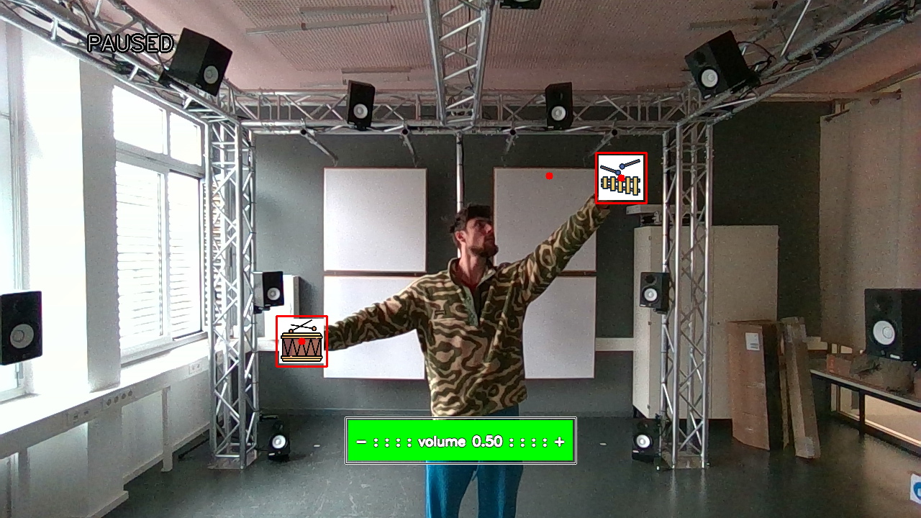

4. Change Volume
To adjust the volume, hold one hand over an instrument to display the volume bar. Then, hover your other hand over the desired position on the bar to set the volume. Alternatively, grab an instrument and drag it over the volume bar.
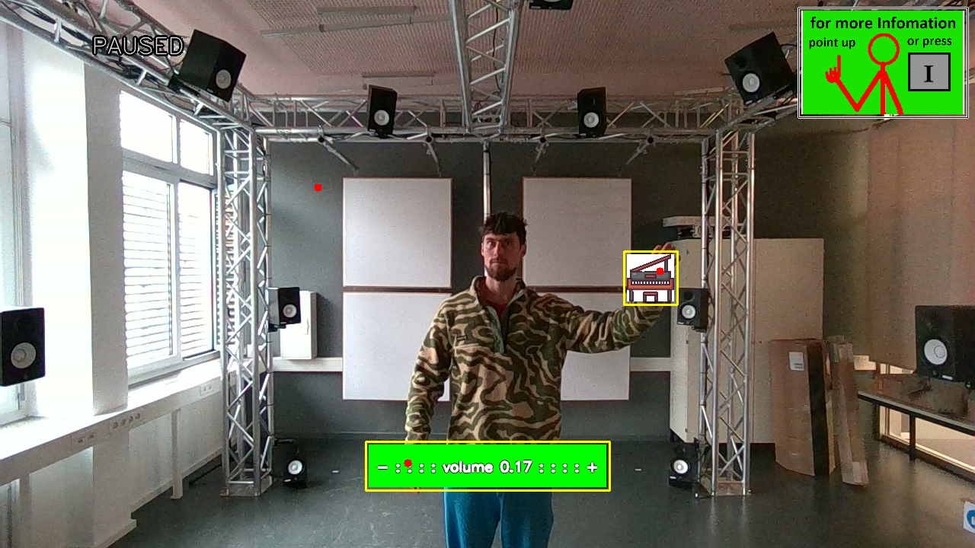

5. Adjust Menu
Just like the instruments, you can move the instrument menu and the volume bar around the screen. This only affects their visual position, allowing you to place them wherever they are least distracting.

6. Additional controls
Action | How to use it / key
Show or hide the information menu | Hold the index finger pointing upward for about 1 second (gesture). Press `I` for the keyboard shortcut. Hover over the Info button in the top-right corner with your hand or mouse pointer.
Clear/reset the GUI | Use the configured clear gesture: Thumb held pointing downward in front of the body for 1 second, or press `R`. This resets the instrument GUI state.
Change display/feedback mode | Use the visibility-mode  gesture: cover your eyes for 1 second, or press `V`. The available modes are configured by the developer.
Pause/resume video processing | Press `Space`. This is mainly useful during video playback/testing.
Toggle processing overlay | Press `Enter` to toggle on and off the processing of the entire gesture control
Save screenshot | Press `P`, saves the shown Frame in "… \Stitchi1.0\screenshots".
Exit | Use the ending gesture by crossing your hands above your head or press `Esc`. This terminates the entire gesture control application.
Restart application | Press `Q`.
Navigate a normal video file | `W` / `S` step by one frame; `A` / `D` jump by more frames. These controls apply to ordinary video playback, not live camera input or bag-file.

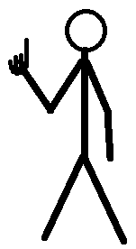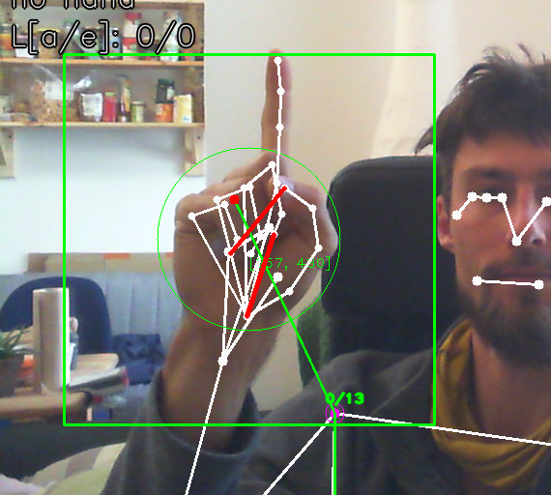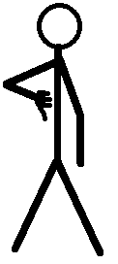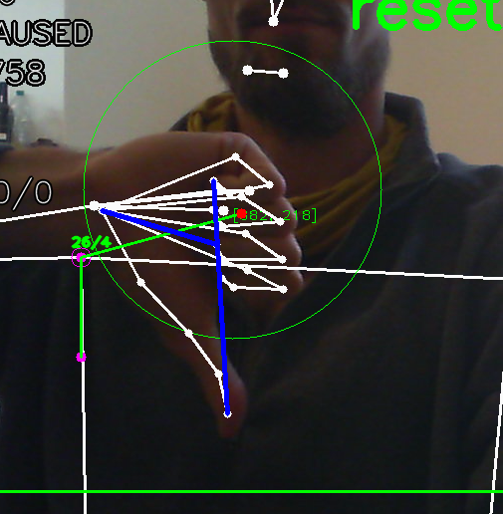

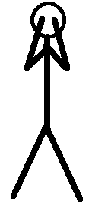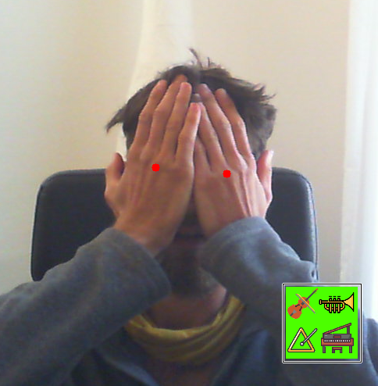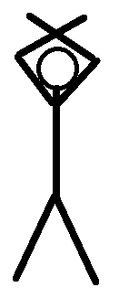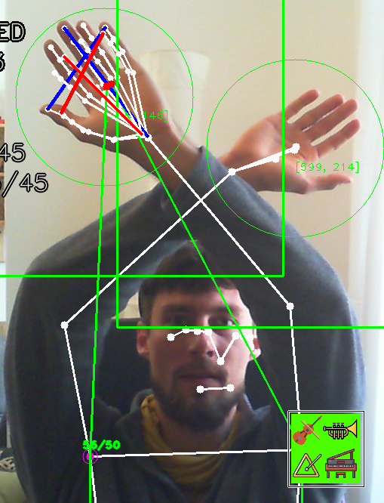

7. Good operating practice
- Keep hand landmarks visible during pointing.
- Move deliberately when grabbing, pointing, and releasing.
- Wait for the visible feedback after each control action before starting the next one.
- Do not change camera position after calibration unless a developer updates the room/camera settings.
- Treat the current software as a research prototype; recognition can be affected by lighting, clothing, body position, and camera geometry.

