**CO2 Emissions predictive model by weight and volume**

**Code:**

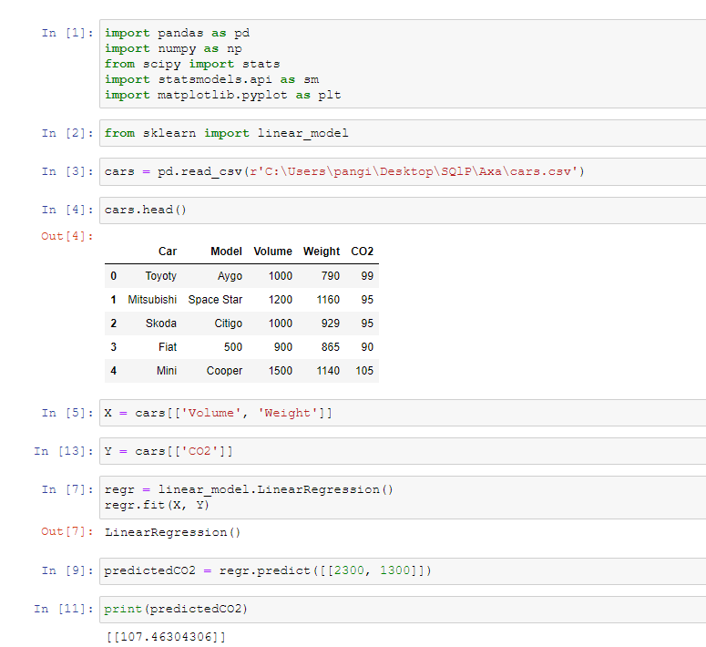

In [5] # fitting the independent variables.

In [13] #fitting the dependent variable.

In [7] #regression object that is ready to predict CO2 values based on a car's weight and volume.

In [9] #predicting the CO2 emission of a car where the weight is 2300kg, and the volume is 1300cm3 (engine size).

In [11] #based on 2300kg weight and 1300cm3 volume, a car will produce 107.4 grams of CO2 for every kilometer it drives.