沙盒：https://10-0-1-165-32794.neo4jsandbox.com/browser/

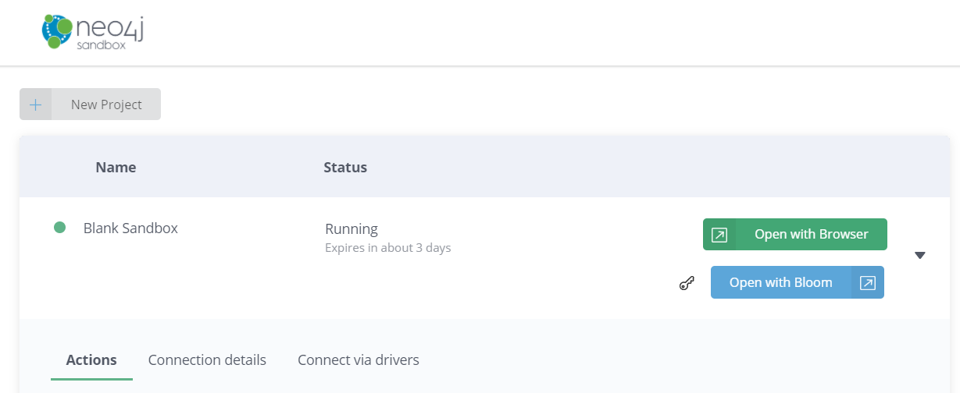

**导入数据**

CREATE

(nAlice:User {name: 'Alice', seed: 42}),

(nBridget: User {name: 'Bridget', seed: 42}),

(nCharles: User {name: 'Charles', seed: 42}),

(nDoug: User {name: 'Doug'}),

(nMark: User {name: 'Mark'}),

(nMichael: User {name: 'Michael'}),

(nAlice)-[:LINK {weight: 1}]->(nBridget),

(nAlice)-[:LINK {weight: 1}]->(nCharles),

(nCharles)-[:LINK {weight: 1}]->(nBridget),

(nAlice)-[:LINK {weight: 5}]->(nDoug),

(nMark)-[:LINK {weight: 1}]->(nDoug),

(nMark)-[:LINK {weight: 1}]->(nMichael),

(nMichael)-[:LINK {weight: 1}]->(nMark);

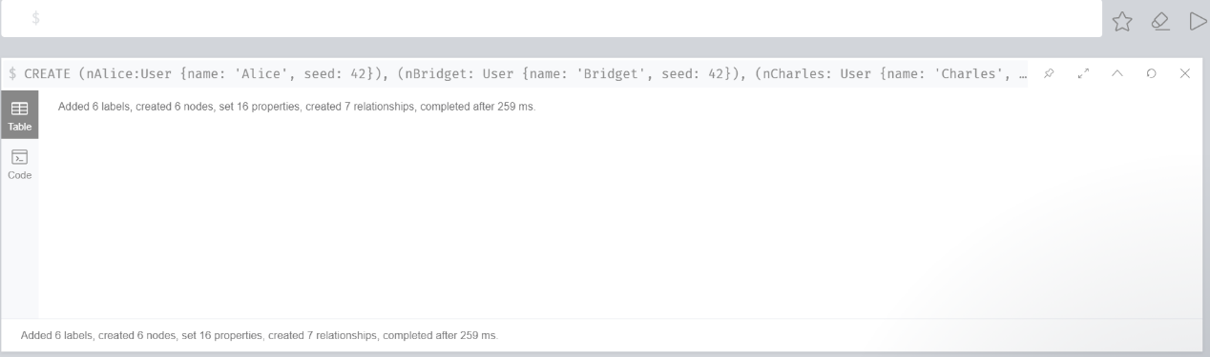

**验证数据**

match (u:User) return *

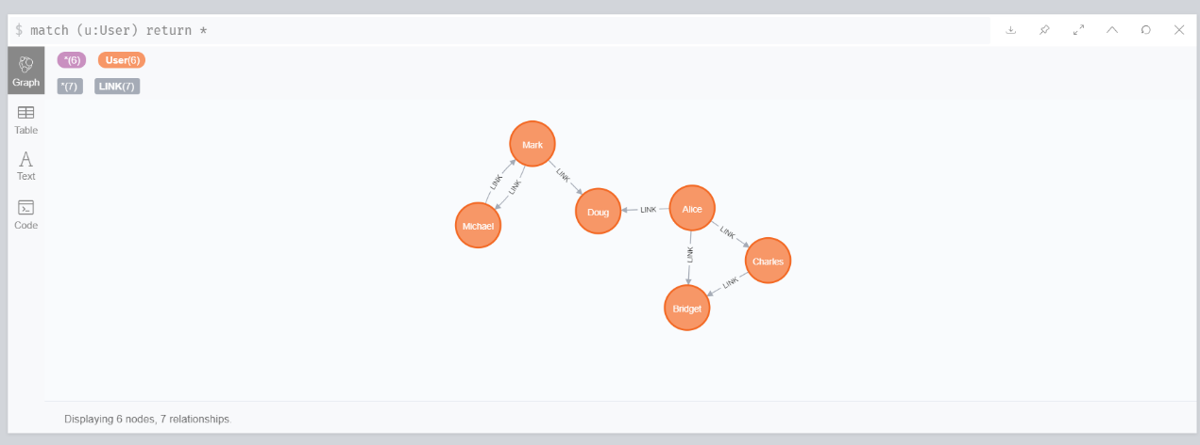

**准备**

CALL gds.graph.create(

'myGraph',

'User',

{

LINK: {

orientation: 'UNDIRECTED'

}

},

{

nodeProperties: 'seed',

relationshipProperties: 'weight'

}

)

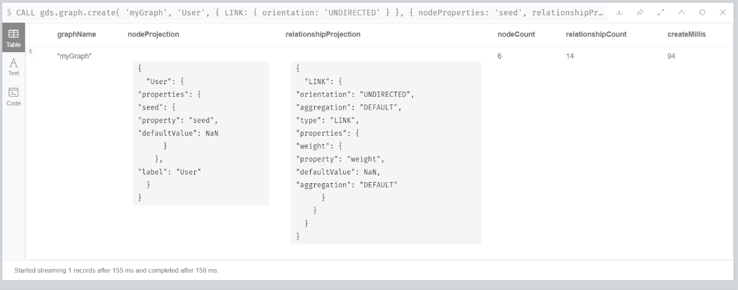

**评估需要的资源**

CALL gds.louvain.write.estimate('myGraph', { writeProperty: 'community' })

YIELD nodeCount, relationshipCount, bytesMin, bytesMax, requiredMemory

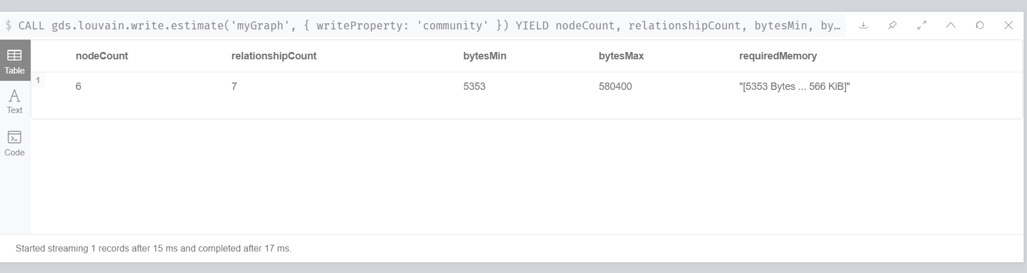

**Louvain算法**

CALL gds.louvain.stream('myGraph')

YIELD nodeId, communityId, intermediateCommunityIds

RETURN gds.util.asNode(nodeId).name AS name, communityId, intermediateCommunityIds

ORDER BY name ASC

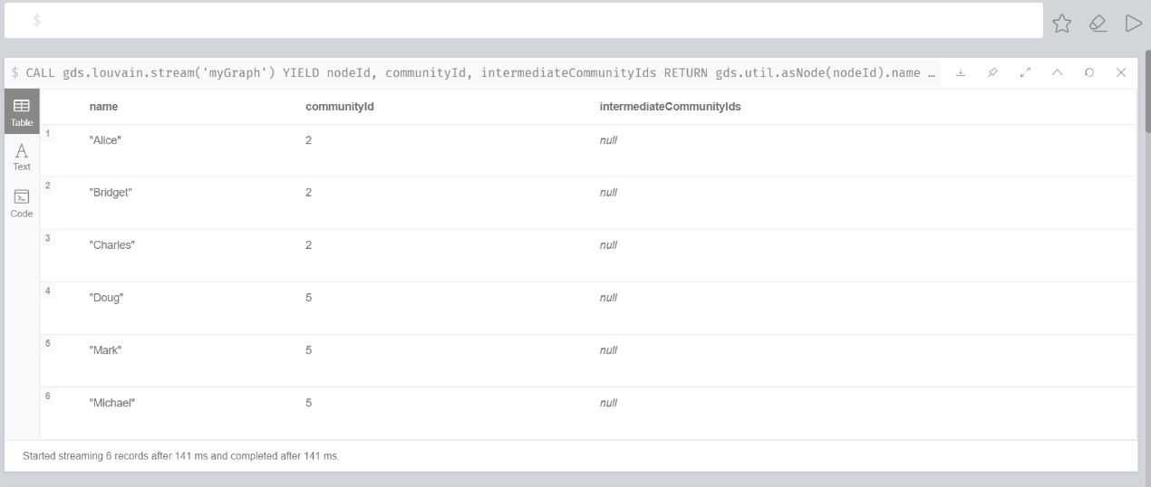

**社区数**

CALL gds.louvain.stats('myGraph')

YIELD communityCount

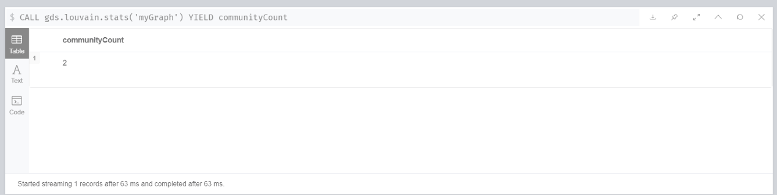

**模数**

CALL gds.louvain.mutate('myGraph', { mutateProperty: 'communityId' })

YIELD communityCount, modularity, modularities

