FIRE7SEVEN.WORLD is a transient art gallery utilizing blockchain technology. I’ve commissioned this project myself to serve as a way to recalibrate my artistic expression through the internet.

The goal is to raise a minimum of $5,000USD worth of a specific cryptocurrency by selling 77 digital collectibles, referred to as Eumons, which are a collection a self portraits and a token of utility that will decide the fate of the videos and music currently available and attributable to the music maker and creator, Eumonik.

**PLAN:**

Monthly Eumonik YouTube Revenue: ~$500USD X 10 months left in 2022 = ~$5,000USD

Starting 1 MARCH 2022, all videos on the Eumonik YouTube channel will have monetization turned OFF.

FIRE7SEVEN commencing…

**Your decision will be honored greatly.**

77 Eumons on the Solana blockchain

Each summoned to power at 0.77SOL

77 Eumons X 0.77SOL = ~$5,000USD

**Your financial support will prove the worth of my efforts.**

If all 77 Eumons are summoned to power, all Eumonik videos and music will remain public

If all 77 Eumons are not summoned to power, all Eumonik videos (except for sponsored videos) and music will be deleted from all social media and streaming platforms, along with the corresponding accounts, except for YouTube to keep the sponsored videos public and Twitter to keep in touch for the time being

Regardless of mission outcome, monetization will be turned OFF on all Eumonik YouTube videos

**NOTE TO POTENTIAL EUMON SUMMONERS:**

All Eumons possess the additional utility to retrieve audio files from Eumonik’s digital storage devices and deliver them to the requester’s email address, which may be valuable to those who seek sound recordings and raw materials for music production or simply would like access to any deleted videos, music, or projects.

**TESTING**

Mobile-focused and looking forward to a world where the markets are decentralized by either in-person handshake deals or publicly-verifiable blockchain transactions, the bulk of requirements for this project are derived from successfully interacting with the Solana blockchain, to include displaying the 77 digital collectibles, receiving cryptocurrency to the proper Solana address, and, after the sale, sending the 77 digital collectibles to their respective owners. Currently, the most popular Solana wallet is Phantom, which is not available on Android at the moment. The Phantom extension works best with Google Chrome, which will be tested on both Mac and PC. Future developments with Solana wallets, including Android availability for the Phantom wallet app, will lead to updated testing of client requirements.

**GROWTH AND MAINTENANCE**

The fire7seven.world domain will temporarily host (around 12 months) a project-specific website needed only to sell and transfer the 77 digital collectibles, with an estimated value of $5,000USD worth of the Solana cryptocurrency. The website will act as an information landing page until the proposed day of the sale, when it will then be more of a pop-up store to sell the 77 digital collectibles. The upkeep of the website will be minimal as it will not be serving any curated content or consistent updates. Once the sale is complete, the website will be updated to reflect that and will remain up until all 77 digital collectibles have successfully been transferred to their owners or the expiration date and time of the sale has transpired.

**ORGANIZATION**

The website’s intended response is an emotional call to market, that being the focal point, it will be presented in a much more linear dialogue, like an important conversation with a long-missed family member. The seamless and flowing style of a one-page landing website will serve the need for simplicity before the sale of 77 digital collectibles, named Eumons. Upon commencement of the project’s intended function, the flow of the website will remain as intended with the store, or “Summon Eumon” section being the centrality of the website’s utility during that time. The locked header will provide easy navigation to the page anchors and keep navigation simple.

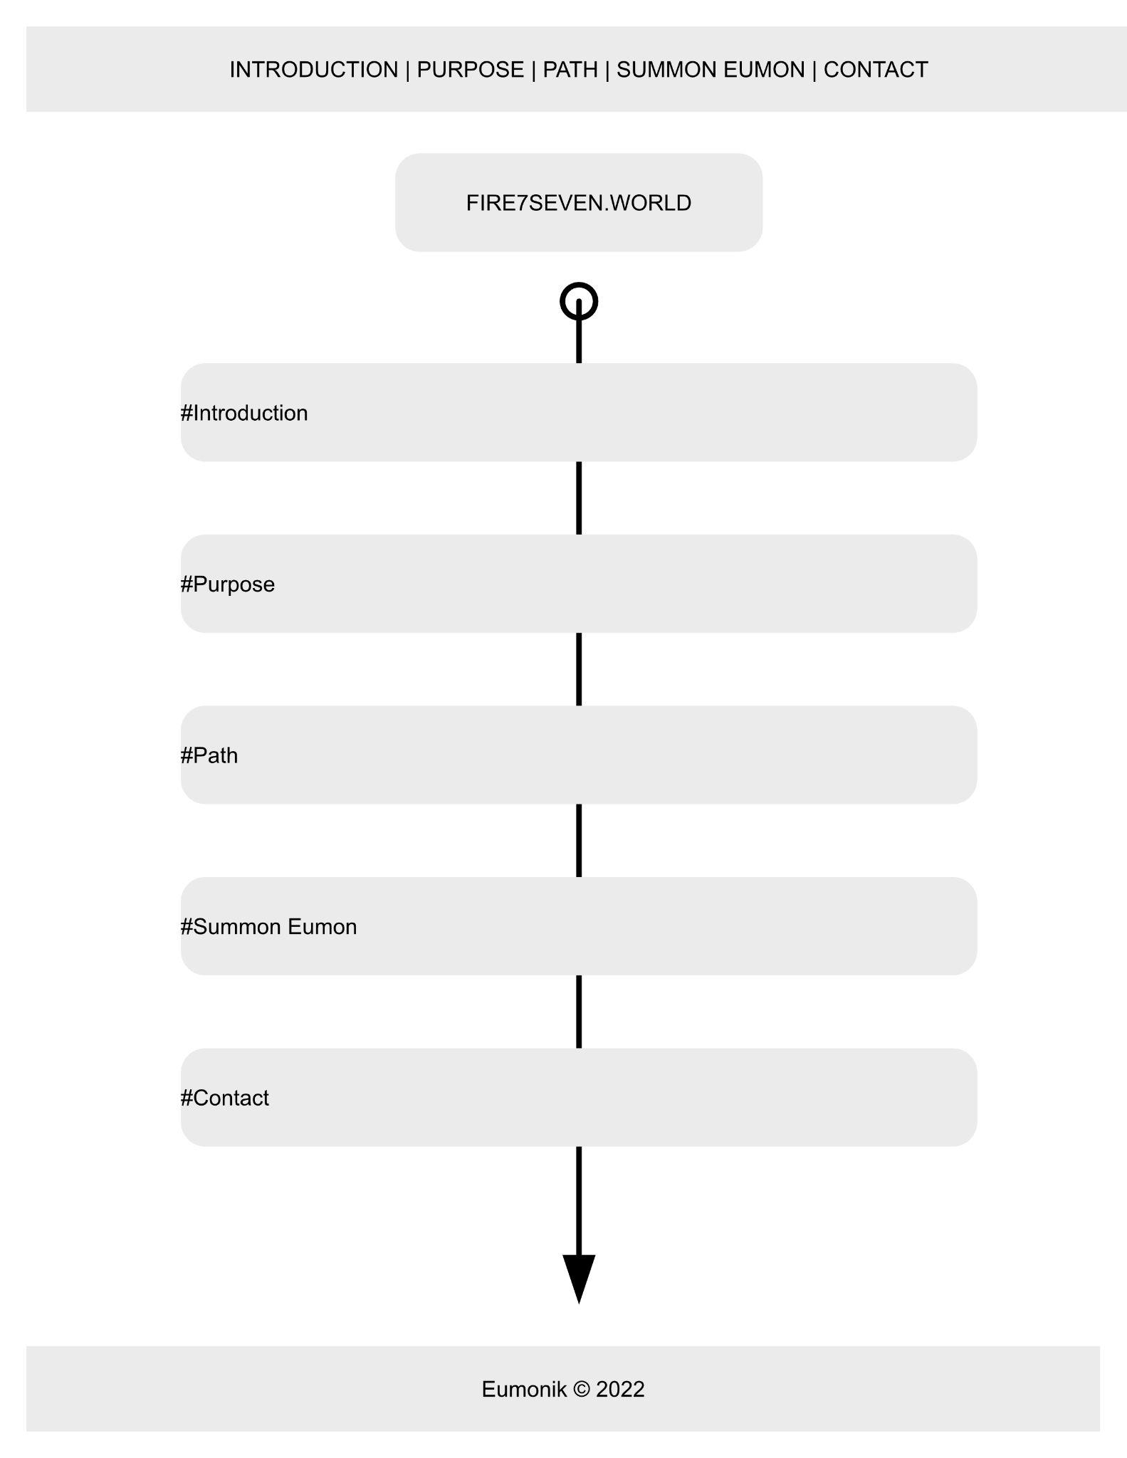

**WEB HOSTING**

Fire7seven.world was successfully registered today through Namecheap.com and has been secured with a provided Comodo SSL certificate. With this being a Solana-based NFT art project, I will be using the Rust language and Anchor framework. The greatest consideration for this project is that the hosting is fully compatible and integrated with the Solana blockchain ecosystem, including the nuances of the Solana Programming Library, versus that of the Ethereum Virtual Machine, or even non-blockchain hosting service providers.

**MARKETING**

Synchronizing the release of this digital collectible and community utility project with an upcoming YouTube milestone seems fit for the client. At the clear surpassing of 50,000 subscribers on the Eumonik YouTube channel, a video explaining this entire project with the above-mentioned talking points, musical background, and visual storytelling will be released to all Eumonik social media pages, with the main video being hosted publicly on the Eumonik YouTube channel and modified-for-platform versions being distributed on all other social media platforms. The growing frenzy of people interested in NFTs, new crypto projects and creative web3 perspectives is alive and well on Twitter. If any paid promotion is agreed upon before the launch of this project, the client has considered promoting a tweet or two. Aside from that, SEO is not a priority that will be leveraged, as the target audience is people who familiar with and following Eumonik, or have an unstoppable excitement to partake in a NFT project with an individualized real life story and incentivized utility.

**SECURITY**

Fire7seven.world will be an online marketplace for this limited sale of 77 digital collectibles through the Solana blockchain ecosystem, which means security and account management is dictated by different standards, a chief example of that being that lack of username and password. The website will use a “Connect Wallet” button at the top, once authentication is complete, the user is able to purchase 1 of the 77 digital collectibles. Utilizing the Solana Programming Library (SPL), which is written in Rust and also has support for C. Fortunately, because this involves new programming concepts and decentralized security principles, I will be using the Anchor framework, which eliminates many of the security concerns when programming a new Solana project from scratch only using Rust.

**REFERENCES**

Anchor. (n.d.). Project Serum. Retrieved February 22, 2022, from <https://project-serum.github.io/anchor/>

Program Languages. (2021, May 8). Solana Wiki. Retrieved February 22, 2022, from <https://solana.wiki/docs/solidity-guide/dev-environment/program-languages/>

**ADDITIONAL COPY FOR WEBSITE & CONCEPTUAL NARRATIVE**

**INTRODUCTION:**

Self-Proclaimed Music Producer and YouTube Content Creator, Eumonik, commissions the creation of an inventive yet disruptive self portrait and digital art gallery. Jargon aside, it’s a Solana NFT drop for exit liquidity from a broken relationship. Using decentralized blockchain technology to freely transact digital creations of all kinds, Eumonik no longer is, and, henceforth, will not be subject to, in any capacity, here and now, forever more and beyond, the cruel dealings of damaged and distanced individuals, indirectly or directly, knowingly or unbeknownst, possessed or high and mighty, dictating decisions in darkness that then dwell in the systems they’ve developed, to further drone on into the dire idiots that have dove down to unfit depths of depleted baselessness, groveling inauthenticity, and spineless showmanship, ripe for self-destruction, if not infernal combustion, a dry-rotted cavity set to be consumed and smolder eternally, a prison of self, a master only in mirror, a place of my own, a hell for a home, a life unfit for those that are called to GO TO THE WORLDS AND BE THE GOOD.

**Yes, this is a matter of life and death.**

**PURPOSE:**

I aim to creatively, respectfully, and wisely eradicate the hold of internet sensationalism and the grip of censorship-friendly “community guidelines” on my journey through the refining flames of life.

It’s foolish for powerful people to asymmetrically unite themselves to bastions of cowardice. I have been both a fool and a coward. I am now strongly compelled to move in power and do something fun, brilliant, and profitable.

I am long on YouTube, financially speaking. I am preparing to exit from that position. Come to think of it, the vast majority of people who are beholden to the centralized powers controlling the mediums in which we communicate and gather as a collective society, hopefully in peace and in reason, are lacking a certain gravitas that, according to some apparently outdated hierarchy, speaking of gravity, no longer carries any weight in this modern world. Case in point: “Yo, I am Eumonik.” Woe to you, indeed! Therefore, we see justice; empirical, sovereign, unending and sure, as nothing to wait over, let alone carry the weight ourselves.

**Wait the move OR Move the weight.**

Think of the hours I’ve spent grueling over fickle video edits and proper light placement, when my heart was crying to hear me say, “I don’t like pretending this feels good just because it looks good.” It took me failing and then kneeling, in isolation, at the rubble of my destruction, to truly, with a newly wrecked recklessness, pursue that solemn and still voice, like a pinch in my side when I’m sucking thin air in the Rocky Mountains. Ironically and fortunately enough, I am now here in the land of the lowly where the valley summits heights and meekness nurtures fields of plenty. The lifeforce of my entire efforts have been in vain, if not for those, yes those, that care. Unfortunately, I am no longer in a position to care. This indifference, or emotional liquidation, comes at a cost and, rightly so, comes with a benefit, that will be put to market in a creative and revolutionary fashion! To avoid distraction, dissent, and divisive discussions, I will not explain in full detail the reasons compelling me to this drastic and dastard decision. I will, however, allow you to decide.

**From the soil grows the seed.**

Digesting the confrontational truth, the one that slices and dices, is difficult to manage here on Earth. The stumbling blocks in front of our eyes prohibits us from seeing the lies behind the GUIse of a guiding light. If not for Freedom, I’d still not see nor admire the sunrise. If not for Love, I’d still deny affection, enthusiasm, and attention to my family, while wholeheartedly, yet crookedly, serving a digital avatar of my own wrinkled skin to convince others I’m something worth bargaining over and staking advertising space in front of. I gladly, with sheepish naivety and shrouded worthlessness, accepted a deal that never consulted my Heart, that never asked, “Why? Oh, sweet child o’ mine, why have you stopped believing?”

**The Devil is not in the details. The Devil is on clear display.**

Aside from a few outliers, all of my videos uploaded to YouTube are 1080p. Apparently, that resolution produces an image still too crunchy to see the nuanced tension of the human condition, especially when crafty edits and planned events highlight only a mirage to be accepted as flesh and bone, but only destined for an arrangement of pixels pleading for a certain “thumbs up”. From the top to the bottom, from the intro to the end screen, I have been hiding in front of you the entire time, slowly dying.

**Money and fame will leave you scorned. The Joy of the Lord is my strength.**

**PLAN:**

Monthly Eumonik YouTube Revenue: ~$500USD X 10 months left in 2022 = ~$5,000USD

Starting 1 MARCH 2022, all videos on the Eumonik YouTube channel will have monetization turned OFF.

FIRE7SEVEN commencing…

**Your decision will be honored greatly.**

77 Eumons on the Solana blockchain

Each summoned to power at 0.77SOL

77 Eumons X 0.77SOL = ~$5,000USD

**Your financial support will prove the worth of my efforts.**

If all 77 Eumons are summoned to power, all Eumonik videos and music will remain public

If all 77 Eumons are not summoned to power, all Eumonik videos (except for sponsored videos) and music will be deleted from all social media and streaming platforms, along with the corresponding accounts, except for YouTube to keep the sponsored videos public and Twitter to keep in touch for the time being

Regardless of mission outcome, monetization will be turned OFF on all Eumonik YouTube videos

**NOTE TO POTENTIAL EUMON SUMMONERS:**

All Eumons possess the additional utility to retrieve audio files from Eumonik’s digital storage devices and deliver them to the requester’s email address, which may be valuable to those who seek sound recordings and raw materials for music production or simply would like access to any deleted videos, music, or projects.

**FIRE7SEVEN**

FIRE7SEVEN is an emergency evacuation plan enacted by the Highest Order of the Euphonious Mons Intergalactic Existence and Stuff (H.O.E.M.I.E.S., pronounced home-eez), of which Eumonik is the High Priest and Soul Brother #1 (and #2, #3, #4, #5, #6, #7…#77).

**FUEL the FIRE**

The word of the HOEMIES has summoned 77 fire-fighting, glass-shattering Eumons (pronounced yu-monz), each uniquely equipped with supersonic, sonic, and subsonic capabilities to extinguish and shatter the smoke and mirrors, respectively, of the smoldering, glitter-covered, pile of sh*t that we all fear greatly, yet is only an illusion of self, which, in this emergency evacuation plan, is Eumonik, himself!

**FIRE the FUEL**

FIRE7SEVEN is Kyle James Jezwinski finally coming out of the bonds beset by decades of coercion, fear, doubt, and manipulation. Hiding in plain sight, I’ve broadcasted lies to acquire fake internet points, emboldened vain and loathing wafts of false security (like early Tuesday morning upper-management business meetings, meaningless Excel spreadsheet tracking macros, or live streaming on the internet, at like 2 in the morning, in an attempt to cure the fleeting flatulence of fattened and swollen loneliness), and I’ve glossed over details to avoid buying products at retail. I mean, honestly, free products are great! Although, something less great is much greater. I have danced and screamed and cried and laughed and lied, unashamedly, like a monkey covered in its own filth wishing for a banana sundae, in front of a camera that I decided to purchase and use for this very purpose. I built a castle out of my fecal matter and then became disgruntled when no one celebrated in my courts, wretched stench of selfishness notwithstanding. I’ve despised others that had bigger castles, shinier, and with more towers, towels, paper towels, best friends, cathedrals, hallways, tapestries, and thrones, with bodacious courtyards full of rambunctious, supportive, and empowering superfans. For too long, I have squanderingly denied the fire in the pit of my side, somewhere around my left oblique, that crushingly squeeks, “Burn it, burn it to the ground”.