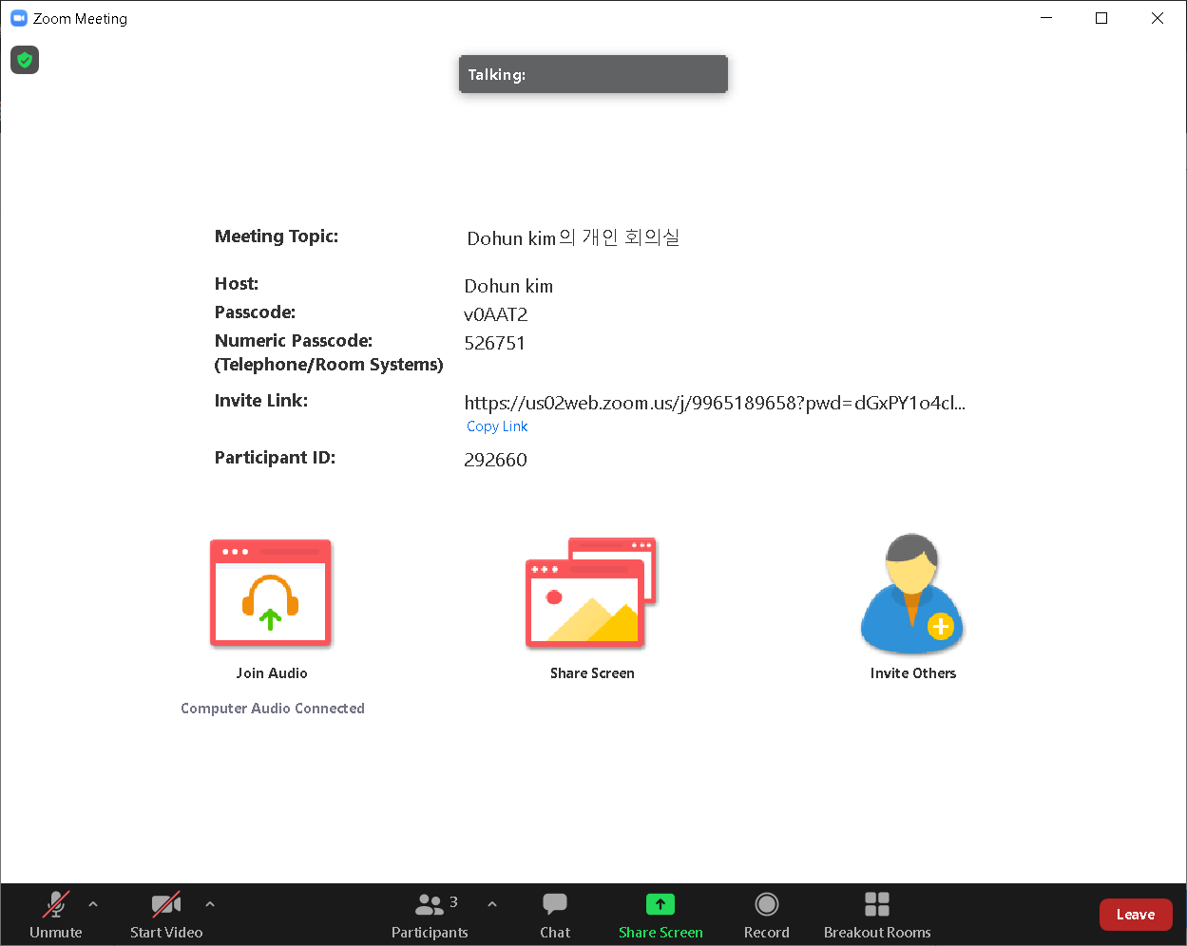

This figure is what you guys will see when you come in zoom (our real-time lecture platform). There are various functions at the bottom of our screen (Mike and Video on-off, Screen share, Chatting etc.).

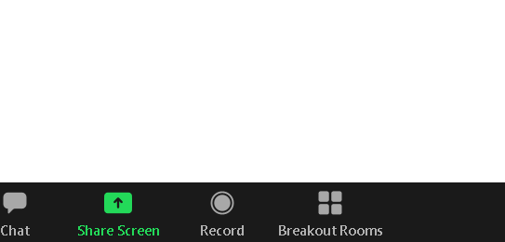

When submitting your files, we will use the "Breakout Rooms” button.

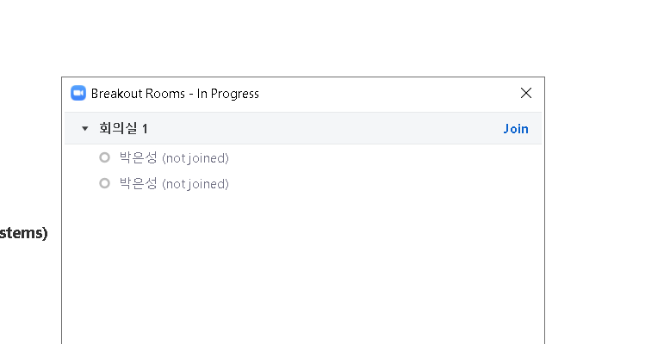

Click on the "Breakout Rooms" button boxed in red and you'll see this screen.

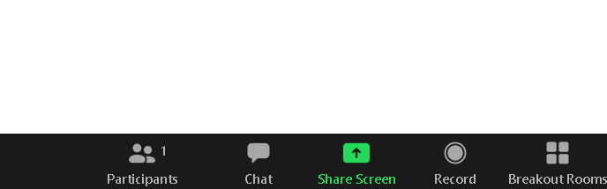

Press the "Join" button then you can enter another conference room. And when you press the "Chat" button, the chat screen pops up.

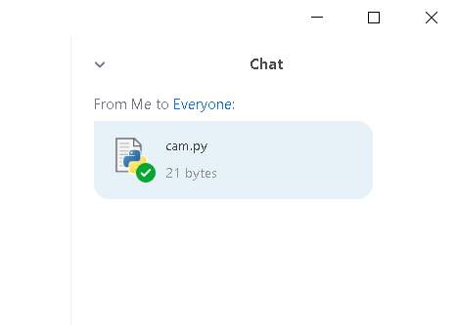

Drag and drop your Python file (.py) onto the chat window. And then you can upload your files.

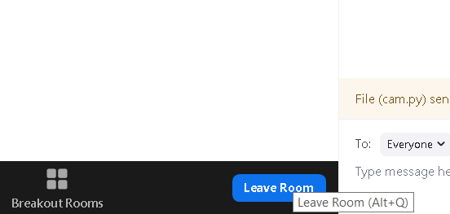

Press the “Leave Room” Button then you can move to the main conference room.