**[Session 1] Python Basics Supplement**

**print() function**

**print()** function is one of most important function in Python, because we can see the result of expression or function’s return value by using this.

Basically, we can use like this:

* **print(value, sep, end)**
* **value**: Something that can be printed. As we mentioned in the lecture, this can contain multiple items.
* **sep**: We can specify the separator. If we print multiple items, then we put separator between each item. For example, print(1, 2, 3, sep=“_”) will print “1_2_3”. The default is “ ”, a whitespace.
* **end**: We can specify ending character. The default is “\n”, a line feed. (and this is why many lines are printed when we call print() function many times) For example, print(“hello”, end=“!”) prints “hello!”, without line feed.
* Note that, these can be omitted all, print() is also ok.

**input() function**

We can get some input from user, by using **input()** function. We can show some prompt(the signal or message that computer is ready for the input) with parameter. (Like print() function, we can put many things as long as these can be printed)

The return value of the input() function is the **string** you are typed (and then Enter). Sometimes, we may want to get a number from user. How can we do that? Use int() function to convert its type.



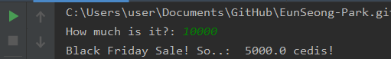

**Special characters**

String can contain some special characters.

* ‘\n’: line feed.
* ‘\b’: backspace
* ‘\t’: tab
* ‘\\’: backslash(\)

**Boolean**

We can apply many operations between boolean values.

* **A and B**: if A and B are True, then True. Otherwise False.
* **A or B**: if either A or B are True, then True.
* **not A**: if A is True then False. if A is False, then True.

Also, we can get boolean in many ways:

* **!=, ==, >, <, >=, <=**: If the result is true, then True.
* **A in B**: For an iterable object (such as string, list) B, if A is included in B, then True. Otherwise False. (You also can use not in)
* **A is B**: If A and B are same object with common ID, then True. Otherwise False. (You can see each id by using id() function)

There are some values that can be evaluated to False.

* **False**
* **0**
* **None**
* **[], (), "", ''**

**Indexing & slicing of list / tuple / string**

These three datatypes have in the following commons:

* **Can be iterated**: We can traverse each element (or character). (e.g. for statement)
* **Can be indexed:** We can access ith element directly, with [i]. (e.g. (1, 3, 2, 1)[2] => 2)
* **Can be sliced:** We can get a sub-data from the original, according to certain rules

Indexing and slicing are very important (and powerful) operations in Python. You should be accustomed to using these.

**(Index Rule)**

1. **Index starts at 0**. In order to access to ith element, we use (Data)[i-1], not (Data)[i].
2. Index out of range will cause error. For example, (1, 2, 3)[3] is an invalid indexing
3. Negative index can be valid. For example, list[-1] is the last element, and list[-2] is the second-last element. Note that, if the number of elements is n, then index under -n is invalid.
   * So, For some list with n items, list[i] = list[-(n-i)]

**(Slicing Rule)**

1. Basically, for some iterable data, A, use A[start:end:step]. All of them can be omitted. (even A[:] or A[::] are ok) The default of step is 1. For a list A, with n items
   1. A[:end] = A[0:end] = A[0:end:1]
   2. A[start:] = A[start:n-1] = A[start:n-1:1]
   3. A[:] = A[::] = A
2. In A[start:end], A[end] is not included.

We uploaded some exercises for practice of this.

**Nested loop**

Some loop can be in another loop. We call this **nested loop**. Let’s see the example.

for i in range(3):  
 for j in range(3):  
 print(i, j)

Can you guess the print result?

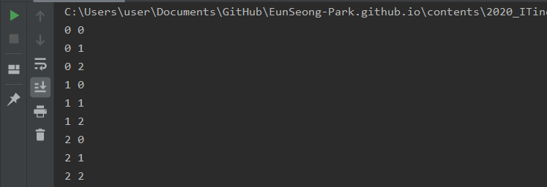

**More about loop**

You can use loop (for / while) in many ways. Some keywords are provided.

* **pass**: Do not anything.
* **continue**: Complete the current iteration immediately, and then start next one (if possible)
* **break**: Terminate the entire loop immediately.

**pass** can be used in other statements using colon(:) such as if/elif/else, def (function). Usually, we can use it as a placeholder. Note that if there is no content after colon-statement, then an error is occurred.

if False:  
else:  
 print("hello")

It should be like this:

if False:  
 pass  
else:  
 print("hello")

Or, in for statement,

for i in range(100):  
 pass

We sometimes want to skip an iteration or skip the following codes. Then we can use **continue** keyword. We can use it like this:

for i in range(5):  
 if i == 3:  
 continue  
 print(i)

In this example, numbers between 0 and 4 are printed, except 3 because print(i) was not executed when i was 3.

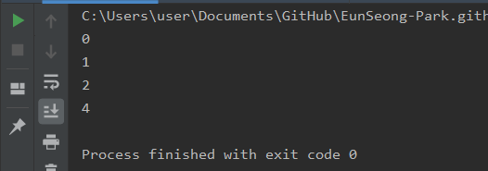

**break** terminates the entire loop. For example,

for i in range(1000000):  
 if i == 3:  
 break  
 print(i)

The program will print only 0, 1, 2. because the loop was broken when i was 3.

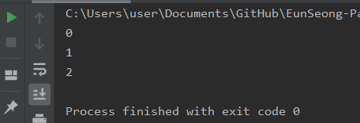

Note that, break and continue breaks / continues ONLY ONE nearest loop.

my_sum = 0  
for i in range(3):  
 for j in range(3):  
 my_sum += 1  
  
print(my_sum)

This program prints 9. How about this?

my_sum = 0  
for i in range(3):  
 for j in range(3):  
 if j == 2:  
 break  
 my_sum += 1  
  
print(my_sum)

Since the break does not break the i-loop, the program will print 6.

**Function: recursion**

The situation that some function calls itself is called “**recursion**”. Recursion is sometimes useful, because it can simplify the code. For example, we will implement “Fibonacci number” function in two ways.

def fibo(n):  
 if n == 0:  
 return 0  
 elif n == 1:  
 return 1  
 else:  
 result = 0  
 a, b = 0, 1  
 for i in range(2,n+1):  
 result = a + b  
 a = b  
 b = result  
 return result

def fibo_recursion(n):  
 if n == 0:  
 return 0  
 elif n == 1:  
 return 1  
 else:  
 return fibo_recursion(n-2) + fibo_recursion(n-1)

The latter code has better readability and is more straightforward.

However, note that, **recursion must be ended eventually**. If the function calls itself infinitely, our computer cannot withstand and causes some problem. This is called “**stack overflow**”. (Fortunately, in most programming language prevents this, but we still cannot run the program properly.) So read your code carefully, and ensure that the recursion can be terminated eventually.

**Function: parameter and argument**

In the lecture, we used the terms “parameter” and “argument”. How do they differ? Usually, we define these like:

* **Parameter**: The name of “variable” when some function or method is defined
* **Argument**: The “value” passed to some function or method

So, for example,

def one_adder(n):  
 return n + 1  
  
  
one_adder(15)

We can say that, the function, one_adder uses a parameter, n, and we called one_adder with a argument, 15.