**[Session 3] OpenCV Exercise**

**Note**

You don't need to solve everything, because it is not mandatory and graded, just for practice! We will provide a solution after the real-time class. But, if you have some problem and ask us, then we will give you some help or hints. **Good luck!**

**Exercise 1**

The followings are exercises for practice of basic image processing. As an example, I will use the picture. Just try these by your image

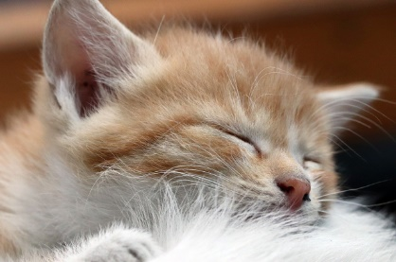

**(1.1) Fill with some color (All, left, upper, quarter)**

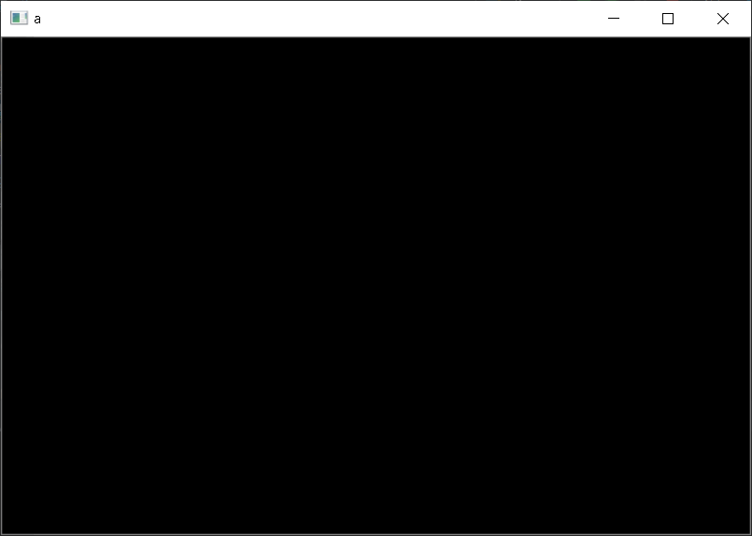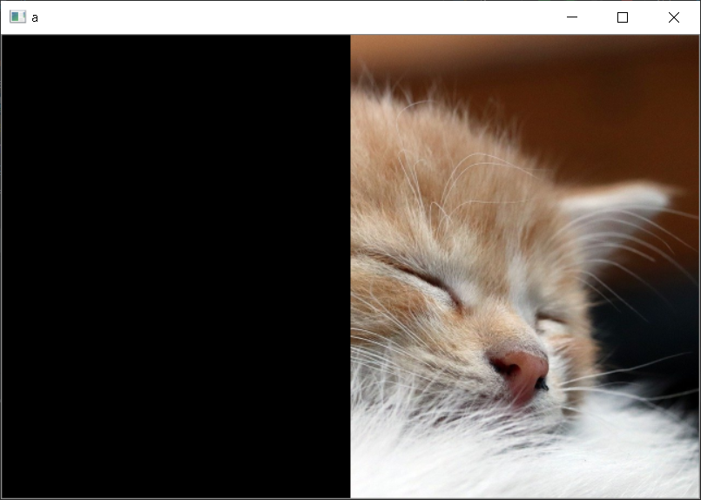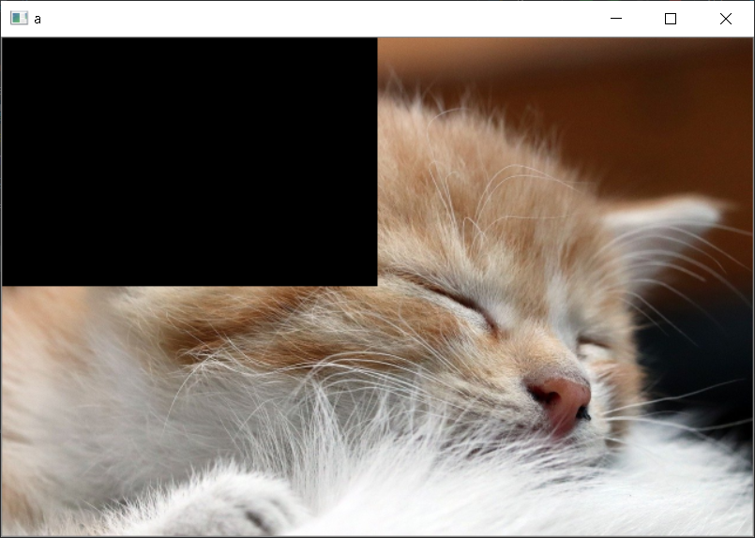

**(1.2) Small-copy**

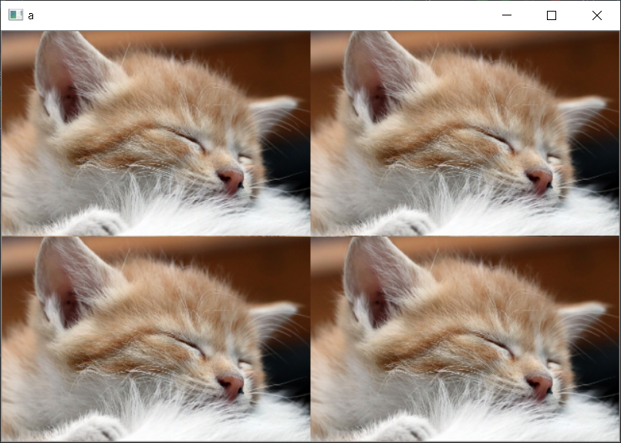

**(1.3) Zoom-in (note that window size should be same!**

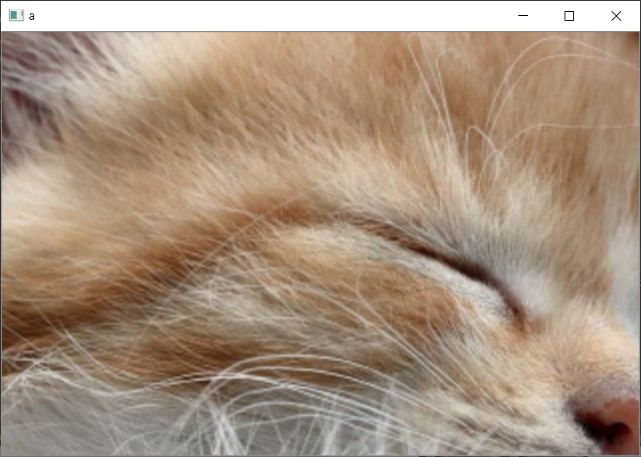

**(1.3) Draw something**

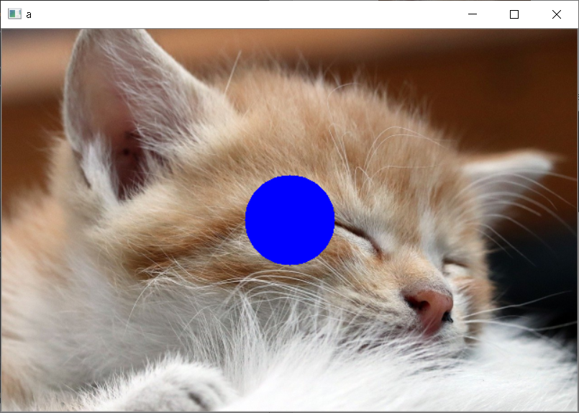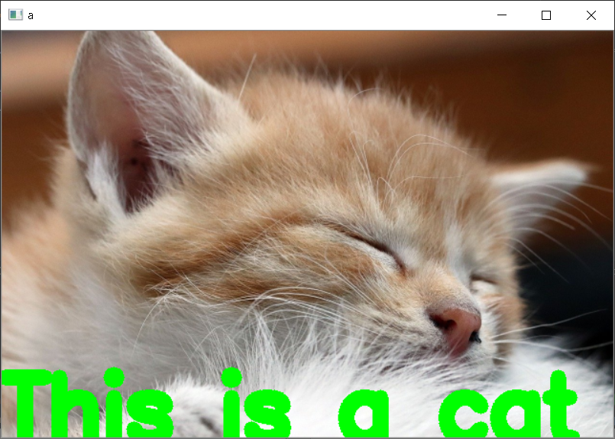

**Exercise 2**

You will make **an analog clock** with OpenCV. You should follow the instruction.

* It is an **(circular) analog clock**.
* Use **600 x 600** screen size.
* You can freely choose the style.
* Your clock **should be faster than real clock**, to see if it works well or not. (you can choose any rate)
* You can use **time** library. **time.time()** function: it returns current time (integer: second / float: microsecond)
* Also, you may need **math** library. Representing clock hand may needs a think and math but try by yourself!

This is an example. It should be able to circulate!

