Feature Importance & Business Insights
Santander Customer Satisfaction · Model: XGBoost (n=300, depth=5, lr=0.05) · 76,020 customers, baseline unsatisfied rate = 3.96%

1. Background
The strongest base model in this project is the XGBoost ensemble (public AUC 0.84) developed by Austin. While the modeling layer of the problem is well addressed, the first item of the instructor's feedback explicitly asked for something more: identify which features have the largest impact on prediction outcomes, and where features are interpretable, use them to provide business insights to stakeholders.
Wenyu produced the Top 20 feature importance ranking using XGBoost gain-based importance (the bar chart with ind_var30 ranked first). Gain-based importance, however, only answers "which features the model uses most." It does not address two questions that matter for a business audience:
- Directional question — for each important feature, do higher or lower values push customers toward dissatisfaction?
- Business interpretability question — among the features that can be understood, which specific customer segments are more likely to be dissatisfied?
Two follow-up analyses were conducted to address these questions.

2. SHAP Analysis: A More Reliable Feature Importance View with Direction

Methodology
SHAP values were computed for the same XGBoost model used by Wenyu, using the SHAP TreeExplainer. Unlike gain importance, which counts how often a feature is used as a split point in the trees, SHAP directly measures how much each feature shifts an individual customer's predicted probability. As a result, SHAP simultaneously answers both "how important is this feature" and "in which direction does it influence the prediction."
Three sets of visualizations were generated: a Top 20 SHAP bar chart (mean absolute SHAP values), a beeswarm summary plot (visualizing direction across all customers), and SHAP dependence plots for the top 6 features (feature value vs SHAP value scatter).

Insight 1 — Gain ranking misled the team; SHAP is the more reliable view
When the gain ranking and the SHAP ranking are placed side by side, the difference is substantial:
Rank | Gain (Wenyu) | SHAP
1 | ind_var30 | var15 (age)
2 | saldo_var30 | saldo_var30
3 | ind_var26_cte | saldo_medio_var5_hace3
4 | var15 | saldo_medio_var5_ult3

The most striking difference: gain ranks ind_var30 first, but SHAP places it in the 17th position. This is because gain measures how much loss reduction a feature contributes when used as a split, which systematically overstates the importance of binary indicator variables (0/1) that are repeatedly used as split points. SHAP measures the actual impact on predicted probability and aligns more closely with what business stakeholders want to understand.
Conclusion: the presentation should communicate feature importance using SHAP rankings, not gain rankings.

Insight 2 — Top 5 features capture roughly 50% of the model's predictive signal
By mean absolute SHAP value, the top 5 features account for about 56% of all prediction signal:
- var15 (age) — 30.7%
- saldo_var30 (current account balance) — 13.2%
- saldo_medio_var5_hace3 (historical avg balance, 3 periods ago) — 5.9%
- saldo_medio_var5_ult3 (recent avg balance, last 3 periods) — 3.6%
- saldo_medio_var5_hace2 (historical avg balance, 2 periods ago) — 3.4%
This means that for a business audience, there is no need to walk through 308 features. Explaining age + current balance + historical balance already covers roughly half of the predictive logic of the model.

Insight 3 — The SHAP dependence plot for var15 reveals a sharp "23-year-old cliff"
The SHAP dependence plot for var15 is one of the most informative visuals from this analysis. It shows:
- Ages 5–22: SHAP values cluster around -2 (strongly pushing toward "satisfied")
- At age 23, an extremely steep jump occurs: SHAP values move from around -2 directly to about +0.5
- Ages 23–55: SHAP values continue rising, peaking around 45–55 (about +1, pushing toward "dissatisfied")
- After age 60: SHAP values gradually decline
The relationship is clearly non-linear — not a simple "older customers are more dissatisfied" linear pattern. The model has identified several distinct segments along the age dimension. The business bucket analysis in Section 3 further confirms this finding.

3. Business Bucket Analysis on Interpretable Features

Methodology
Most features in the Top 20 are anonymized (e.g., imp_op_var41_efect_ult3), and their precise meaning cannot be confirmed. However, the Kaggle community has reached consensus on four features:
- var15 = customer age
- saldo_var30 = an account balance ("saldo" is Spanish for "balance")
- ind_var30 = product holding indicator (0/1)
- ind_var26_cte = another product holding indicator (0/1)
For each of these four features, a bucket-level cross-tabulation against the TARGET variable was performed: sample size, unsatisfied rate, and lift relative to the overall 3.96% baseline. Each was paired with a bar chart (dark bars = unsatisfied rate, light bars = sample size, red dashed line = baseline).

Insight 4 — Middle-aged customers are the most dissatisfied, not young customers (counter-intuitive)
Age bucket | Sample size | Unsatisfied rate | Lift
<23 | 1,212 | 0.00% | 0.00x
23–30 | 40,650 | 1.65% | 0.42x
30–45 | 20,968 | 6.80% | 1.72x
45–60 | 9,224 | 7.65% | 1.93x
60+ | 3,966 | 5.17% | 1.31x

Middle-aged customers (30–60) show dissatisfaction rates close to 2x the baseline, far higher than other age groups. This aligns precisely with the SHAP dependence finding in Section 2: the SHAP peak for var15 sits at age 45–55.
Business interpretation: this is not a "young customers are difficult" story. Rather, the bank's core active customer segment — middle-aged working professionals — has the highest expectations and is the most affected by service issues. This is a valuable insight for the bank's service strategy: customer experience improvements should be targeted at active middle-aged customers, not at young customers.
Important caveat on the <23 bucket: the 1,212 customers in this group show 0.00% dissatisfaction, which may appear to suggest "young customers are perfectly satisfied." A sanity check on the raw data shows that ages 5–22 are sparsely populated (a few dozen customers per year of age), then a sharp jump occurs at age 22 (940 customers) and again at age 23 (20,170 customers). This indicates the <23 group is largely composed of sub-accounts, dependent accounts, or inactive accounts — not primary banking customers. The appropriate baseline for young primary customers is the 23–30 bucket, where dissatisfaction is still well below average (1.65%). When presenting to stakeholders, this caveat must be stated explicitly to avoid misinterpretation.

Insight 5 — Zero-balance customers are the dominant dissatisfaction segment (corroborates Austin's earlier EDA)
Balance | Sample size | Unsatisfied rate | Lift
≤ 0 | 20,430 | 8.84% | 2.24x
> 0 | 55,590 | 2.16% | 0.55x

Customers with zero balance (around 20,000 customers) are 4x more likely to be dissatisfied than customers with positive balance. Austin had previously noted in EDA that low-activity customers tend to be dissatisfied; this bucket analysis provides a concise quantitative confirmation.
A finer quintile analysis shows that nearly all dissatisfied customers concentrate in the lowest bucket (balance ≤ 0). Even the 0–3 unit bucket already drops dissatisfaction to 2.08%. The actionable implication for the bank is concrete: driving any kind of activity into a customer's account substantially reduces dissatisfaction risk.

Insight 6 — ind_var30 and saldo_var30 represent two facets of the same product
ind_var30 | Sample size | Unsatisfied rate | Lift
0 (not held) | 20,310 | 8.79% | 2.22x
1 (held) | 55,710 | 2.19% | 0.55x

The ind_var30 = 0 group (20,310) overlaps almost exactly with the saldo_var30 ≤ 0 group (20,430). This indicates that ind_var30 is the holding flag for the product whose balance is saldo_var30 — they are essentially two facets of the same underlying product.
This also partially explains why gain importance ranked ind_var30 first: the high correlation between these two features causes their signal to be double-counted in gain. SHAP, which allocates contributions across correlated features more fairly, places ind_var30 at rank 17 — consistent with the picture that there is essentially one underlying signal here.
Business interpretation: customers who do not hold this core banking product are the dominant churn-risk segment, and this is the same story as "zero-balance customers are the most dissatisfied" told from a different angle.

Supplementary Figure — Activity, Zero Balance, and ind_var30 Risk Comparison
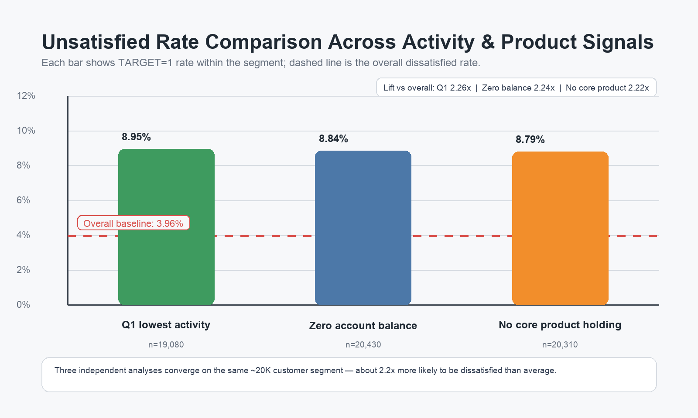
Three independent analyses converge on the same ~20K customer segment: Q1 lowest activity, saldo_var30 <= 0, and ind_var30 == 0 are each about 2.2x more likely to be dissatisfied than average. This reinforces that low activity, zero/negative balance, and no ind_var30 product holding are different views of the same actionable high-risk customer profile.

Insight 7 — A small but high-risk subgroup (ind_var26_cte = 1)
ind_var26_cte | Sample size | Unsatisfied rate | Lift
0 | 73,925 | 3.88% | 0.98x
1 (held) | 2,095 | 6.68% | 1.69x

The direction here is opposite to ind_var30: the small group of customers who hold ind_var26_cte are more dissatisfied. They represent only 2.7% of the customer base, but their dissatisfaction rate is 1.7x the baseline.
Business interpretation: this is a "small but high-risk" subgroup. It may correspond to a specific banking product (a particular loan service, credit card fee structure, or insurance product) with a service issue. This is a particularly actionable insight: the bank does not need to overhaul its entire product portfolio — investigating the root cause of dissatisfaction in this single product group is a focused, achievable intervention.

4. Summary: Three Core Business Insights
Bringing the analyses together, three concrete insights are ready to communicate to the team or business stakeholders:
- Three drivers explain the model: age + current balance + historical balance (combined SHAP share ≈ 50%). The presentation does not need to walk through 308 features.
- High-risk customer profile: middle-aged (30–60) + low or zero balance + low activity. These three dimensions also reinforce each other.
- ind_var26_cte is an overlooked small subgroup: only 2.7% of customers, but with elevated dissatisfaction. The bank can target this group with a focused root-cause investigation.

5. Deliverables
- 5-page English PDF report (feature_importance_business_insights_report.pdf) — contains all charts, tables, analyses, and recommendations; suitable for direct delivery to instructor or business stakeholders.
- Two Python scripts — SHAP analysis and business bucket analysis, both built on Wenyu's run_xgboost_fe.py interface for consistency with team code style.
- Charts — SHAP beeswarm, SHAP bar chart, 6 SHAP dependence plots, 4 business bucket bar charts (each anchored to the 3.96% baseline).
- Two CSVs — SHAP ranking table and business bucket summary table, ready to be pasted into the final write-up Table 2.

