1. Advice for exams:

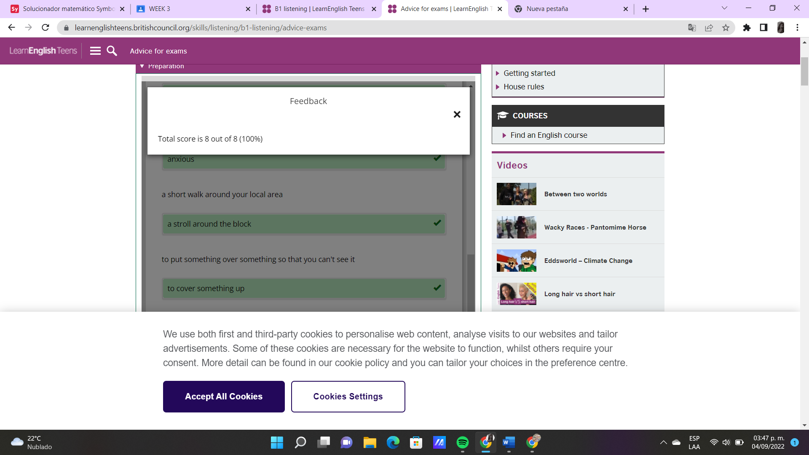

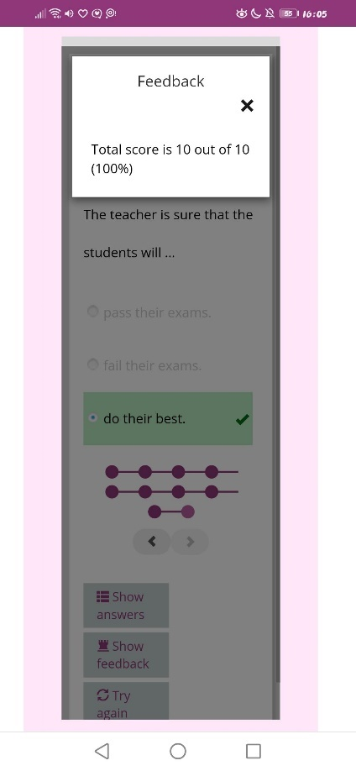 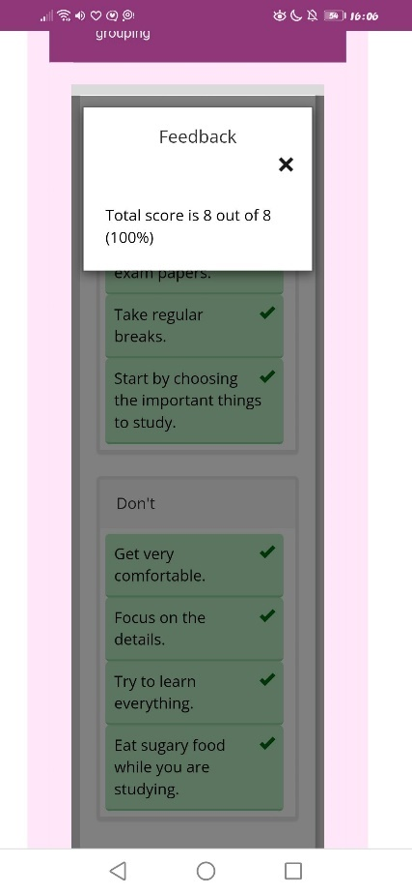

Does any of this advice surprise you? Have you got any good advice to share for studying for exams?

No, any of those advices surprised me, because those are things that I have always done while studying, but an advice I could give other students is that they find their own methods to study, since we all learn in a different way, because, for example, some people take notes after the teacher finishes explaining because they understand and learn better if they do this, some others instead, take notes while the teacher is explaining and they also understand the topic.

1. Celebrations:

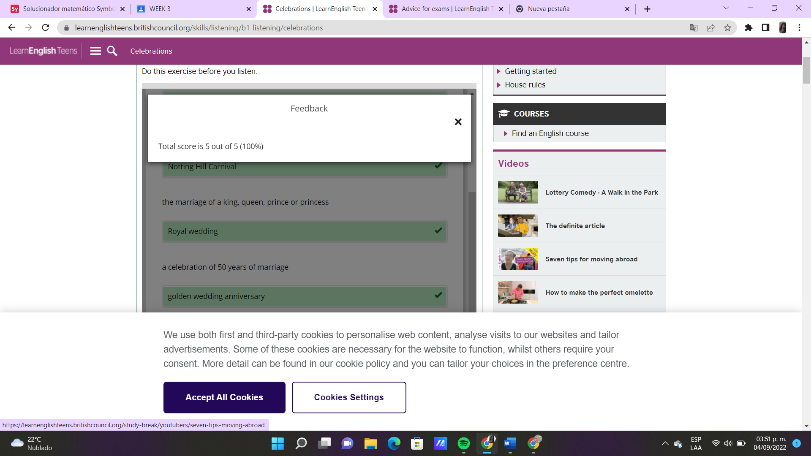

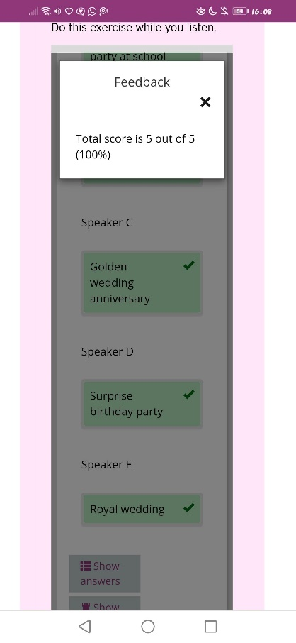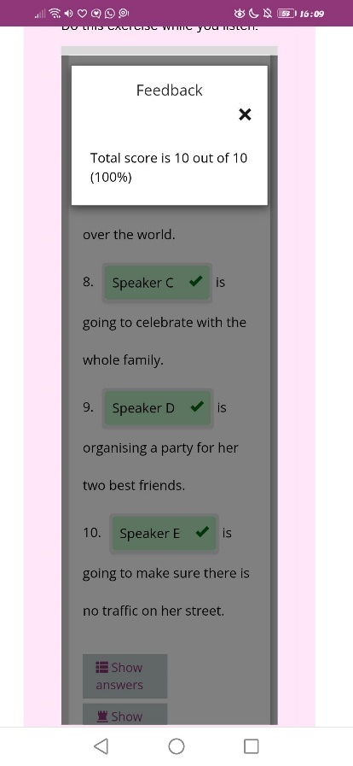

Do you have any celebrations planned? What are you celebrating? What are you going to do?

No, I don’t really like parties or celebrations, but right now, the closest important celebration for me is Christmas. Probably I’ll have a dinner with my family, while we talk and eat delicious food, and after that, we will open presents, take so pictures and talk a little bit more.

1. Shopping:

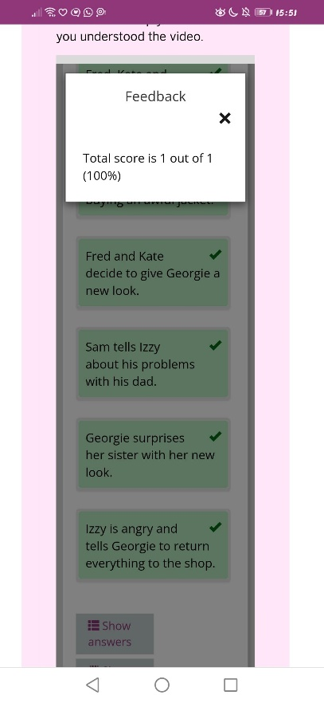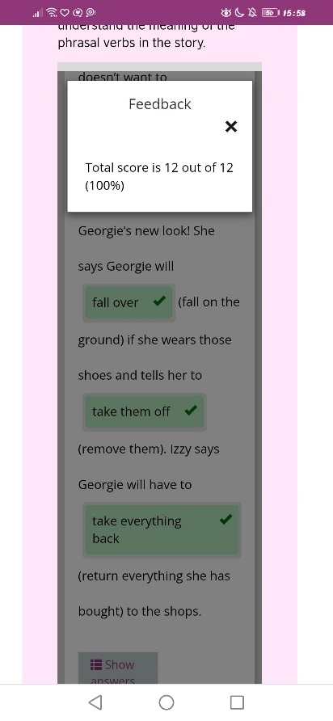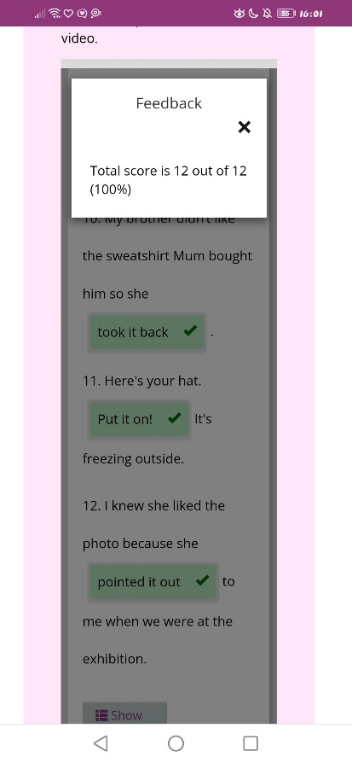

Would you like to have a new look?

Yes, I would like to have a new of look, I would like to buy more "grunge aesthetic" clothes and dye my hair, but I don't know where to find these clothes, because in stores, there aren't that many clothes of this style and when there are this kind of clothes, the are too expensive.